Personality Development

Volume 1

Authors
Dr. K. KARUNAKARAN
Dr. K. FAMITHA BEGUM
Dr. SHILPI AGARWAL
Dr. A. GOKULAKRISHNAN

Published by: New Chennai Publications
New Chennai Publications
No: 16/ 22 JAWAHARLAL NEHRU STREET,
NEW PERUNGALATHUR,
CHENNAI,
TAMIL NADU,
INDIA
600063

Authors: Dr. K. KARUNAKARAN, Dr. K. FAMITHA BEGUM, Dr. SHILPI AGARWAL, Dr. A. GOKULAKRISHNAN

The author/publisher has attempted to trace and acknowledge the materials reproduced in this publication and apologize if permission is not sought in prior. Please write to us for any rectification.
Copyright © PDKaru
Publication Year: 2025
Pages: 211
Paper Back: ISBN: 978-81-984949-5-5
Book DOI: https://doi.org/10.5281/zenodo.17505227
Price: Rs. 198/-

About the Authors
Dr.K.Karunakaran is a Professor in Mechanical Engineering at Vels Institute of Science, Technology, and Advanced Studies, Chennai. With 22 years of teaching and 10 years’ experience in industry. He holds Ph.D. in Manufacturing, M.E. in CAD/CAM, and M.B.A. in HR. He has published over 32 papers in SCI/Scopus-indexed journals, h-index of 8, and over 205 citations.

Dr.K. Famitha begum is a seasoned academician and researcher with over 5 years of teaching experience in the field of Management Studies. She is currently serving as ASSISTANT Professor in the Department of Business Administration at Vels Institute Of science, Technology, & Advanced studies. Dr.K.FamithaBegum holds a Ph.D. in Management and has guided numerous students in their research projects and dissertations. Her areas of expertise include Human Resource Management, Organizational Behaviour, and Strategic Management. With a strong passion for research and innovation,)

Dr. Shilpi Agarwal is a distinguished academician and currently works as a UG Coordinator & Assistant Professor of English at JAIN (Deemed-to-be University), Bengaluru. A Fulbright Fellow at the University of Texas at Austin (2009–2010), she holds a PhD in English from Annamalai University, an M.Phil. and M.A. in English from the University of Lucknow, and a B.A. in English and Mass Communication. With over fourteen years of teaching experience across institutions such as CIPET - Ahmedabad, National P.G. College - Lucknow, and the University of Texas at Austin.
Dr. A. Gokulakrishnan is presently working as an Assistant Professor at Vels Institute of Science, Technology, and Advanced Studies. He was awarded a Ph.D. in Management from M.S. University in 2016. He has published more than 22 national and international papers to his credit. He organized various national and international conferences, workshops, and FDPs in various institutions. He has expertise in Basic Management, Human Resource Management, and Research Methodology. He has also guided 04 Ph.D. scholars in Management. He is one of the Editorial Board Members of the International Journal of Advanced Research in Commerce Management and Finance.

Preface
Personality is not merely a reflection of how we look or behave; it is the sum of our values, thoughts, emotions, communication, and actions that shape our identity. In a world that is constantly evolving with new challenges, the need for a strong, adaptable, and confident personality has become more important than ever. Personality development is, therefore, not a one-time event, but a continuous journey of self-discovery and refinement.
This book, Personality Development, has been crafted with the objective of guiding learners, students, young professionals, and anyone who aspires to enhance their personal and interpersonal skills. We have attempted to present the concept of personality in a holistic manner—bringing together behavioral understanding, communication proficiency, emotional intelligence, ethical values, leadership qualities, and overall attitude towards life.
Our approach in this book integrates practical knowledge, real-life examples, reflective exercises, and self-assessment tools, enabling every reader to apply the learning to daily life. Each chapter encourages self-reflection and offers actionable strategies to improve confidence, motivation, social relationships, and career readiness.
We express our sincere gratitude to the educational institutions, experts, mentors, and students who have inspired and supported us in developing this work. We hope this book serves as a valuable companion in your journey toward becoming the best version of yourself.
With warm regards,
The Authors

S.NO | CHAPTER / TOPICS | PAGE NO.
 | UNIT I : FOUNDATION OF PERSONALITY DEVELOPMENT
1.1 | Definition And Concept Of Personality | 3
1.2 | Dimensions and determinants of personality | 6
1.3 | Personality traits and their significance | 9
1.4 | Theories of personality | 11
1.5 | Importance of personality development | 15
1.6 | Meaning and benefits of self-awareness | 17
1.7 | Developing self-awareness techniques | 19
1.8 | SWOT Analysis | 20
1.9 | Components and application of SWOT | 22
1.10 | Concept of success and failure | 24
1.11 | Factors responsible for success and causes of failure | 26
1.12 | Hurdles in achieving success and overcoming strategies | 30
1.13 | Goal setting: meaning, importance, and principles | 32
1.14 | Effective goal setting at the right level | 34
 | UNIT II : ATTITUDE, MOTIVATION, AND SELF-MANAGEMENT
2.1 | Concept and significance of attitude | 45
2.2 | Formation and types of attitudes | 47
2.3 | Factors affecting attitudes and measurement methods | 48
2.4 | Positive vs. negative attitudes: advantages and disadvantages | 49
2.5 | Barriers to attitude change and methods for attitude transformation | 50
2.6 | Ways to develop positive attitude | 52
2.7 | Concept and significance of motivation | 53
2.8 | Internal and external motives | 54
2.9 | Importance of self-motivation and factors leading to de-motivation | 55
2.10 | Self-monitoring: meaning and techniques | 57
2.11 | High vs. low self-monitor characteristics | 58
2.12 | Self-monitoring and job performance relationship | 59
2.13 | Definition and factors influencing perception | 60
2.14 | Perception process and common errors | 61
2.15 | Avoiding perceptual errors and improving accuracy | 62
 | UNIT III : SELF-ESTEEM AND INTERPERSONAL SKILLS
3.1 | Understanding self-esteem: definition and symptoms | 71
3.2 | Advantages of positive self-esteem | 75
3.3 | Low self-esteem: symptoms and personality characteristics | 78
3.4 | Do's and don'ts for developing positive self-esteem | 82
3.5 | Positive vs. negative self-esteem comparison | 86
3.6 | Defining aggressive, submissive, and assertive behaviors | 90
3.7 | Assertiveness in communication and techniques | 93
3.8 | Benefits of being assertive and improving assertiveness | 96
3.9 | Lateral thinking approaches | 100
 | UNIT IV : LEADERSHIP AND TEAM DYNAMICS
4.1 | Team building: meaning, types, and importance | 113
4.2 | Creating effective teams and team dynamics | 117
4.3 | Leadership: definition, styles, and theories | 121
4.4 | Qualities of an effective leader | 124
4.5 | Character building principles | 128
4.6 | Conflict management: definition, types, and levels | 132
4.7 | Conflict resolution strategies and management techniques | 136
4.8 | Negotiation skills: principles, types, and process | 138
4.9 | Common mistakes in negotiation and how to avoid them | 142
 | UNIT V : COMMUNICATION AND EMOTIONAL INTELLIGENCE
5.1 | Definition and importance of communication | 155
5.2 | Communication process, symbols, and networks | 159
5.3 | Barriers in communication and overcoming strategies | 161
5.4 | Transactional Analysis: EGO states and types of transactions | 165
5.5 | Johari Window and life positions | 168
5.6 | Emotional Intelligence: meaning and components | 172
5.7 | Significance of managing emotional intelligence | 176
5.8 | Developing emotional quotient | 180
5.9 | Stress management: sources, symptoms, and consequences | 183
5.10 | Strategies for managing stress effectively | 186

SYLLABUS
UNIT I: FOUNDATION OF PERSONALITY DEVELOPMENT
Definition and concept of personality - Dimensions and determinants of personality - Personality traits and their significance - Theories of personality (Freud & Erikson) - Importance of personality development - Meaning and benefits of self-awareness - Developing self-awareness techniques - SWOT Analysis (Strengths, Weaknesses, Opportunities, Threats) - Components and application of SWOT - Concept of success and failure - Factors responsible for success and causes of failure - Hurdles in achieving success and overcoming strategies - Goal setting: meaning, importance, and principles - Effective goal setting at the right level.
UNIT II: ATTITUDE, MOTIVATION, AND SELF-MANAGEMENT
Concept and significance of attitude - Formation and types of attitudes - Factors affecting attitudes and measurement methods - Positive vs. negative attitudes: advantages and disadvantages - Barriers to attitude change and methods for attitude transformation - Ways to develop positive attitude - Concept and significance of motivation - Internal and external motives - Importance of self-motivation and factors leading to de-motivation - Self-monitoring: meaning and techniques - High vs. low self-monitor characteristics - Self-monitoring and job performance relationship - Definition and factors influencing perception - Perception process and common errors - Avoiding perceptual errors and improving accuracy.
UNIT III: SELF-ESTEEM AND INTERPERSONAL SKILLS
Understanding self-esteem: definition and symptoms - Advantages of positive self-esteem - Low self-esteem: symptoms and personality characteristics - Do's and don'ts for developing positive self-esteem - Positive vs. negative self-esteem comparison - Defining aggressive, submissive, and assertive behaviors - Assertiveness in communication and techniques - Benefits of being assertive and improving assertiveness - Lateral thinking approaches.
UNIT IV: LEADERSHIP AND TEAM DYNAMICS
Team building: meaning, types, and importance - Creating effective teams and team dynamics - Leadership: definition, styles, and theories - Qualities of an effective leader - Character building principles - Conflict management: definition, types, and levels - Conflict resolution strategies and management techniques - Negotiation skills: principles, types, and process - Common mistakes in negotiation and how to avoid them.
UNIT V: COMMUNICATION AND EMOTIONAL INTELLIGENCE
Definition and importance of communication - Communication process, symbols, and networks - Barriers in communication and overcoming strategies - Transactional Analysis: EGO states and types of transactions - Johari Window and life positions - Emotional Intelligence: meaning and components - Significance of managing emotional intelligence - Developing emotional quotient - Stress management: sources, symptoms, and consequences - Strategies for managing stress effectively.
1
FOUNDATION OF PERSONALITY DEVELOPMENT
INTRODUCTION
The foundation of personality development serves as the cornerstone for understanding human behavior and individual growth. This chapter explores the fundamental concepts that shape who we are and how we can enhance our personal and professional capabilities. The journey of personality development begins with understanding the basic definitions and concepts that govern human personality, followed by an exploration of the various dimensions and determinants that influence our character formation.
Personality development is not merely an academic subject but a practical necessity in today's competitive world. The ability to understand oneself, recognize personal strengths and weaknesses, and work towards continuous improvement has become essential for success in both personal and professional spheres. This chapter provides a comprehensive foundation that will enable students to embark on their personality development journey with clarity and purpose.
The concepts presented in this chapter form the building blocks for all subsequent learning in personality development. From understanding the basic nature of personality to mastering the art of goal setting, each topic is designed to provide practical tools and theoretical knowledge that can be immediately applied in real-life situations. The integration of psychological theories with practical applications ensures that students gain both depth of understanding and practical skills necessary for effective personality development.
1.1 DEFINITION AND CONCEPT OF PERSONALITY:
Personality represents the unique combination of characteristics, traits, and patterns that define an individual's distinctive way of thinking, feeling, and behaving. The term personality originates from the Latin word "persona," which referred to the theatrical masks worn by actors in ancient Rome. This etymology reflects the idea that personality is the face we present to the world, though it encompasses much more than mere external appearance.
The concept of personality extends beyond surface-level behaviors to include the deep-seated psychological structures that drive human action. It encompasses the relatively stable patterns of thoughts, emotions, and behaviors that make each person unique. Personality is not static but rather a dynamic system that evolves throughout life while maintaining certain core characteristics that remain consistent across different situations and time periods.
Modern psychology views personality as a complex interplay between inherited genetic factors and environmental influences. This interaction creates a unique individual profile that influences how a person perceives the world, makes decisions, forms relationships, and responds to challenges. Understanding personality is essential for personal growth, career development, and building effective relationships in both personal and professional contexts.
Types of Personality Classifications:
Different psychological approaches have proposed various ways to classify personality types. The most widely recognized classification systems include the Myers-Briggs Type Indicator (MBTI), which identifies 16 personality types based on four key dimensions, and the Big Five personality traits model, which measures personality across five major factors. These classification systems help individuals understand their natural tendencies and preferences.
Personality vs Character:
While personality and character are often used interchangeably, they represent distinct concepts. Personality refers to the natural patterns of thinking, feeling, and behaving that emerge from both genetic and environmental influences. Character, on the other hand, represents the moral and ethical aspects of personality that are developed through conscious choice and life experiences.
Individual Differences:
No two individuals possess identical personalities, even when they share similar genetic backgrounds or environmental conditions. These individual differences manifest in various ways, including cognitive styles, emotional responses, social preferences, and behavioral patterns. Understanding these differences is crucial for effective communication, team building, and leadership development.
Personality Development Process:
Personality development is a lifelong process that involves the gradual formation and refinement of individual characteristics. This process is influenced by various factors including family upbringing, educational experiences, cultural background, and significant life events. The development process is not linear but involves periods of stability, growth, and sometimes dramatic change.
Cultural Influences on Personality:
Cultural factors play a significant role in shaping personality development. Different cultures emphasize different values, behaviors, and social norms, which influence how personality traits are expressed and valued. Understanding cultural influences is particularly important in today's globalized business environment where cross-cultural communication and collaboration are essential.
Personality in Professional Context:
In professional settings, personality influences leadership effectiveness, team dynamics, communication styles, and career success. Different roles and industries may favor certain personality characteristics, making it important for individuals to understand how their personality fits with their chosen career path and how they can adapt their approach for maximum effectiveness.
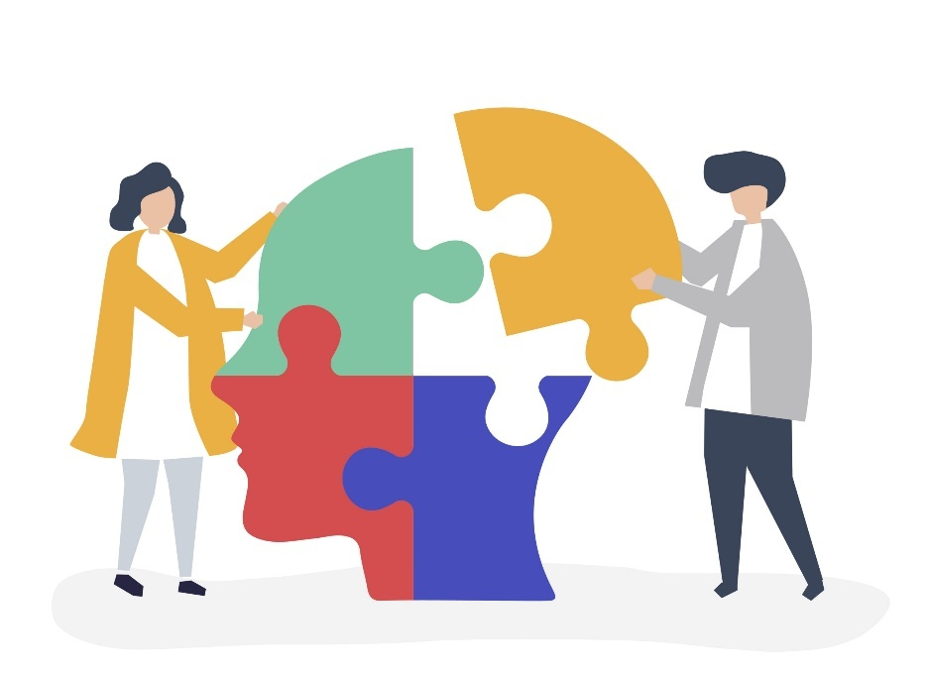
1.2 DIMENSIONS AND DETERMINANTS OF PERSONALITY:
The dimensions of personality represent the various aspects or components that collectively form an individual's personality profile. These dimensions provide a framework for understanding the complexity of human personality and offer insights into how different aspects of personality interact to influence behavior. The most widely accepted dimensional model is the Big Five personality traits, which includes openness to experience, conscientiousness, extraversion, agreeableness, and neuroticism.
Each dimension represents a continuum along which individuals can be placed, rather than discrete categories. This approach recognizes that personality traits exist in varying degrees and that most people exhibit a combination of characteristics from different dimensions. Understanding these dimensions helps individuals identify their natural strengths, areas for improvement, and how they might be perceived by others in various situations.
The determinants of personality refer to the various factors that influence personality development and expression. These determinants can be broadly categorized into biological, psychological, and social factors. The interplay between these different categories of determinants creates the unique personality profile that characterizes each individual.
Biological Determinants:
Genetic inheritance plays a fundamental role in personality development, with research suggesting that many personality traits have a significant hereditary component. Twin studies and adoption studies have provided evidence that traits such as extraversion, neuroticism, and conscientiousness are partially inherited from parents. However, genetic predisposition does not determine personality completely, as environmental factors also play a crucial role.
Environmental Determinants:
Environmental factors include all external influences that shape personality development, such as family environment, educational experiences, peer relationships, and cultural context. The family environment is particularly influential during early childhood, as it provides the first social context in which personality traits begin to emerge and develop.
Psychological Determinants:
Psychological factors include cognitive processes, emotional patterns, and individual learning experiences that influence personality development. These factors involve how individuals process information, form beliefs about themselves and the world, and develop coping mechanisms for dealing with life's challenges.
Situational Factors:
While personality traits tend to be relatively stable, situational factors can influence how personality is expressed in different contexts. The same individual may behave differently in various situations, depending on social expectations, role requirements, and environmental pressures. Understanding situational influences helps explain why personality expression can vary across different contexts.
Developmental Stages:
Personality development occurs throughout the lifespan, with certain periods being particularly important for trait formation. Early childhood experiences have a lasting impact on personality development, while adolescence and early adulthood are periods of significant personality change and consolidation. Even in later life, personality continues to evolve in response to new experiences and challenges.
Interaction Effects:
The various determinants of personality do not operate independently but interact in complex ways to shape individual development. Gene-environment interactions mean that genetic predispositions may be expressed differently depending on environmental conditions. Similarly, psychological factors may mediate the relationship between biological and environmental influences.
TABLE 1.1:
Determinant Category | Key Factors | Impact Level | Development Stage
Biological | Genetics, Brain Structure, Hormones | High (40-60%) | Early Childhood
Environmental | Family, Culture, Education, Peers | High (30-50%) | Throughout Life
Psychological | Cognition, Emotions, Learning | Moderate (20-30%) | Adolescence-Adulthood
Social | Relationships, Group Dynamics | Moderate (25-40%) | Childhood-Adulthood
Experiential | Life Events, Success/Failure | Variable (10-50%) | Throughout Life

1.3 PERSONALITY TRAITS AND THEIR SIGNIFICANCE:
Personality traits represent the relatively stable characteristics that describe patterns of thinking, feeling, and behaving across different situations and over time. These traits serve as the building blocks of personality and provide a way to understand and predict individual behavior. Traits are typically described along continuums, with individuals falling at different points along each dimension rather than fitting into discrete categories.
The significance of personality traits extends far beyond academic interest, as they have practical implications for career success, relationship satisfaction, leadership effectiveness, and overall life outcomes. Understanding one's personality traits provides valuable self-knowledge that can guide decision-making, career choices, and personal development efforts. Organizations increasingly use personality assessments in recruitment, team building, and leadership development programs.
Personality traits also play a crucial role in determining how individuals respond to different situations, handle stress, interact with others, and pursue their goals. By understanding their trait profile, individuals can better align their choices with their natural inclinations while also identifying areas where they may need to develop new skills or modify their approach.
The Big Five Personality Traits:
The Big Five model represents the most widely accepted framework for understanding personality traits. This model identifies five major dimensions: openness to experience, conscientiousness, extraversion, agreeableness, and neuroticism. Each trait represents a broad category that encompasses multiple specific characteristics and behaviors.
Trait Stability and Change:
While personality traits are generally stable across time, they are not completely fixed. Research shows that traits can change gradually over the lifespan, with some traits showing more stability than others. Conscientiousness and agreeableness tend to increase with age, while neuroticism typically decreases. Understanding trait stability helps individuals set realistic expectations for personality development.
Trait Expression in Different Contexts:
Personality traits are expressed differently depending on the situation and context. The same individual may display different levels of extraversion in professional versus social settings, or show varying degrees of conscientiousness depending on the importance they place on different tasks. This contextual variability is normal and does not indicate inconsistency in personality.
Trait Combinations and Personality Types:
While the Big Five model focuses on individual traits, the combination of traits creates unique personality profiles. Different combinations of high and low scores across the five dimensions result in distinct personality types with their own strengths, challenges, and behavioral patterns. Understanding these combinations provides a more complete picture of personality.
Cultural Considerations in Trait Assessment:
Personality traits may be expressed and valued differently across cultures. What is considered appropriate extraversion in one culture may be seen as excessive in another. Cultural awareness is important when interpreting personality trait assessments and when working with individuals from diverse backgrounds.
Practical Applications of Trait Knowledge:
Understanding personality traits has practical applications in many areas of life, including career planning, team formation, leadership development, and relationship building. Organizations use trait assessments to match individuals with roles that fit their natural inclinations, while individuals can use trait knowledge to make more informed decisions about their career paths and personal development goals.
1.4 THEORIES OF PERSONALITY - ERIKSONIAN APPROACH:
Erik Erikson's psychosocial theory of personality development extended and modified Freudian theory by emphasizing social and cultural influences on personality formation. Unlike Freud's focus on psychosexual stages, Erikson proposed eight psychosocial stages that span the entire lifespan, each presenting a unique crisis or challenge that must be resolved for healthy development. This approach recognizes that personality development continues throughout life rather than being fixed in early childhood.
Erikson's theory is particularly valuable for understanding how social relationships, cultural context, and life experiences contribute to personality development. Each stage presents a developmental task that, when successfully resolved, leads to the acquisition of specific virtues or strengths. Failure to resolve a stage adequately can result in difficulties that may persist throughout life, though later experiences can provide opportunities for resolution.
The psychosocial approach emphasizes the adaptive and growth-oriented aspects of personality development, viewing each crisis as an opportunity for positive change and development. This perspective is particularly relevant for understanding adult development and the ongoing process of personality growth throughout the lifespan.
The Eight Psychosocial Stages:
Erikson's eight stages begin with trust versus mistrust in infancy and continue through integrity versus despair in later life. Each stage builds upon previous stages and presents specific challenges related to social relationships and identity formation. The successful resolution of each stage contributes to the development of specific psychological strengths or virtues.
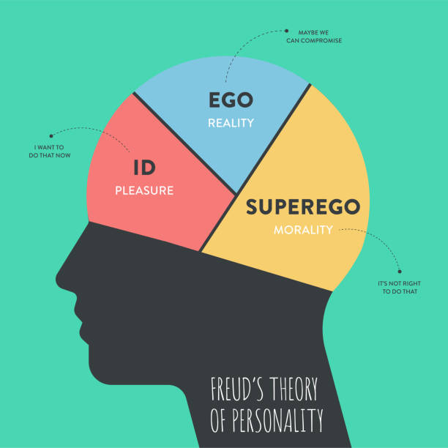
Identity Formation:
Erikson placed particular emphasis on identity formation during adolescence, introducing the concept of identity crisis as a normal part of development. This stage involves exploring different roles, values, and beliefs to develop a coherent sense of self. The successful resolution of identity crisis leads to the virtue of fidelity and the ability to commit to relationships and causes.
Generativity and Legacy:
In middle adulthood, Erikson identified the challenge of generativity versus stagnation, which involves contributing to the welfare of future generations through work, family, and community involvement. This stage highlights the importance of finding meaning and purpose in life through productive activities and mentoring others.
Cultural and Social Influences:
Erikson's theory acknowledges the significant role of cultural and social factors in personality development. Different cultures may emphasize different values and provide different opportunities for resolving developmental crises. This cultural sensitivity makes Eriksonian theory particularly relevant for understanding personality development in diverse societies.
Lifelong Development Perspective:
Unlike theories that focus primarily on childhood experiences, Erikson's approach recognizes that personality development continues throughout the lifespan. Each life stage presents new challenges and opportunities for growth, suggesting that individuals can continue to develop and change their personality characteristics throughout their lives.
Applications in Personal Development:
Eriksonian theory provides a framework for understanding personal challenges and growth opportunities at different life stages. Individuals can use this knowledge to better understand their current developmental tasks and work toward positive resolution of life crises. The theory is also valuable for counselors and coaches working with clients at different life stages.
1.5 IMPORTANCE OF PERSONALITY DEVELOPMENT:
Personality development plays a fundamental role in determining an individual's success and satisfaction in both personal and professional spheres of life. In today's competitive and interconnected world, technical skills alone are insufficient for achieving long-term success. Employers, colleagues, and social connections increasingly value individuals who possess well-developed personality traits such as emotional intelligence, communication skills, adaptability, and leadership abilities.
The importance of personality development extends beyond immediate practical benefits to encompass overall life satisfaction and psychological well-being. Individuals with well-developed personalities tend to experience greater self-confidence, better relationships, reduced stress levels, and a stronger sense of purpose and direction in life. These benefits create a positive cycle where improved personality characteristics lead to better outcomes, which in turn reinforce further personality development.
Furthermore, personality development enables individuals to adapt more effectively to changing circumstances and challenges. In an era of rapid technological and social change, the ability to continuously learn, adapt, and grow has become essential for long-term success and relevance. Personality development provides the foundation for this adaptability by fostering traits such as resilience, curiosity, and openness to new experiences.
Professional Benefits:
In the workplace, personality development contributes to career advancement, leadership effectiveness, and job satisfaction. Employers consistently report that soft skills and personality characteristics are among the most important factors in hiring and promotion decisions. Well-developed personalities enable individuals to communicate effectively, work collaboratively, handle conflicts constructively, and inspire others.
Personal Relationships:
Personality development significantly impacts the quality of personal relationships, including family relationships, friendships, and romantic partnerships. Individuals with well-developed personalities tend to be better communicators, more empathetic listeners, and more effective at resolving conflicts. These skills contribute to deeper, more satisfying relationships and stronger social support networks.
Self-Actualization:
Personality development is closely linked to the concept of self-actualization, which involves realizing one's full potential and becoming the best version of oneself. This process involves developing self-awareness, identifying personal values and goals, and working consistently toward personal growth and improvement. Self-actualized individuals tend to experience greater life satisfaction and psychological well-being.
Stress Management:
Well-developed personalities include effective stress management skills and emotional regulation abilities. Individuals who have invested in personality development are better equipped to handle pressure, cope with setbacks, and maintain emotional balance during challenging situations. This resilience contributes to both mental health and professional effectiveness.
Leadership and Influence:
Personality development is essential for effective leadership and the ability to positively influence others. Leaders with well-developed personalities can inspire trust, communicate vision effectively, motivate team members, and create positive organizational cultures. These leadership abilities are valuable not only in formal leadership roles but also in informal influence situations.
Adaptability and Change Management:
In a rapidly changing world, the ability to adapt to new situations, learn new skills, and embrace change has become increasingly important. Personality development fosters traits such as flexibility, curiosity, and resilience that enable individuals to thrive in changing environments rather than merely surviving them.
1.6 MEANING AND BENEFITS OF SELF-AWARENESS:
Self-awareness represents the foundation of all personality development and refers to the ability to accurately perceive one's own emotions, thoughts, behaviors, strengths, weaknesses, and impact on others. It involves both internal self-awareness, which focuses on understanding oneself, and external self-awareness, which involves understanding how others perceive and respond to oneself. This dual perspective provides a comprehensive understanding that forms the basis for personal growth and development.
The development of self-awareness is an ongoing process that requires honest self-reflection, feedback from others, and a willingness to acknowledge both positive and negative aspects of oneself. Many individuals struggle with self-awareness because it can be uncomfortable to confront areas where improvement is needed or to acknowledge the gap between their self-perception and how others perceive them.
However, the benefits of developing self-awareness far outweigh the temporary discomfort that may accompany the process. Self-aware individuals are better equipped to make informed decisions, build stronger relationships, manage their emotions effectively, and pursue goals that align with their values and capabilities. They are also more likely to seek feedback, learn from mistakes, and continuously improve their performance.
Enhanced Decision Making:
Self-aware individuals make better decisions because they understand their own values, preferences, strengths, and limitations. This self-knowledge enables them to choose options that align with their authentic selves and to avoid decisions that conflict with their core values or exceed their current capabilities. They are also more likely to recognize when they need additional information or support before making important decisions.
Improved Emotional Intelligence:
Self-awareness is a key component of emotional intelligence, which involves the ability to recognize, understand, and manage emotions effectively. Self-aware individuals can identify their emotional triggers, understand the impact of their emotions on their behavior, and develop strategies for emotional regulation. This emotional intelligence contributes to better relationships and more effective communication.
Better Relationships:
Self-awareness improves relationships by enabling individuals to understand their communication style, recognize their impact on others, and adjust their behavior when necessary. Self-aware people are more likely to take responsibility for their actions, apologize when appropriate, and work constructively to resolve conflicts. They are also better at empathizing with others and understanding different perspectives.
Increased Self-Confidence:
Paradoxically, self-awareness often leads to increased self-confidence, even though it involves acknowledging weaknesses and areas for improvement. This occurs because self-aware individuals develop a realistic and balanced view of themselves that includes both strengths and weaknesses. This balanced perspective reduces anxiety about potential criticism and enables them to focus on leveraging their strengths while working to improve their weaknesses.
Enhanced Learning and Growth:
Self-aware individuals are more effective learners because they can accurately assess their current knowledge and skills, identify learning needs, and monitor their progress. They are more likely to seek feedback, reflect on their experiences, and adjust their approach based on what they learn. This continuous learning orientation contributes to ongoing personal and professional development.
Stress Reduction:
Self-awareness can reduce stress by helping individuals understand their stress triggers, recognize early warning signs of stress, and develop effective coping strategies. Self-aware people are more likely to maintain realistic expectations for themselves and others, which reduces the frustration and disappointment that often contribute to stress.
1.7 DEVELOPING SELF-AWARENESS TECHNIQUES:
Developing self-awareness requires intentional effort and the application of specific techniques and strategies. The process involves both internal reflection and external feedback gathering, as both perspectives are necessary for a complete understanding of oneself. Effective self-awareness development requires consistency, patience, and a willingness to be honest about both strengths and areas for improvement.
The techniques for developing self-awareness can be broadly categorized into reflective practices, feedback-seeking strategies, assessment tools, and mindfulness approaches. Each category offers different benefits and insights, and most individuals find that using a combination of techniques provides the most comprehensive understanding of themselves.
It is important to approach self-awareness development with a growth mindset, viewing discoveries about oneself as opportunities for improvement rather than fixed limitations. This perspective encourages continuous learning and development rather than defensiveness or discouragement when areas for improvement are identified.
Reflective Practices:
Regular self-reflection is one of the most important techniques for developing self-awareness. This can include journaling, meditation, or simply setting aside time each day to think about experiences, reactions, and patterns of behavior. Reflective practices help individuals identify recurring themes, understand their motivations, and recognize areas where their behavior may not align with their intentions.
360-Degree Feedback:
Seeking feedback from multiple sources, including supervisors, peers, subordinates, and personal contacts, provides valuable external perspective on one's behavior and impact. This comprehensive feedback helps identify blind spots and areas where self-perception differs from others' perceptions. The key to effective feedback gathering is asking specific questions and remaining open to criticism.
Personality Assessments:
Formal personality assessments such as the Myers-Briggs Type Indicator, DISC assessment, or Big Five personality test can provide structured insights into personality traits, preferences, and behavioral tendencies. While these assessments should not be viewed as definitive or limiting, they can offer valuable starting points for self-reflection and discussion with others.
Mindfulness and Present-Moment Awareness:
Mindfulness practices help individuals become more aware of their thoughts, emotions, and reactions in real-time. This present-moment awareness enables better understanding of automatic responses and provides opportunities to choose more conscious and intentional behaviors. Regular mindfulness practice can significantly enhance overall self-awareness.
Values Clarification Exercises:
Understanding personal values is a crucial component of self-awareness. Values clarification exercises help individuals identify what is truly important to them and assess whether their actions align with these values. This alignment between values and behavior is essential for authentic living and long-term satisfaction.
Behavioral Tracking:
Systematically tracking behaviors, reactions, and outcomes can reveal patterns that might not be apparent through casual reflection. This might involve tracking mood changes, productivity levels, communication effectiveness, or other relevant behaviors. The data collected can provide objective insights into personal patterns and triggers.
TABLE 1.2:
SWOT Component | Focus Area | Key Questions | Action Type | Time Frame
Strengths | Internal Positive | What advantages do I have? | Leverage and maximize | Immediate
Weaknesses | Internal Negative | What needs improvement? | Address and minimize | Short-term
Opportunities | External Positive | What favorable trends exist? | Exploit and capitalize | Medium-term
Threats | External Negative | What obstacles threaten progress? | Counter and prepare | Ongoing
Integration | Strategic Planning | How do factors interact? | Synthesize and align | Long-term

1.8 SWOT ANALYSIS :
SWOT Analysis represents a powerful strategic planning tool that can be effectively applied to personal development and self-assessment. The acronym SWOT stands for Strengths, Weaknesses, Opportunities, and Threats, providing a comprehensive framework for evaluating both internal capabilities and external circumstances. When applied to personal development, SWOT analysis helps individuals gain a structured understanding of their current position and develop strategic plans for improvement.
The strength of SWOT analysis lies in its systematic approach to evaluation, which ensures that important factors are not overlooked. By examining both positive and negative internal factors (strengths and weaknesses) alongside external factors (opportunities and threats), individuals can develop a balanced and realistic view of their situation. This comprehensive perspective forms the foundation for effective goal setting and strategic planning.
Personal SWOT analysis differs from organizational SWOT analysis in its focus on individual characteristics, skills, and circumstances rather than business factors. However, the fundamental principles remain the same: honest assessment, strategic thinking, and action-oriented planning. The process requires individuals to be objective and realistic about their assessment while maintaining a positive, growth-oriented perspective.
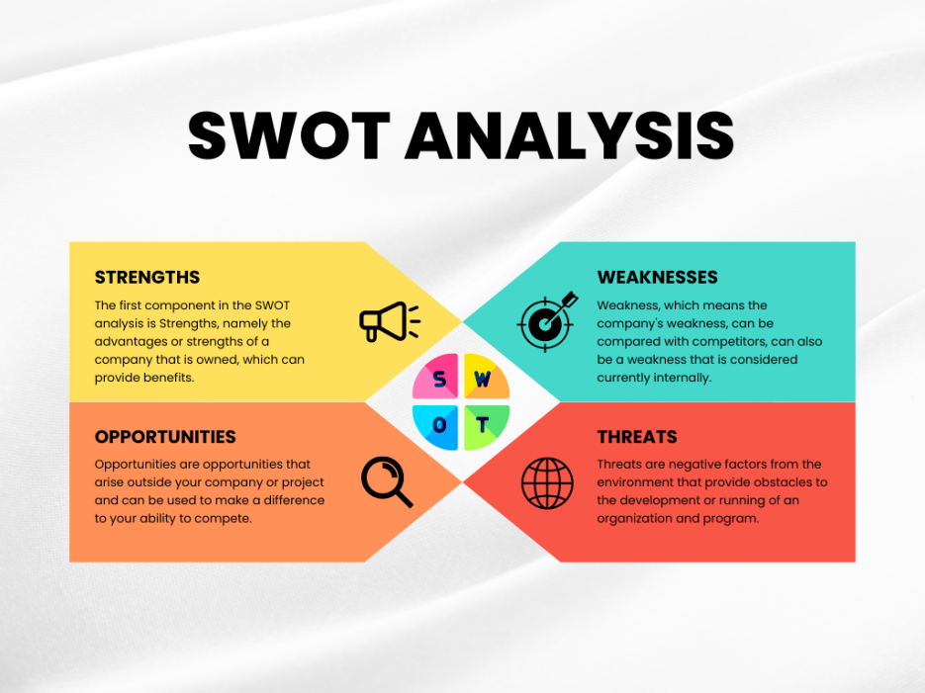
Strengths Identification:
Strengths represent internal positive attributes that give an individual advantages in pursuing their goals. These can include technical skills, personality traits, knowledge areas, experiences, relationships, or any other positive characteristics that contribute to success. Identifying strengths accurately requires honest self-assessment combined with feedback from others, as individuals often underestimate their own capabilities.
Weaknesses Assessment:
Weaknesses are internal factors that create disadvantages or limitations in achieving goals. These might include skill gaps, negative personality traits, limited experience, or other factors that hinder performance. The key to effective weakness assessment is viewing these limitations as opportunities for improvement rather than permanent obstacles. This growth-oriented perspective encourages development rather than discouragement.
Opportunities Recognition:
Opportunities are external factors that could be leveraged to achieve goals or advance personal development. These might include industry trends, networking possibilities, educational programs, job openings, or any other external circumstances that could be beneficial. Identifying opportunities requires awareness of the external environment and the ability to recognize how external factors could be used advantageously.
Threats Analysis:
Threats represent external factors that could potentially hinder goal achievement or create challenges. These might include economic conditions, competition, technological changes, or other external circumstances that could negatively impact progress. Understanding threats enables individuals to develop contingency plans and take proactive steps to minimize potential negative impacts.
1.9 COMPONENTS AND APPLICATION OF SWOT:
Components Framework
Internal Environmental Analysis: Comprehensive examination of organizational resources, capabilities, culture, and structural elements that influence strategic decision-making processes. This component involves evaluating human capital effectiveness, operational efficiency metrics, financial performance indicators, technological infrastructure adequacy, organizational culture alignment, leadership effectiveness, and internal communication systems. Through systematic internal assessment, organizations identify performance drivers, resource optimization opportunities, structural improvements, and capability development requirements essential for competitive positioning and strategic success.
External Environmental Scanning: Systematic monitoring and evaluation of external factors, trends, and forces that impact organizational performance and strategic direction. This component encompasses industry analysis, competitive intelligence gathering, regulatory environment assessment, economic trend evaluation, technological advancement tracking, social demographic shifts, and political landscape monitoring. External scanning enables organizations to anticipate market changes, identify emerging trends, recognize competitive threats, discover collaboration opportunities, and adapt strategic approaches to evolving business environments.
Stakeholder Impact Assessment: Comprehensive evaluation of how various stakeholder groups influence and are affected by organizational strategies and decisions. This component includes customer satisfaction analysis, supplier relationship evaluation, investor expectation assessment, employee engagement measurement, community impact consideration, regulatory compliance review, and partner collaboration effectiveness. Stakeholder analysis helps organizations balance competing interests, build supportive relationships, manage expectations, address concerns proactively, and develop strategies that create value for multiple stakeholder groups.
Competitive Intelligence Matrix: Structured framework for analyzing competitor strategies, market positioning, capabilities, and performance relative to organizational objectives. This component involves competitor profiling, market share analysis, competitive advantage assessment, strategic initiative tracking, pricing strategy evaluation, product portfolio comparison, and competitive response prediction. Competitive intelligence enables organizations to benchmark performance, identify differentiation opportunities, anticipate competitive moves, develop counter-strategies, and position themselves effectively within competitive landscapes.
SWOT Matrix Development:
Creating a SWOT matrix involves systematically listing factors in each category and then analyzing the relationships between them. The most valuable insights often come from examining how different factors interact, such as how strengths can be used to capitalize on opportunities or how weaknesses might make an individual more vulnerable to threats.
Strategic Planning Applications:
The ultimate value of SWOT analysis lies in its application to strategic planning and goal setting. The insights gained from SWOT analysis should inform decisions about which goals to pursue, what strategies to employ, and what resources to develop or acquire. This strategic application ensures that personal development efforts are focused and aligned with both capabilities and circumstances.
TABLE 1.3:
SWOT Component | Focus Area | Key Questions | Action Type | Time Frame
Strengths | Internal Positive | What advantages do I have? | Leverage and maximize | Immediate
Weaknesses | Internal Negative | What needs improvement? | Address and minimize | Short-term
Opportunities | External Positive | What favorable trends exist? | Exploit and capitalize | Medium-term
Threats | External Negative | What obstacles threaten progress? | Counter and prepare | Ongoing
Integration | Strategic Planning | How do factors interact? | Synthesize and align | Long-term

1.10 CONCEPT OF SUCCESS AND FAILURE:
The concepts of success and failure are fundamental to human experience and personal development, yet they are often misunderstood or defined too narrowly. Success is not merely the achievement of specific goals or the accumulation of wealth and status, but rather the ongoing process of growth, contribution, and alignment with personal values. Similarly, failure should not be viewed as a permanent condition or personal shortcoming, but as a valuable learning experience that contributes to eventual success.
Understanding success and failure in a broader context enables individuals to maintain motivation during challenging times and to appreciate progress that might not be immediately visible to others. This perspective also helps prevent the discouragement that can result from comparing oneself to others or from focusing exclusively on external measures of achievement.
The relationship between success and failure is complex and interdependent. Most significant successes involve overcoming multiple failures and setbacks along the way. Learning to view failure as a necessary component of the success process, rather than its opposite, is essential for maintaining resilience and motivation during difficult periods.
Defining Personal Success:
Personal success must be defined individually based on one's values, circumstances, and aspirations. What represents success for one person may not be meaningful for another. Effective success definition involves considering multiple dimensions of life, including career, relationships, health, personal growth, and contribution to others. This multidimensional approach prevents the narrow focus that can lead to achievement in one area at the expense of others.
Internal vs External Measures:
Success can be measured using internal criteria (personal satisfaction, growth, alignment with values) or external criteria (income, status, recognition). While external measures are more visible and often emphasized by society, internal measures are typically more strongly correlated with long-term satisfaction and well-being. Balancing both types of measures provides a more complete picture of success.
The Learning Value of Failure:
Failure provides valuable learning opportunities that are often unavailable through success alone. Failed attempts reveal weaknesses in planning, execution, or understanding that can be addressed in future efforts. Additionally, failure develops resilience, problem-solving skills, and emotional strength that contribute to eventual success. Many highly successful individuals attribute their achievements partly to lessons learned from earlier failures.
Success as a Process:
Rather than viewing success as a destination to be reached, it is more helpful to understand success as an ongoing process of growth, contribution, and achievement. This process orientation maintains motivation during difficult periods and prevents the letdown that can occur when specific goals are achieved. It also encourages continuous improvement and lifelong learning.
Cultural and Social Influences:
Definitions of success and failure are significantly influenced by cultural background, social environment, and peer groups. These external influences can be helpful in providing motivation and direction, but they can also create pressure to pursue goals that are not personally meaningful. Developing awareness of these influences helps individuals make more authentic choices about their definition of success.
Reframing Setbacks:
Learning to reframe setbacks as temporary challenges rather than permanent failures is essential for maintaining motivation and resilience. This reframing involves focusing on what can be learned from the experience, what progress has been made despite the setback, and what adjustments can be made going forward. This positive reframing prevents discouragement and maintains forward momentum.
1.11 FACTORS RESPONSIBLE FOR SUCCESS AND CAUSES OF FAILURE:
Success and failure result from the interaction of multiple factors, some within individual control and others influenced by external circumstances. Understanding these factors enables individuals to focus their efforts on areas where they can have the greatest impact while also preparing for factors beyond their direct control. The factors responsible for success typically include personal characteristics, strategic planning, consistent action, and favorable circumstances.
Research in psychology and business has identified several key factors that consistently contribute to success across different domains. These include goal clarity, persistence, continuous learning, relationship building, adaptability, and emotional intelligence. While the specific weight of each factor may vary depending on the situation, successful individuals typically demonstrate strength in multiple areas rather than relying on a single characteristic or skill.
Similarly, failure often results from predictable causes that can be identified and addressed. Common causes of failure include lack of clear goals, inadequate planning, insufficient persistence, poor relationships, resistance to change, and emotional mismanagement. Understanding these failure patterns enables individuals to take proactive steps to avoid common pitfalls.
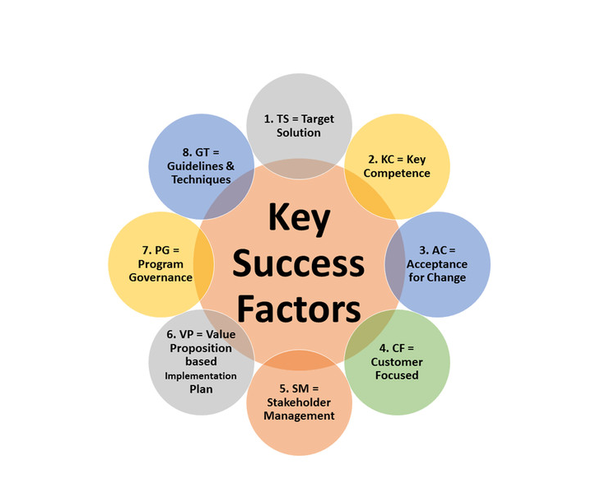
Personal Characteristics for Success:
Successful individuals typically demonstrate certain personal characteristics including self-discipline, persistence, optimism, and willingness to take calculated risks. These characteristics can be developed through conscious effort and practice, making them accessible to anyone committed to personal development. Self-discipline enables consistent action toward goals, while persistence helps individuals overcome setbacks and obstacles.
Strategic Planning and Goal Setting:
Success requires more than good intentions; it requires strategic planning and systematic goal setting. This involves identifying specific, measurable objectives, developing action plans, allocating resources effectively, and monitoring progress regularly. Strategic planning helps ensure that efforts are focused and coordinated rather than scattered and inefficient.
Continuous Learning and Adaptation:
In a rapidly changing world, the ability to learn continuously and adapt to new circumstances has become essential for success. This involves staying current with relevant knowledge and skills, seeking feedback, experimenting with new approaches, and adjusting strategies based on results. Continuous learners are better prepared to capitalize on opportunities and overcome challenges.
Relationship Building and Networking:
Success rarely occurs in isolation; it typically requires the support, collaboration, and resources of others. Building strong relationships and maintaining professional networks provides access to opportunities, knowledge, and support that are essential for achieving significant goals. Effective relationship building involves providing value to others, maintaining regular contact, and being genuinely interested in others' success.
Common Causes of Failure:
Understanding common causes of failure helps individuals avoid predictable pitfalls and develop strategies for overcoming challenges. Lack of clear goals is one of the most common causes of failure, as it leads to unfocused efforts and makes it difficult to measure progress. Without clear objectives, individuals may work hard but fail to achieve meaningful results.
Inadequate Preparation and Planning:
Many failures result from inadequate preparation and planning. This includes underestimating the time, resources, or skills required for success, failing to anticipate potential obstacles, and lacking contingency plans for dealing with setbacks. Thorough preparation increases the likelihood of success and reduces the impact of unexpected challenges.
Fear of Failure and Risk Aversion:
Paradoxically, excessive fear of failure often leads to failure by preventing individuals from taking the risks necessary for success. This fear can manifest as procrastination, perfectionism, or avoiding challenging opportunities. Overcoming fear of failure requires developing a healthy relationship with risk and viewing potential setbacks as learning opportunities rather than disasters.
Poor Time Management:
Effective time management is essential for success, yet many individuals struggle with prioritizing tasks, avoiding distractions, and maintaining focus on important activities. Poor time management leads to missed deadlines, incomplete projects, and stress that can undermine overall performance. Developing strong time management skills is essential for achieving complex goals.
Lack of Emotional Intelligence:
Emotional intelligence plays a crucial role in success, particularly in roles that require interpersonal interaction and leadership. Individuals who struggle to understand and manage their own emotions, or who have difficulty relating to others, may find it challenging to build the relationships and influence necessary for success.
1.12 HURDLES IN ACHIEVING SUCCESS AND OVERCOMING STRATEGIES:
The path to success is rarely smooth and typically involves numerous hurdles and obstacles that must be overcome. These hurdles can be categorized into internal obstacles (such as limiting beliefs, fear, and lack of skills) and external obstacles (such as competition, economic conditions, and resource limitations). Understanding these potential hurdles enables individuals to prepare for them proactively and develop strategies for overcoming them when they arise.
Internal hurdles are often more challenging to address than external ones because they require changes in thinking, behavior, or emotional responses. These might include perfectionism, procrastination, fear of failure, limiting beliefs about one's capabilities, or inadequate self-confidence. While these internal obstacles can be significant, they are also within individual control and can be addressed through conscious effort and appropriate strategies.
External hurdles, while often beyond direct control, can frequently be managed or worked around through creative problem-solving, strategic planning, and relationship building. These might include economic downturns, increased competition, limited resources, or unfavorable market conditions. Successful individuals learn to adapt their strategies to external circumstances rather than being defeated by them.
Perfectionism and Analysis Paralysis:
Perfectionism can be a significant hurdle to success because it often prevents individuals from taking action or completing projects. The desire to make everything perfect can lead to endless revisions, missed deadlines, and abandoned projects. Overcoming perfectionism involves accepting that excellence is often better than perfection and that completed work is more valuable than perfect work that never gets finished.
Fear-Based Obstacles:
Various fears can create significant hurdles to success, including fear of failure, fear of success, fear of criticism, and fear of change. These fears often operate at an unconscious level but can significantly influence decision-making and behavior. Overcoming fear-based obstacles requires identifying the specific fears involved, examining their validity, and gradually taking small steps outside one's comfort zone.
Limited Resources and Support:
Many individuals face the hurdle of limited financial resources, inadequate support systems, or lack of access to necessary tools and information. While these limitations are real, they can often be overcome through creativity, resourcefulness, and strategic partnerships. This might involve seeking mentorship, joining professional organizations, pursuing educational opportunities, or finding creative ways to access needed resources.
Procrastination and Lack of Motivation:
Procrastination represents one of the most common hurdles to success and can result from various underlying causes including fear, perfectionism, lack of clarity, or inadequate motivation. Overcoming procrastination requires identifying the root cause and implementing appropriate strategies such as breaking large tasks into smaller steps, creating accountability systems, or addressing underlying fears or concerns.
Negative Self-Talk and Limiting Beliefs:
Internal dialogue and beliefs about one's capabilities can create significant hurdles to success. Negative self-talk and limiting beliefs can undermine confidence, reduce motivation, and prevent individuals from pursuing challenging opportunities. Overcoming these mental obstacles requires developing awareness of thought patterns, challenging negative beliefs, and consciously cultivating more positive and realistic self-talk.
Time Management and Priority Challenges:
Poor time management and difficulty prioritizing tasks can create significant hurdles to success. This might manifest as spending too much time on low-value activities, failing to allocate sufficient time for important projects, or becoming overwhelmed by competing demands. Overcoming these challenges requires developing clear priorities, improving planning skills, and learning to say no to activities that do not support primary goals.
Building Resilience and Persistence:
Developing resilience and persistence is essential for overcoming hurdles and maintaining progress toward success. This involves cultivating a growth mindset, learning from setbacks, maintaining perspective during difficult periods, and developing coping strategies for managing stress and disappointment. Resilient individuals view hurdles as temporary challenges rather than permanent obstacles.
1.13 GOAL SETTING - MEANING, IMPORTANCE, AND PRINCIPLES:
Goal setting represents one of the most fundamental and powerful tools for personal and professional development. Goals provide direction, motivation, and a framework for measuring progress, transforming vague aspirations into concrete, actionable plans. Effective goal setting goes beyond simply writing down desired outcomes; it involves creating a systematic approach to achievement that includes specific objectives, timelines, action steps, and regular review processes.
The importance of goal setting extends far beyond task completion or achievement motivation. Goals serve as a bridge between current reality and desired future states, providing clarity about what needs to be accomplished and how progress will be measured. They also help individuals prioritize activities, allocate resources effectively, and maintain focus during distracting or challenging periods.
Research in psychology has consistently demonstrated that individuals who set specific, challenging goals achieve significantly better performance than those who simply try to "do their best" or who set easy goals. This goal-setting effect occurs because goals direct attention, mobilize effort, increase persistence, and motivate the development of task-specific strategies and skills.
Types of Goals:
Goals can be categorized in various ways, including short-term versus long-term, outcome goals versus process goals, and personal versus professional goals. Short-term goals typically span days to months and provide immediate direction and motivation. Long-term goals extend over months to years and provide overall direction and purpose. Understanding different types of goals enables individuals to create comprehensive goal systems that address both immediate needs and long-term aspirations.
SMART Goal Framework:
The SMART framework provides specific criteria for effective goal setting, requiring goals to be Specific, Measurable, Achievable, Relevant, and Time-bound. Specific goals clearly define what is to be accomplished, while measurable goals include criteria for tracking progress. Achievable goals are realistic given available resources and constraints, while relevant goals align with broader objectives and values. Time-bound goals include specific deadlines that create urgency and enable progress monitoring.
Alignment with Values and Priorities:
Effective goals must align with personal values and priorities to maintain long-term motivation and satisfaction. Goals that conflict with deeply held values are difficult to sustain and may lead to internal conflict even if achieved. This alignment process requires individuals to understand their own values and ensure that their goals support rather than undermine what is most important to them.
Goal Hierarchy and Integration:
Effective goal setting often involves creating hierarchical goal systems where long-term objectives are broken down into intermediate milestones and specific action steps. This hierarchical approach ensures that daily activities support weekly objectives, which in turn support monthly goals, and so forth. Integration across different life areas prevents the achievement of goals in one area from undermining success in others.
Overcoming Goal-Setting Challenges:
Common challenges in goal setting include setting unrealistic goals, lack of specificity, insufficient planning, and inadequate review processes. Unrealistic goals can lead to discouragement and abandonment, while vague goals make it difficult to develop action plans or measure progress. Regular goal review and adjustment processes help ensure that goals remain relevant and achievable as circumstances change.
Motivation and Goal Achievement:
Understanding the relationship between motivation and goal achievement is essential for maintaining progress over time. Motivation typically fluctuates throughout the goal achievement process, making it important to develop systems and habits that maintain progress even when motivation is low.
1.14 EFFECTIVE GOAL SETTING AT THE RIGHT LEVEL:
Setting goals at the right level of difficulty represents a critical skill that balances challenge with achievability to maximize motivation and performance. Goals that are too easy fail to motivate significant effort or promote growth, while goals that are too difficult can lead to discouragement and abandonment. The optimal goal difficulty level stretches individual capabilities while remaining within the realm of possibility given available resources and constraints.
The concept of "right level" goal setting involves understanding individual capabilities, available resources, time constraints, and external circumstances that might influence goal achievement.
Effective goal setting at the right level also involves understanding the dynamic nature of goal difficulty. As individuals develop new skills and capabilities through the goal achievement process, goals that initially seemed challenging may become relatively easy. This progression requires regular goal review and adjustment to ensure that goals continue to provide appropriate challenge and motivation.
Assessing Current Capabilities:
Setting goals at the right level requires accurate assessment of current skills, knowledge, resources, and circumstances. This assessment should be honest and realistic, neither underestimating capabilities (which leads to unchallenging goals) nor overestimating them (which leads to unrealistic goals). The assessment process might involve self-evaluation, feedback from others, and analysis of past performance in similar situations.
The Stretch Goal Concept:
Stretch goals represent objectives that are significantly more ambitious than normal performance levels but still achievable with exceptional effort and creativity. These goals are designed to stimulate innovation, extraordinary effort, and breakthrough thinking. However, stretch goals must be balanced with more achievable objectives to maintain motivation and confidence when breakthrough performance does not occur.
Progressive Goal Advancement:
Effective goal setting often involves creating progressive advancement systems where individuals work toward increasingly challenging objectives over time. This might involve mastering basic skills before attempting advanced applications, or achieving smaller successes before pursuing larger objectives. Progressive advancement maintains motivation by providing regular success experiences while building the capabilities needed for more challenging goals.
Resource and Constraint Analysis:
Setting goals at the right level requires realistic analysis of available resources including time, money, skills, support systems, and external circumstances. Goals that require resources beyond what is available or likely to become available are not appropriately leveled. This analysis should consider both current resources and resources that can be reasonably acquired during the goal achievement process.
TABLE 1.4:
Goal Level | Characteristics | Benefits | Success Indicators
Too Easy | Minimal challenge required | Quick completion, confidence boost | Achieved without effort
Appropriate | Challenging but achievable | Optimal motivation, development | Steady progress visible
Too Difficult | Unrealistic expectations | High aspiration potential | Little progress despite effort
Stretch Goals | Significantly ambitious | Innovation, breakthrough performance | Exceptional effort needed
Maintenance | Sustaining current level | Stability, consistency | No improvement required

Revision Question:
Short Answer Questions:
- Define personality and explain how it differs from character in terms of development and expression.
- List and briefly describe the five dimensions of the Big Five personality model.
- What are the three components of personality according to Freudian theory and how do they interact?
- Explain the difference between internal and external self-awareness and why both are important.
- What does the acronym SMART stand for in goal setting and why is each component important?
Long Answer Questions:
- Compare and contrast Freudian and Eriksonian theories of personality development, discussing their key similarities, differences, and practical applications in modern personality development.
- Analyze the relationship between self-awareness and personality development, explaining how various self-awareness techniques contribute to personal growth and professional effectiveness.
- Discuss the importance of personality development in today's competitive world, examining its impact on career success, relationships, and overall life satisfaction.
- Evaluate the role of SWOT analysis in personal development, explaining how each component contributes to strategic planning and goal achievement.
- Examine the factors that contribute to success and failure, analyzing how understanding these factors can help individuals develop strategies for overcoming common obstacles and achieving their goals.

Case Studies:
Case Study 1: The Perfectionist's Dilemma
Sarah is a 28-year-old marketing manager who has always been known for her attention to detail and high-quality work. However, her perfectionist tendencies have begun to create problems both personally and professionally. She spends excessive time refining projects that are already excellent, often missing deadlines as a result. Her colleagues have started to view her as unreliable despite the superior quality of her work. Sarah's perfectionism also affects her personal life, as she avoids social activities and new experiences because she fears not performing perfectly.
Recently, Sarah was passed over for a promotion she had been working toward for two years. Her supervisor explained that while her work quality was exceptional, her inability to meet deadlines and her reluctance to take on new challenges made her unsuitable for the leadership role. This feedback was devastating to Sarah, who had always believed that perfectionism was a strength rather than a limitation.
Sarah realizes that she needs to address her perfectionist tendencies but doesn't know where to start. She fears that lowering her standards will result in mediocre work and damage her reputation. She also struggles with anxiety when she considers submitting work that she hasn't polished to what she considers perfection. Her perfectionism has become deeply ingrained in her identity, making it difficult to envision herself operating differently.
Sarah's friends and family have tried to help by reassuring her that "good enough" really is good enough in many situations, but she finds it difficult to accept this advice. She worries that others don't understand the satisfaction she gets from creating perfect work or the anxiety she experiences when she can't achieve her standards. She wants to change but feels trapped by her own expectations and fears.
Discussion Questions: How can Sarah use personality development concepts to address her perfectionist tendencies? What specific techniques from the chapter could help her develop more balanced standards while maintaining her commitment to quality? How might SWOT analysis help Sarah understand her situation and develop a plan for change? What role does self-awareness play in Sarah's situation, and how can she use self-awareness techniques to better understand her perfectionist behavior? How can Sarah set more appropriate goals that challenge her to grow while avoiding the paralysis that comes from unrealistic standards?
Case Study 2: The Manager's Identity Crisis
David is a 35-year-old senior manager at a technology company who has recently begun questioning his career path and life choices. Despite achieving what most would consider significant success - a high salary, prestigious title, and recognition from his peers - David feels increasingly dissatisfied and disconnected from his work. He finds himself going through the motions at work without the enthusiasm and motivation he once had.
The problem began when David started comparing his career to those of his former classmates who chose different paths. Some became entrepreneurs, others pursued academic careers, and still others chose work in non-profit organizations.
While David earns more than most of them, he envies their apparent passion for their work and their sense of making a meaningful contribution. David realizes that he chose his career path primarily based on external expectations and financial considerations rather than personal interests and values.
David's identity crisis is affecting his performance at work and his relationships at home. He has become irritable and withdrawn, questioning whether he has wasted years of his life pursuing goals that weren't truly his own. His wife is concerned about his increased stress levels and his talk about making dramatic career changes. David feels stuck between his desire for meaningful work and his financial responsibilities to his family.
Recently, David attended a leadership development program where participants were asked to identify their personal values and assess how well their current roles aligned with these values.
This exercise revealed a significant gap between what David values most (creativity, autonomy, social impact) and what his current role provides (stability, status, financial reward). The realization was both enlightening and troubling, as it confirmed his growing sense that he was living someone else's definition of success.
Discussion Questions: How can David use self-awareness techniques to better understand his values, interests, and authentic goals? What role did external influences play in David's original career choice, and how can he balance external expectations with personal fulfillment?
How might David conduct a personal SWOT analysis to assess his current situation and identify potential paths forward? What factors should David consider when defining success for himself, and how can he balance personal fulfillment with practical responsibilities? How can David approach goal setting to create a more satisfying career path while managing the risks associated with significant change?
Case Study 3: The Struggling Team Leader
Maria is a 32-year-old engineer who was recently promoted to team leader of a software development group. While she was an excellent individual contributor with strong technical skills, Maria is struggling with the leadership aspects of her new role.
She has difficulty delegating tasks, often preferring to complete complex work herself rather than explaining it to team members. When conflicts arise between team members, Maria tends to avoid addressing them directly, hoping they will resolve themselves.
Maria's team has become increasingly frustrated with her management style. They feel micromanaged when she redoes their work, yet unsupported when she fails to provide clear direction or feedback. Several team members have mentioned in casual conversations that they miss their previous leader, who was better at communication and conflict resolution. Maria is aware of these complaints but feels overwhelmed and unsure how to improve her leadership effectiveness.
The situation came to a head during a recent project where missed deadlines and quality issues resulted in client dissatisfaction. Maria's supervisor called her in for a discussion about her team's performance and suggested that she might benefit from leadership training or coaching.
Maria was defensive during this conversation, arguing that her team members weren't meeting her standards and that she couldn't be responsible for their lack of motivation.
Upon reflection, Maria realizes that she has been so focused on technical aspects of the work that she has neglected the people management aspects of leadership. She wants to improve but doesn't know where to start.
Her confidence has been shaken by the recent feedback, and she's beginning to question whether she's cut out for leadership. Maria is considering asking to return to her previous individual contributor role, but she also recognizes that this might limit her career advancement opportunities.
Discussion Questions: What personality traits and skills does Maria need to develop to become an effective leader? How can Maria use self-awareness techniques to better understand her leadership strengths and weaknesses? What role do the various theories of personality development play in understanding Maria's leadership challenges?
How can Maria set appropriate goals for her leadership development while managing her current team responsibilities? What strategies can Maria use to overcome her tendency to avoid conflict and improve her delegation skills?
How might Maria's technical background both help and hinder her leadership development, and how can she leverage her strengths while addressing her limitations?

Fun Activity:
Personality Development Challenge
"The 21-Day Personality Growth Sprint"
This engaging activity is designed to help students apply the concepts learned in Chapter 1 through a structured, interactive challenge that promotes self-awareness and goal setting.
Activity Overview: Students participate in a 21-day challenge where they select one personality trait or skill to develop, create a specific improvement plan, and track their progress daily. The activity combines self-reflection, peer support, and practical application of chapter concepts.
Setup Instructions: Each student chooses a personality development area based on their personal SWOT analysis (e.g., improving assertiveness, developing better listening skills, increasing emotional awareness, or enhancing goal-setting abilities). They create a "Personality Development Passport" containing their baseline assessment, daily tracking sheets, and reflection prompts.
Daily Activities (15-20 minutes each):
Days 1-7: Self-awareness building through daily reflection journals and one specific behavioral observation
Days 8-14: Implementation of chosen development technique with peer accountability partner check-ins
Days 15-21: Integration phase combining multiple techniques with progress measurement and adjustment
Peer Component: Students form "Development Duos" where they serve as accountability partners, providing weekly feedback, celebrating progress, and offering support during challenging moments. Each duo meets for 10-minute check-ins three times per week.
Assessment and Rewards: Progress is measured through self-assessment rubrics, peer feedback, and observable behavioral changes. Students who complete the challenge receive certificates and share their success stories with the class. The activity concludes with a group reflection session where participants discuss insights gained and plans for continued development.
Learning Outcomes: This activity reinforces key chapter concepts including self-awareness techniques, goal setting principles, SWOT analysis application, and the importance of consistent effort in personality development. Students gain practical experience in behavior change while building supportive relationships with classmates.
Contextual Factors:
The right level for goal setting varies depending on contextual factors including time available, competing priorities, support systems, and external pressures. Goals that might be appropriate during periods of stability may be too ambitious during times of high stress or major life changes. Effective goal setters adjust their goal difficulty based on these contextual considerations.
Feedback and Adjustment Systems:
Maintaining goals at the right level requires ongoing feedback and adjustment systems. Regular progress review enables individuals to identify when goals are too easy (evidenced by rapid progress without significant effort) or too difficult (evidenced by little progress despite sustained effort). These feedback systems enable timely goal adjustment to maintain optimal challenge levels.
Balancing Multiple Goals:
When setting multiple goals simultaneously, the total challenge level must be considered in addition to individual goal difficulty. Several moderately challenging goals pursued simultaneously may create an overall challenge level that is too high, even if each individual goal is appropriately leveled. Effective goal setting considers the cumulative demand of all active goals.
**********

2
ATTITUDE, MOTIVATION, AND SELF-MANAGEMENT

INTRODUCTION
The second pillar of personality development focuses on understanding and mastering the internal forces that drive human behavior. Attitude, motivation, and self-management form an interconnected system that determines how individuals approach challenges, interact with others, and pursue their goals. This chapter explores these fundamental concepts and provides practical strategies for developing more effective patterns of thinking, feeling, and behaving.
Understanding attitude is essential because it serves as the lens through which individuals interpret experiences and make decisions. Attitudes shape perceptions, influence emotions, and drive behaviors in ways that can either facilitate or hinder personal and professional success. The ability to recognize, evaluate, and modify attitudes when necessary represents a crucial skill for anyone committed to continuous improvement and growth.
Motivation provides the energy and direction for sustained effort toward meaningful goals. Without proper motivation, even the most well-designed plans and strategies fail to produce results. Self-management skills enable individuals to regulate their thoughts, emotions, and behaviors in ways that support long-term success rather than short-term impulses. Together, these three elements create the foundation for effective personal leadership and professional achievement.
2.1 CONCEPT AND SIGNIFICANCE OF ATTITUDE:
Attitude represents a learned predisposition to respond favorably or unfavorably to people, objects, situations, or ideas. It encompasses cognitive beliefs, emotional feelings, and behavioral tendencies that combine to create relatively stable patterns of response. Attitudes are not innate but are developed through experience, observation, and social learning, making them modifiable through conscious effort and appropriate interventions.
The significance of attitude extends far beyond personal preferences or opinions. Attitudes influence perception by acting as filters that determine what information receives attention and how that information is interpreted. They affect decision-making by creating biases toward certain choices and away from others. Attitudes also influence motivation by making some goals more appealing and others less attractive.
Understanding attitude is particularly important for professionals because workplace success depends heavily on how individuals approach their responsibilities, interact with colleagues, and respond to challenges. Positive attitudes contribute to better teamwork, increased innovation, higher job satisfaction, and more effective leadership. Negative attitudes can undermine even the most talented individuals by creating barriers to collaboration, learning, and growth.
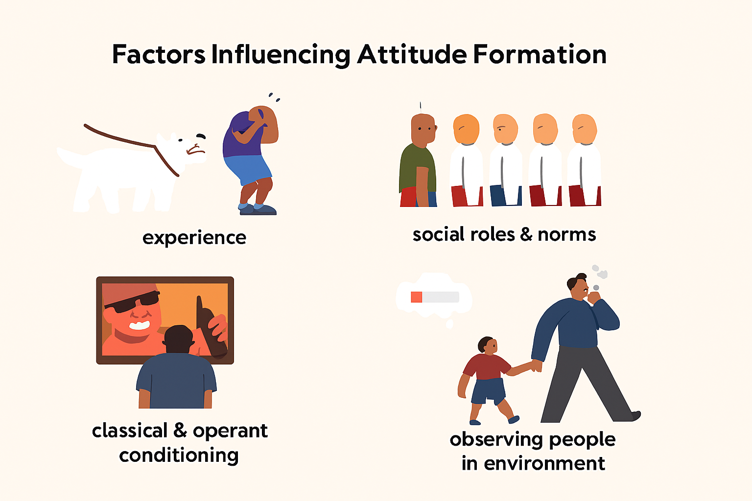
Components of Attitude:
Attitudes consist of three interconnected components: cognitive, affective, and behavioral. The cognitive component includes beliefs, thoughts, and knowledge about the attitude object. The affective component encompasses emotions and feelings associated with the attitude object. The behavioral component involves tendencies to act in certain ways toward the attitude object.
Functions of Attitudes:
Attitudes serve several important psychological functions including knowledge organization, ego defense, value expression, and social adjustment. The knowledge function helps simplify complex information by providing frameworks for understanding. The ego-defensive function protects self-esteem by maintaining positive self-concepts.
2.2 FORMATION AND TYPES OF ATTITUDES:
Attitude formation is a complex process that occurs throughout life as individuals encounter new experiences, information, and social influences. The process begins in early childhood through family interactions and continues through formal education, peer relationships, media exposure, and professional experiences. Understanding how attitudes form provides insight into why people hold certain attitudes and how those attitudes might be changed when necessary.
The formation process involves both conscious and unconscious learning mechanisms. Conscious attitude formation occurs when individuals deliberately evaluate information and make reasoned decisions about their beliefs and preferences. Unconscious attitude formation happens through repeated exposure, emotional associations, and social modeling without deliberate reflection.
Different types of attitudes serve different functions and exhibit different characteristics in terms of stability, intensity, and resistance to change. Recognizing these different types helps individuals understand their own attitude patterns and develop more effective strategies for attitude modification when desired changes would support personal or professional goals.
Direct Experience Formation:
Attitudes formed through direct personal experience tend to be stronger, more stable, and more predictive of behavior than those formed through indirect means. Direct experience provides concrete evidence that supports attitude development and creates emotional connections that reinforce attitude strength.
Work-Related Attitudes:
Several specific attitude types are particularly important in professional contexts. Job satisfaction reflects attitudes toward work tasks, working conditions, and organizational policies. Organizational commitment represents attitudes toward the organization as a whole. Team attitudes influence collaboration and group effectiveness.
2.3 FACTORS AFFECTING ATTITUDES AND MEASUREMENT METHODS:
Numerous factors influence attitude formation, maintenance, and change throughout an individual's lifetime. These factors operate at different levels including personal characteristics, social influences, situational contexts, and cultural environments. Understanding these influences provides insight into why attitudes vary between individuals and how they might be modified when change would be beneficial for personal or professional development.
Personal factors include personality traits, cognitive abilities, past experiences, and current needs that predispose individuals toward certain attitudes. Social factors encompass family influences, peer pressure, reference group norms, and media exposure that shape attitude development through social learning processes. Situational factors involve immediate environmental conditions that activate certain attitudes or make attitude change more likely.
Measurement Approaches:
Direct attitude measurement involves asking individuals to report their attitudes through surveys, interviews, or rating scales. This approach is efficient and provides clear information about conscious attitudes, but may be influenced by social desirability bias or lack of self-awareness. Indirect measurement attempts to infer attitudes from behavior, reaction times, or physiological responses.
Cultural Influences:
Cultural background significantly influences attitude formation and expression. Different cultures emphasize different values, norms, and beliefs that shape attitudes toward work, relationships, authority, and personal achievement. Understanding cultural influences is essential for working effectively in diverse environments
TABLE 2.1:
Factor Category | Specific Influences | Impact Strength | Change Potential
Personal | Personality, Experience, Needs | High | Moderate
Social | Family, Peers, Culture | Very High | High
Situational | Environment, Context, Timing | Moderate | Very High
Cognitive | Information, Logic, Reasoning | Moderate | High
Emotional | Feelings, Mood, Affect | High | Moderate

2.4 POSITIVE VS NEGATIVE ATTITUDES - ADVANTAGES AND DISADVANTAGES:
The distinction between positive and negative attitudes represents a fundamental dimension that significantly impacts personal effectiveness, relationship quality, and professional success. Positive attitudes generally involve optimistic, constructive, and solution-focused approaches to life's challenges and opportunities. Negative attitudes typically encompass pessimistic, critical, and problem-focused perspectives that emphasize difficulties and limitations rather than possibilities and strengths.
Understanding the advantages and disadvantages of both positive and negative attitudes provides a balanced perspective that avoids the oversimplification of viewing one as universally good and the other as universally bad. While positive attitudes generally produce better outcomes in most situations, negative attitudes can sometimes provide valuable functions such as realistic risk assessment and critical thinking.
The key to effective attitude management lies in developing the flexibility to adopt the most appropriate attitude for each situation while maintaining an overall positive orientation that supports long-term success and well-being. This balanced approach requires self-awareness, emotional intelligence, and the ability to consciously choose attitudes that align with current goals and circumstances.
Advantages of Positive Attitudes:
Positive attitudes contribute to better physical and mental health through reduced stress levels, stronger immune function, and lower rates of depression and anxiety. They enhance relationships by making individuals more pleasant to be around, more supportive of others, and more effective at resolving conflicts constructively.
Functions of Negative Attitudes:
Negative attitudes serve important functions including alerting individuals to potential dangers, motivating necessary changes, and providing realistic assessments of difficult situations. Critical thinking often involves negative evaluation of ideas or proposals to identify weaknesses and potential problems.
2.5 BARRIERS TO ATTITUDE CHANGE AND METHODS FOR ATTITUDE TRANSFORMATION:
Attitude change often proves challenging because attitudes serve important psychological functions and become deeply integrated with personal identity, social relationships, and established behavioral patterns. Several barriers operate to maintain existing attitudes even when change would be beneficial. These barriers include cognitive dissonance reduction, selective exposure to confirming information, social pressure to maintain consistency, and emotional attachment to current attitudes.
Understanding these barriers is essential for anyone seeking to change their own attitudes or influence attitude change in others. Effective attitude change strategies must address these barriers directly rather than simply providing new information or logical arguments. Successful attitude transformation typically requires sustained effort over time combined with multiple intervention approaches.
Persuasion Techniques:
Effective persuasion involves understanding audience characteristics, using credible sources, presenting compelling evidence, and addressing counterarguments preemptively. The elaboration likelihood model suggests that attitude change can occur through central route processing or peripheral route processing depending on individual motivation and ability.
Experiential Learning:
Direct experience often produces more powerful attitude change than abstract information or logical arguments. Experiential learning approaches include role-playing exercises, immersion experiences, service learning, and guided interactions with attitude objects.
TABLE 2.2:
Change Barrier | Description | Impact Level | Overcoming Strategy
Cognitive Dissonance | Discomfort from conflicting beliefs | High | Gradual exposure, reflection
Social Pressure | Group conformity expectations | Very High | Find supportive communities
Emotional Attachment | Deep feelings tied to attitudes | High | Address underlying emotions
Information Filtering | Selective attention to confirming data | Moderate | Seek diverse sources actively
Identity Protection | Attitudes linked to self-concept | Very High | Reframe identity positively

2.6 WAYS TO DEVELOP POSITIVE ATTITUDE:
Developing a positive attitude is both an art and a science that requires understanding the psychological mechanisms underlying attitude formation and change, combined with practical strategies for implementing desired modifications. Positive attitude development is not about ignoring problems or maintaining unrealistic optimism, but rather about choosing constructive, solution-focused approaches to life's challenges and opportunities.
The process involves several interconnected elements including cognitive restructuring, emotional regulation, behavioral modification, and environmental management. Cognitive restructuring involves identifying and challenging negative thought patterns while developing more balanced and constructive thinking habits. Emotional regulation encompasses managing mood states and emotional reactions in ways that support positive attitudes.
Behavioral modification involves changing actions and habits that reinforce negative attitudes while adopting behaviors that support positive perspectives. Environmental management includes surrounding oneself with positive influences, information sources, and social relationships that reinforce desired attitude changes.
Cognitive Restructuring:
Cognitive restructuring begins with developing awareness of current thought patterns, particularly automatic negative thoughts that occur in response to challenging situations. Common negative thinking patterns include catastrophizing, all-or-nothing thinking, mind reading, and focusing exclusively on problems rather than solutions.
Gratitude Practices:
Regular gratitude practices have been scientifically shown to improve mood, increase life satisfaction, and promote positive attitudes. These practices can include keeping gratitude journals, expressing appreciation to others, or simply taking time each day to reflect on positive aspects of life.
2.7 CONCEPT AND SIGNIFICANCE OF MOTIVATION:
Motivation represents the psychological force that energizes, directs, and sustains behavior toward achieving specific goals or satisfying particular needs. It serves as the bridge between having goals and taking action to achieve them, transforming intentions into actual behavior. Without adequate motivation, even the most well-designed plans and clearly defined objectives remain unrealized possibilities rather than accomplished achievements.
The significance of motivation extends beyond simple goal achievement to encompass overall life satisfaction, personal growth, and professional effectiveness. Motivated individuals experience greater sense of purpose, higher energy levels, increased persistence in the face of obstacles, and more satisfaction from their accomplishments.
Understanding motivation is particularly important for professionals because workplace success requires sustained effort over extended periods, often in the face of obstacles, setbacks, and competing priorities. Motivated employees are more productive, creative, and committed to organizational goals.
Intrinsic vs Extrinsic Motivation:
Intrinsic motivation arises from internal satisfaction derived from the activity itself, such as enjoyment, personal growth, or sense of accomplishment. Extrinsic motivation stems from external rewards or consequences such as money, recognition, or avoiding punishment. While both types can drive behavior, intrinsic motivation tends to be more sustainable.
Achievement Motivation:
Achievement motivation involves the desire to accomplish challenging goals, master difficult skills, and excel in comparison to standards of excellence. Individuals high in achievement motivation tend to set moderately challenging goals, take personal responsibility for outcomes, and seek feedback about their performance.
2.8 INTERNAL AND EXTERNAL MOTIVES:
The distinction between internal and external motives represents a fundamental aspect of motivational psychology that significantly impacts behavior, satisfaction, and performance outcomes. Internal motives originate from within the individual and include factors such as personal interests, values, enjoyment, curiosity, and desire for mastery or self-improvement. External motives are imposed from outside sources and include rewards, punishments, social pressure, and expectations from others.
Understanding this distinction is crucial because internal and external motives produce different effects on behavior quality, persistence, creativity, and overall satisfaction. Research consistently shows that while external motives can be effective for simple, routine tasks, internal motives are superior for complex, creative, or long-term endeavors that require sustained engagement and innovation.
The challenge lies in finding appropriate balance between internal and external motivational approaches while recognizing that external motivators can sometimes undermine internal motivation if applied inappropriately. The most effective motivational systems often begin with external structure and gradually shift toward internal motivation as individuals develop competence and autonomy.
Self-Determination Theory:
Self-determination theory identifies three basic psychological needs that support internal motivation: autonomy, competence, and relatedness. When these needs are satisfied, individuals are more likely to be internally motivated. When these needs are frustrated, people may rely more heavily on external motivators.
Internalization Process:
External motivators can sometimes be internalized through a process where individuals gradually adopt external expectations as their own values and goals. This internalization process is facilitated by environments that support autonomy, provide meaningful rationales for expectations, and allow individuals to experience competence and connection.
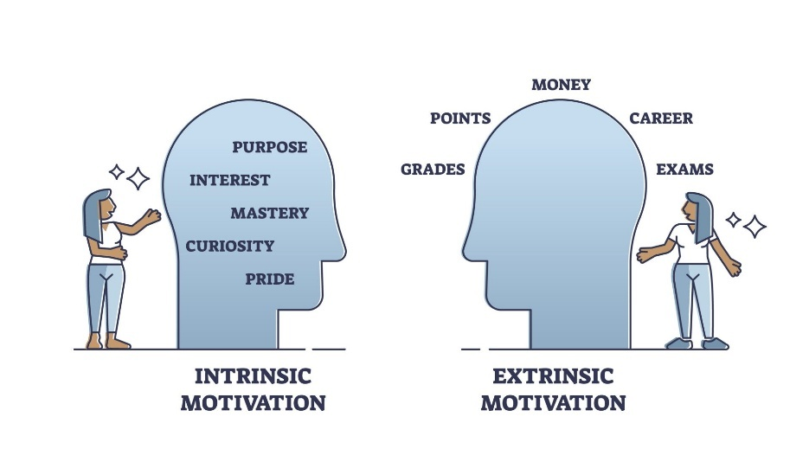
2.9 IMPORTANCE OF SELF-MOTIVATION AND FACTORS LEADING TO DE-MOTIVATION:
Self-motivation represents the ability to energize and direct one's own behavior without relying primarily on external rewards, pressure, or supervision. It involves developing internal drive, maintaining focus on goals, and persisting through obstacles based on personal values, interests, and aspirations. Self-motivation is increasingly important in modern work environments that emphasize autonomy, innovation, and continuous learning.
The importance of self-motivation extends beyond individual benefits to encompass organizational effectiveness and societal progress. Self-motivated individuals are more productive, creative, and adaptable to changing circumstances. They require less supervision, take greater initiative, and contribute more effectively to team and organizational goals.
However, several factors can undermine self-motivation and lead to de-motivation, creating barriers to effective performance and personal satisfaction. Understanding these de-motivating factors is essential for preventing motivational decline and for designing environments that support rather than undermine individual motivation.
Role Clarity:
Unclear role expectations, conflicting priorities, and ambiguous performance standards can significantly undermine motivation by creating confusion about what is expected and how success will be measured. When individuals are uncertain about their responsibilities, they may reduce their effort to avoid making mistakes.
Recognition and Feedback:
Insufficient recognition for good performance and lack of constructive feedback can lead to de-motivation by creating uncertainty about performance quality and reducing satisfaction from accomplishments. Regular, specific, and meaningful feedback helps maintain motivation.
TABLE 2.3:
De-motivation Factor | Description | Impact Level | Prevention Strategy
Lack of Recognition | Insufficient acknowledgment of efforts | High | Regular feedback systems
Unclear Expectations | Ambiguous goals and standards | Very High | Clear communication protocols
Limited Growth | No advancement opportunities | Moderate | Development planning
Work-Life Imbalance | Excessive demands on time | High | Flexible policies
Micromanagement | Excessive control and supervision | Moderate | Trust-building initiatives

2.10 SELF-MONITORING - MEANING AND TECHNIQUES:
Self-monitoring refers to the ability to observe, track, and evaluate one's own behavior, thoughts, emotions, and performance in relation to goals and standards. It involves developing metacognitive awareness that enables individuals to step back from immediate experiences and assess their effectiveness objectively. Self-monitoring serves as a foundation for self-regulation and continuous improvement.
The concept encompasses both trait-like individual differences in natural monitoring tendencies and state-like skills that can be developed through practice and training. Some individuals naturally tend to be more aware of their behavior and its impact on others, while others may need to develop these capabilities more deliberately.
Effective self-monitoring involves several components including attention to relevant behaviors, accurate observation and recording, objective evaluation against standards, and using information to guide future actions. The process is most effective when it focuses on specific, measurable behaviors or outcomes that are clearly linked to important goals or values.
Behavioral Self-Monitoring:
Behavioral self-monitoring involves systematically observing and recording specific behaviors to increase awareness of current patterns and track progress toward desired changes. This might include monitoring study habits, exercise frequency, communication patterns, or time management behaviors.
Performance Self-Monitoring:
Performance self-monitoring focuses on tracking outcomes, productivity, quality indicators, and progress toward specific goals. This might involve monitoring sales results, academic grades, project completion rates, or skill development metrics. Regular performance monitoring enables timely adjustments.
2.11 HIGH VS LOW SELF-MONITOR CHARACTERISTICS:
Self-monitoring exists on a continuum where individuals demonstrate varying degrees of awareness and control over their behavior in social situations. High self-monitors are naturally attuned to social cues and adjust their behavior accordingly, while low self-monitors tend to behave more consistently across different situations based on their internal states and attitudes.
High self-monitors are skilled at reading social situations, adapting their behavior to fit different contexts, and managing the impressions they create in others. They tend to be socially skilled, flexible, and effective in diverse social and professional environments
Low self-monitors tend to be more consistent in their behavior across different situations, guided primarily by their internal attitudes, values, and emotional states rather than external social cues. They are often perceived as authentic and genuine, with strong personal integrity.
High Self-Monitor Advantages:
High self-monitors excel in roles requiring social interaction, networking, leadership, and cross-functional collaboration. They are often effective in sales, management, consulting, and other positions where reading and responding to others is crucial.
Low Self-Monitor Strengths:
Low self-monitors bring authenticity, consistency, and strong personal convictions to their roles. They are often trusted for their integrity and reliability. Their consistent behavior makes them dependable team members.
TABLE 2.4:
Self-Monitor Level | Key Characteristics | Social Behavior | Professional Impact
High Monitor | Adaptable, socially aware | Adjusts to context easily | Strong networking skills
Moderate Monitor | Balanced approach | Selective adaptation | Flexible leadership style
Low Monitor | Consistent, authentic | Maintains personal style | Strong personal brand
Situational Monitor | Context-dependent | Varies by importance | Strategic adaptation
Developing Monitor | Learning awareness | Gradually improving | Growing social skills

2.12 SELF-MONITORING AND JOB PERFORMANCE RELATIONSHIP:
The relationship between self-monitoring and job performance is complex and depends heavily on the specific requirements of different roles and organizational contexts. Research has shown that self-monitoring can predict performance in certain types of positions while having little impact on others. Understanding this relationship helps individuals identify roles that match their natural tendencies.
Self-monitoring particularly impacts performance in roles that require social interaction, influence, adaptation to different audiences, and managing multiple relationships simultaneously. These might include sales positions, management roles, consulting work, customer service, and team leadership positions.
However, the relationship is not always positive, and high self-monitoring can sometimes create challenges in roles that require consistency, authenticity, or technical expertise where social adaptation is less important. Additionally, the costs of constant behavioral adaptation can create stress and reduce performance if not managed effectively.
Performance in Leadership:
Self-monitoring significantly impacts leadership effectiveness, but the optimal level depends on leadership context and followers' needs. High self-monitors often excel in transformational leadership roles where they must inspire diverse groups and adapt their approach to different situations.
Career Advancement:
Self-monitoring often influences career advancement patterns, with high self-monitors more likely to advance into leadership and relationship-intensive roles. However, advancement opportunities also depend on organization culture, industry characteristics, and individual career goals.
2.13 DEFINITION AND FACTORS INFLUENCING PERCEPTION:
Perception represents the process by which individuals select, organize, and interpret sensory information to create meaningful understanding of their environment and experiences. It serves as the bridge between objective reality and subjective experience, transforming raw sensory data into coherent, meaningful information that guides thinking, emotions, and behavior.
Understanding perception is crucial for personal and professional effectiveness because it directly impacts how individuals interpret events, evaluate others, make decisions, and respond to situations. Perception shapes reality for each person, creating individual differences in how the same situation is understood and approached.
The perceptual process involves several stages including attention and selection, organization and categorization, and interpretation and meaning-making. Each stage is influenced by various factors that can enhance or distort accuracy. Developing awareness of these influences enables individuals to improve their perceptual accuracy.
Physiological Factors:
Individual differences in sensory capabilities significantly influence perception through variations in vision, hearing, taste, smell, and touch sensitivity. Age-related changes, health conditions, fatigue levels, and other physiological factors affect what information is detected and how clearly it is perceived.
Psychological Factors:
Past experiences, current needs, emotional states, and personality characteristics significantly influence how information is perceived and interpreted. Individuals tend to perceive what they expect to see based on previous experiences and current mental frameworks.
2.14 PERCEPTION PROCESS AND COMMON ERRORS:
The perception process involves three main stages: selection, organization, and interpretation, each of which can introduce errors that reduce accuracy and effectiveness. Understanding these stages and their potential pitfalls enables individuals to improve their perceptual accuracy and make better decisions.
The selection stage involves choosing which information to pay attention to from the vast amount of available sensory input. This filtering process is necessary because human cognitive capacity is limited, but it can also lead to important information being overlooked or irrelevant information being overemphasized.
Organization involves grouping and structuring selected information into meaningful patterns and categories. This process helps make sense of complex information but can also introduce distortions through oversimplification, inappropriate categorization, or false pattern recognition.
Selective Attention Errors:
Selective attention involves focusing on certain information while ignoring other available data. While this focusing ability is essential for managing information overload, it can lead to important information being missed. Common selective attention errors include focusing only on confirming information.
Attribution Errors:
Attribution involves explaining the causes of behavior and events, but this process is prone to systematic errors. The fundamental attribution error involves overestimating the role of personality factors while underestimating situational influences when explaining others' behavior.
2.15 AVOIDING PERCEPTUAL ERRORS AND IMPROVING ACCURACY:
Improving perceptual accuracy requires developing awareness of common perceptual errors combined with systematic strategies for more objective and complete information processing. While perfect objectivity is impossible due to the inherently subjective nature of perception, significant improvements in accuracy can be achieved through conscious effort and appropriate techniques.
The key to improving perceptual accuracy lies in slowing down the perception process to allow more thorough consideration of available information, seeking multiple perspectives, and systematically checking for common biases and errors. This approach requires conscious effort and may initially feel inefficient, but it leads to better decisions and fewer mistakes over time.
Effective perceptual accuracy improvement also involves creating systems and processes that support more objective evaluation while recognizing that some degree of subjectivity is both inevitable and sometimes valuable. The goal is not to eliminate all subjective interpretation but rather to ensure that subjective elements are balanced with objective analysis.
Systematic Information Gathering:
Improving perceptual accuracy begins with more systematic and comprehensive information gathering that goes beyond first impressions and easily available data. This involves actively seeking multiple sources of information, looking for contradictory evidence, and ensuring adequate time for thorough evaluation.
Multiple Perspective Seeking:
Actively seeking perspectives from others helps overcome individual biases and blind spots by providing alternative viewpoints and interpretations. This might involve consulting with colleagues, seeking feedback from different stakeholders, or considering how others might view the same situation.

sRevision Questions:
Short Answer Questions:
- Define attitude and explain how it differs from temporary opinions or mood states.
- List and briefly describe the three main components that make up an individual's attitude structure.
- What is the difference between intrinsic and extrinsic motivation and which is generally more sustainable?
- Explain what self-monitoring means and how it differs from simple self-awareness.
- What are the three main stages of the perception process and why is each stage important?
Long Answer Questions:
- Analyze the relationship between attitudes and behavior, discussing why attitudes don't always predict behavior and what factors strengthen this relationship.
- Compare and contrast the advantages and disadvantages of positive versus negative attitudes, explaining when each might be more appropriate or functional.
- Evaluate the various barriers to attitude change and discuss comprehensive strategies for overcoming resistance to attitude modification in professional settings.
- Examine the factors that lead to de-motivation in workplace settings and develop a systematic approach for maintaining self-motivation despite challenging circumstances.
- Discuss the impact of perceptual errors on decision-making and interpersonal relationships, providing specific strategies for improving perceptual accuracy in professional contexts.

Case Studies:
Case Study 1: The Negative Team Member
Jennifer is a talented software developer who recently joined a fast-growing technology startup. Despite her technical skills being exactly what the company needs, her consistently negative attitude is creating problems for her team and the broader organization. During team meetings, Jennifer frequently focuses on potential problems with proposed solutions, expresses skepticism about project timelines, and questions whether new initiatives will succeed.
Jennifer's negativity stems from her previous experience at a large corporation where many projects failed due to poor planning and unrealistic expectations. She believes her critical perspective helps teams avoid mistakes and set more realistic goals. However, her current teammates are becoming frustrated with what they perceive as constant pessimism and resistance to new ideas. Several team members have begun excluding Jennifer from informal planning discussions, and her manager has received complaints about her impact on team morale.
The situation came to a head during a crucial project planning meeting where Jennifer's extensive critique of the proposed approach led to heated arguments and ultimately delayed important decisions. Her manager, David, recognizes Jennifer's technical value but is concerned about her cultural fit and impact on team dynamics. David wants to address the situation constructively but is unsure how to help Jennifer modify her approach while still benefiting from her analytical skills.
Jennifer is unaware of how negatively her behavior is being perceived by others. She sees herself as being realistic and helpful by identifying potential problems before they occur. She is frustrated that her teammates seem to ignore obvious risks and make overly optimistic assumptions. Jennifer values her reputation as a thorough, analytical thinker and worries that being more positive might compromise her professional standards or lead to poor decisions.
Discussion Questions: How can Jennifer's manager help her understand the difference between constructive criticism and destructive negativity? What attitude change strategies would be most effective for helping Jennifer develop a more balanced perspective while maintaining her analytical strengths? How might Jennifer's past experiences be influencing her current attitudes, and how can this understanding inform the change approach? What role does self-awareness play in Jennifer's situation, and how can she develop better understanding of her impact on others? How can the team learn to better utilize Jennifer's critical thinking skills while addressing the motivational impact of her negative attitude?
Case Study 2: The Motivation Crisis
Michael is a 29-year-old marketing manager at a mid-sized consulting firm who has been struggling with declining motivation over the past six months. After three years of strong performance and steady advancement, Michael finds himself going through the motions at work without the enthusiasm and drive that previously characterized his approach to his career. He continues to meet basic performance expectations but has stopped taking initiative, pursuing development opportunities, or contributing innovative ideas.
The motivation decline began when Michael was passed over for a promotion he had been expecting. Although his supervisor explained that the decision was based on the need for someone with different experience, Michael interpreted it as a reflection of his capabilities and future potential. Since then, he has questioned whether his efforts are being recognized and whether he has a meaningful future with the organization.
Michael's reduced motivation is affecting his performance in subtle but important ways. He no longer volunteers for challenging assignments, participates less actively in team meetings, and has stopped the informal mentoring of junior staff that previously distinguished his contributions. His supervisor has noticed the changes but hasn't addressed them directly, hoping that Michael's motivation would return naturally.
The situation is complicated by Michael's personal life, where he is also questioning major decisions about his career direction, relationships, and long-term goals. He feels stuck in patterns that no longer provide satisfaction but is uncertain about what changes would improve his situation. Michael recognizes that his motivation has declined but feels unable to generate genuine enthusiasm for his current responsibilities or clear direction for future goals.
Discussion Questions: What internal and external factors might be contributing to Michael's motivational decline, and how do they interact with each other? How can Michael rebuild his self-motivation while addressing the underlying concerns about recognition and career advancement? What role should Michael's supervisor play in addressing the motivation issues, and what approaches would be most effective? How might Michael use goal-setting and self-monitoring techniques to rebuild his motivation and sense of direction? What strategies can Michael employ to find meaning and purpose in his current role while exploring longer-term career options?
Case Study 3: The Perception Problem
Rachel is a senior project manager who prides herself on being decisive and action-oriented. However, her quick decision-making style has begun to create problems because she often misreads situations and makes judgments based on incomplete information. In the past month, she has made several decisions that later proved to be based on incorrect assumptions about team member capabilities, client requirements, and project constraints.
The most recent incident involved Rachel's decision to reassign a critical task from Tom, a team member she perceived as struggling, to Sarah, whom she viewed as more reliable. Rachel's perception was based on observing Tom asking questions during a team meeting and Sarah appearing confident and prepared. However, Tom's questions actually indicated thorough preparation and attention to detail, while Sarah's confidence masked her lack of understanding of the technical requirements.
The reassignment created significant problems because Tom had already invested substantial time in understanding the task requirements and had developed innovative approaches that were lost when the work was transferred. Sarah struggled with the technical complexity and ultimately required extensive support from other team members. The project was delayed, and team morale suffered due to the perceived unfairness and inefficiency of the decision.
Rachel is beginning to recognize a pattern in her decision-making but is unsure how to slow down her process without appearing indecisive or losing the reputation for quick action that she values. She has received feedback about jumping to conclusions but struggles to identify specific ways to improve her perceptual accuracy while maintaining her effectiveness as a project manager.
Discussion Questions: What perceptual errors is Rachel making, and what factors might be contributing to these errors in her role as a project manager? How can Rachel develop better information-gathering processes without compromising her ability to make timely decisions? What strategies can Rachel use to improve her accuracy in evaluating team member capabilities and performance? How might Rachel's self-monitoring skills need to develop to help her recognize when she might be making perceptual errors? What organizational or team processes could be implemented to provide better information for Rachel's decision-making while supporting her leadership effectiveness?

Fun Activity:
The Attitude-Motivation Challenge: "The Perception Reality Check"
This interactive activity helps students apply Chapter 2 concepts through a structured challenge that focuses on attitude awareness, motivation assessment, and perception accuracy improvement.
Activity Overview
Students participate in a week-long challenge where they track their attitudes, monitor their motivation levels, and practice perception accuracy techniques. The activity combines self-assessment, peer feedback, and practical experimentation with behavior change strategies.
Setup Instructions
Each student creates a "Personal Effectiveness Tracker" containing daily attitude logs, motivation assessments, and perception accuracy exercises. They identify one specific attitude they want to improve, one motivation area they want to strengthen, and one perception skill they want to develop.
Daily Activities (20-25 minutes each)
Days 1-2: Baseline Assessment
Students complete attitude surveys, motivation questionnaires, and perception accuracy tests using standardized instruments. They identify personal triggers, behavioral patterns, and areas needing improvement while establishing baseline measurements for progress tracking.
Days 3-4: Intervention Implementation
Participants practice attitude reframing exercises, motivation enhancement techniques, and systematic perception checking methods. Daily interventions include cognitive restructuring, goal-setting frameworks, and assumption-testing protocols tailored to individual improvement goals.
Days 5-6: Peer Partnership Activities
Students form "Effectiveness Trios" for attitude discussions, motivation accountability, and perception accuracy practice with feedback. Each trio meets twice for 15-minute sessions where members serve as observers, accountability partners, and feedback providers.
Day 7: Integration and Evaluation
Final assessment through self-reflection, peer evaluation, and progress measurement using identical baseline instruments. Students analyze successful strategies and create maintenance plans for continued development.
Group Component
Students form "Effectiveness Trios" where they serve as observers, accountability partners, and feedback providers for each other's development goals. Each trio meets for 15-minute sessions twice during the week to practice perception skills and provide motivational support.
Assessment and Recognition
Progress is measured through pre/post assessments, peer feedback ratings, and behavioral change documentation. Students who demonstrate significant improvement in their chosen areas receive recognition and share their successful strategies with the class.
Learning Outcomes
This activity reinforces key concepts including attitude formation and change, motivation sources and maintenance, self-monitoring techniques, and perception accuracy improvement. Students gain practical experience in behavior change while building collaborative relationships and developing meta-cognitive awareness of their own psychological processes.

**********
3
SELF-ESTEEM AND INTERPERSONAL SKILLS

INTRODUCTION
The development of strong interpersonal skills forms the backbone of professional success in today's competitive business environment. This unit examines the relationship between self-esteem and effective communication, exploring how individuals can build confidence while maintaining respectful and productive relationships with colleagues, superiors, and subordinates.
Self-esteem serves as the foundation upon which all interpersonal interactions are built. When professionals possess healthy self-regard, they communicate with clarity, make decisions with confidence, and navigate workplace challenges with resilience. The ability to express oneself assertively without being aggressive or submissive represents a key competency that distinguishes successful leaders from their peers.
The concepts presented in this unit provide practical frameworks for understanding behavioral patterns and communication styles. Students will learn to identify different approaches to interpersonal interaction and develop skills that enable them to respond appropriately in various professional situations. The integration of lateral thinking techniques further enhances problem-solving capabilities and creative communication strategies.
3.1 UNDERSTANDING SELF-ESTEEM: DEFINITION AND CORE COMPONENTS:
Self-esteem represents the cornerstone of professional development and interpersonal effectiveness in organizational settings. This psychological construct influences every aspect of workplace behavior, from communication patterns to leadership capabilities. Understanding the fundamental nature of self-esteem provides the foundation for developing stronger professional relationships and enhanced career prospects.
The measurement and evaluation of self-esteem requires systematic examination of behavioral patterns, thought processes, and emotional responses across various professional situations. Organizations increasingly recognize the connection between employee self-esteem levels and overall performance metrics, making this understanding valuable for both individual development and organizational success.
Definition and Fundamental Concepts: Self-esteem represents an individual's overall subjective emotional evaluation of their own worth and capabilities in professional and personal contexts. This psychological construct encompasses beliefs about oneself as well as emotional states associated with those beliefs, directly influencing decision-making processes, communication effectiveness, and leadership potential. The concept extends beyond simple self-confidence to include deeper understanding of personal values, strengths, and areas requiring development. Research indicates that self-esteem develops through continuous assessment of personal achievements, failures, and social interactions throughout an individual's career progression. Professional environments often challenge existing self-perceptions, requiring individuals to adapt and grow while maintaining stable identity foundations that support consistent performance and relationship building.
Symptoms of Healthy Self-Esteem: Individuals with balanced self-esteem demonstrate consistent behavioral patterns that reflect inner confidence and self-acceptance across various professional situations and challenges. They express opinions clearly without excessive concern for approval from others, participate actively in meetings and discussions, and contribute meaningfully to team projects and organizational initiatives. These professionals take calculated risks and view failures as learning opportunities rather than personal deficiencies, maintaining resilience during difficult periods and bouncing back from setbacks with renewed determination. Communication patterns reflect authenticity and respect for diverse perspectives, enabling them to build strong working relationships and navigate complex organizational dynamics effectively. Decision-making processes involve careful consideration of options without paralysis or impulsiveness, leading to well-reasoned choices that advance both personal and organizational objectives with confidence and competence in challenging business environments.
Workplace Manifestations: Professionals with healthy self-esteem contribute positively to organizational culture through their interactions, work approach, and collaborative attitudes toward colleagues and superiors. They volunteer for challenging projects and actively seek opportunities for skill development, demonstrating initiative and commitment to continuous professional growth. Performance evaluations are received constructively with focus on development rather than defensiveness, allowing them to integrate feedback effectively into their professional development plans. Team participation demonstrates active engagement while respecting others' contributions, fostering positive group dynamics and productive collaborative relationships. Leadership opportunities are approached with enthusiasm tempered by realistic assessment of capabilities, ensuring successful project outcomes and team satisfaction. Conflict situations are handled diplomatically with emphasis on resolution rather than winning or avoiding confrontation, maintaining professional relationships while addressing important business issues effectively.
Self-Assessment Indicators: Recognition of personal self-esteem levels requires honest evaluation of thoughts, feelings, and behaviors across different professional and personal situations. Individuals should examine their responses to criticism, praise, and challenging circumstances, noting patterns in emotional reactions and behavioral adjustments. Patterns of self-talk reveal underlying beliefs about personal worth and capabilities, providing insight into internal dialogue that influences external performance and relationship quality. Social interactions provide valuable data about comfort levels with expressing disagreement, seeking support, and maintaining professional boundaries in various organizational contexts. Professional goal-setting behaviors indicate whether individuals set appropriate challenges or limit themselves unnecessarily due to fear of failure or unrealistic expectations. Recognition of these indicators enables targeted development efforts and more effective self-management strategies.
Impact on Professional Relationships: Self-esteem levels directly influence the quality and effectiveness of professional relationships across organizational hierarchies and functional areas. Individuals with healthy self-esteem engage authentically with colleagues, building trust through consistent behavior and reliable performance. They communicate needs and boundaries clearly without aggression or excessive accommodation, maintaining professional respect while advocating for important interests. Networking activities are approached with genuine interest in mutual benefit rather than solely personal gain, creating lasting professional connections that support career advancement and organizational success. Mentoring relationships flourish as these individuals seek guidance while offering support to others, contributing to positive organizational culture and knowledge sharing initiatives.
Development Through Professional Experience: Self-esteem evolves through accumulated professional experiences, feedback, and personal reflection over time. Successful project completions build confidence while challenging assignments stretch capabilities and expand comfort zones. Regular feedback from supervisors, peers, and subordinates provides external validation and areas for improvement, contributing to more accurate self-assessment and realistic goal setting. Professional training and development opportunities enhance skills while building confidence in new competency areas. Recognition and rewards reinforce positive self-perception while failures and setbacks provide opportunities for resilience building and character development. The integration of these experiences creates a more robust and stable sense of professional identity that supports continued growth and adaptation in changing business environments.

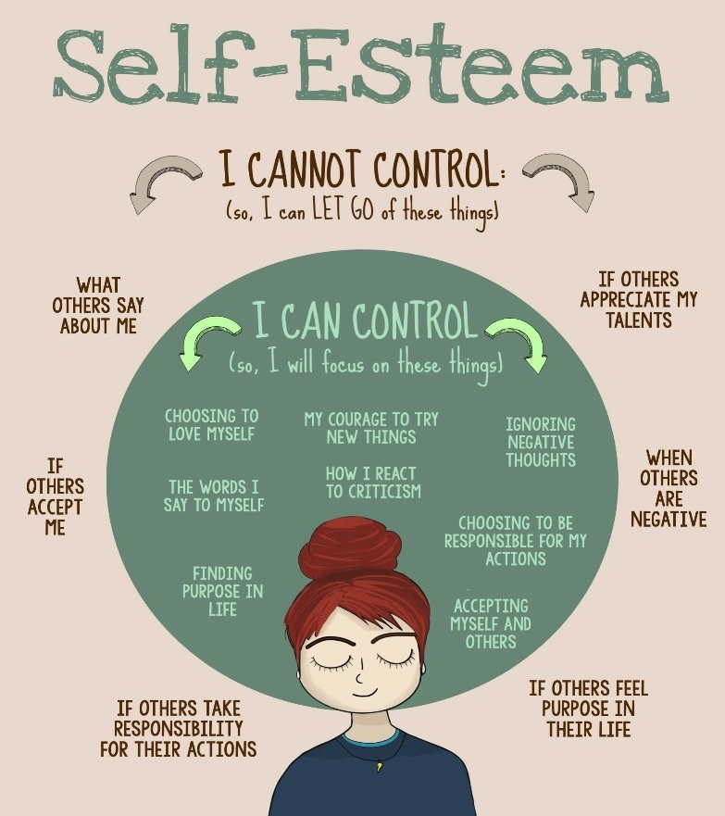

3.2 ADVANTAGES OF POSITIVE SELF-ESTEEM IN PROFESSIONAL SETTINGS:
Positive self-esteem serves as a catalyst for professional success and organizational effectiveness across various industries and career levels. Individuals who maintain healthy self-regard contribute significantly to team performance, innovation initiatives, and organizational culture development. The benefits extend beyond individual achievement to encompass broader organizational outcomes and competitive advantages.
The relationship between self-esteem and professional performance demonstrates clear patterns that organizations can leverage for improved business results. Companies that invest in employee self-esteem development often experience reduced turnover, increased engagement, and enhanced customer satisfaction scores.
Enhanced Decision-Making Capabilities: Professionals with positive self-esteem make decisions with greater confidence and clarity, leading to more effective business outcomes and organizational success. They analyze situations objectively without excessive second-guessing or fear of making mistakes, enabling faster response times in competitive business environments. Risk assessment becomes more balanced as they neither avoid all risks nor take reckless chances, instead evaluating opportunities based on realistic analysis of potential outcomes and organizational capabilities. Decision implementation proceeds smoothly because they commit fully to chosen courses of action while remaining flexible enough to adjust strategies based on new information or changing circumstances. Team members respond positively to decisive leadership, creating momentum and enthusiasm for project completion and goal achievement.
Improved Communication Effectiveness: Individuals with healthy self-esteem communicate more clearly and persuasively across all organizational levels and external stakeholder relationships. They express ideas with conviction while remaining open to alternative perspectives and constructive criticism from colleagues and superiors. Presentation skills improve naturally as confidence reduces anxiety and enables focus on content delivery rather than personal concerns about audience reactions. Conflict resolution becomes more effective as they address issues directly without becoming defensive or aggressive, maintaining focus on problem-solving rather than personal protection. Written communication reflects clarity and professionalism, enhancing organizational reputation and facilitating better business relationships with clients, partners, and vendors.
Increased Innovation and Creativity: Positive self-esteem fosters creative thinking and innovation by reducing fear of failure and encouraging experimentation with new approaches. Individuals feel comfortable suggesting unconventional solutions and challenging existing processes when improvements seem possible, contributing to organizational adaptation and competitive advantage. Brainstorming sessions become more productive as they contribute freely without excessive concern about judgment from colleagues or supervisors. Risk-taking in creative endeavors increases appropriately, leading to breakthrough innovations and improved business processes. Collaboration with diverse team members improves as they value different perspectives and integrate various viewpoints into comprehensive solutions that address complex business challenges effectively.
Stronger Leadership Potential: Professionals with positive self-esteem naturally develop leadership qualities that inspire and motivate team members toward common organizational objectives. They accept leadership responsibilities willingly and perform effectively under pressure, maintaining team morale during challenging periods and organizational changes. Delegation skills improve as they trust others and provide appropriate support without micromanaging or undermining team member capabilities. Mentoring relationships develop naturally as they share knowledge and experience generously while continuing their own professional development. Vision communication becomes more compelling as authentic confidence inspires others to commit to organizational goals and participate actively in achievement strategies.
Better Stress Management: Healthy self-esteem provides resilience and coping mechanisms that enable effective performance under pressure and during organizational transitions. Work-life balance becomes more manageable as they set appropriate boundaries and prioritize activities based on personal values and professional responsibilities. Physical and emotional health remain stable during demanding periods, supporting consistent performance and reliable team participation. Problem-solving under stress improves as they maintain perspective and focus on solutions rather than dwelling on difficulties or obstacles. Recovery from setbacks occurs more quickly, enabling them to support colleagues and contribute to organizational resilience during challenging business cycles.
Enhanced Career Advancement: Positive self-esteem accelerates career progression through improved performance, stronger relationships, and increased visibility within organizations. They pursue promotional opportunities actively while accurately assessing their readiness and development needs, creating realistic career plans that align with organizational opportunities. Professional networking expands naturally as authentic confidence attracts mentors, sponsors, and collaborative partners who support career growth. Skill development occurs more rapidly as they embrace challenging assignments and learning opportunities without excessive fear of failure or inadequacy. Performance evaluations improve consistently as supervisors recognize their contributions, reliability, and potential for increased responsibility and organizational leadership roles.
3.3 LOW SELF-ESTEEM: SYMPTOMS AND PROFESSIONAL IMPACT:
Low self-esteem creates significant obstacles to professional development and organizational contribution, affecting both individual performance and team dynamics. Recognition of these symptoms enables targeted intervention strategies that can transform career trajectories and improve workplace relationships. Understanding the manifestations of low self-esteem provides the foundation for developing appropriate support systems and personal development plans.
The impact of low self-esteem extends beyond individual performance to influence organizational culture, team effectiveness, and business outcomes. Companies that address self-esteem issues proactively often experience improved employee engagement and reduced turnover costs.
Behavioral Symptoms and Manifestations: Individuals with low self-esteem exhibit consistent patterns of behavior that limit their professional effectiveness and career advancement opportunities. They avoid challenging assignments and leadership roles, preferring familiar tasks that feel safe but provide limited growth potential. Decision-making becomes paralyzed by excessive analysis and fear of making mistakes, leading to missed opportunities and delayed project completion. Communication patterns reflect hesitancy and qualification of statements, reducing their influence and credibility in meetings and professional discussions. Perfectionism emerges as a coping mechanism, causing delays and excessive attention to minor details while missing broader strategic objectives. Social interactions become strained as they interpret neutral comments negatively and assume others view them unfavorably, creating unnecessary tension and misunderstandings in workplace relationships.
Communication and Interpersonal Challenges: Low self-esteem significantly impairs communication effectiveness and relationship building across professional contexts. They struggle to express disagreement or alternative viewpoints, even when their perspectives could benefit project outcomes or organizational decision-making processes. Networking activities are avoided or approached with anxiety, limiting exposure to career opportunities and professional development resources. Presentation skills suffer as anxiety and self-doubt interfere with content delivery and audience engagement. Feedback reception becomes defensive as criticism is interpreted as personal attacks rather than opportunities for professional growth and skill enhancement. Collaboration difficulties arise as they either withdraw from team participation or overcompensate through excessive accommodation that compromises project quality and personal boundaries.
Performance and Productivity Issues: Professional performance suffers as low self-esteem creates internal barriers to effective work completion and career advancement. They underestimate their capabilities and accept lower-level assignments despite possessing skills for more challenging roles. Quality standards become inconsistent as perfectionism alternates with resignation, leading to either excessive time investment or premature completion of important tasks. Initiative decreases as they wait for explicit instructions rather than taking appropriate action based on professional judgment and organizational objectives. Innovation and creativity decline as fear of failure prevents experimentation and risk-taking that could benefit organizational performance. Time management becomes problematic as procrastination and second-guessing interfere with efficient task completion and deadline achievement.
Career Development Limitations: Low self-esteem creates self-imposed barriers that significantly limit career progression and professional growth opportunities. They avoid applying for promotions or challenging positions despite meeting qualifications, assuming they lack necessary capabilities or that others are more deserving. Professional development activities are avoided or approached reluctantly, limiting skill acquisition and knowledge expansion. Mentoring relationships fail to develop as they hesitate to seek guidance or advice from senior professionals who could accelerate their career advancement. Networking opportunities are missed or ineffectively utilized due to anxiety and perceived inadequacy in professional social situations. Goal setting becomes unrealistic in either direction, with either excessive ambition that leads to disappointment or insufficient challenge that prevents growth and development.
Impact on Team Dynamics: Low self-esteem affects not only individual performance but also broader team effectiveness and organizational culture. Team meetings become less productive as they either withdraw from participation or require excessive reassurance and support from colleagues. Leadership potential remains unrealized as they avoid responsibilities that could benefit from their knowledge and experience. Conflict situations become more difficult to resolve as they interpret disagreement personally and struggle to separate professional issues from personal worth. Collaboration suffers as they either defer excessively to others or become defensive when their contributions are questioned or modified. Morale can be affected as their anxiety and negativity influence team atmosphere and enthusiasm for shared projects and organizational objectives.
Long-term Professional Consequences: The cumulative effect of low self-esteem creates lasting impacts on career trajectories and professional satisfaction. Career stagnation occurs as opportunities are avoided or pursued half-heartedly, leading to limited advancement and income growth. Professional relationships remain superficial as authentic connection requires confidence and vulnerability that low self-esteem inhibits. Skill development plateaus as they avoid challenges that could enhance capabilities and increase market value. Job satisfaction decreases as they feel undervalued and underutilized, despite often possessing greater capabilities than their current roles require. Organizational contribution remains limited as their potential remains unrealized, representing lost opportunities for both individual fulfillment and business success.
TABLE 3.1:
Aspect | High Self-Esteem | Moderate Self-Esteem | Low Self-Esteem
Decision Making | Makes confident decisions with appropriate risk assessment and timely implementation | Takes time to consider options but eventually decides with reasonable confidence | Struggles with decision paralysis and second-guessing, often delaying important choices
Communication Style | Expresses ideas clearly and persuasively while remaining open to feedback | Communicates effectively but may seek additional validation before presenting | Hesitates to share opinions and qualifies statements excessively
Response to Criticism | Receives feedback constructively and uses it for improvement | Generally accepts criticism well but may need time to process | Takes criticism personally and becomes defensive or withdrawn
Risk Taking | Takes calculated risks and learns from both successes and failures | Considers risks carefully and takes moderate chances when appropriate | Avoids risks and prefers safe, familiar situations
Leadership Approach | Leads with confidence and inspires others through authentic presence | Shows leadership potential with some development needs | Avoids leadership roles and defers to others consistently

3.4 DEVELOPING POSITIVE SELF-ESTEEM: DO'S AND DON'TS:
The development of positive self-esteem requires systematic effort and consistent application of proven strategies across personal and professional domains. Successful self-esteem building involves both adopting beneficial practices and eliminating counterproductive behaviors that undermine confidence and self-worth. This process demands patience and persistence as change occurs gradually through repeated positive experiences and mindset shifts.
Professional environments provide excellent opportunities for self-esteem development through achievement, recognition, and skill building. Organizations benefit significantly when employees develop healthy self-regard, as this translates into improved performance, innovation, and collaboration across all business functions.
Essential Do's for Self-Esteem Development: Successful self-esteem building requires consistent implementation of positive practices that reinforce personal worth and capability. Individuals should celebrate achievements regardless of size, acknowledging progress and success to build momentum and confidence over time. Regular self-reflection helps identify strengths and accomplishments that may otherwise go unrecognized, creating a more balanced and accurate self-assessment. Goal setting should focus on realistic, achievable objectives that stretch capabilities while ensuring success experiences that build confidence. Skill development through training, education, and challenging assignments enhances competency and provides tangible evidence of growth and capability. Professional relationships should be cultivated actively, as positive interactions and feedback from colleagues reinforce self-worth and provide valuable support networks. Physical and mental health maintenance through exercise, proper nutrition, and stress management supports overall well-being and confidence levels that translate into professional effectiveness.
Critical Don'ts to Avoid: Certain behaviors and thought patterns consistently undermine self-esteem development and must be consciously avoided or eliminated. Negative self-talk and internal criticism create destructive mental patterns that reinforce inadequacy and limit potential achievement. Comparing oneself to others leads to unrealistic standards and diminished self-worth, as everyone faces different circumstances and possesses different strengths. Perfectionism creates impossible standards that guarantee disappointment and reinforce feelings of inadequacy despite objective success. Avoiding challenges and new experiences prevents growth and skill development while reinforcing beliefs about personal limitations. Seeking constant external validation creates dependence on others' opinions rather than developing internal standards and confidence. Dwelling on past failures and mistakes prevents forward progress and maintains focus on negative experiences rather than learning and growth opportunities.
Building Professional Competence: Self-esteem development in professional contexts requires focused attention on skill building and performance improvement. Individuals should seek feedback regularly from supervisors, peers, and subordinates to gain objective perspectives on performance and areas for development. Challenging assignments should be pursued actively as they provide opportunities to stretch capabilities and achieve success in new areas. Professional development activities including training, conferences, and certification programs enhance knowledge and skills while demonstrating commitment to growth. Mentoring relationships provide guidance, support, and perspective that accelerate professional development and confidence building. Industry involvement through professional associations and networking activities expands knowledge and builds valuable relationships that support career advancement. Documentation of achievements and positive feedback creates tangible records of success that can be referenced during difficult periods or self-doubt.
Developing Positive Relationships: Healthy self-esteem flourishes in environments characterized by supportive and respectful relationships. Individuals should surround themselves with positive, encouraging people who provide honest feedback and genuine support for personal and professional growth. Communication skills should be developed to express needs, boundaries, and opinions clearly and respectfully. Conflict resolution abilities enable maintenance of relationships during disagreements while protecting personal interests and values. Empathy and active listening skills enhance relationship quality and provide deeper connections with colleagues and friends. Networking should focus on mutual benefit and genuine interest in others rather than solely personal gain. Collaborative approaches to projects and problem-solving build stronger team relationships and demonstrate interpersonal effectiveness that enhances professional reputation and career prospects.
Maintaining Physical and Mental Wellness: Self-esteem development requires attention to overall health and well-being as physical and mental states significantly influence confidence and performance levels. Regular exercise improves physical health while releasing endorphins that enhance mood and self-perception. Proper nutrition supports energy levels and cognitive function that enable better performance and decision-making capabilities. Adequate sleep ensures optimal mental and physical functioning while providing resilience during stressful periods. Stress management techniques including meditation, relaxation exercises, and time management prevent overwhelm and maintain emotional stability. Work-life balance protects against burnout while ensuring time for relationships and activities that provide fulfillment and perspective. Professional counseling or coaching provides additional support and strategies for addressing specific self-esteem challenges and accelerating development progress.
Creating Supportive Environments: Self-esteem thrives in environments that provide encouragement, recognition, and opportunities for growth and contribution. Individuals should actively seek organizations and roles that align with their values and provide opportunities for meaningful contribution and advancement. Team selection and project involvement should consider the supportive nature of colleagues and supervisors when possible. Physical workspace organization and personalization can reinforce positive self-image and professional identity. Recognition and celebration of achievements should be shared appropriately with colleagues and supervisors to reinforce success and build reputation. Community involvement and volunteer activities provide additional opportunities for contribution and recognition that enhance overall self-worth and social connection. Continuous learning and growth mindset should be maintained to ensure ongoing development and adaptation to changing professional requirements and opportunities.
TABLE 3.2:
Category | Effective Strategies | Common Mistakes | Professional Impact
Goal Setting | Set specific, measurable, achievable objectives with clear timelines | Setting unrealistic goals or avoiding goal setting entirely | Creates clear progress markers and builds confidence through achievement
Feedback Reception | Seek feedback actively and use it constructively for improvement | Avoiding feedback or taking criticism too personally | Accelerates professional development and strengthens relationships
Challenge Acceptance | Pursue appropriate challenges that stretch capabilities safely | Either avoiding all challenges or taking excessive risks | Builds competence and confidence while expanding skill sets
Self-Talk Patterns | Practice positive, realistic internal dialogue and self-encouragement | Engaging in negative self-criticism or unrealistic positive thinking | Influences mood, motivation, and performance across all activities
Relationship Building | Cultivate supportive professional relationships based on mutual respect | Isolating oneself or maintaining only superficial connections | Provides support network and opportunities for collaboration and growth

3.5 COMPARISON BETWEEN POSITIVE AND NEGATIVE SELF-ESTEEM:
Understanding the fundamental differences between positive and negative self-esteem provides clarity for personal development efforts and organizational management strategies. These contrasting patterns affect every aspect of professional life, from daily interactions to long-term career planning and achievement. Recognition of these differences enables targeted interventions that can transform individual performance and organizational culture.
The comparison between positive and negative self-esteem reveals clear patterns that predict professional success and personal satisfaction. Organizations can use this understanding to create environments that foster positive self-regard while identifying employees who may benefit from additional support and development opportunities.
Behavioral Differences in Professional Settings: Individuals with positive self-esteem approach professional challenges with confidence and resilience, viewing obstacles as opportunities for growth and learning. They participate actively in meetings, contribute ideas freely, and take calculated risks that advance both personal and organizational objectives. Decision-making occurs efficiently with appropriate consideration of options and consequences, leading to timely action and project advancement. Collaboration flows naturally as they value others' contributions while confidently sharing their own expertise and perspectives. Leadership opportunities are embraced enthusiastically with focus on team success rather than personal recognition or protection from criticism. Conversely, individuals with negative self-esteem exhibit patterns of avoidance and self-limitation that restrict both personal achievement and organizational contribution. They hesitate to volunteer for challenging assignments, participate minimally in group discussions, and require excessive reassurance before taking action.
Communication Patterns and Effectiveness: Positive self-esteem enables clear, confident communication that enhances professional relationships and organizational effectiveness. These individuals express ideas with conviction while remaining open to alternative perspectives and constructive feedback from colleagues. Presentation skills reflect natural confidence that engages audiences and facilitates effective information transfer. Conflict situations are addressed directly with focus on problem resolution rather than personal protection or victory. Written communication demonstrates professionalism and clarity that enhances organizational reputation and facilitates business relationships. Negative self-esteem creates communication barriers that limit professional effectiveness and relationship quality. Speech patterns include excessive qualifiers and hesitation that diminish credibility and influence in professional discussions. Presentation anxiety interferes with content delivery and audience engagement, limiting career advancement opportunities.
Response to Challenges and Opportunities: Those with positive self-esteem view challenges as opportunities for growth and skill development, approaching difficult situations with problem-solving orientation and persistence. They pursue promotional opportunities and career advancement actively while accurately assessing their readiness and development needs. Failure is interpreted as learning experience rather than personal inadequacy, enabling quick recovery and continued progress toward objectives. Innovation and creativity flourish as they experiment with new approaches without excessive fear of failure or judgment from others. Individuals with negative self-esteem perceive challenges as threats to be avoided rather than opportunities for advancement and learning. Career opportunities are declined or pursued half-heartedly due to perceived inadequacy despite objective qualifications. Failure becomes confirmation of personal deficiency rather than feedback for improvement, creating cycles of avoidance and stagnation.
Long-term Career Trajectories: Positive self-esteem creates upward career trajectories characterized by consistent advancement, expanding responsibilities, and increasing organizational influence. Professional relationships develop depth and authenticity that provide ongoing support and opportunities for collaboration and advancement. Skill development occurs continuously as challenges are embraced and learning opportunities are pursued actively. Job satisfaction remains high as roles align with capabilities and provide meaningful contribution to organizational success. Negative self-esteem leads to career stagnation and underutilization of capabilities, resulting in limited advancement and reduced earning potential over time. Professional relationships remain superficial as authentic connection requires vulnerability and confidence that low self-esteem inhibits. Skill development plateaus as growth opportunities are avoided or approached reluctantly, limiting market value and career options.
Impact on Team and Organizational Performance: Team members with positive self-esteem contribute energy, optimism, and solution-focused thinking that enhances group effectiveness and morale. They support colleagues' success genuinely while pursuing their own objectives, creating collaborative environments that benefit all participants. Innovation increases as they share ideas freely and build upon others' suggestions without excessive concern about credit or recognition. Organizational culture benefits from their authentic engagement and commitment to shared objectives and values. Those with negative self-esteem can drain team energy through pessimism, excessive need for reassurance, and reluctance to take appropriate risks or initiative. Collaboration becomes strained as they require disproportionate support while contributing less than their potential would suggest. Innovation suffers as they hesitate to share ideas or build upon others' suggestions, limiting creative problem-solving and organizational adaptation.
TABLE 3.3:
Dimension | Positive Self-Esteem | Negative Self-Esteem | Organizational Impact
Risk Tolerance | Takes calculated risks and learns from outcomes | Avoids risks and prefers safe, familiar situations | Higher innovation and adaptation vs. stagnation and missed opportunities
Feedback Utilization | Welcomes feedback and uses it constructively for growth | Avoids feedback or becomes defensive when receiving it | Accelerated development vs. limited learning and improvement
Collaboration Quality | Contributes confidently while valuing others' input | Either withdraws or defers excessively to team members | Enhanced team performance vs. reduced collective capability
Leadership Readiness | Accepts leadership roles and develops others effectively | Avoids leadership responsibilities despite having capabilities | Strong succession planning vs. leadership gaps and development needs
Change Adaptation | Embraces change as opportunity for growth and learning | Resists change and prefers maintaining status quo | Organizational agility vs. resistance to necessary adaptations

3.6 ASSERTIVE, SUBMISSIVE, AND AGGRESSIVE COMMUNICATION BEHAVIOURS:
Understanding the three primary communication styles provides essential foundation for developing effective interpersonal skills in professional environments. Each style represents different approaches to expressing needs, managing conflict, and building relationships with colleagues, supervisors, and subordinates. Assertive communication emerges as the most effective approach for achieving professional objectives while maintaining positive relationships and personal integrity.
The ability to recognize and modify communication patterns significantly impacts career advancement, team effectiveness, and organizational culture. Professionals who master assertive communication techniques contribute more effectively to organizational success while building stronger, more authentic relationships across all levels of hierarchy.
Defining Assertive Communication: Assertive communication represents the balanced approach to expressing thoughts, feelings, and needs while respecting the rights and perspectives of others. This communication style demonstrates confidence without arrogance, directness without aggression, and firmness without rigidity in professional interactions. Assertive individuals express disagreement clearly while maintaining respect for alternative viewpoints and the people who hold them. They set boundaries appropriately, communicate expectations clearly, and advocate for their interests without diminishing others' rights or contributions. Body language aligns with verbal communication, displaying open posture, appropriate eye contact, and confident but not intimidating presence. Voice tone remains calm and steady, conveying conviction without emotional volatility or intimidation tactics that damage relationships and reduce effectiveness.
Characteristics of Submissive Communication: Submissive communication patterns reflect underlying insecurity and excessive concern for others' approval at the expense of personal needs and organizational effectiveness. Individuals exhibiting submissive behavior consistently avoid expressing disagreement even when their perspectives could benefit decision-making processes or project outcomes. They agree to unreasonable requests and excessive workloads without negotiation, leading to burnout and reduced quality of work performance. Boundaries remain undefined or are compromised frequently, creating situations where they are taken advantage of by colleagues or supervisors who recognize their reluctance to advocate for themselves. Non-verbal communication includes poor eye contact, slumped posture, and soft speech that diminishes credibility and influence in professional settings. Decision-making authority is deferred to others even in areas where they possess expertise and responsibility, reducing their contribution and potential impact on organizational success.
Understanding Aggressive Communication: Aggressive communication reflects attempts to dominate interactions and achieve objectives through intimidation, manipulation, or disregard for others' rights and perspectives. This approach may produce short-term results but consistently damages relationships and undermines long-term effectiveness in collaborative environments. Aggressive individuals interrupt others frequently, dismiss alternative viewpoints without consideration, and use voice tone and body language to intimidate rather than persuade or collaborate. They prioritize their own needs and objectives without appropriate consideration for team goals or organizational harmony. Conflict escalation occurs frequently as their approach triggers defensive responses from colleagues and creates ongoing tension in professional relationships. Authority is exercised through position power rather than influence and respect, leading to compliance without commitment and reduced team morale and performance over time.
Professional Impact of Communication Styles: Different communication approaches produce dramatically different outcomes in terms of career advancement, relationship quality, and organizational contribution. Assertive communicators advance more rapidly as they advocate effectively for opportunities while building supportive relationships that facilitate collaboration and mentorship. Their ability to express disagreement constructively leads to better decision-making and problem-solving in team environments. Respect from colleagues and supervisors develops naturally as their consistent, authentic approach builds trust and credibility over time. Submissive communicators often experience career stagnation as they fail to advocate for advancement opportunities and allow others to receive credit for their contributions. Team effectiveness suffers when they withhold valuable input or fail to raise important concerns about project direction or resource allocation. Professional relationships may appear harmonious on the surface but lack the depth and authenticity that comes from honest communication and mutual respect.
Situational Adaptation and Flexibility: Effective professionals develop the ability to adapt their communication style appropriately based on situational requirements while maintaining assertive foundation. Crisis situations may require more directive communication to ensure rapid response and clear decision-making. Collaborative projects benefit from participative approaches that encourage input from all team members. Performance management conversations require clear, direct communication about expectations and consequences while maintaining respect for individual dignity. Cultural differences within organizations or international business relationships may require adjustment of directness levels and communication protocols while maintaining core assertive principles. The key involves maintaining respect for self and others while adapting delivery methods to achieve optimal outcomes in specific contexts.
Developing Assertive Communication Skills: Building assertive communication capabilities requires practice and conscious effort to modify ingrained patterns that may have developed over years of professional and personal experience. Role-playing exercises help develop comfort with difficult conversations and conflict situations in low-risk environments. Feedback from trusted colleagues and mentors provides external perspective on communication effectiveness and areas for improvement. Professional development programs and communication training enhance understanding of techniques and provide structured practice opportunities. Self-monitoring of communication patterns increases awareness of automatic responses and enables conscious choice of more effective approaches. Gradual application in increasingly challenging situations builds confidence and skill while reducing risk of failure or relationship damage during the learning process.
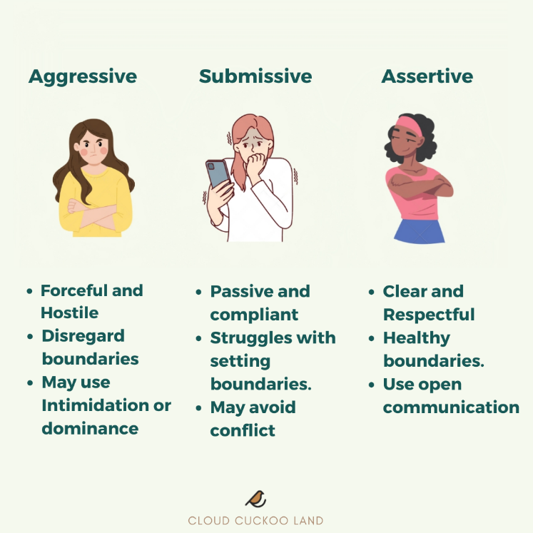
3.7 ASSERTIVENESS IN PROFESSIONAL COMMUNICATION AND DEVELOPMENT TECHNIQUES:
Assertiveness represents the foundation of effective professional communication, enabling individuals to express themselves authentically while maintaining respect for others and achieving organizational objectives. This communication approach builds stronger relationships, enhances leadership effectiveness, and creates positive organizational culture that supports collaboration and innovation. Developing assertive communication skills requires understanding both the underlying principles and practical techniques that can be applied across various professional situations.
The mastery of assertive communication techniques distinguishes high-performing professionals from their peers, contributing significantly to career advancement and organizational success. These skills become particularly valuable in leadership roles where influence and relationship management determine team effectiveness and business outcomes.
Core Principles of Assertive Communication: Assertive communication rests on fundamental beliefs about human dignity, mutual respect, and the importance of authentic self-expression in professional relationships. The principle of equal rights recognizes that all individuals deserve to express their thoughts, feelings, and needs regardless of organizational hierarchy or role differences. Personal responsibility involves owning one's communication choices and their consequences while avoiding blame and manipulation tactics that damage relationships. Honesty and transparency form the foundation of assertive interactions, requiring courage to express truth even when it may be uncomfortable or challenging for others to hear. Respect for others' perspectives demonstrates maturity and professionalism while creating environments where diverse viewpoints can be expressed and considered. Win-win orientation seeks solutions that address multiple parties' needs rather than zero-sum approaches that create winners and losers in professional relationships.
Verbal Techniques for Assertive Expression: Effective assertive communication employs specific verbal techniques that convey confidence while maintaining respect and openness to dialogue. "I" statements express personal perspectives and feelings without attacking or blaming others, reducing defensive responses and maintaining focus on issues rather than personalities. Clear, specific language eliminates ambiguity and ensures that messages are understood accurately, preventing misunderstandings that can lead to conflict or poor decision-making. Appropriate questioning techniques gather information and clarify understanding while demonstrating respect for others' viewpoints and expertise. Acknowledgment of others' positions shows respect even when disagreement exists, maintaining relationship quality while addressing substantive issues. Compromise and negotiation language indicates willingness to find mutually acceptable solutions rather than rigid adherence to initial positions that may prevent optimal outcomes.
Non-Verbal Communication Elements: Body language and vocal qualities significantly impact the effectiveness of assertive communication, often conveying more meaning than verbal content alone. Eye contact demonstrates confidence and sincerity while showing respect for the person being addressed, though cultural differences may require adjustment of intensity and duration. Posture should reflect openness and confidence without appearing aggressive or intimidating, maintaining appropriate distance and avoiding threatening gestures. Voice tone remains calm and steady, conveying conviction without emotional volatility that can escalate conflicts or reduce credibility. Facial expressions should align with verbal content, demonstrating authenticity and emotional intelligence that builds trust and rapport. Gestures can emphasize points and demonstrate engagement while avoiding movements that distract from the message or appear threatening to others.
Managing Difficult Conversations: Assertive communication becomes particularly valuable when addressing challenging topics or conflicts that could damage relationships or organizational effectiveness if handled poorly. Preparation involves clarifying objectives, anticipating potential responses, and identifying desired outcomes that serve both individual and organizational interests. Timing selection ensures that conversations occur when all parties can focus appropriately without excessive pressure or distraction that could interfere with effective communication. Opening statements should establish positive intent and mutual respect while introducing the topic clearly and directly. Active listening during responses demonstrates respect for others' perspectives while gathering information needed for effective problem-solving and relationship maintenance. Solution focus maintains emphasis on resolving issues rather than assigning blame or dwelling on past problems that cannot be changed.
Building Confidence Through Practice: Developing assertive communication skills requires systematic practice in progressively challenging situations that build competence and confidence over time. Low-risk situations provide opportunities to practice techniques without significant consequences, allowing for learning and adjustment of approaches. Role-playing exercises with trusted colleagues or mentors create safe environments for trying new approaches and receiving constructive feedback. Professional development programs offer structured learning and practice opportunities with expert guidance and peer support. Gradual application in more challenging situations builds confidence while minimizing risk of relationship damage or career consequences during the learning process. Self-reflection after assertive interactions helps identify what worked well and areas for continued improvement, accelerating skill development and increasing effectiveness.
Overcoming Common Barriers: Many professionals face internal and external barriers that prevent effective assertive communication despite understanding its importance and techniques. Fear of rejection or conflict often stems from past experiences or cultural conditioning that equates assertiveness with aggression or selfishness. Perfectionism can prevent attempts at assertive communication due to concerns about making mistakes or not handling situations flawlessly from the beginning. People-pleasing tendencies conflict with assertive expression of disagreement or personal needs, requiring conscious effort to balance relationship maintenance with authentic self-expression. Cultural background may influence comfort levels with direct communication, requiring adaptation of techniques while maintaining core assertive principles. Organizational culture sometimes discourages assertive communication, necessitating careful navigation and possible influence efforts to create more supportive environments for authentic expression and healthy conflict resolution.
3.8 BENEFITS OF ASSERTIVE COMMUNICATION AND PROFESSIONAL APPLICATIONS:
Assertive communication provides substantial benefits for individual career advancement and organizational effectiveness across various industries and professional contexts. These advantages extend beyond immediate interaction outcomes to influence long-term relationship quality, team performance, and organizational culture development. Understanding these benefits motivates continued skill development and provides rationale for organizational investment in communication training and development programs.
The implementation of assertive communication principles creates positive cycles of interaction that enhance both individual satisfaction and organizational performance. Professionals who master these skills often become informal leaders and positive influences within their organizations regardless of formal authority or position level.
Enhanced Professional Relationships: Assertive communication builds stronger, more authentic professional relationships characterized by mutual respect and trust. Colleagues appreciate the honesty and directness that eliminates guesswork and hidden agendas common in less effective communication styles. Conflict resolution improves significantly as issues are addressed directly before they escalate into major problems that damage relationships and affect team performance. Collaboration becomes more effective as team members feel safe expressing diverse viewpoints and concerns without fear of attack or dismissal. Mentoring relationships develop more naturally as assertive individuals both seek guidance appropriately and offer support to others without manipulation or excessive deference. Networking opportunities expand as authentic communication attracts others who value genuine professional relationships over superficial connections.
Increased Leadership Effectiveness: Leadership capabilities improve dramatically as assertive communication enables clear vision articulation, effective feedback delivery, and authentic relationship building with team members. Decision-making processes become more inclusive as team members contribute input freely, knowing their perspectives will be heard and considered respectfully. Performance management conversations become more productive as expectations are communicated clearly and feedback is delivered constructively without personal attack or excessive accommodation. Change management efforts succeed more frequently as leaders can address resistance honestly while maintaining relationship quality and team cohesion. Delegation becomes more effective as instructions are given clearly and follow-up occurs without micromanagement or neglect of accountability requirements.
Career Advancement Opportunities: Assertive communication accelerates career progression by increasing visibility, demonstrating leadership potential, and building supportive networks that facilitate advancement opportunities. Performance evaluations improve as accomplishments are communicated effectively and development needs are discussed honestly with supervisors. Promotional opportunities are pursued more successfully as candidates can articulate their qualifications confidently while addressing concerns or limitations honestly. Salary negotiations become more effective as compensation discussions are approached professionally with clear documentation of value provided and market research supporting requests. Professional recognition increases as contributions are communicated appropriately without excessive modesty or aggressive self-promotion that alienates colleagues and supervisors.
Improved Stress Management: Assertive communication reduces workplace stress by addressing issues directly before they become overwhelming problems that affect performance and well-being. Boundary setting prevents excessive workload and unreasonable demands that lead to burnout and reduced effectiveness over time. Conflict situations are resolved more quickly and completely, eliminating ongoing tension and anxiety that can affect physical and mental health. Work-life balance improves as personal needs and limitations are communicated clearly to supervisors and colleagues who can then adjust expectations appropriately. Emotional regulation becomes more effective as authentic expression prevents buildup of resentment and frustration that can explode inappropriately or create chronic stress conditions.
Enhanced Team Performance: Teams benefit significantly when members communicate assertively, creating environments characterized by open dialogue, creative problem-solving, and mutual support. Information sharing improves as team members express concerns, suggestions, and ideas freely without fear of judgment or retaliation. Decision-making becomes more effective as diverse perspectives are heard and integrated into solutions that address multiple stakeholder needs. Innovation increases as creative ideas are shared and built upon collaboratively rather than withheld due to fear or excessive deference to authority. Accountability improves as expectations are communicated clearly and performance issues are addressed directly before they impact team effectiveness and morale.
Organizational Culture Impact: Organizations benefit from assertive communication as it creates cultures of honesty, respect, and continuous improvement that support business success and employee satisfaction. Customer service improves as employees can address concerns directly while maintaining positive relationships and finding solutions that meet client needs. Quality standards increase as problems are identified and addressed quickly rather than hidden or ignored due to fear of negative consequences. Innovation and adaptation accelerate as diverse viewpoints are expressed and considered in strategic planning and operational decision-making processes. Employee engagement increases as individuals feel heard and valued, leading to reduced turnover and increased productivity across all organizational levels.
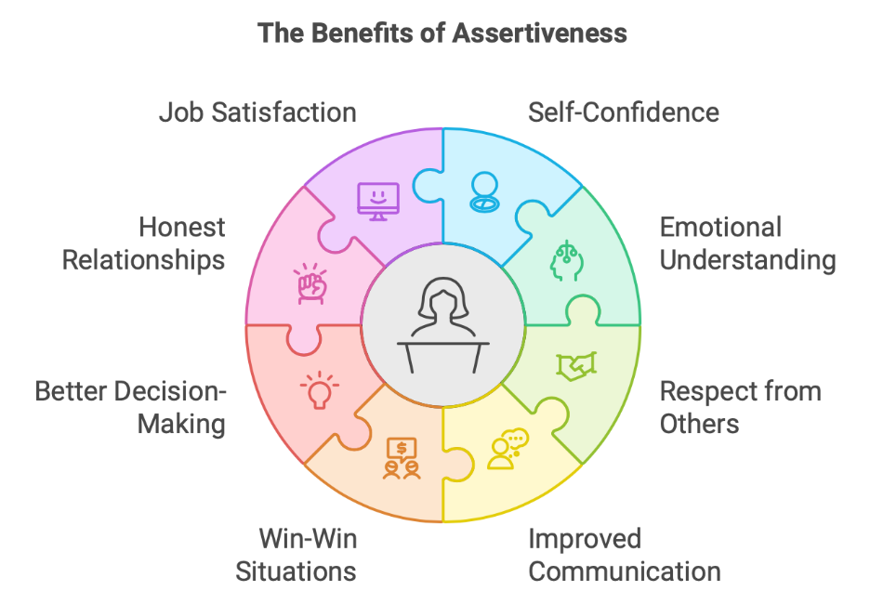
3.9 LATERAL THINKING APPROACHES IN PROFESSIONAL PROBLEM-SOLVING:
Lateral thinking represents a systematic approach to generating creative solutions and alternative perspectives that transcend conventional problem-solving methods. This cognitive technique, developed by Edward de Bono, encourages individuals to explore unconventional approaches and challenge assumptions that may limit innovative thinking. In professional contexts, lateral thinking enhances decision-making capabilities and enables breakthrough solutions to complex business challenges.
The application of lateral thinking techniques in professional environments fosters innovation, improves team creativity, and develops competitive advantages through unique approaches to common business problems. Organizations that encourage lateral thinking often experience increased adaptability and improved problem-solving capabilities across all functional areas.
Understanding Lateral Thinking Principles: Lateral thinking operates on the principle that traditional logical thinking, while valuable, can create mental patterns that limit creative exploration and innovative problem-solving. This approach deliberately seeks alternatives to obvious solutions by challenging assumptions and exploring seemingly unrelated concepts that might provide fresh insights. The technique involves suspending judgment temporarily to allow exploration of ideas that might initially appear impractical or irrelevant. Pattern disruption becomes a deliberate strategy for escaping habitual thought processes that may prevent recognition of better solutions. Random stimulation techniques introduce unrelated elements to spark new connections and perspectives that might not emerge through conventional analysis. The goal involves generating multiple alternatives rather than finding the single "right" answer, expanding the range of possibilities before evaluation and selection occur.
Practical Techniques for Professional Application: Several specific techniques enable professionals to apply lateral thinking principles effectively in workplace situations and business problem-solving contexts. The "random word" technique involves selecting an unrelated word or concept and exploring connections between it and the problem being addressed, often revealing unexpected insights or approaches. "Provocation" involves deliberately proposing ideas that seem impossible or impractical to stimulate thinking in new directions that might lead to feasible solutions. "Alternative uses" thinking explores unusual applications for existing resources, products, or processes that might provide competitive advantages or cost savings. "Assumption reversal" involves identifying and deliberately contradicting fundamental assumptions about problems to reveal new possibilities that conventional thinking might miss. "Six Thinking Hats" provides a structured approach to examining problems from multiple perspectives including emotional, logical, creative, and critical viewpoints that enhance comprehensive analysis.
Application in Team Problem-Solving: Lateral thinking techniques become particularly powerful when applied in team settings where diverse perspectives and experiences can build upon creative insights generated through structured processes. Brainstorming sessions benefit from lateral thinking rules that encourage wild ideas and building upon others' suggestions without immediate evaluation or criticism. Problem definition exercises use lateral thinking to ensure teams address root causes rather than symptoms, preventing solutions that fail to resolve underlying issues. Solution generation becomes more creative as teams explore multiple approaches before converging on preferred alternatives, increasing the likelihood of innovative and effective outcomes. Implementation planning benefits from lateral thinking approaches that anticipate unexpected obstacles and develop creative contingency plans that maintain project momentum. Continuous improvement processes use lateral thinking to identify opportunities for innovation and efficiency that conventional analysis might overlook completely.
Overcoming Mental Barriers: Lateral thinking helps professionals overcome common mental barriers that limit creative problem-solving and innovative thinking in workplace environments. Functional fixedness, which limits perception of alternative uses for familiar tools or processes, is addressed through systematic exploration of unconventional applications and approaches. Confirmation bias, which leads to seeking information that supports existing beliefs while ignoring contradictory evidence, is countered by deliberately seeking alternative perspectives and challenging initial assumptions. Pattern recognition, while generally helpful, can become limiting when it prevents consideration of novel approaches that don't fit established mental models or previous successful solutions. Risk aversion may prevent exploration of innovative approaches due to fear of failure, but lateral thinking provides low-risk methods for testing creative ideas before full implementation.
Innovation and Competitive Advantage: Organizations that systematically apply lateral thinking approaches often develop significant competitive advantages through innovative products, services, and processes that distinguish them from competitors. Product development benefits from lateral thinking techniques that identify unmet customer needs and create solutions that transcend traditional category boundaries or functional limitations. Service delivery improvements emerge from exploring alternative approaches to customer interaction and problem resolution that enhance satisfaction while reducing costs. Process innovation occurs when lateral thinking reveals more efficient or effective methods for accomplishing organizational objectives and delivering value to stakeholders. Market positioning strategies benefit from lateral thinking approaches that identify unique value propositions and differentiation strategies that competitors find difficult to replicate.
Integration with Traditional Analysis: Lateral thinking complements rather than replaces traditional analytical approaches, creating comprehensive problem-solving methodologies that combine creativity with rigorous evaluation and implementation planning. Initial problem exploration uses lateral thinking to generate multiple perspectives and potential solutions that expand the range of possibilities being considered. Feasibility analysis applies traditional logical thinking to evaluate creative alternatives based on practical constraints, resource requirements, and potential outcomes. Cost-benefit analysis examines the financial and strategic implications of innovative solutions to ensure they provide appropriate value relative to implementation requirements. Risk assessment considers potential negative consequences of creative approaches while identifying mitigation strategies that enable safe implementation of promising innovations.
TABLE 3.4:
Thinking Approach | Best Applications | Key Techniques | Professional Benefits
Logical Analysis | Well-defined problems with clear parameters and established solution methods | Sequential reasoning, data analysis, cause-effect relationships | Reliable, systematic solutions with predictable outcomes and proven effectiveness
Lateral Thinking | Complex, ambiguous problems requiring innovative approaches and breakthrough solutions | Random stimulation, assumption challenging, pattern disruption | Creative alternatives, competitive advantage, breakthrough innovations
Hybrid Approach | Strategic challenges requiring both innovation and practical implementation | Lateral generation followed by logical evaluation and systematic execution | Optimal solutions that balance creativity with feasibility and organizational requirements
Intuitive Thinking | Situations requiring rapid decisions with incomplete information | Pattern recognition, experience-based judgment, emotional intelligence | Quick responses and relationship-sensitive solutions in dynamic environments
Systems Thinking | Complex organizational challenges with multiple stakeholders and interdependent factors | Holistic analysis, feedback loops, stakeholder mapping | Comprehensive solutions that address root causes and unintended consequences

Revision Questions:
Short Answer Questions:
- Define self-esteem and explain its three core components in professional contexts.
- List five behavioral symptoms that indicate healthy self-esteem in workplace settings.
- What are the main differences between assertive and aggressive communication styles?
- Explain the concept of lateral thinking and provide two practical techniques.
- Describe three specific benefits of positive self-esteem for career advancement.
Long Answer Questions:
- Analyze the relationship between self-esteem levels and leadership effectiveness, discussing how positive and negative self-esteem impact team performance and organizational culture.
- Evaluate the role of assertive communication in conflict resolution, examining specific techniques and their applications in professional disagreements and negotiations.
- Discuss the integration of lateral thinking approaches with traditional analytical methods in strategic business problem-solving and decision-making processes.
- Examine the development process for building positive self-esteem in professional settings, including specific strategies, common barriers, and measurement approaches.
- Compare and contrast the long-term career implications of different communication styles, analyzing their impact on professional relationships, advancement opportunities, and organizational contribution.
Case Studies:
Case Study 1: The Promotion Dilemma
Sarah Martinez has worked as a marketing analyst at Global Consumer Products for three years, consistently delivering high-quality work and receiving positive performance evaluations. Her supervisor, Jennifer Kim, recently approached her about applying for a marketing manager position that has become available. The role would involve managing a team of four analysts and leading strategic marketing initiatives for the company's largest product line.
Despite her qualifications and Jennifer's encouragement, Sarah feels uncertain about pursuing the opportunity. She worries that she lacks the necessary leadership experience and fears that managing former peers might create conflicts. Sarah has observed that the previous marketing manager, David Chen, was very assertive and sometimes aggressive in meetings, which made her uncomfortable. She wonders if she needs to adopt a similar communication style to be successful in the role.
Sarah's colleagues have mixed opinions about her potential promotion. Two coworkers, Mike Thompson and Lisa Rodriguez, have expressed support and offered to help with her transition if she gets the position. However, another colleague, Robert Jackson, made comments suggesting that the role might be "too much responsibility" for someone with Sarah's background. These comments have increased Sarah's self-doubt and made her question whether she should pursue the opportunity.
The application deadline is approaching, and Sarah must decide whether to submit her materials. She recognizes that this represents a significant career advancement opportunity, but her internal dialogue is filled with negative self-talk about her capabilities and worthiness for the position. Jennifer has offered to provide mentoring and support during the transition period, but Sarah remains hesitant about taking on increased responsibility and potential failure.
During a recent team meeting, Sarah had an idea for improving the current marketing campaign's effectiveness, but she didn't share it because she assumed others wouldn't find it valuable. Later, she learned that the team spent significant time developing a similar concept, and her early insight could have saved considerable effort. This experience highlighted both her analytical capabilities and her tendency to undervalue her contributions.
Sarah's husband encourages her to apply for the position, pointing out her track record of success and natural leadership qualities he has observed in community volunteer activities. However, Sarah's mother expresses concern about the additional stress and time commitments, suggesting that Sarah should "be satisfied with her current role" rather than risk failure in a more demanding position. These conflicting external messages add to Sarah's confusion about the best course of action.
The marketing manager position would require Sarah to present monthly performance reports to senior leadership, negotiate with external vendors, and make strategic recommendations that could significantly impact company revenue. She has the technical skills and knowledge required for these responsibilities but lacks confidence in her ability to influence others and navigate potential conflicts that might arise in a leadership role.
Case Study 2: The Team Conflict Resolution Challenge
David Park serves as project manager for a critical software development initiative at TechForward Solutions, leading a team of six developers with diverse backgrounds and working styles. The project, which involves creating a new customer relationship management system, has fallen behind schedule due to ongoing conflicts between team members that have escalated over the past month.
The primary conflict involves two senior developers: Emma Thompson and Carlos Rodriguez. Emma prefers detailed planning and extensive documentation before beginning development work, while Carlos advocates for agile approaches with minimal upfront planning and iterative development cycles. Their disagreements have become personal, with Emma describing Carlos as "reckless and unprofessional" and Carlos calling Emma "inflexible and outdated in her thinking."
The conflict has divided the team, with newer developers feeling pressured to choose sides rather than focusing on project deliverables. Team meetings have become unproductive, with Emma and Carlos interrupting each other frequently and dismissing alternative viewpoints. Other team members have begun avoiding participation in discussions to prevent being drawn into the conflict, reducing the team's overall creativity and problem-solving effectiveness.
David recognizes that his own communication style has contributed to the problem. He tends to avoid confrontation and has been hoping that the conflict would resolve itself naturally over time. When tensions escalated during a recent meeting, David responded by changing the subject rather than addressing the underlying issues directly. His attempts to maintain harmony have actually enabled the conflict to worsen and affect project progress.
The organization's culture emphasizes collaboration and innovation, but David has not received formal training in conflict resolution or assertive communication techniques. He worries that addressing the conflict directly might make the situation worse or cause team members to view him as taking sides. However, he also recognizes that continued avoidance is jeopardizing project success and team morale.
Senior management has begun asking questions about the project delays, and David knows he must address the team dynamics soon to prevent further schedule slippage. The client has expressed concern about missed milestones and is considering contract modifications that could affect the company's reputation and future business opportunities. David feels caught between protecting his team members and delivering on organizational commitments.
Emma has approached David privately to request that Carlos be removed from the project, claiming that his approach is undermining quality standards and creating technical debt that will cause problems later. Carlos has made similar private complaints about Emma, suggesting that her methods are slowing progress and preventing the team from adapting to changing requirements effectively. Both team members have valid points, but their inability to communicate respectfully is preventing collaborative problem-solving.
David has considered implementing structured team-building activities or bringing in an external facilitator to help resolve the conflict. However, budget constraints and project timelines limit his options for extensive interventions. He must find practical approaches that can be implemented quickly while maintaining focus on project deliverables and deadline commitments. The situation requires both immediate conflict resolution and longer-term strategies for preventing similar issues in future projects.
Case Study 3: The Innovation Challenge
Maria Rodriguez leads the product development team at Creative Solutions Inc., a mid-sized consulting firm specializing in business process improvement for manufacturing companies. The company has been successful using traditional analytical approaches to identify efficiency opportunities and cost reduction strategies for clients. However, recent market research indicates that competitors are gaining advantage through innovative service offerings and creative problem-solving methodologies.
The company's CEO, James Wilson, has challenged Maria's team to develop breakthrough approaches that will differentiate Creative Solutions from competitors and attract new clients in emerging market segments. Traditional consulting methods are becoming commoditized, and clients increasingly expect innovative solutions that go beyond standard process optimization and cost-cutting recommendations.
Maria's team consists of five experienced consultants who are highly skilled in analytical thinking and proven methodologies. However, they have become comfortable with established approaches and show resistance to exploring unconventional problem-solving techniques. During brainstorming sessions, team members tend to converge quickly on familiar solutions rather than exploring creative alternatives that might provide greater value to clients.
The team's most recent client engagement illustrates the challenge. Manufacturing Plus, a automotive parts supplier, requested help improving their production scheduling system. Maria's team conducted thorough analysis and provided detailed recommendations for software upgrades and process modifications. However, a competitor subsequently proposed an innovative approach involving predictive analytics and artificial intelligence integration that excited the client and won a larger contract.
Maria recognizes that her team needs to develop lateral thinking capabilities and creative problem-solving skills to remain competitive. However, she faces resistance from team members who worry that unfamiliar approaches might lead to client dissatisfaction or project failures. Senior consultant Robert Chen expressed concern that "experimental methods" could damage the company's reputation for reliable, proven solutions.
The pressure for innovation creates tension within the team, as members struggle to balance creative exploration with the need for practical, implementable recommendations. Junior consultant Lisa Park has suggested incorporating design thinking workshops and lateral thinking exercises into client engagements, but senior team members question whether clients would value such approaches or view them as unnecessary complications.
Time pressures from client deadlines leave little opportunity for experimentation and skill development. Maria must find ways to build innovation capabilities while maintaining current project commitments and quality standards. The company's training budget is limited, and team members already work long hours on client projects, making it difficult to invest time in developing new competencies.
Maria herself feels conflicted about embracing radical changes to proven methodologies that have built the company's reputation and success. She understands the need for innovation but worries about the risks of implementing unfamiliar approaches with important clients. The challenge involves transforming team culture and capabilities while preserving the analytical rigor and professional standards that clients expect from Creative Solutions.
Recent industry conference presentations have highlighted examples of consulting firms using gamification, scenario planning, and collaborative innovation techniques to deliver exceptional value to clients. Maria sees opportunities to integrate these approaches with traditional analytical methods, but she needs to develop team buy-in and competency before proposing changes to client engagement models.
Fun Activity: The Self-Esteem and Communication Style Assessment Game
Objective: Help participants identify their current self-esteem levels and communication patterns while practicing assertive communication techniques in a supportive, engaging environment.
Setup and Materials:
Divide participants into groups of 4-5 people
Provide each group with scenario cards, role-play props, and assessment worksheets
Create a comfortable space with moveable chairs and tables for small group discussions
Prepare flip chart paper and markers for group presentations
Game Mechanics: Each group receives a set of workplace scenario cards representing common professional situations requiring assertive communication. Participants take turns role-playing different characters while others observe and provide feedback. Scenarios include performance reviews, team meetings, client interactions, and conflict resolution situations.
The game progresses through three rounds: identification (recognizing communication styles), practice (trying assertive approaches), and integration (combining techniques with personal strengths). Points are awarded for accurate identification of communication styles, creative problem-solving approaches, and supportive feedback to team members.
Round One - Style Recognition: Participants observe brief role-plays and identify whether communication styles are assertive, aggressive, or submissive. Discussion follows each scenario to explore the impact of different approaches on relationships and outcomes. Groups earn points for accurate identification and thoughtful analysis of communication effectiveness.
Round Two - Assertive Practice: Using the same scenarios, participants practice assertive responses while incorporating lateral thinking techniques to generate creative solutions. Team members provide coaching and encouragement, creating supportive environment for trying new approaches. Points are awarded for effort, creativity, and appropriate use of assertive communication principles.
Round Three - Personal Integration: Participants reflect on their own communication patterns and develop action plans for applying assertive techniques in their specific professional contexts. Groups share insights and commit to supporting each other's development efforts. Final scoring includes self-assessment accuracy and quality of personal development planning.
The activity concludes with group presentations of key insights and commitment to specific behavioral changes that will enhance professional effectiveness and relationship quality. Participants leave with practical tools and supportive peer networks for continued development.

**********
4
LEADERSHIP AND TEAM DYNAMICS
INTRODUCTION:
The contemporary business environment demands leaders who can navigate complex organizational structures while building cohesive teams that deliver exceptional results. This unit explores the fundamental principles of leadership development and team dynamics, examining how effective leaders create environments that foster collaboration, innovation, and high performance. Understanding these concepts enables professionals to develop the skills necessary for leading diverse teams and managing organizational challenges.
Leadership effectiveness in modern organizations depends on the ability to inspire others, manage conflicts constructively, and negotiate solutions that benefit all stakeholders. The integration of team building principles with conflict management and negotiation skills creates a comprehensive framework for organizational success. These competencies become increasingly important as businesses face rapid change, global competition, and evolving workforce expectations.
The concepts presented in this unit provide practical tools for developing leadership capabilities and building effective teams. Students will learn to identify different leadership styles, understand team development processes, and master conflict resolution techniques. The focus on character building and negotiation skills ensures that future leaders can maintain ethical standards while achieving organizational objectives through collaborative approaches.
4.1 TEAM BUILDING: MEANING, TYPES, AND ORGANIZATIONAL IMPORTANCE:
Team building represents a systematic approach to developing collaborative relationships and improving group performance within organizational settings. This process involves deliberate activities and interventions designed to enhance communication, build trust, and align individual efforts with team objectives. Effective team building creates foundations for sustained high performance while addressing interpersonal dynamics that can either support or hinder organizational success.
The strategic importance of team building extends beyond immediate performance improvements to encompass long-term organizational culture development and competitive advantage creation. Organizations that invest systematically in team building often experience enhanced employee engagement, reduced turnover, and improved customer satisfaction as teams work more effectively together.
Definition and Core Elements: Team building encompasses all activities and processes designed to improve team effectiveness, communication, and collaborative performance within organizational contexts. This systematic approach focuses on developing shared understanding of goals, roles, and expectations while building interpersonal relationships that support productive working partnerships. The process involves identifying team strengths and weaknesses, addressing communication barriers, and creating structures that enable effective collaboration. Team building activities range from formal workshops and retreats to ongoing developmental interventions that address specific performance challenges. The goal extends beyond temporary motivation to create lasting behavioral changes that improve team dynamics and organizational results. Effective team building integrates task-focused activities with relationship-building exercises to address both performance requirements and interpersonal dynamics that influence team success.
Types of Team Building Approaches: Various team building methodologies address different aspects of team performance and organizational needs, allowing leaders to select approaches that match specific challenges and objectives. Problem-solving focused team building addresses specific business challenges or operational issues while building collaborative problem-solving capabilities and team cohesion. Communication-centered approaches improve information sharing, active listening skills, and interpersonal understanding among team members with different backgrounds and working styles. Trust-building activities create psychological safety and mutual confidence that enables risk-taking, honest feedback, and authentic collaboration in challenging situations. Role clarification exercises define individual responsibilities, decision-making authority, and interdependencies that prevent confusion and conflict while improving coordination. Goal-setting team building aligns individual objectives with team targets and organizational priorities, ensuring that all efforts contribute to shared success.
Organizational Benefits and Outcomes: Systematic team building initiatives generate measurable benefits that enhance organizational performance and competitive positioning in the marketplace. Productivity improvements result from better coordination, reduced duplication of effort, and more effective utilization of individual strengths and capabilities. Quality enhancements occur as teams develop shared standards, peer accountability, and collaborative problem-solving approaches that prevent errors and improve outcomes. Innovation increases when teams create environments that encourage creative thinking, experimentation, and building upon diverse perspectives and experiences. Employee satisfaction improves through stronger relationships, clearer role expectations, and increased sense of contribution to meaningful organizational objectives. Retention rates increase as team building creates supportive work environments where individuals feel valued, challenged, and connected to colleagues and organizational mission.
Implementation Strategies and Best Practices: Successful team building requires careful planning, systematic implementation, and ongoing reinforcement to create lasting behavioral changes and performance improvements. Assessment of current team dynamics identifies specific strengths to leverage and challenges to address through targeted interventions and developmental activities. Customized approaches align team building activities with organizational culture, team composition, and specific performance objectives rather than applying generic solutions. Leadership involvement demonstrates commitment and provides modeling of desired behaviors while ensuring that team building initiatives align with broader organizational priorities. Follow-up activities reinforce learning and behavioral changes while providing opportunities to address new challenges and continue team development over time. Measurement and evaluation track progress toward objectives and identify areas requiring additional attention or different approaches to achieve desired outcomes.
Overcoming Common Challenges: Team building initiatives often encounter obstacles that can limit effectiveness unless addressed proactively through careful planning and adaptive implementation strategies. Resistance to participation may stem from previous negative experiences, skepticism about benefits, or concerns about time investment, requiring clear communication about objectives and voluntary participation when possible. Cultural differences within diverse teams require sensitivity to varying communication styles, values, and expectations while finding common ground that supports collaboration. Time constraints and competing priorities necessitate integration of team building with regular work activities rather than separate events that may seem disconnected from business objectives. Personality conflicts and existing tensions require skilled facilitation and possibly individual coaching to address underlying issues before group activities can be effective. Sustaining momentum beyond initial activities requires ongoing reinforcement, regular check-ins, and adaptation of approaches based on changing team needs and organizational circumstances.
Technology Integration and Virtual Teams: Modern team building must address the reality of distributed teams, remote work, and technology-mediated collaboration that characterizes contemporary organizational structures. Virtual team building activities utilize online platforms and digital tools to create engaging experiences that build relationships and improve collaboration despite physical distance. Communication technology training helps team members effectively use collaboration platforms, video conferencing, and project management systems that support distributed teamwork. Digital trust-building addresses unique challenges of virtual relationships where non-verbal communication is limited and informal interaction opportunities are reduced. Hybrid team approaches accommodate teams with both co-located and remote members, ensuring that all team members feel included and can contribute effectively regardless of location. Technology-supported measurement and feedback systems track team performance and dynamics in virtual environments while providing data for continuous improvement of team building approaches.
4.2 CREATING EFFECTIVE TEAMS AND UNDERSTANDING TEAM DYNAMICS:
Creating effective teams requires understanding the complex interpersonal, organizational, and task-related factors that influence group performance and collaboration. Team dynamics encompass all interactions, relationships, and processes that occur within teams as they work toward common objectives. Mastering these concepts enables leaders to design team structures, manage team development processes, and intervene effectively when teams face challenges.
The science of team effectiveness reveals that high-performing teams share certain characteristics while adapting their approaches to specific contexts, challenges, and organizational environments. Understanding these patterns provides frameworks for team design, development, and management that can be applied across various industries and organizational settings.
Essential Components of Team Effectiveness: High-performing teams demonstrate consistent patterns of behavior and structure that enable sustained success across different challenges and organizational contexts. Clear purpose and shared objectives provide direction and motivation while enabling team members to align individual efforts with collective goals and organizational priorities. Defined roles and responsibilities prevent confusion and overlap while ensuring that all necessary functions are covered and team members understand their contributions to overall success. Effective communication processes enable information sharing, decision-making, and conflict resolution while building relationships that support collaboration and mutual support. Trust and psychological safety create environments where team members can express ideas freely, admit mistakes without fear, and take appropriate risks that advance team objectives. Mutual accountability ensures that all team members meet commitments and support collective success rather than focusing solely on individual performance and recognition.
Team Development Stages and Processes: Teams evolve through predictable developmental stages that require different leadership approaches and interventions to support continued progress toward high performance. Forming stages involve initial team assembly where members become acquainted, establish basic ground rules, and begin understanding team objectives and individual roles. Storming periods feature conflict and competition as team members test boundaries, challenge leadership, and work through different perspectives and approaches to team objectives. Norming phases establish working agreements, communication patterns, and collaborative approaches that enable effective teamwork and mutual support. Performing stages demonstrate high productivity, effective collaboration, and ability to adapt to challenges while maintaining focus on objectives and supporting individual and team development. Understanding these stages enables leaders to provide appropriate support, intervention, and resources that facilitate team development and prevent common pitfalls.
Managing Team Composition and Diversity: Effective teams balance diversity with cohesion, leveraging different perspectives and capabilities while maintaining alignment and collaborative working relationships. Skill diversity ensures that teams possess all competencies necessary for task completion while providing opportunities for cross-training and knowledge sharing among team members. Cognitive diversity brings different thinking styles, problem-solving approaches, and creative perspectives that enhance innovation and prevent groupthink that can limit team effectiveness. Demographic diversity including age, gender, cultural background, and experience provides broader perspectives while requiring attention to inclusion and communication patterns that support all team members. Personality diversity balances different working styles, communication preferences, and motivational factors while requiring careful management to prevent conflict and ensure productive collaboration. The key involves leveraging diversity benefits while building shared understanding and collaborative working relationships that enable team success.
Communication Patterns and Information Flow: Team effectiveness depends heavily on communication systems that support information sharing, decision-making, and relationship maintenance among all team members. Formal communication structures define reporting relationships, meeting schedules, and information sharing protocols that ensure all team members have access to necessary information for effective performance. Informal communication networks build relationships and enable rapid information sharing that supports both task completion and team cohesion through spontaneous interaction and collaboration. Feedback systems provide regular input on individual and team performance while enabling continuous improvement and adaptation to changing circumstances and requirements. Decision-making processes clarify authority, involve appropriate team members, and ensure that decisions are communicated effectively and implemented consistently. Conflict resolution mechanisms address disagreements constructively while maintaining relationships and team focus on shared objectives.
Performance Management and Accountability: High-performing teams establish systems that monitor progress, maintain accountability, and support continuous improvement in both individual and collective performance. Goal setting processes align individual objectives with team targets while providing clear metrics for measuring progress and success across all dimensions of team performance. Regular review meetings track progress toward objectives while identifying obstacles, resource needs, and opportunities for improvement or adaptation of approaches. Peer feedback systems enable team members to support each other's development while maintaining accountability for commitments and performance standards. Recognition and celebration activities acknowledge both individual contributions and team achievements while reinforcing behaviors that support continued high performance. Corrective action processes address performance issues promptly and fairly while maintaining team cohesion and focus on shared objectives and organizational priorities.
Adaptation and Continuous Improvement: Effective teams maintain flexibility and learning orientation that enables adaptation to changing circumstances while continuously improving their collaborative capabilities and performance outcomes. Environmental scanning identifies external factors that may affect team performance while enabling proactive adaptation rather than reactive responses to changing circumstances. Process evaluation examines team working methods, communication patterns, and decision-making approaches while identifying opportunities for improvement and increased effectiveness. Learning integration incorporates insights from both successes and failures into improved approaches while building team knowledge and capability for future challenges. Innovation cultivation encourages experimentation with new approaches while maintaining focus on objectives and learning from both successful and unsuccessful attempts. Change management capabilities enable teams to adapt roles, processes, and objectives in response to organizational needs while maintaining team cohesion and performance levels.
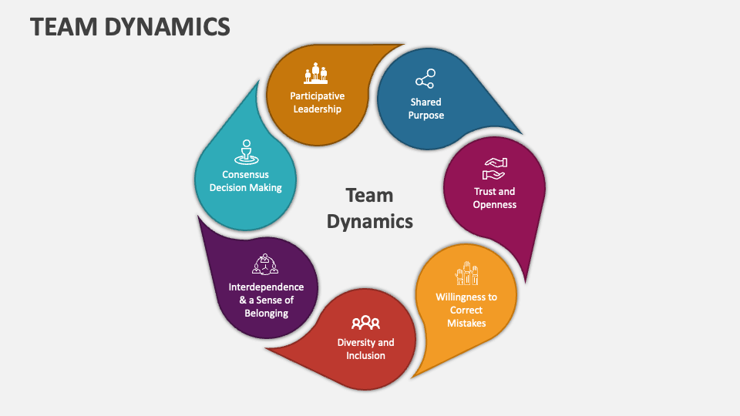
4.3 LEADERSHIP: DEFINITION, STYLES, AND THEORETICAL FRAMEWORKS:
Leadership represents the ability to influence, inspire, and guide individuals and groups toward achieving common objectives while developing their capabilities and maintaining organizational values. This complex phenomenon encompasses personal characteristics, behavioral patterns, and situational factors that enable individuals to create positive change and drive performance improvements. Understanding leadership theory and practice provides foundation for developing effective leadership capabilities and applying appropriate approaches across different contexts.
The evolution of leadership theory reflects growing understanding of the complexity and contextual nature of effective leadership, moving from trait-based approaches to situational and transformational models that emphasize adaptability and relationship building. Modern leadership frameworks integrate multiple perspectives to provide comprehensive guidance for leadership development and application.
Defining Leadership and Core Functions: Leadership involves the process of influencing others to achieve common goals while developing individual and organizational capabilities through inspiration, guidance, and support. This multifaceted role requires vision creation and communication that provides direction and motivation while aligning individual efforts with organizational objectives. Decision-making responsibilities involve analyzing complex situations, considering multiple perspectives, and choosing courses of action that advance both short-term performance and long-term sustainability. Change management capabilities enable leaders to guide organizations through transitions while maintaining stability and helping individuals adapt to new circumstances and requirements. People development functions focus on building individual and team capabilities while providing coaching, feedback, and growth opportunities that enhance organizational capacity. Relationship building creates networks of trust and collaboration that enable effective communication, problem-solving, and achievement of shared objectives across organizational boundaries.
Traditional Leadership Styles and Applications: Different leadership styles reflect various approaches to influencing others and managing organizational activities, each with specific strengths and appropriate applications in different contexts. Autocratic leadership involves centralized decision-making and direct control over subordinate activities, most effective in crisis situations or when quick decisions are required without extensive consultation. Democratic leadership emphasizes participation and collaboration in decision-making processes, building commitment and utilizing diverse perspectives while taking more time to reach consensus. Laissez-faire approaches provide minimal direction and allow subordinates significant autonomy, most effective with highly skilled and motivated individuals who require little supervision. Transactional leadership focuses on exchanges between leaders and followers, using rewards and consequences to motivate performance according to established standards and expectations. Each style has appropriate applications based on situational factors including follower readiness, task requirements, and organizational culture.
Contemporary Leadership Theories: Modern leadership theories address the complexity and dynamic nature of leadership in contemporary organizational environments, emphasizing relationships, transformation, and adaptation. Transformational leadership focuses on inspiring and motivating followers to achieve exceptional performance while developing their capabilities and commitment to organizational vision and values. Situational leadership emphasizes adapting leadership style to match follower development levels and task requirements, recognizing that effective leadership varies based on circumstances and individual needs. Authentic leadership emphasizes self-awareness, relational transparency, and ethical behavior while building trust and credibility through consistent actions that align with stated values. Servant leadership prioritizes serving others and developing their capabilities while achieving organizational objectives through empowerment and support rather than control. These approaches recognize that effective leadership requires flexibility, emotional intelligence, and commitment to both performance and people development.
Leadership Competencies and Skills: Effective leadership requires development of specific competencies that enable influence, relationship building, and organizational achievement across various contexts and challenges. Communication skills enable clear vision articulation, active listening, and persuasive interaction that builds understanding and commitment among diverse stakeholders. Emotional intelligence encompasses self-awareness, self-regulation, empathy, and social skills that enable effective relationship management and adaptive responses to complex interpersonal dynamics. Strategic thinking capabilities involve analyzing complex situations, identifying opportunities and threats, and developing plans that align resources with objectives while anticipating future challenges. Problem-solving skills enable creative analysis of challenges while developing innovative solutions that address root causes rather than symptoms. These competencies can be developed through training, coaching, experience, and deliberate practice in various leadership situations.
Cultural and Contextual Considerations: Leadership effectiveness varies across cultures, organizational contexts, and situational factors that influence what approaches will be most successful and appropriate. Cultural dimensions including power distance, individualism, uncertainty avoidance, and time orientation affect expectations about leadership behavior and follower responses to different approaches. Organizational culture influences the acceptability and effectiveness of various leadership styles while providing context for understanding what behaviors will be supported and rewarded. Industry characteristics including rate of change, regulatory environment, and competitive dynamics affect leadership requirements and the skills most critical for success. Generational differences in values, communication preferences, and work expectations require adaptive leadership approaches that can engage and motivate diverse workforce populations. Understanding these factors enables leaders to adapt their approaches while maintaining authenticity and effectiveness across different contexts.
Leadership Development and Assessment: Effective leadership development requires systematic approaches that build competencies while providing opportunities to practice and refine skills in various contexts. Self-assessment tools help identify current strengths and development needs while providing baseline measurements for tracking improvement over time. 360-degree feedback provides perspectives from supervisors, peers, and subordinates while offering comprehensive insights into leadership effectiveness and impact. Coaching relationships provide personalized guidance and support while helping leaders develop specific competencies and navigate challenging situations. Action learning projects combine skill development with real business challenges while providing opportunities to practice leadership in meaningful contexts. These approaches work best when integrated into comprehensive development programs that provide ongoing support and reinforcement of learning.
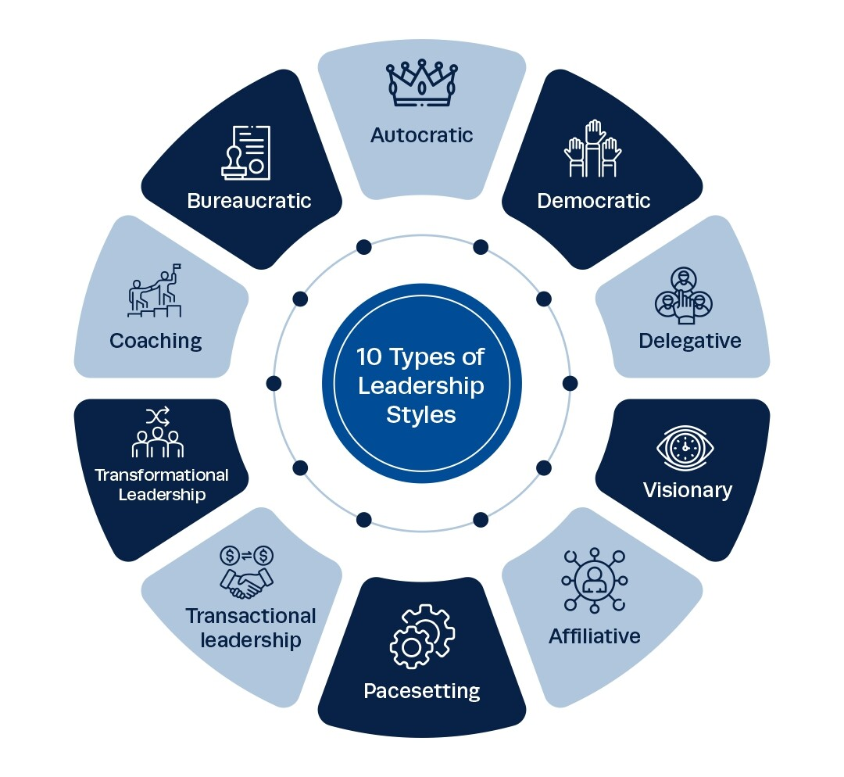
4.4 QUALITIES OF EFFECTIVE LEADERS AND CHARACTER DEVELOPMENT:
Effective leadership emerges from a combination of personal qualities, developed competencies, and character traits that enable individuals to inspire trust, drive performance, and create positive organizational change. These qualities can be developed through deliberate effort, experience, and commitment to continuous improvement. Understanding the essential characteristics of effective leaders provides a framework for personal development and leadership assessment.
Character development represents the foundation of sustainable leadership effectiveness, as technical skills and knowledge must be supported by integrity, ethical behavior, and authentic relationships. Organizations increasingly recognize that character-based leadership creates more sustainable success than approaches focused solely on results without attention to values and relationships.
Core Personal Qualities and Traits: Effective leaders demonstrate consistent personal qualities that enable them to build trust, influence others, and maintain effectiveness across various challenges and circumstances. Integrity forms the foundation of leadership credibility, involving consistent alignment between stated values and actions while maintaining ethical standards even under pressure. Emotional stability enables leaders to remain calm and focused during crises while providing reassurance and clear thinking when others may be anxious or confused. Self-confidence allows leaders to make difficult decisions and take appropriate risks while inspiring confidence in others through their conviction and determination. Resilience enables recovery from setbacks and failures while maintaining optimism and continuing to move forward despite obstacles and disappointments. These qualities create the personal foundation that enables other leadership competencies to be effective and sustainable over time.
Interpersonal Effectiveness and Relationship Building: Leadership success depends heavily on the ability to build and maintain positive relationships with diverse individuals and groups across organizational levels and external boundaries. Empathy enables leaders to understand others' perspectives and emotions while responding appropriately to individual needs and concerns in various situations. Active listening skills demonstrate respect for others while gathering important information and building trust through genuine attention to others' ideas and concerns. Communication clarity ensures that messages are understood while adapting communication style to different audiences and situations for maximum effectiveness. Influence capability enables leaders to persuade and motivate others without relying solely on formal authority while building commitment to shared objectives. These interpersonal skills enable leaders to create networks of support and collaboration that amplify their effectiveness beyond what they could achieve individually.
Vision and Strategic Thinking Capabilities: Effective leaders possess the ability to see beyond current circumstances while creating compelling visions of future possibilities that inspire and guide organizational action. Strategic perspective enables analysis of complex situations while identifying opportunities and threats that may not be immediately apparent to others. Future orientation involves thinking beyond immediate challenges while anticipating trends and changes that will affect organizational success. Innovation mindset encourages creative thinking and experimentation while balancing appropriate risk-taking with practical constraints and requirements. Systems thinking enables understanding of interconnections and dependencies while considering how changes in one area may affect other aspects of organizational performance. These cognitive capabilities enable leaders to provide direction and guidance that helps organizations navigate complexity and change successfully.
Decision-Making and Problem-Solving Excellence: Leadership effectiveness requires the ability to analyze complex situations, consider multiple alternatives, and make sound decisions under pressure and uncertainty. Analytical thinking enables breaking down complex problems into manageable components while gathering and evaluating relevant information from multiple sources. Judgment involves weighing alternatives and consequences while making decisions that balance multiple stakeholder interests and organizational requirements. Risk assessment capabilities enable appropriate evaluation of potential outcomes while taking calculated risks that advance organizational objectives without exposing the organization to unnecessary dangers. Speed and decisiveness enable timely action when opportunities or threats require quick response, while maintaining quality in decision-making processes. These decision-making capabilities ensure that leaders can provide clear direction and take appropriate action even in challenging circumstances.
Adaptability and Continuous Learning: Effective leaders demonstrate flexibility and commitment to ongoing development that enables them to remain effective as circumstances and requirements change over time. Learning orientation involves seeking feedback and new information while remaining open to changing approaches based on new insights and experiences. Flexibility enables adaptation to changing circumstances while maintaining focus on core objectives and values that provide stability and direction. Curiosity drives exploration of new ideas and approaches while encouraging innovation and continuous improvement in both personal and organizational performance. Humility enables recognition of limitations and mistakes while seeking input and assistance from others who may have greater expertise or different perspectives. These qualities enable leaders to continue developing their effectiveness while helping their organizations adapt and grow in changing environments.
Character Development Strategies and Practices: Building strong character and leadership qualities requires deliberate effort and systematic approaches that integrate personal development with professional experience and feedback from others. Self-reflection practices including journaling, meditation, and regular assessment help identify values, strengths, and areas for development while maintaining self-awareness and personal growth. Mentoring relationships provide guidance and perspective from experienced leaders while offering opportunities to learn from others' experiences and insights. Challenging assignments stretch capabilities while providing opportunities to practice leadership in meaningful contexts that test and develop character under pressure. Feedback seeking involves actively requesting input from supervisors, peers, and subordinates while using this information to improve effectiveness and address development needs. Community service and volunteer activities provide opportunities to practice leadership while contributing to meaningful causes that build character and perspective.
4.5 CHARACTER BUILDING PRINCIPLES FOR LEADERSHIP DEVELOPMENT:
Character building represents the intentional development of moral and ethical qualities that form the foundation of effective leadership and sustainable organizational success. This process involves cultivating virtues, strengthening moral reasoning capabilities, and developing the internal compass that guides decision-making and behavior in challenging situations. Character-based leadership creates trust, inspires commitment, and establishes credibility that enables long-term effectiveness.
The development of strong character requires systematic attention to values clarification, ethical decision-making processes, and consistent practice of behaviors that reflect integrity and authenticity. Organizations benefit significantly when leaders demonstrate strong character, as this creates cultures of trust, accountability, and ethical behavior that support sustainable performance.
Fundamental Character Principles: Core character principles provide the foundation for ethical leadership and serve as guideposts for decision-making and behavior in all circumstances. Honesty involves truthfulness in communication and transparency in actions while admitting mistakes and providing accurate information even when it may be difficult or uncomfortable. Integrity requires alignment between values and actions while maintaining ethical standards regardless of external pressures or potential personal benefits from compromise. Courage enables taking appropriate stands on important issues while addressing difficult situations and conflicts that others might avoid due to potential consequences. Compassion involves genuine concern for others' welfare while treating all individuals with dignity and respect regardless of their position or circumstances. These principles create the moral foundation that enables leaders to build trust and credibility while making decisions that serve the greater good rather than solely personal interests.
Ethical Decision-Making Frameworks: Effective character development requires systematic approaches to ethical decision-making that help leaders navigate complex situations where right and wrong may not be immediately clear. Stakeholder analysis identifies all parties who may be affected by decisions while considering the interests and rights of each group in determining the most ethical course of action. Consequentialist evaluation examines potential outcomes and their impacts while choosing actions that produce the greatest good for the greatest number of people. Deontological assessment focuses on duties and principles while ensuring that actions are consistent with moral rules and obligations regardless of potential consequences. Virtue ethics consideration asks what a person of good character would do while focusing on the character implications of different choices and actions. Integrating multiple frameworks provides comprehensive analysis that supports sound ethical decision-making in complex situations.
Values Clarification and Application: Strong character development requires clear understanding of personal values and systematic application of these values in all aspects of leadership and organizational behavior. Values identification involves examining beliefs and principles that guide decision-making while articulating core values that will not be compromised regardless of circumstances. Priority ranking helps resolve conflicts between competing values while providing guidance when difficult choices must be made between equally important principles. Behavioral translation converts abstract values into specific actions and behaviors while creating concrete guidelines for daily decision-making and interaction with others. Consistency maintenance ensures that values are applied uniformly across different situations and relationships while avoiding the temptation to compromise principles for short-term benefits or convenience. Regular review and reflection help maintain awareness of values and their application while making adjustments as understanding and circumstances evolve over time.
Building Moral Courage and Resilience: Character development requires cultivation of moral courage that enables leaders to take appropriate stands on important issues despite potential negative consequences or opposition from others. Conviction development involves strengthening commitment to core principles while building confidence in the importance of maintaining ethical standards regardless of external pressures. Risk acceptance acknowledges that ethical leadership sometimes requires personal sacrifice while maintaining focus on doing the right thing rather than the easy or popular thing. Support system building creates networks of like-minded individuals who provide encouragement and guidance while helping maintain ethical standards during difficult periods. Resilience cultivation enables recovery from setbacks and failures while maintaining commitment to character development and ethical behavior even when such behavior is not rewarded or recognized. These capabilities ensure that leaders can maintain their integrity and effectiveness even in challenging organizational and competitive environments.
Developing Authenticity and Self-Awareness: Authentic leadership requires deep self-knowledge and commitment to being genuine rather than trying to conform to external expectations or popular leadership images. Self-assessment involves honest evaluation of strengths, weaknesses, values, and motivations while maintaining realistic understanding of personal capabilities and limitations. Feedback integration incorporates input from others while using this information to improve self-awareness and address blind spots that may limit effectiveness. Vulnerability acceptance acknowledges imperfections and mistakes while demonstrating humility and humanity that builds trust and connection with others. Continuous learning maintains openness to new insights and growth while avoiding the arrogance that can develop when leaders become too confident in their abilities. These practices create authentic leadership that resonates with others and builds the trust necessary for long-term effectiveness and organizational success.
Creating Ethical Organizational Cultures: Character-based leaders play crucial roles in developing organizational cultures that support ethical behavior and decision-making throughout all levels and functions. Modeling behavior demonstrates ethical standards through personal actions while providing examples for others to follow in their own decision-making and behavior. Communication emphasis highlights the importance of character and ethics while discussing these topics regularly and openly in various organizational forums. Recognition systems acknowledge and reward ethical behavior while celebrating individuals who demonstrate strong character even when such behavior requires personal sacrifice. Training programs provide frameworks and tools for ethical decision-making while building organizational capability for addressing complex moral and ethical issues. These approaches create environments where character and ethics are valued and supported rather than merely discussed or assumed to exist naturally.
TABLE 4.1:
Character Principle | Key Behaviors | Leadership Application | Organizational Impact
Integrity | Alignment between values and actions, truthfulness, promise-keeping | Consistent decision-making, transparent communication, reliable follow-through | Trust building, credibility enhancement, ethical culture development
Courage | Standing up for principles, addressing difficult issues, taking calculated risks | Confronting problems, making unpopular but necessary decisions, protecting team members | Innovation encouragement, problem resolution, positive change leadership
Humility | Acknowledging limitations, seeking feedback, sharing credit, learning from mistakes | Collaborative leadership, continuous improvement, talent development | Learning culture creation, employee engagement, succession planning
Compassion | Empathy, concern for others, fair treatment, support during difficulties | People-centered leadership, conflict resolution, inclusive decision-making | Employee well-being, retention improvement, positive workplace culture
Justice | Fairness, equality, merit-based decisions, consistent application of policies | Equitable resource allocation, fair performance evaluation, ethical hiring practices | Trust enhancement, legal compliance, diverse talent attraction and retention

4.6 CONFLICT MANAGEMENT: DEFINITION, TYPES, AND ORGANIZATIONAL IMPACT:
Conflict management encompasses the processes, strategies, and skills used to address disagreements and tensions that arise in organizational settings. Rather than viewing conflict as inherently negative, effective conflict management recognizes that disagreements can be constructive when handled appropriately, leading to improved decision-making, innovation, and relationship strength. Understanding conflict dynamics and management approaches enables leaders to create environments where differences are addressed productively.
The ability to manage conflict effectively represents a critical leadership competency that influences team performance, organizational culture, and long-term success. Organizations that develop strong conflict management capabilities often experience improved employee engagement, better decision-making, and enhanced ability to adapt to change and challenges.
Understanding Conflict and Its Sources: Organizational conflict arises from various sources and manifests in different forms, requiring nuanced understanding to enable appropriate management approaches and interventions. Resource conflicts emerge when individuals or groups compete for limited resources including budget, personnel, time, or equipment needed to accomplish their objectives. Role conflicts occur when responsibilities are unclear, overlapping, or contradictory, leading to confusion about expectations and accountability for various activities and outcomes. Value conflicts arise from differences in beliefs, priorities, or principles that guide decision-making and behavior, often reflecting deeper cultural or philosophical differences. Communication conflicts result from misunderstandings, poor information sharing, or different communication styles that prevent effective interaction and collaboration. Interpersonal conflicts involve personality clashes, relationship issues, or emotional reactions that interfere with professional working relationships and team effectiveness.
Types and Levels of Organizational Conflict: Conflict occurs at multiple levels within organizations, each requiring different management approaches and interventions to address effectively and constructively. Intrapersonal conflict involves internal struggles within individuals regarding competing priorities, values, or role expectations that may affect their performance and well-being. Interpersonal conflict occurs between individuals and often involves disagreements about work methods, resource allocation, or personal differences that affect their ability to collaborate effectively. Intragroup conflict emerges within teams or departments when members disagree about goals, procedures, or individual contributions to collective efforts and success. Intergroup conflict develops between different teams, departments, or organizational units that may have competing objectives, resource needs, or perspectives on organizational priorities. Organizational conflict involves broader systemic issues that affect multiple levels and groups while potentially impacting overall organizational culture and effectiveness.
Functional versus Dysfunctional Conflict: Not all conflict is detrimental to organizational performance; understanding the difference between constructive and destructive conflict enables appropriate management responses and interventions. Functional conflict stimulates creativity, improves decision-making, and prevents groupthink while challenging assumptions and encouraging consideration of alternative perspectives and approaches. This type of conflict focuses on tasks, ideas, and processes rather than personal attacks or relationship damage while maintaining respect among participants. Dysfunctional conflict interferes with productivity, damages relationships, and creates negative organizational climate while diverting attention from important goals and objectives. Such conflict often becomes personal, emotional, and destructive while reducing collaboration and trust among team members and organizational units. The key involves managing conflict to maximize beneficial outcomes while minimizing destructive effects on relationships and performance.
Impact on Team Performance and Culture: Conflict significantly influences team dynamics, productivity, and organizational culture in ways that can either support or undermine long-term success and effectiveness. Positive impacts include increased creativity and innovation as diverse perspectives are expressed and considered in decision-making processes and problem-solving activities. Improved decision quality results from thorough examination of alternatives and critical evaluation of proposals rather than quick consensus without adequate consideration. Enhanced problem-solving capabilities develop as teams learn to address disagreements constructively while building skills for handling future challenges and differences. Stronger relationships may emerge when conflicts are resolved successfully, creating deeper trust and understanding among team members who have worked through difficulties together.
Negative Consequences of Unmanaged Conflict: When conflict is not addressed appropriately, it can create significant problems that affect individual well-being, team performance, and organizational success over time. Decreased productivity occurs when energy and attention are diverted from important tasks to ongoing disputes and tensions that remain unresolved. Reduced morale and job satisfaction result from stressful work environments where individuals feel anxious, frustrated, or unsupported in their professional activities.
Conflict Assessment and Analysis: Effective conflict management begins with thorough assessment of the situation to understand underlying causes, stakeholder interests, and potential solutions that address root issues rather than symptoms. Stakeholder mapping identifies all parties affected by or involved in the conflict while understanding their perspectives, interests, and potential contributions to resolution. Issue clarification separates substantive disagreements from interpersonal tensions while focusing attention on problems that can be addressed through collaborative problem-solving approaches.
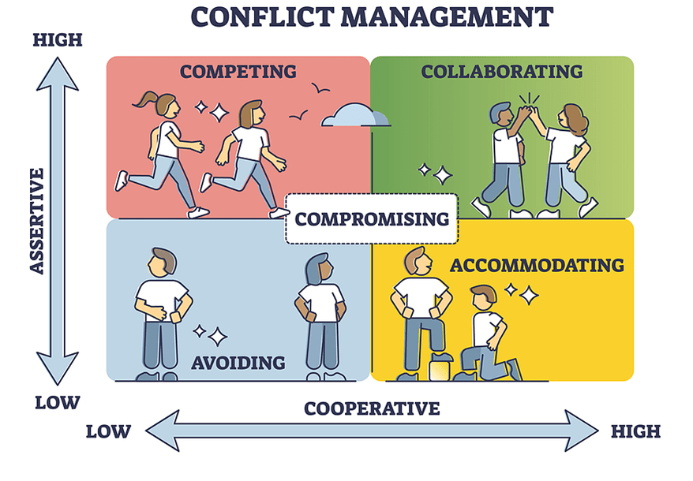

4.7 CONFLICT RESOLUTION STRATEGIES AND MANAGEMENT TECHNIQUES:
Conflict resolution encompasses a range of strategies and techniques that enable individuals and organizations to address disagreements constructively while maintaining relationships and achieving mutually beneficial outcomes. Effective conflict resolution requires understanding of various approaches and the ability to select and implement strategies appropriate to specific situations and stakeholder needs.
The mastery of conflict resolution techniques enables leaders to transform potentially destructive disagreements into opportunities for learning, relationship building, and organizational improvement. These skills become increasingly important as organizations become more complex and diverse, creating greater potential for misunderstandings and conflicts.
Collaborative Problem-Solving Approaches: Collaborative approaches to conflict resolution focus on finding solutions that address the underlying interests and needs of all parties while maintaining relationships and building future cooperation. Interest-based negotiation moves beyond stated positions to explore underlying needs and concerns while seeking creative solutions that satisfy multiple parties' fundamental requirements. Joint problem-solving brings conflicting parties together to analyze situations objectively while developing mutually acceptable solutions through shared effort and creativity. Win-win orientation seeks outcomes that provide benefits to all parties rather than zero-sum solutions where one party's gain comes at another's expense.
Communication-Based Resolution Techniques: Effective communication forms the foundation of successful conflict resolution by enabling understanding, empathy, and collaborative problem-solving between disagreeing parties. Active listening techniques ensure that all parties feel heard and understood while gathering complete information about perspectives and concerns that may not be immediately apparent. Reframing helps parties view situations from different perspectives while reducing defensiveness and opening possibilities for creative solutions. Clarification questions gather additional information while demonstrating genuine interest in understanding others' viewpoints and concerns. Acknowledgment statements validate others' feelings and
Mediation and Third-Party Intervention: When parties cannot resolve conflicts independently, neutral third parties can facilitate communication and problem-solving while providing structure and objectivity to resolution processes. Mediation involves neutral facilitators who help parties communicate effectively while guiding them through systematic problem-solving processes without imposing solutions. Arbitration provides binding decisions from neutral third parties when voluntary resolution is not possible while offering faster resolution than formal legal proceedings. Ombudsman services offer confidential consultation and informal resolution assistance while providing alternatives to formal grievance procedures. Coaching support helps individuals develop conflict resolution skills while providing guidance for handling specific situations more effectively. The choice of intervention depends on the nature of the conflict, relationship between parties, and organizational context that influences what approaches will be most effective and acceptable.
Negotiation Strategies and Tactics: Effective conflict resolution often requires negotiation skills that enable parties to reach mutually acceptable agreements while maintaining relationships and addressing underlying interests. Preparation involves gathering information about issues, alternatives, and stakeholder interests while developing clear objectives and strategies for negotiation sessions. Opening strategies establish positive tone and framework for discussion while creating environment conducive to collaborative problem-solving rather than adversarial competition. Concession patterns involve strategic give-and-take that demonstrates flexibility while maintaining focus on achieving essential objectives and interests.
Managing Emotional Aspects of Conflict: Conflict often involves strong emotions that can either facilitate or hinder resolution depending on how they are acknowledged and managed throughout the process. Emotional awareness involves recognizing and understanding the feelings of all parties while addressing emotional needs alongside substantive issues and concerns. De-escalation techniques reduce tension and defensiveness while creating calmer environment for rational discussion and problem-solving activities. Empathy building helps parties understand each other's perspectives and feelings while reducing animosity and increasing willingness to find mutually acceptable solutions.
Implementing and Monitoring Solutions: Successful conflict resolution requires careful implementation and follow-up to ensure that agreements are maintained and underlying issues do not resurface in problematic ways. Agreement documentation clearly specifies commitments, timelines, and responsibilities while providing reference points for evaluating compliance and success. Implementation planning identifies specific steps and resources needed while assigning accountability for various aspects of solution implementation. Monitoring systems track progress and compliance while providing early warning of potential problems or need for adjustments to agreements. Follow-up meetings provide opportunities to assess effectiveness while making necessary modifications to ensure continued success and relationship quality.
Preventing Future Conflicts: Effective conflict management includes proactive measures that reduce the likelihood of destructive conflicts while creating environments that support constructive disagreement and problem-solving. Communication system improvements enhance information sharing and understanding while reducing misunderstandings that often lead to unnecessary conflicts. Role clarification exercises define responsibilities and expectations while preventing conflicts that arise from unclear or overlapping duties. Team building activities improve relationships and collaboration while building trust and understanding that makes conflict resolution easier when disagreements occur.
4.8 NEGOTIATION SKILLS: PRINCIPLES, TYPES, AND STRATEGIC PROCESSES:
Negotiation represents a fundamental communication and problem-solving process that enables individuals and organizations to reach agreements, resolve conflicts, and create mutually beneficial outcomes. This skill becomes increasingly important in complex organizational environments where cooperation and collaboration across different groups, functions, and organizations determine success. Mastering negotiation principles and techniques enhances leadership effectiveness and enables better outcomes in various professional situations.
Effective negotiation requires understanding of human psychology, strategic thinking, and communication skills that enable influence without coercion while building relationships that support long-term cooperation and success. These capabilities can be developed through study, practice, and reflection on negotiation experiences.
Fundamental Negotiation Principles: Successful negotiation rests on core principles that guide behavior and decision-making throughout the negotiation process while ensuring ethical conduct and sustainable outcomes. Preparation forms the foundation of effective negotiation, involving research on issues, alternatives, and other parties while developing clear objectives and strategies for achieving desired outcomes. Mutual respect maintains professionalism and dignity while creating positive environment for problem-solving even when parties have significant disagreements. Interest identification moves beyond stated positions to understand underlying needs and concerns while seeking creative solutions that address fundamental requirements of all parties.
Types of Negotiation Situations: Different negotiation contexts require varying approaches and strategies based on relationship importance, issue complexity, and future interaction expectations between parties. Distributive negotiations involve dividing limited resources where one party's gain typically comes at another's expense, requiring competitive strategies that maximize individual outcomes while maintaining necessary relationships. Integrative negotiations seek win-win solutions that create value for all parties through creative problem-solving and collaboration that expands available resources or benefits. Multi-party negotiations involve complex dynamics with multiple stakeholders who may have different interests, alliances, and power relationships that affect negotiation processes and outcomes.
Strategic Planning and Preparation: Thorough preparation significantly increases negotiation success by providing information, alternatives, and strategies that enable confident and effective participation in discussions. Stakeholder analysis identifies all parties with interests in negotiation outcomes while understanding their perspectives, priorities, and potential contributions to successful agreements. BATNA development (Best Alternative to Negotiated Agreement) establishes strong alternatives that provide leverage and confidence while preventing acceptance of agreements that are worse than available alternatives. Issue prioritization ranks various topics by importance while identifying areas where flexibility is possible and where firm positions must be maintained. Strategy development outlines approaches for achieving objectives while anticipating potential responses and preparing adaptive tactics for different scenarios
Communication and Persuasion Techniques: Effective negotiation requires sophisticated communication skills that enable influence, understanding, and relationship building throughout the negotiation process. Question strategies gather information and clarify understanding while demonstrating interest in others' perspectives and building rapport through active engagement. Listening techniques ensure complete understanding of others' positions and interests while identifying opportunities for creative problem-solving and mutual gain. Persuasion approaches present arguments and proposals effectively while appealing to logic, emotions, and shared interests in ways that motivate agreement. Reframing techniques help parties view situations differently while reducing defensiveness and opening possibilities for creative solutions. Non-verbal communication including body language, tone of voice, and physical positioning supports verbal messages while creating appropriate atmosphere for productive discussions.
Managing Negotiation Dynamics: Successful negotiators understand and manage the interpersonal and strategic dynamics that influence negotiation processes and outcomes throughout various stages of discussion. Power assessment evaluates relative strengths and weaknesses while developing strategies that effectively utilize available leverage without damaging relationships unnecessarily. Timing considerations involve pacing discussions appropriately while recognizing when to make concessions, present proposals, or close agreements for maximum effectiveness.
Closing and Implementation Strategies: Successful negotiations require effective closure and implementation processes that ensure agreements are clearly understood, properly documented, and successfully executed by all parties. Agreement clarification ensures that all aspects are clearly understood while preventing misunderstandings that could lead to future conflicts or implementation problems. Documentation processes record commitments, timelines, and responsibilities while providing reference points for monitoring compliance and resolving any disputes that may arise. Implementation planning identifies specific steps and resources needed while assigning accountability for various aspects of agreement execution. Monitoring systems track progress and compliance while providing mechanisms for addressing problems or making necessary adjustments to ensure continued success. Relationship follow-up maintains positive connections while building foundation for future cooperation and negotiation when additional agreements may be needed.
TABLE 4.2:
Negotiation Type | Key Characteristics | Primary Strategies | Success Factors
Distributive | Fixed resources, competitive dynamics, win-lose orientation | Position-based bargaining, leverage utilization, concession management | Strong BATNA, accurate information, strategic patience
Integrative | Value creation opportunities, collaborative approach, win-win potential | Interest exploration, creative problem-solving, relationship building | Trust development, open communication, joint problem-solving
Multi-party | Complex stakeholder dynamics, coalition possibilities, varied interests | Alliance building, issue management, process facilitation | Clear process design, stakeholder management, communication coordination
Cross-cultural | Different values and norms, varied communication styles, diverse expectations | Cultural adaptation, relationship emphasis, patience and flexibility | Cultural intelligence, respect demonstration, local knowledge
Internal | Ongoing relationships, shared organizational goals, hierarchy considerations | Collaborative approach, mutual benefit focus, long-term thinking | Relationship preservation, organizational alignment, trust maintenance

4.9 COMMON NEGOTIATION MISTAKES AND AVOIDANCE STRATEGIES:
Understanding and avoiding common negotiation mistakes significantly improves outcomes while building more effective negotiation capabilities over time. These mistakes often stem from inadequate preparation, emotional reactions, or strategic errors that can be prevented through awareness and systematic approach development. Learning from common pitfalls enables negotiators to develop more effective strategies and achieve better results.
Successful negotiators develop awareness of potential mistakes while implementing systematic approaches that reduce the likelihood of errors and improve consistency of outcomes across different negotiation situations and contexts.
Preparation and Planning Mistakes: Inadequate preparation represents one of the most common and costly negotiation errors that can be prevented through systematic planning and research before entering negotiations. Insufficient research about issues, alternatives, and other parties leaves negotiators without essential information needed for effective decision-making and strategic positioning. Unclear objectives result in unfocused negotiations where important interests may be compromised due to lack of clear priorities and success criteria. Weak BATNA development leaves negotiators without strong alternatives while reducing their confidence and leverage during discussions. Unrealistic expectations about outcomes or other parties' positions create disappointment and may lead to poor decision-making during negotiations. Time pressure due to inadequate planning may force hasty decisions that could be avoided through better scheduling and preparation processes.
Communication and Interpersonal Errors: Poor communication during negotiations can damage relationships and prevent achievement of optimal outcomes even when substantive agreements might be possible with better interaction approaches. Talking too much while listening too little prevents understanding of others' interests and concerns while missing opportunities for creative problem-solving and relationship building. Emotional reactions including anger, frustration, or defensiveness can escalate conflicts while reducing rational decision-making capabilities and problem-solving effectiveness. Personal attacks or blame language damages relationships while shifting focus from substantive issues to interpersonal conflicts that are more difficult to resolve
Strategic and Tactical Errors: Various strategic mistakes can reduce negotiation effectiveness while potentially damaging relationships and preventing optimal outcomes that might be achievable with better approaches. Making first offers that are too extreme can anchor discussions inappropriately while creating defensive responses that make agreement more difficult to achieve. Conceding too quickly or too much may signal weakness while leaving value on the table that could have been captured through more strategic negotiation. Falling into competitive traps where negotiations become win-lose battles prevents exploration of integrative solutions that could benefit all parties significantly.
Decision-Making and Closure Mistakes: Poor decision-making during negotiations can result in agreements that are not in parties' best interests while potentially creating implementation problems and future conflicts. Pressure acceptance involves agreeing to terms due to artificial time pressure rather than genuine deadlines while potentially accepting inferior outcomes that could be improved through patience. Sunk cost fallacy leads negotiators to continue unproductive discussions because of time already invested rather than walking away when better alternatives are available.
Cognitive Biases and Mental Traps: Various psychological biases can affect negotiation judgment while leading to suboptimal decisions that could be avoided through awareness and systematic decision-making processes. Anchoring bias causes excessive influence of initial offers or positions while preventing appropriate adjustment based on new information and analysis. Confirmation bias leads to seeking information that supports existing positions while ignoring contradictory evidence that might suggest better alternatives. Overconfidence can result in inadequate preparation while leading to unrealistic expectations about negotiation outcomes and other parties' responses.
Prevention Strategies and Best Practices: Developing systematic approaches and awareness of common mistakes enables negotiators to avoid pitfalls while improving their effectiveness and outcomes over time. Preparation checklists ensure thorough analysis of issues, alternatives, and strategies while providing systematic approach to pre-negotiation planning and research. Process discipline maintains focus on interests rather than positions while following proven frameworks for integrative problem-solving and relationship management. Emotion management techniques help maintain composure while dealing effectively with stress, pressure, and interpersonal challenges that may arise during negotiations.
Learning and Continuous Improvement: Effective negotiators commit to ongoing learning and improvement while systematically analyzing their experiences to identify successful strategies and areas needing development. Post-negotiation analysis examines what worked well and what could be improved while capturing lessons learned for application in future situations. Skill development activities including training, reading, and practice help build negotiation capabilities while staying current with new techniques and approaches. Feedback integration incorporates input from others while using this information to adjust strategies and improve effectiveness in future negotiations. Success pattern recognition identifies approaches that consistently produce good outcomes while building repertoire of proven strategies for different types of negotiations. These practices enable continuous improvement while building negotiation expertise that enhances leadership effectiveness and organizational outcomes over time.

Revision Questions:
Short Answer Questions:
- Define team building and explain its three primary benefits for organizational performance.
- List four stages of team development and describe the key characteristics of each stage.
- What are the main differences between transformational and transactional leadership styles?
- Explain the concept of functional versus dysfunctional conflict in organizational settings.
- Describe three essential principles that guide effective negotiation processes.
Long Answer Questions:
- Analyze the relationship between leadership styles and team effectiveness, discussing how different approaches impact team performance and organizational culture development.
- Evaluate the role of character development in leadership effectiveness, examining how integrity and ethical behavior influence long-term leadership success and organizational trust.
- Discuss the integration of conflict management strategies with team building activities, analyzing how proactive conflict resolution contributes to team development and performance improvement.
- Examine the application of negotiation principles in leadership contexts, exploring how negotiation skills enhance decision-making processes and stakeholder relationship management.
- Compare and contrast different approaches to team dynamics management, analyzing their effectiveness across various organizational contexts and cultural environments.
Case Studies:
Case Study 1: The Struggling Project Team
Rachel Thompson has been appointed as the new project manager for a critical software integration project at DataSync Corporation, a mid-sized technology services company. The project involves integrating multiple customer databases into a unified system for a major client, with a deadline of six months and a budget of $2.5 million. The previous project manager, Mark Stevens, left the company unexpectedly, leaving behind a team that has been working together for three months but has made limited progress.
The team consists of six members with diverse backgrounds and expertise levels. Senior developer Kevin Martinez has fifteen years of experience but tends to work independently and rarely communicates with other team members about his progress or challenges. Junior developer Amanda Foster is enthusiastic and eager to learn but often feels overwhelmed by the technical complexity and seeks constant reassurance from colleagues. Database administrator Tony Chen has the technical expertise needed for the project but frequently clashes with Kevin about system architecture decisions and implementation approaches.
Quality assurance specialist Maria Rodriguez has identified numerous issues with the current development approach but struggles to communicate her concerns effectively to the development team members. Business analyst Jennifer Park serves as the liaison with the client but has been receiving mixed messages from team members about project status and timelines. Systems administrator Robert Johnson joined the team recently and feels excluded from important discussions and decision-making processes.
Rachel quickly discovers that the team has been operating without clear roles and responsibilities, leading to duplicated efforts and important tasks falling through the cracks. Team meetings are irregular and often become heated arguments between Kevin and Tony, while other members either remain silent or attempt to mediate unsuccessfully. The client has begun expressing concern about missed milestones and lack of visible progress, putting additional pressure on the team to deliver results.
Communication problems extend beyond technical discussions to include interpersonal tensions that affect team morale and productivity. Kevin believes that his experience entitles him to make major architectural decisions independently, while Tony argues that his database expertise should give him authority over data-related choices. Amanda feels caught in the middle and has started avoiding meetings where conflicts typically occur. Maria's quality concerns are being dismissed as premature, leading to frustration and decreased engagement.
The organizational culture at DataSync emphasizes collaboration and innovation, but the team's dysfunction threatens both project success and company reputation with an important client. Rachel recognizes that she needs to address both task-related issues and interpersonal dynamics to get the project back on track. She has limited experience managing diverse teams but understands that failure to resolve these issues quickly could result in project failure and potential loss of the client relationship.
Rachel must develop a comprehensive approach that addresses role clarification, communication improvement, conflict resolution, and team building while maintaining focus on project deliverables and client expectations. The situation requires both immediate interventions to address current problems and longer-term strategies to build a cohesive, high-performing team that can successfully complete the project and potentially work together on future initiatives.
Case Study 2: The Leadership Transition Challenge
Michael Rodriguez has recently been promoted to Director of Operations at GlobalTech Manufacturing, a multinational company with 500 employees across three facilities. He is replacing Sarah Johnson, a respected leader who successfully managed the department for eight years before accepting a position with another company. Michael has strong technical expertise and has been with the company for five years, but this is his first senior management role with significant leadership responsibilities.
The operations department includes four managers who report directly to Michael, each overseeing different aspects of manufacturing operations. Production Manager Janet Thompson has been with the company for twelve years and was considered for Michael's position before the company decided to promote him instead. She has extensive operational knowledge but tends to resist changes to established procedures and processes. Quality Manager David Kim is highly competent but prefers to work independently and rarely participates in departmental meetings or collaborative initiatives.
Maintenance Manager Lisa Foster is innovative and results-oriented but sometimes implements changes without proper consultation with other departments, creating coordination problems. Supply Chain Manager Carlos Rivera is well-respected by his team but lacks confidence in presenting ideas to senior leadership and tends to defer to others' opinions in management meetings. Each manager has different leadership styles and approaches to managing their teams, creating inconsistency in departmental culture and employee experience.
Michael's promotion has created mixed reactions throughout the organization. Some employees are excited about having a younger leader who understands current technology and operational challenges. Others question whether he has sufficient management experience to handle the complex interpersonal and strategic issues that come with the director role. Several senior employees have expressed concerns about potential changes to policies and procedures that have been successful under Sarah's leadership.
The manufacturing industry is facing increased competition and pressure to reduce costs while maintaining quality standards. Senior leadership expects Michael to identify efficiency improvements and cost reduction opportunities while maintaining the high-performance culture that Sarah established. Customer demands for faster delivery and customization are increasing, requiring operational flexibility and innovation that may challenge existing processes and systems.
Michael recognizes that his success depends on building effective working relationships with his management team while establishing his credibility and authority in the new role. He must balance respect for existing successful practices with the need for innovation and adaptation to changing business requirements. The challenge involves developing his own leadership style while managing the diverse personalities and approaches of his direct reports.
Janet's resistance to change could become a significant obstacle if not addressed diplomatically, given her knowledge and influence within the organization. David's independence, while sometimes beneficial, may limit team coordination and information sharing needed for optimal departmental performance. Lisa's innovation must be channeled more collaboratively to prevent disruption of other departments' operations. Carlos needs support to build confidence and contribute more actively to strategic discussions and decision-making.
Michael must also establish relationships with senior leadership and other department heads while proving that he can successfully manage both operational performance and people development responsibilities. The transition period is critical for setting expectations, building trust, and demonstrating leadership capabilities that justify the company's confidence in his promotion.
Case Study 3: The Multi-Cultural Negotiation Dilemma
Alexandra Chen serves as Vice President of International Business Development at TechGlobal Solutions, a software company expanding into Asian markets. She is leading negotiations for a strategic partnership with Yamamoto Industries, a Japanese manufacturing company, to integrate TechGlobal's supply chain management software with Yamamoto's operations across fifteen facilities in Japan, Korea, and Taiwan. The potential deal is worth $15 million over three years and could open doors to additional opportunities in the Asian market.
The negotiation process has been ongoing for four months and involves complex technical, financial, and cultural considerations. The American team includes Alexandra, Technical Director Robert Martinez, and Financial Analyst Jennifer Park, who is Korean-American and provides cultural insights for the Korean market aspects. The Japanese team is led by Senior Executive Hiroshi Yamamoto, with Technical Manager Kenji Tanaka and Operations Director Akiko Sato participating in various discussions.
Cultural differences have created several challenges throughout the negotiation process. The Japanese team prefers extensive relationship-building activities and consensus-building discussions before addressing specific contract terms, while the American team is focused on quickly reaching agreement on technical specifications and pricing. Decision-making processes differ significantly, with the Japanese team requiring approval from multiple organizational levels, causing delays that create pressure on the American side to meet quarterly targets.
Communication styles have led to misunderstandings and frustration on both sides. The Japanese negotiators rarely express disagreement directly, instead using subtle indications that the American team sometimes misinterprets as agreement. The American team's direct communication style and eagerness to address problems immediately has been perceived as pushy and disrespectful by the Japanese participants. Jennifer's attempts to bridge cultural gaps have helped but cannot address all the complexities involved.
Technical integration challenges have emerged as both sides realize that their systems and processes are more different than initially anticipated. The American software requires modifications to work effectively with Japanese manufacturing processes, while Yamamoto's systems need upgrades to support full integration. These technical issues have cost implications that affect the financial terms being negotiated, creating additional complexity for both sides.
Pricing negotiations have become particularly challenging due to different approaches to contract structure and payment terms. TechGlobal prefers performance-based pricing with payments tied to implementation milestones, while Yamamoto wants fixed pricing with traditional payment schedules. The Japanese company's procurement processes require detailed cost breakdowns and justifications that TechGlobal considers proprietary information, creating tension about information sharing and transparency.
Time pressure is mounting as TechGlobal's fiscal year ends in six weeks and the sales team needs this deal to meet annual targets. Senior leadership is questioning why the negotiations are taking so long and pushing for faster resolution. However, the Japanese team has indicated that rushing the process could damage the relationship and jeopardize not only this deal but also future opportunities with other Japanese companies.
Alexandra recognizes that success requires balancing her company's business needs with respect for Japanese business culture and relationship-building expectations. She must find ways to accelerate progress without appearing disrespectful while addressing the technical and financial complexities that have emerged. The situation requires sophisticated negotiation skills, cultural sensitivity, and creative problem-solving to achieve a mutually beneficial outcome.
Fun Activity: The Leadership Challenge Simulation
Objective: Provide participants with hands-on experience in leadership decision-making, team dynamics management, and conflict resolution through an engaging business simulation that mirrors real-world challenges.
Setup and Materials:
Divide participants into groups of 6-8 people representing different departments in a fictional company
Provide each group with company background information, departmental goals, and individual role descriptions
Create scenario cards with emerging challenges that require leadership responses and team collaboration
Prepare evaluation forms and reflection worksheets for learning capture and discussion
Game Structure: The simulation unfolds over four rounds representing quarterly business periods, with each round presenting new challenges that require leadership responses, team coordination, and stakeholder negotiation. Participants rotate through different leadership roles while dealing with budget constraints, resource allocation decisions, personnel issues, and strategic challenges that affect multiple departments and organizational stakeholders.
Each round includes planning sessions where teams develop strategies, implementation phases where decisions are executed and results determined, and reflection periods where participants analyze outcomes and identify lessons learned. Points are awarded based on financial performance, team effectiveness, stakeholder satisfaction, and quality of leadership decisions demonstrated throughout the simulation experience.
Round One - Team Formation: Participants assume roles and establish team dynamics while addressing initial challenges related to goal setting, role clarification, and resource allocation. Leadership positions rotate every round to provide multiple participants with leadership experience and perspective on different aspects of team management and organizational challenges.
Round Two - Conflict Management: Teams face internal conflicts and external pressures that require negotiation skills, conflict resolution techniques, and collaborative problem-solving approaches. Participants practice different leadership styles while learning to adapt their approaches based on situational requirements and stakeholder needs.
Round Three - Strategic Decision-Making: Complex scenarios require teams to make difficult decisions under pressure while balancing competing interests and resource constraints. Emphasis is placed on ethical decision-making, stakeholder communication, and implementation planning that considers both short-term results and long-term implications.
Round Four - Integration and Learning: Teams reflect on their experiences while identifying successful strategies and areas for improvement in their leadership and team management approaches. Final presentations share key insights and commit to specific behavioral changes that will enhance professional effectiveness.
The activity concludes with group discussion of leadership principles, team dynamics insights, and practical applications for workplace situations. Participants complete self-assessments and peer evaluations while developing personal action plans for continued leadership development and team effectiveness improvement.

**********

5
COMMUNICATION AND EMOTIONAL INTELLIGENCE

INTRODUCTION
Communication serves as the foundation for all organizational activities, enabling coordination, relationship building, and achievement of business objectives across diverse stakeholder groups. This unit explores the multifaceted nature of communication processes and their integration with emotional intelligence capabilities that determine professional effectiveness. Understanding these concepts empowers individuals to build stronger relationships, manage emotions effectively, and navigate complex organizational dynamics with greater success.
Emotional intelligence has emerged as a critical competency for leadership effectiveness and career advancement in contemporary business environments. The ability to understand and manage emotions, both personal and interpersonal, significantly influences decision-making quality, relationship strength, and organizational performance. These skills become particularly important during periods of change, conflict, and high-pressure situations that characterize modern business operations.
The concepts presented in this unit provide practical frameworks for enhancing communication effectiveness while developing emotional intelligence capabilities that support professional growth and organizational contribution. Students will learn to identify communication barriers, apply transactional analysis principles, and master stress management techniques that enable sustained high performance in challenging environments.
5.1 DEFINITION AND IMPORTANCE OF COMMUNICATION IN ORGANIZATIONS:
Communication represents the process of sharing information, ideas, and emotions between individuals or groups to achieve understanding and coordinate activities toward common objectives. This fundamental organizational process enables everything from basic task coordination to complex strategic planning and culture development. Effective communication serves as the primary mechanism through which organizations function, adapt, and achieve their goals while building relationships that support long-term success.
The strategic importance of communication extends beyond information transfer to encompass relationship building, culture creation, and organizational effectiveness that determines competitive advantage. Organizations with superior communication capabilities consistently outperform competitors in areas including employee engagement, customer satisfaction, innovation, and financial performance.
Defining Communication and Its Core Elements: Communication involves the systematic process of transmitting messages between senders and receivers through various channels while achieving mutual understanding and coordinated action. This process includes message encoding where ideas and information are converted into symbols, words, or signals that can be transmitted effectively to intended recipients. Channel selection determines the medium through which messages travel, including face-to-face interaction, written documents, electronic communication, or other methods appropriate to the message and context.
Communication Functions in Organizational Settings: Communication serves multiple essential functions that enable organizational operation, coordination, and success across all levels and departments within complex business environments. Information sharing ensures that individuals and teams have access to knowledge needed for effective decision-making and task completion while preventing duplication of effort and resource waste. Coordination enables synchronized activities between different departments, teams, and individuals while ensuring that organizational objectives are pursued consistently and efficiently across all functions. Motivation and inspiration occur through communication that connects individual efforts to organizational purpose while providing recognition, feedback, and encouragement that sustain high performance
Strategic Communication Impact: Effective organizational communication creates significant competitive advantages through improved operational efficiency, enhanced innovation capability, and stronger stakeholder relationships that support business success. Decision-making quality improves when relevant information flows freely between organizational levels while diverse perspectives are considered and integrated into planning processes. Innovation acceleration occurs when ideas and knowledge are shared openly while collaborative problem-solving approaches generate creative solutions to business challenges. Customer satisfaction increases through clear communication about products, services, and expectations while responsive communication addresses concerns and builds loyalty
Communication Complexity in Modern Organizations: Contemporary business environments present unique communication challenges that require sophisticated understanding and adaptive approaches to achieve effectiveness across diverse contexts and stakeholder groups. Globalization creates needs for cross-cultural communication that bridges different languages, values, and business practices while maintaining message clarity and relationship quality. Technology integration provides new communication channels and capabilities while requiring skills to use these tools effectively and appropriately for different purposes and audiences. Organizational complexity increases communication requirements as matrix structures, virtual teams, and partnership arrangements create more complicated relationship networks and information flow patterns. Generational diversity introduces varying communication preferences and styles that must be accommodated while maintaining organizational coherence and effectiveness. Speed expectations demand rapid communication responses while maintaining accuracy and thoughtfulness that support good decision-making and relationship maintenance.
Measuring Communication Effectiveness: Successful communication assessment requires systematic evaluation of both process quality and outcome achievement while identifying areas for improvement and continued development. Message clarity can be measured through comprehension testing, feedback quality, and absence of misunderstandings that lead to errors or conflicts in organizational activities. Response rates and engagement levels indicate whether communication captures attention and motivates desired actions while building commitment to organizational objectives.
Technology Integration and Digital Communication: Modern communication effectiveness requires mastery of digital tools and platforms that enable rapid, efficient, and flexible interaction across geographical and organizational boundaries. Email communication demands skills in writing clear, concise messages while managing volume and prioritizing responses appropriately for different stakeholder groups and business needs. Video conferencing capabilities enable face-to-face interaction despite physical distance while requiring technical skills and adapted communication approaches for virtual environments. Collaboration platforms facilitate team communication and project coordination while requiring training and discipline to use effectively without creating information overload or confusion.
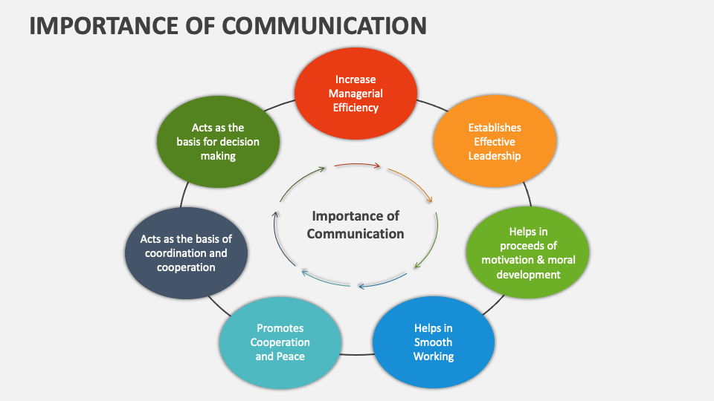
5.2 COMMUNICATION PROCESS, SYMBOLS, AND NETWORK STRUCTURES:
The communication process involves systematic steps and components that determine whether messages are transmitted accurately and achieve their intended effects. Understanding this process enables identification of potential breakdown points and improvement opportunities that enhance communication effectiveness. Symbols and networks provide the infrastructure through which organizational communication occurs, influencing both the efficiency and quality of information sharing and relationship building.
Effective communication requires mastery of both the technical aspects of message transmission and the human dynamics that influence how messages are received, interpreted, and acted upon by different individuals and groups within organizational contexts.
Understanding the Communication Process Model: The communication process follows a systematic sequence of steps that transform ideas and information into shared understanding and coordinated action between individuals or groups. Source identification establishes who is initiating communication and what qualifications, credibility, and motivations they bring to the interaction, as these factors significantly influence how messages are received and interpreted. Message formulation involves organizing thoughts and information into coherent structure while considering audience needs, knowledge levels, and interests that affect how information should be presented.
Decoding and Feedback Mechanisms: Successful communication depends on receivers accurately interpreting transmitted messages while providing feedback that enables senders to confirm understanding and make necessary adjustments. Decoding involves translation of received symbols or words into meaning while filtering information through personal experiences, knowledge, and biases that may affect interpretation accuracy. Noise identification recognizes various forms of interference that can distort messages including physical distractions, emotional states, competing priorities, or technical problems that prevent clear reception. Understanding verification occurs through active listening, questioning, and paraphrasing techniques that confirm accurate interpretation while identifying areas where clarification may be needed. Feedback provision enables two-way communication that improves accuracy while building relationships and ensuring that communication objectives are achieved effectively.
Symbolic Communication and Meaning Creation: Communication relies heavily on symbols including words, images, gestures, and other representations that carry meaning between individuals while recognizing that interpretation may vary based on cultural background and personal experience. Verbal symbols including spoken and written language provide explicit information while requiring shared understanding of vocabulary, grammar, and context to achieve accurate communication. Non-verbal symbols including body language, facial expressions, tone of voice, and physical positioning convey significant additional meaning that may support or contradict verbal messages
Organizational Communication Networks: Communication networks determine how information flows through organizations while influencing efficiency, accuracy, and relationship development across different levels and departments. Formal networks follow official organizational structure including hierarchical reporting relationships, committee structures, and official communication channels that provide predictable information flow patterns. Informal networks emerge naturally through personal relationships, shared interests, and social interactions that may provide faster information transmission but with potentially less accuracy or official authority. Centralized networks channel most communication through specific individuals or positions while providing control and consistency but potentially creating bottlenecks and limiting information access. Decentralized networks distribute communication capability more broadly while enabling faster response and greater participation but requiring more coordination to maintain coherence.
Communication Flow Patterns: Information movement through organizational networks follows various patterns that affect both efficiency and effectiveness of communication while influencing relationship development and decision-making quality. Downward communication flows from higher to lower organizational levels while providing direction, instruction, and feedback that guide activities and performance expectations. Upward communication enables information flow from subordinates to supervisors while providing progress reports, problem identification, and suggestions that inform management decision-making.
Network Analysis and Optimization: Effective communication management requires systematic analysis of existing networks while identifying opportunities for improvement that enhance both information flow and relationship quality. Network mapping identifies actual communication patterns while comparing these with intended or optimal arrangements to reveal gaps, redundancies, or bottlenecks that affect performance. Key communicator identification recognizes individuals who play central roles in information flow while ensuring that these positions are supported and utilized effectively for organizational benefit. Bottleneck elimination addresses points where communication flow is restricted while developing alternative channels or improving capacity to maintain effectiveness.
5.3 BARRIERS IN COMMUNICATION AND STRATEGIC OVERCOMING METHODS:
Communication barriers represent obstacles that prevent effective message transmission, accurate understanding, or appropriate response between individuals or groups. These barriers can occur at any point in the communication process and may stem from personal, organizational, or environmental factors that interfere with successful communication. Understanding and addressing these barriers is essential for improving communication effectiveness and building stronger professional relationships.
Effective barrier management requires systematic identification of potential obstacles combined with proactive strategies that prevent communication problems while building organizational capability for clear, efficient, and relationship-enhancing interaction across all levels and functions.
Physical and Environmental Barriers: Physical obstacles can significantly impair communication effectiveness by interfering with message transmission or creating distractions that prevent full attention and understanding. Noise interference includes both auditory distractions such as machinery, traffic, or conversations that make it difficult to hear messages clearly, and visual distractions that divert attention from speakers or written materials. Distance challenges affect communication when physical separation makes face-to-face interaction difficult while potentially reducing the richness and immediacy of interaction that supports understanding and relationship building. Technology limitations including poor audio quality, unreliable internet connections, or inadequate equipment can create frustration and message distortion that undermines communication effectiveness.
Psychological and Emotional Barriers: Individual psychological states and emotional conditions significantly influence both sending and receiving communication while potentially creating barriers that prevent effective understanding and response. Stress and anxiety can reduce attention, impair memory, and increase misinterpretation while creating emotional reactions that interfere with rational processing of information and appropriate response. Preconceptions and biases filter incoming information while potentially distorting interpretation based on previous experiences, stereotypes, or assumptions about senders or message content.
Language and Cultural Barriers: Differences in language, culture, and communication styles create significant obstacles to effective communication, particularly in diverse organizations and global business environments. Language differences including vocabulary limitations, accent variations, or technical jargon can prevent clear understanding while creating frustration and potential misinterpretation of intended messages. Cultural variations in communication styles, including directness levels, formality expectations, and non-verbal communication patterns, can lead to misunderstandings and relationship problems. Value differences may cause individuals to interpret messages through different frameworks while potentially creating conflict over priorities, approaches, or acceptable behaviors.
Organizational and Structural Barriers: Organizational design and culture can create systematic barriers that prevent effective communication while requiring structural or policy changes to address effectively. Hierarchical barriers including status differences, power imbalances, or formal protocols may inhibit open communication while preventing upward feedback or cross-functional collaboration that could improve organizational effectiveness. Information overload occurs when individuals receive more communication than they can process effectively while potentially causing important messages to be overlooked or misunderstood.
Technological and Digital Communication Barriers: Modern communication increasingly relies on technology that can create new barriers while requiring digital literacy and adaptive approaches to maintain effectiveness across different platforms and channels. Technical difficulties including system failures, compatibility problems, or user inexperience can disrupt communication while creating frustration and delays that affect productivity and relationship quality. Information overload through email, instant messaging, and other digital channels can overwhelm recipients while reducing attention to important messages and decreasing overall communication effectiveness.
Systematic Barrier Identification and Assessment: Effective barrier management requires systematic approaches that identify existing obstacles while assessing their impact on communication effectiveness and organizational performance. Communication audits examine current practices, effectiveness levels, and problem areas while gathering feedback from stakeholders about communication quality and areas for improvement. Survey instruments can measure communication satisfaction, perceived barriers, and suggestions for enhancement while providing quantitative data about communication effectiveness across different groups and functions. Focus groups enable detailed discussion of communication challenges while generating specific recommendations for addressing identified barriers and improving overall effectiveness.
Strategic Approaches for Barrier Elimination: Successful barrier reduction requires comprehensive strategies that address root causes while building organizational capability for sustained communication effectiveness and continuous improvement. Training programs can build communication skills while addressing specific barrier types such as cross-cultural communication, active listening, or digital communication effectiveness for different employee groups. Environmental modifications including workspace improvements, technology upgrades, or policy changes can eliminate structural barriers while creating more supportive conditions for effective communication. Process improvements such as meeting management, feedback systems, or communication protocols can enhance effectiveness while ensuring that communication activities achieve their intended objectives efficiently.
TABLE 5.1:
Barrier Type | Common Examples | Impact on Communication
Physical | Noise, distance, poor technology | Message distortion, reduced attention, technical failures
Psychological | Stress, bias, emotional states | Misinterpretation, defensive responses, selective listening
Cultural | Language differences, varying communication styles, value conflicts | Misunderstandings, relationship tensions, inappropriate responses
Organizational | Hierarchy, information overload, unclear roles | Limited feedback, delayed information, coordination problems
Technological | System failures, digital divide, security concerns | Communication disruption, unequal access, reduced information sharing

5.4 TRANSACTIONAL ANALYSIS: EGO STATES AND TYPES OF TRANSACTIONS:
Transactional Analysis provides a comprehensive framework for understanding interpersonal communication patterns and psychological dynamics that influence relationship quality and communication effectiveness. Developed by Eric Berne, this approach identifies different ego states that people operate from during interactions while explaining how these states affect communication outcomes and relationship development. Understanding Transactional Analysis enables more effective communication and improved relationship management across personal and professional contexts.
The application of Transactional Analysis principles in organizational settings enhances communication effectiveness while providing tools for conflict resolution, team development, and leadership effectiveness that support both individual growth and organizational success.
Understanding EGO States and Their Characteristics: Transactional Analysis identifies three distinct ego states that represent different aspects of personality and influence how individuals communicate and interact with others in various situations. The Parent ego state contains attitudes, feelings, and behavior patterns learned from parental figures and authority figures during childhood development, manifesting in two primary forms during adult interactions. Critical Parent behaviors include judging, criticizing, controlling, and setting rules while often using "should" and "must" language that can create defensiveness in others. Nurturing Parent behaviors involve caring, supporting, protecting, and helping others while demonstrating warmth and concern for their well-being and development.
Adult EGO State Characteristics and Functions: The Adult ego state represents the rational, logical, and objective aspect of personality that processes information, solves problems, and makes decisions based on current reality rather than emotional reactions or past conditioning. Adult communication demonstrates characteristics including fact-based analysis, logical reasoning, objective evaluation of alternatives, and appropriate emotional responses that fit current circumstances rather than past experiences. This ego state enables effective problem-solving, decision-making, and collaborative interaction that focuses on achieving mutually beneficial outcomes through rational discussion and analysis
Child EGO State Variations and Impact: The Child ego state contains feelings, impulses, and behavior patterns from childhood experiences, manifesting in three distinct forms that influence adult communication and relationship patterns. Natural Child behaviors include spontaneity, creativity, curiosity, and emotional expressiveness that can bring energy and innovation to interactions while sometimes lacking appropriate boundaries or consideration for others. Adapted Child behaviors develop in response to parental and social expectations, including compliance, rebellion, withdrawal, or attention-seeking that may not be appropriate in current adult situations. Little Professor represents the intuitive and creative aspects of child thinking that can provide valuable insights and innovative solutions while sometimes lacking logical analysis or practical considerations. Understanding Child ego state influences helps individuals recognize when their responses may be driven by past experiences rather than current situations while enabling more conscious choice about appropriate communication approaches.
Types of Transactions and Their Outcomes: Transactional Analysis categorizes communication exchanges based on which ego states are involved while predicting likely outcomes and relationship effects of different transaction types. Complementary transactions occur when communication flows between the expected ego states without crossing lines, such as Adult-to-Adult exchanges that focus on problem-solving or Parent-to-Child interactions that involve guidance and support. These transactions tend to continue smoothly without conflict while achieving their intended purposes effectively.
Analyzing Communication Patterns and Relationships: Effective application of Transactional Analysis requires systematic observation and analysis of communication patterns while identifying opportunities for improvement in both personal effectiveness and relationship quality. Pattern recognition involves identifying which ego states individuals tend to use most frequently while examining how these patterns affect their relationships and professional effectiveness. Relationship dynamics analysis examines how different ego state combinations create various relationship qualities while identifying changes that could improve satisfaction and productivity. Conflict analysis uses Transactional Analysis to understand disagreement sources while developing strategies for resolution that address underlying psychological dynamics rather than just surface issues. Communication effectiveness assessment examines whether current patterns achieve intended objectives while building or damaging relationships that are important for ongoing success. This analysis provides foundation for developing more conscious and effective communication approaches.
Practical Applications in Professional Settings: Transactional Analysis principles can be applied systematically to improve communication effectiveness, leadership capabilities, and team dynamics within organizational contexts. Leadership development benefits from understanding how different ego states affect influence and relationship building while enabling more conscious choice about appropriate approaches for different situations and individuals. Team communication improvement involves helping team members recognize their own patterns while learning to communicate from Adult ego states that support collaboration and problem-solving rather than creating defensive or competitive dynamics. Conflict resolution uses Transactional Analysis to identify underlying psychological dynamics while helping parties move to Adult-to-Adult communication that focuses on mutual problem-solving rather than defending positions.
Developing Communication Consciousness and Choice: Mastery of Transactional Analysis requires developing awareness of personal patterns while building capability to choose communication approaches consciously based on situational requirements and desired outcomes. Self-awareness development involves recognizing personal ego state preferences while understanding how these patterns affect others and relationship outcomes in various professional and personal contexts. Response flexibility enables conscious choice about which ego state to use while adapting communication approach to achieve optimal results in different situations with various individuals. Emotional regulation helps manage triggers that automatically activate particular ego states while maintaining Adult perspective even in challenging or emotionally charged situations. Relationship building focuses on creating Adult-to-Adult communication patterns that support mutual respect, collaboration, and problem-solving while avoiding psychological games that damage trust and effectiveness. Continuous improvement involves ongoing observation and adjustment of communication patterns while building greater consciousness and skill in applying Transactional Analysis principles for personal and professional benefit.
5.5 JOHARI WINDOW AND LIFE POSITIONS IN INTERPERSONAL DYNAMICS:
The Johari Window provides a powerful framework for understanding self-awareness and interpersonal relationships by examining different types of knowledge and information that exist between individuals. Created by Joseph Luft and Harrington Ingham, this model helps individuals understand how self-disclosure and feedback contribute to relationship development and personal growth. The integration with life positions from Transactional Analysis creates comprehensive understanding of interpersonal dynamics.
Understanding these concepts enables more effective relationship building, improved self-awareness, and enhanced communication that supports both personal development and professional effectiveness in various organizational and social contexts. . Life Positions form through repeated relational experiences in early childhood: "I'm OK, You're OK" develops from consistent, attuned caregiving, while "I'm Not OK, You're OK" emerges from messages of inadequacy, and "I'm OK, You're Not OK" forms as a defensive response to neglect or abuse. During adolescence, both frameworks undergo reorganization as identity exploration expands the Unknown Arena and peer relationships can challenge established Life Positions. Healthy adult development involves gradually expanding the Open Arena through authentic relationships while maintaining appropriate boundaries
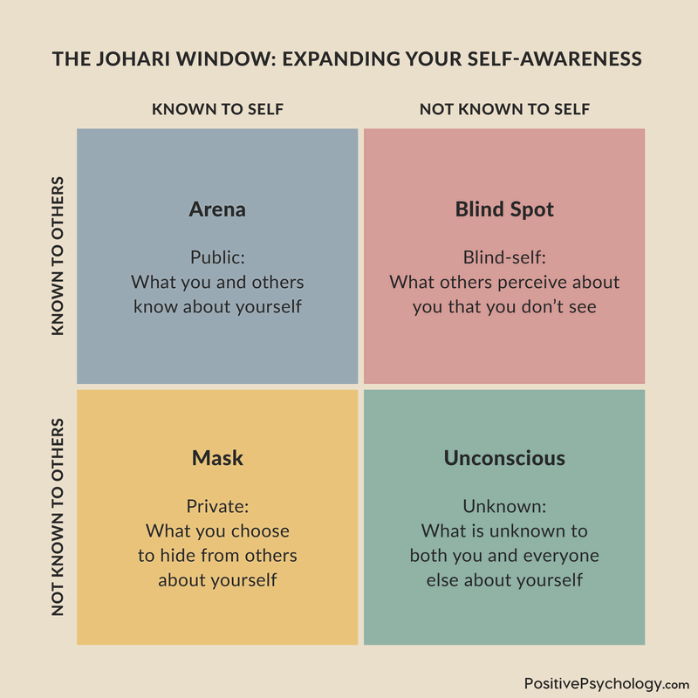
Understanding the Four Quadrants of the Johari Window: The Johari Window divides interpersonal knowledge into four distinct areas that represent different combinations of what individuals know about themselves and what others know about them. The Open Area contains information that is known both to the individual and to others, including obvious characteristics, shared experiences, and publicly communicated thoughts and feelings that form the basis for open communication and relationship building. This area typically expands as relationships develop and trust increases, enabling more authentic interaction and mutual understanding.
Exploring the Blind and Unknown Areas: The Blind Area represents information that others can observe about an individual but that the person does not recognize in themselves, including unconscious behaviors, habits, and mannerisms that affect how others perceive and respond to them. Feedback from others can help individuals become aware of blind spots while providing opportunities for self-improvement and more effective interaction with colleagues and friends. The Unknown Area contains information that neither the individual nor others currently recognize, including undiscovered talents, unconscious motivations, and potential capabilities that may emerge through new experiences or deeper self-exploration
Self-Disclosure Strategies and Benefits: Appropriate self-disclosure helps expand the Open Area while building trust, understanding, and stronger relationships in both personal and professional contexts. Strategic sharing involves revealing relevant personal information gradually while assessing others' responses and reciprocal sharing that indicates developing trust and mutual respect. Professional disclosure focuses on work-related experiences, values, and perspectives that help colleagues understand motivations and working styles without sharing overly personal information that may be inappropriate for workplace relationships. Risk assessment considers potential benefits and consequences of sharing particular information while ensuring that disclosure serves relationship building rather than creating vulnerability or discomfort.
Feedback Seeking and Integration: Active feedback seeking helps reduce the Blind Area while increasing self-awareness and opportunities for personal and professional development through others' perspectives and observations. Feedback requests should be specific and focused on particular behaviors or situations while creating safe environments where others feel comfortable providing honest observations and suggestions. Active listening during feedback reception demonstrates respect for others' perspectives while gathering complete information that can inform self-improvement efforts and behavior modification. Non-defensive responses encourage continued feedback while showing appreciation for others' willingness to share observations that may be difficult to hear but valuable for growth.
Life Positions and Their Impact on Relationships: Transactional Analysis identifies four fundamental life positions that represent basic attitudes individuals hold toward themselves and others, significantly influencing communication patterns and relationship quality. "I'm OK, You're OK" represents the healthiest position characterized by mutual respect, positive regard, and collaborative approaches to interaction and problem-solving that support effective relationships and communication. "I'm OK, You're Not OK" reflects arrogance or superiority attitudes that may lead to condescending communication and relationship problems that limit collaboration and mutual respect. "I'm Not OK, You're OK" indicates feelings of inferiority or inadequacy that may result in submissive behavior or excessive deference that limits personal contribution and authentic communication. "I'm Not OK, You're Not OK" represents the most problematic position characterized by pessimism and futility that can create negative communication patterns and relationship difficulties that affect both personal satisfaction and professional effectiveness.
Integrating Johari Window with Life Positions: The combination of Johari Window awareness with understanding of life positions creates comprehensive approach to relationship development and communication improvement. Self-awareness development involves examining personal life positions while using Johari Window concepts to identify areas for growth and improved understanding of self and others. Relationship assessment evaluates how current life positions affect communication patterns while identifying opportunities for moving toward more positive and collaborative attitudes that support better outcomes.
Practical Applications for Professional Development: Understanding Johari Window and life positions enables systematic approach to relationship building and communication improvement in organizational contexts while supporting career development and team effectiveness. Team development activities can use these concepts to improve communication, build trust, and enhance collaboration while creating environments where individuals feel safe to share ideas and receive feedback constructively. Leadership development benefits from increased self-awareness and feedback skills while enabling more effective coaching, performance management, and relationship building with team members and colleagues.
TABLE 5.2:
Johari Quadrant | Knowledge Level | Development Strategy
Open Area | Known to self and others | Maintain transparency, continue sharing appropriate information
Hidden Area | Known to self only | Strategic self-disclosure, build trust gradually
Blind Area | Known to others only | Seek feedback actively, increase self-awareness
Unknown Area | Unknown to all | Explore new experiences, encourage discovery
Life Position Impact | Attitude foundation | Develop "I'm OK, You're OK" perspective for healthy relationships

5.6 EMOTIONAL INTELLIGENCE: MEANING AND ESSENTIAL COMPONENTS:
Emotional intelligence represents the ability to recognize, understand, and manage emotions effectively in oneself and others while using emotional information to guide thinking, behavior, and relationship management. This competency has become increasingly recognized as critical for professional success, leadership effectiveness, and personal satisfaction across various contexts. Emotional intelligence enables individuals to navigate complex social situations, build stronger relationships, and make better decisions by integrating emotional and rational information.
The development of emotional intelligence capabilities provides significant advantages in professional environments where collaboration, influence, and relationship management determine success more than technical skills alone. Organizations increasingly value employees who can work effectively with diverse groups while managing stress and conflict constructively.
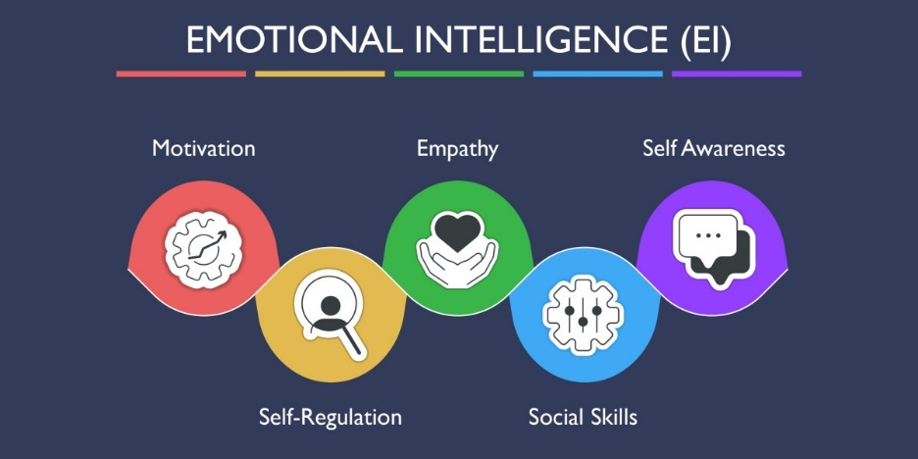
Defining Emotional Intelligence and Its Scope: Emotional intelligence encompasses the ability to perceive, understand, and manage emotions effectively while using emotional information to enhance thinking, decision-making, and interpersonal relationships. This multifaceted capability involves recognizing emotional states in oneself and others while understanding how emotions influence behavior, motivation, and relationship dynamics in various situations. The scope includes both intrapersonal skills focused on self-awareness and self-management, and interpersonal skills that enable effective relationship building and social navigation across different contexts and cultures. Emotional intelligence differs from traditional intelligence measures by focusing on emotional and social competencies rather than purely cognitive abilities, though research demonstrates that both types of intelligence contribute to overall life and professional success. Understanding this definition helps individuals appreciate the importance of developing emotional capabilities alongside technical and analytical skills for comprehensive professional effectiveness and personal satisfaction.
Self-Awareness as the Foundation: Self-awareness represents the cornerstone of emotional intelligence, involving accurate recognition and understanding of personal emotions, strengths, limitations, and values that influence behavior and decision-making in various situations. Emotional self-awareness includes the ability to identify and name emotions as they occur while understanding their intensity, duration, and impact on thinking and behavior patterns in different contexts. Accurate self-assessment involves realistic evaluation of personal strengths and weaknesses while maintaining confidence without arrogance and recognizing limitations without excessive self-criticism that could limit growth and effectiveness. Self-confidence emerges from accurate self-knowledge while enabling individuals to trust their abilities and judgment without requiring constant external validation or approval from others
Self-Management and Emotional Regulation: Self-management involves the ability to regulate emotions effectively while maintaining control over impulses, reactions, and behaviors even in challenging or stressful situations that might trigger automatic responses. Emotional self-control enables individuals to manage disruptive emotions and maintain composure while thinking clearly and making rational decisions even under pressure or during conflict situations. Adaptability involves flexibility in handling change while adjusting approaches based on new information or changing circumstances without becoming overwhelmed or resistant to necessary modifications. Achievement orientation motivates individuals to pursue goals with persistence while maintaining high personal standards and continuously seeking improvement in performance and capabilities. Positive outlook enables individuals to maintain optimism and see opportunities even in difficult situations while inspiring others and maintaining motivation during challenging periods. These self-management capabilities enable sustained high performance while building resilience and effectiveness across various professional and personal contexts.
Social Awareness and Empathy Development: Social awareness encompasses the ability to understand others' emotions, needs, and perspectives while recognizing social dynamics and organizational politics that influence group behavior and decision-making processes. Empathy involves the ability to understand and share others' emotional experiences while responding appropriately to their needs and concerns in ways that build trust and strengthen relationships. Organizational awareness includes understanding organizational culture, power dynamics, and informal networks while navigating complex political situations effectively to achieve objectives while maintaining positive relationships.
Relationship Management and Social Skills: Relationship management represents the culmination of emotional intelligence capabilities, enabling individuals to influence, communicate, and work effectively with others while building and maintaining positive relationships that support mutual success. Influence involves the ability to persuade and motivate others while building commitment to shared goals and objectives through inspiration rather than coercion or manipulation that could damage relationships. Coach and mentor capabilities enable individuals to help others develop their potential while providing guidance, feedback, and support that contributes to their growth and success. Conflict management skills enable constructive resolution of disagreements while maintaining relationships and finding solutions that address underlying interests rather than just surface positions
Measuring and Developing Emotional Intelligence: Effective emotional intelligence development requires systematic assessment of current capabilities while implementing targeted strategies for improvement in specific areas that will enhance overall effectiveness and relationship quality. Self-assessment tools help individuals evaluate their emotional intelligence capabilities while identifying strengths to leverage and areas requiring development focus and targeted improvement efforts. 360-degree feedback provides comprehensive perspectives from supervisors, peers, and subordinates while offering insights into how emotional intelligence capabilities are perceived and experienced by others in various contexts. behavior and continued development of emotional intelligence capabilities throughout their careers.
Workplace Applications and Benefits: Emotional intelligence capabilities provide significant advantages in professional environments while contributing to both individual success and organizational effectiveness across various functions and levels. Leadership effectiveness improves as emotionally intelligent leaders build stronger relationships with team members while inspiring higher performance and commitment through authentic communication and empathetic understanding. Customer service quality increases when employees can read customer emotions accurately while responding appropriately to needs and concerns that build loyalty and satisfaction. Sales performance benefits from ability to understand customer motivations and concerns while building trust and rapport that facilitates purchase decisions and long-term relationships.
5.7 SIGNIFICANCE OF MANAGING EMOTIONAL INTELLIGENCE IN LEADERSHIP:
Managing emotional intelligence represents a critical leadership competency that influences team performance, organizational culture, and business outcomes across all levels and functions within contemporary organizations. Leaders with high emotional intelligence create more positive work environments while achieving better results through enhanced relationships, improved communication, and more effective conflict resolution. This capability becomes particularly important during periods of change, crisis, and high-pressure situations that require strong emotional management and interpersonal skills.
The strategic importance of emotional intelligence in leadership continues to grow as organizations become more complex, diverse, and collaborative while requiring leaders who can inspire and guide others through authentic relationships rather than relying solely on positional authority or technical expertise.
Emotional Intelligence Impact on Leadership Effectiveness: Leaders with high emotional intelligence demonstrate superior performance across multiple dimensions that directly affect team and organizational success while building sustainable competitive advantages through people development and engagement. Decision-making quality improves when leaders integrate emotional information with rational analysis while considering the human impact of decisions and building support for implementation through effective communication and relationship management. Influence capability increases as emotionally intelligent leaders understand what motivates others while communicating in ways that resonate with different personality types and cultural backgrounds to build commitment rather than mere compliance.
Building Trust and Credibility Through Emotional Intelligence: Trust formation represents a fundamental leadership challenge that is significantly enhanced through emotional intelligence capabilities that demonstrate authenticity, reliability, and genuine concern for others' welfare and development. Authenticity emerges when leaders demonstrate self-awareness and behave consistently with stated values while admitting mistakes and showing vulnerability that builds human connection rather than creating distance through perceived perfection. Empathy demonstration shows genuine understanding of others' perspectives and emotions while responding appropriately to individual needs and concerns that builds loyalty and commitment to shared objectives.
Team Development and Performance Enhancement: Emotionally intelligent leaders create team environments that maximize individual potential while fostering collaboration, innovation, and high performance through skilled relationship management and emotional climate creation. Individual development occurs when leaders recognize team members' unique strengths, motivations, and development needs while providing appropriate challenges, support, and feedback that accelerates growth and career advancement. Psychological safety creation enables team members to express ideas freely, admit mistakes without fear, and take appropriate risks while knowing that the leader will respond supportively and constructively to both successes and failures.
Organizational Culture Development and Change: Leaders with high emotional intelligence play crucial roles in shaping organizational culture while creating environments that support employee engagement, innovation, and sustained high performance across all levels and functions. Culture modeling demonstrates desired behaviors and attitudes while showing how emotional intelligence capabilities should be applied in daily interactions and decision-making processes throughout the organization. Communication effectiveness enables leaders to articulate vision and values clearly while inspiring others to embrace and embody cultural expectations that support organizational success. Change leadership requires ability to understand and address emotional reactions to organizational transitions while helping individuals and groups adapt successfully to new circumstances, processes, or expectations.
Managing Emotional Contagion and Climate: Leaders significantly influence emotional climate within their organizations through their own emotional states and responses while creating ripple effects that affect overall morale, productivity, and organizational effectiveness. Positive emotional modeling demonstrates optimism, enthusiasm, and resilience while inspiring others to maintain similar attitudes even during challenging periods or stressful situations that might otherwise create negative organizational climate. Stress management capabilities enable leaders to remain calm and focused while providing stability and reassurance that helps others maintain performance and emotional equilibrium during difficult circumstances.
Developing Emotional Intelligence in Others: Effective leaders invest in developing emotional intelligence capabilities throughout their organizations while creating cultures that value and reward these competencies alongside technical skills and performance outcomes. Coaching and mentoring relationships provide opportunities for leaders to help others develop self-awareness, emotional regulation, and relationship skills while offering guidance and support that accelerates individual growth and organizational capability building. Training program development ensures that emotional intelligence concepts and skills are integrated into leadership development initiatives while providing systematic approaches for building these capabilities across organizational levels. Feedback provision includes regular discussions about emotional intelligence applications while helping individuals understand how their emotional behaviors affect others and organizational effectiveness. Recognition systems acknowledge emotional intelligence demonstrations while celebrating individuals who model these capabilities and contribute to positive organizational climate and culture development. Performance evaluation integration ensures that emotional intelligence competencies are considered in advancement decisions while reinforcing their importance for organizational success and individual career development.
TABLE 5.3:
EI Component | Leadership Application | Organizational Impact
Self-Awareness | Authentic leadership, values-based decisions | Increased trust, consistent culture
Self-Management | Emotional regulation, stress management | Stable leadership, crisis resilience
Social Awareness | Team understanding, stakeholder management | Better decisions, improved relationships
Relationship Management | Influence, team building, conflict resolution | Higher engagement, collaborative culture
Empathy | Individual consideration, responsive leadership | Employee satisfaction, retention improvement

5.8 DEVELOPING EMOTIONAL QUOTIENT FOR PROFESSIONAL SUCCESS:
Developing emotional quotient represents a systematic approach to building the emotional intelligence capabilities that enable professional success and personal satisfaction across various career contexts and life situations. This development process requires commitment to self-reflection, practice, and continuous learning while applying emotional intelligence principles in daily interactions and professional activities. The investment in emotional quotient development provides significant returns through enhanced relationships, improved performance, and greater career advancement opportunities.
The strategic development of emotional intelligence capabilities enables individuals to navigate complex organizational environments while building the relationships and influence necessary for leadership effectiveness and long-term career success in competitive business environments.
Systematic Assessment and Development Planning: Effective emotional quotient development begins with comprehensive assessment of current capabilities while creating targeted development plans that address specific areas for improvement and leverage existing strengths. Self-reflection exercises help individuals examine their emotional patterns, triggers, and responses while identifying situations where emotional intelligence could be improved to achieve better outcomes and relationships. Assessment tools including validated instruments and 360-degree feedback provide objective measures of emotional intelligence capabilities while comparing individual results to established benchmarks and best practices. Gap analysis identifies specific areas where development is needed while prioritizing improvement efforts based on impact on professional effectiveness and career advancement opportunities
Building Self-Awareness Through Mindful Practice: Self-awareness development requires deliberate attention to internal experiences while building capability to recognize and understand emotions as they occur in various professional and personal contexts. Mindfulness practices including meditation, reflection, and present-moment awareness help individuals observe their thoughts and emotions without judgment while developing greater sensitivity to internal experiences and their impact on behavior. Journaling activities provide structured opportunities to examine emotional experiences while identifying patterns, triggers, and responses that may need modification for improved effectiveness. Feedback seeking from trusted colleagues and mentors provides external perspectives while helping individuals understand how their emotional expressions affect others in various professional situations
Emotional Regulation and Self-Management Skills: Developing emotional regulation capabilities enables individuals to manage their emotional responses effectively while maintaining performance and relationship quality even in challenging or stressful professional situations. Cognitive reframing techniques help individuals interpret situations differently while reducing negative emotional reactions and maintaining perspective during difficult circumstances or conflicts. Stress management strategies including relaxation techniques, time management, and boundary setting help individuals maintain emotional equilibrium while preventing overwhelm that could affect performance or relationships. Impulse control development involves recognizing emotional urges while choosing appropriate responses rather than reacting automatically to triggers or provocative situations.
Enhancing Social Awareness and Empathy: Social awareness development enables individuals to read others' emotions accurately while understanding group dynamics and organizational context that influence interpersonal interactions and professional effectiveness. Active listening skills help individuals focus completely on others while gathering both verbal and non-verbal information that provides insight into emotions, needs, and perspectives that may not be explicitly stated. Observation skills enable individuals to notice subtle emotional cues while interpreting body language, facial expressions, and voice tone that communicate important information about others' internal experiences.
Relationship Management and Influence Skills: Effective relationship management requires integration of all emotional intelligence capabilities while applying them strategically to build influence, resolve conflicts, and achieve objectives through collaborative approaches rather than coercion or manipulation. Communication skills development focuses on expressing emotions appropriately while adapting communication style to different audiences and situations for maximum effectiveness and relationship building. Influence techniques enable individuals to persuade others while building commitment through understanding of motivations, concerns, and interests that guide behavior and decision-making. Conflict resolution skills help individuals address disagreements constructively while maintaining relationships and finding solutions that satisfy underlying interests rather than just surface positions.
Continuous Learning and Application: Sustainable emotional quotient development requires ongoing commitment to learning and application while continuously refining capabilities based on experience, feedback, and changing professional requirements and opportunities. Practice opportunities should be sought actively while applying emotional intelligence principles in increasingly challenging situations that build competence and confidence over time. Learning integration involves reflecting on experiences while extracting lessons that can inform future behavior and continued development of emotional intelligence capabilities throughout career progression.
Professional Application and Career Benefits: Developed emotional quotient provides significant advantages in professional environments while contributing to career advancement, job satisfaction, and organizational effectiveness across various roles and industries. Leadership opportunities increase as emotionally intelligent individuals demonstrate capability to inspire and guide others while building trust and commitment through authentic relationships and effective communication. Performance improvement results from better stress management, improved relationships, and enhanced decision-making that integrates emotional and rational information for optimal outcomes.
5.9 STRESS MANAGEMENT: SOURCES, SYMPTOMS, AND EFFECTIVE COPING STRATEGIES:
Stress management represents a critical capability for maintaining performance, health, and well-being in contemporary professional environments characterized by rapid change, high expectations, and complex challenges. Understanding stress sources and symptoms enables proactive management approaches that prevent negative impacts while maintaining productivity and personal satisfaction. Effective stress management contributes to both individual success and organizational effectiveness while reducing healthcare costs and improving quality of life.
The ability to manage stress effectively becomes increasingly important as organizations expect higher performance levels while individuals face greater complexity in both professional and personal responsibilities that require sophisticated coping strategies and resilience building.
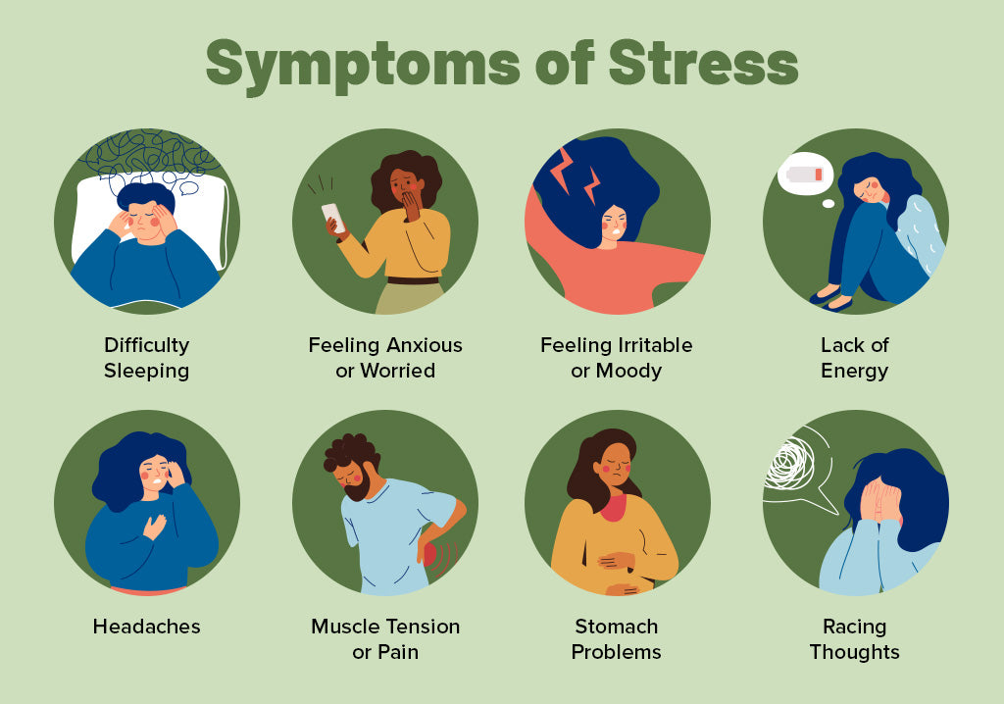
Understanding Stress Sources and Triggers: Stress emerges from various sources within professional and personal environments while affecting individuals differently based on personality, experience, and coping capabilities that influence stress perception and response patterns. Work-related stressors include excessive workload, unrealistic deadlines, role ambiguity, lack of control, and difficult relationships with colleagues or supervisors that create ongoing pressure and anxiety.
Recognizing Stress Symptoms and Warning Signs: Early recognition of stress symptoms enables proactive intervention while preventing escalation to more serious health and performance problems that could affect both individual and organizational effectiveness. Physical symptoms including headaches, muscle tension, fatigue, sleep disturbances, and digestive problems indicate that stress levels are affecting bodily systems while requiring attention and management strategies. Emotional symptoms such as irritability, anxiety, mood swings, depression, and feeling overwhelmed signal that stress is affecting mental health while potentially impacting relationships and decision-making capabilities. Behavioral changes including increased absence, decreased productivity, social withdrawal, increased substance use, or changes in eating patterns indicate that stress is affecting daily functioning and professional performance
Individual Stress Management Techniques: Effective stress management requires development of personal coping strategies while building resilience that enables sustained performance and well-being despite ongoing challenges and pressures in professional environments. Time management skills help individuals prioritize activities while eliminating non-essential tasks and creating realistic schedules that prevent overwhelm and enable completion of important objectives without excessive pressure. Relaxation techniques including deep breathing, progressive muscle relaxation, and meditation provide immediate stress relief while building long-term resilience and emotional regulation capabilities
Workplace Stress Management Strategies: Professional environments require specific stress management approaches that address work-related stressors while maintaining performance and building organizational capability for stress prevention and management. Boundary setting helps individuals separate work and personal life while preventing work stress from affecting personal relationships and activities that provide recovery and restoration. Communication skills enable individuals to express concerns and negotiate workload while building relationships that provide support and reduce interpersonal stress in professional settings.
Organizational Stress Prevention and Support: Organizations play crucial roles in stress management while creating environments that support employee well-being and prevent excessive stress that affects both individual and collective performance. Workload management involves realistic job design while ensuring adequate resources and support for task completion without creating excessive pressure or unrealistic expectations. Communication improvement reduces uncertainty while providing clear expectations, regular feedback, and opportunities for employee input that build engagement and reduce anxiety. Flexibility policies including remote work options, flexible schedules, and leave policies help employees manage personal and professional responsibilities while reducing stress from conflicting demands
Building Resilience and Long-term Coping Capability: Sustainable stress management requires development of resilience that enables individuals to maintain effectiveness while adapting to ongoing challenges and changes in professional and personal environments. Lifestyle management including adequate sleep, nutrition, and exercise provides foundation for stress resistance while supporting overall health and energy that enable better performance and stress management. Mindfulness practices build present-moment awareness while reducing anxiety about future events and regret about past situations that may create unnecessary stress and worry
TABLE 5.4:
Stress Category | Common Sources | Management Strategies
Work-Related | Excessive workload, role conflicts, difficult relationships | Time management, communication skills, boundary setting
Personal | Family issues, financial concerns, health problems | Social support, problem-solving, professional counseling
Environmental | Noise, poor workspace, technology issues | Workspace improvement, ergonomics, environmental control
Change-Related | Job transitions, organizational restructuring, new technology | Adaptation skills, learning mindset, support seeking

5.10 STRATEGIES FOR MANAGING STRESS EFFECTIVELY:
Stress management represents a critical professional competency that enables individuals to maintain performance, health, and well-being in contemporary business environments characterized by rapid change, high expectations, and complex challenges. Understanding stress sources and implementing effective coping strategies prevents negative impacts while maintaining productivity and personal satisfaction across various professional contexts.
The ability to manage stress effectively becomes increasingly important as organizations expect higher performance levels while individuals face greater complexity in both professional and personal responsibilities requiring sophisticated approaches and resilience building techniques.
Understanding Stress Sources and Recognition: Professional stress emerges from various sources within workplace and personal environments while affecting individuals differently based on personality, experience, and coping capabilities influencing stress perception and response patterns. Work-related stressors include excessive workload, unrealistic deadlines, role ambiguity, lack of control, and difficult relationships with colleagues or supervisors creating ongoing pressure and anxiety affecting performance and well-being.
Physical and Emotional Stress Symptoms: Early recognition of stress symptoms enables proactive intervention while preventing escalation to more serious health and performance problems affecting both individual and organizational effectiveness across various professional contexts. Physical symptoms including headaches, muscle tension, fatigue, sleep disturbances, and digestive problems indicate that stress levels are affecting bodily systems while requiring immediate attention and systematic management strategies for long-term health maintenance.
Individual Stress Management Techniques: Effective stress management requires development of personal coping strategies while building resilience that enables sustained performance and well-being despite ongoing challenges and pressures in professional environments and personal life. Time management skills help individuals prioritize activities while eliminating non-essential tasks and creating realistic schedules that prevent overwhelm and enable completion of important objectives without excessive pressure or anxiety. Relaxation techniques including deep breathing, progressive muscle relaxation, meditation, and mindfulness provide immediate stress relief while building long-term resilience and emotional regulation capabilities supporting overall well-being and professional effectiveness.
Workplace Stress Management Strategies: Professional environments require specific stress management approaches that address work-related stressors while maintaining performance and building organizational capability for stress prevention and effective management across all organizational levels. Boundary setting helps individuals separate work and personal life while preventing work stress from affecting personal relationships and activities that provide recovery and restoration outside professional responsibilities.
Building Resilience and Long-term Coping: Sustainable stress management requires development of resilience that enables individuals to maintain effectiveness while adapting to ongoing challenges and changes in professional and personal environments without compromising health or well-being. Lifestyle management including adequate sleep, proper nutrition, and regular exercise provides foundation for stress resistance while supporting overall health and energy that enable better performance and stress management throughout demanding professional and personal periods.
Organizational Stress Prevention and Support: Organizations play crucial roles in stress management while creating environments that support employee well-being and prevent excessive stress affecting both individual and collective performance across all organizational levels and departments. Workload management involves realistic job design while ensuring adequate resources and support for task completion without creating excessive pressure or unrealistic expectations that contribute to employee stress and burnout affecting organizational effectiveness.

Revision Questions:
Short Answer Questions:
- Define communication and explain its four essential elements in organizational contexts.
- List three types of communication barriers and provide one example of each type.
- What are the three ego states in Transactional Analysis and their basic characteristics?
- Explain the four quadrants of the Johari Window and their significance for relationships.
- Describe three key components of emotional intelligence and their workplace applications.
Long Answer Questions:
- Analyze the relationship between communication effectiveness and organizational performance, discussing how communication barriers impact business outcomes and strategies for improvement.
- Evaluate the application of Transactional Analysis in professional settings, examining how understanding ego states can improve communication and conflict resolution.
- Discuss the integration of emotional intelligence with leadership effectiveness, exploring how EQ capabilities enhance decision-making, relationship building, and team performance.
- Examine the role of stress management in professional development, analyzing sources of workplace stress and comprehensive strategies for building resilience and maintaining performance.
- Compare and contrast different approaches to developing emotional intelligence, analyzing their effectiveness across various organizational contexts and individual development needs.
Case Studies
Case Study 1: The Communication Breakdown Crisis
Patricia Williams serves as the Regional Operations Manager for MedTech Solutions, a medical device company with facilities across five states. She manages a team of twelve department heads who oversee manufacturing, quality control, logistics, and customer service operations. Recently, a series of communication breakdowns have created significant problems that threaten both product quality and customer relationships while damaging team morale and operational efficiency.
The crisis began when a new product specification change was communicated through email to department heads with a tight implementation deadline. Manufacturing Manager John Peterson interpreted the specifications one way and began production modifications, while Quality Control Manager Sandra Kim understood them differently and implemented conflicting testing procedures. The logistics team, led by Manager Robert Chen, never received the complete specifications and continued shipping products according to old standards.
When customers began reporting product performance issues, the customer service team, managed by Lisa Rodriguez, was unaware of any specification changes and provided incorrect information to concerned clients. This created additional confusion while damaging customer confidence in the company's reliability and technical expertise. The situation escalated when a major client threatened to cancel a significant contract due to quality inconsistencies and poor communication about product changes.
Patricia discovered that the communication breakdown stemmed from multiple factors including over-reliance on email for complex technical information, unclear message content that allowed multiple interpretations, and lack of confirmation procedures to ensure understanding. Additionally, time pressure prevented adequate discussion and clarification while creating defensive responses when problems emerged. Cultural differences within the diverse team affected communication styles and interpretation of messages while creating additional barriers to effective information sharing.
The team's emotional reactions to the crisis have further complicated resolution efforts. John feels frustrated that his interpretation was questioned while Sandra believes her quality concerns were dismissed initially. Robert is angry about being excluded from important communications while Lisa feels overwhelmed by customer complaints about issues she couldn't have prevented. Trust between departments has eroded as team members blame each other for the problems rather than focusing on systematic solutions.
Patricia recognizes that she needs to address both the immediate crisis and underlying communication problems that created the situation. Her own communication style tends to be direct and task-focused, which may not work effectively with all team members who have different cultural backgrounds and communication preferences. She realizes that emotional intelligence and stress management will be crucial for resolving current tensions while building better communication systems for the future.
The company's senior leadership is demanding quick resolution while customers expect immediate answers and corrective actions. Patricia must manage multiple stakeholder relationships while rebuilding team cohesion and implementing communication improvements that prevent similar problems in the future. The situation requires both crisis management skills and long-term system improvements that address the root causes of communication breakdown.
Time pressure is mounting as the client's contract decision deadline approaches while internal tensions continue to affect daily operations and employee morale. Patricia must demonstrate leadership that addresses both task and relationship issues while building confidence in her team's ability to work together effectively and prevent future communication crises.
Case Study 2: The Emotional Intelligence Leadership Challenge
Michael Chen has been promoted to Director of Business Development at GlobalTech Consulting, a firm specializing in technology implementation for multinational corporations. His new role involves leading a team of eight senior consultants while managing relationships with key clients and internal stakeholders across different cultural backgrounds and business practices. However, his promotion has created unexpected challenges that require significant emotional intelligence and interpersonal skills.
The team includes several strong personalities with different working styles and cultural backgrounds. Senior Consultant Amanda Foster is highly analytical and prefers detailed planning while sometimes appearing inflexible when changes are required. Consultant David Martinez is creative and relationship-focused but tends to make commitments without fully considering resource requirements or timeline implications. International Consultant Yuki Tanaka brings valuable cultural insights but communicates indirectly, making it difficult for other team members to understand her concerns or suggestions.
Recent client interactions have revealed Michael's limitations in emotional intelligence and cross-cultural communication. During a presentation to Japanese executives, his direct communication style and eagerness to close the deal were perceived as pushy and disrespectful, potentially jeopardizing a significant contract opportunity. In another situation, his response to a team member's personal crisis was seen as unsympathetic while his focus on project deadlines during a difficult period damaged the relationship and affected team morale.
Michael's own stress levels are increasing as he struggles to balance demanding client expectations with team development needs while adapting to senior leadership responsibilities that require different skills than his previous individual contributor role. His tendency to work independently and focus on technical solutions doesn't serve him well in situations requiring emotional sensitivity and relationship management across diverse groups and complex organizational dynamics.
The team's performance is suffering as interpersonal tensions affect collaboration while miscommunication with clients threatens business relationships that are crucial for the firm's growth strategy. Amanda has privately expressed frustration about what she perceives as Michael's favoritism toward David while questioning his decision-making processes and communication style. David feels micromanaged despite Michael's stated intention to provide support and guidance for professional development.
Yuki has become increasingly withdrawn from team discussions while her valuable insights are being lost due to communication style differences that prevent effective participation in planning and problem-solving activities. Other team members are taking sides in various conflicts while productivity and client satisfaction scores are declining from their previous high levels under the previous director's leadership.
The firm's senior partners have noticed the performance decline while expressing concern about client feedback regarding team coordination and communication effectiveness during project implementations. They expect Michael to resolve these issues quickly while maintaining revenue targets and client satisfaction levels that support the firm's reputation and competitive positioning in the consulting market.
Michael recognizes that technical expertise alone won't ensure success in his new role while understanding that emotional intelligence development is crucial for effective leadership in this complex, relationship-intensive environment. He needs to develop better self-awareness, emotional regulation, and social skills while learning to adapt his communication and management style to work effectively with diverse team members and international clients.
The situation requires immediate attention to prevent further deterioration while building long-term capability for emotional intelligence application in leadership contexts that will support both individual and team success in challenging business environments.
Case Study 3: The Stress Management and Team Performance Crisis
Sarah Thompson leads the Product Development team at InnovateTech, a fast-growing software company facing intense market competition and aggressive growth targets. The team of ten developers, designers, and project managers has been under extreme pressure for the past six months due to multiple concurrent projects, shortened development cycles, and increasing customer demands for rapid product updates and new features.
Stress levels throughout the team have reached critical points while affecting both individual performance and team collaboration in ways that threaten project success and employee retention. Senior Developer Mark Johnson has been working 70-hour weeks while showing signs of burnout including irritability, decreased creativity, and conflicts with colleagues who previously respected his technical expertise and collaborative approach. His recent mistakes in code development have created delays while requiring additional resources to correct problems that would normally be prevented.
UX Designer Jennifer Park has been experiencing anxiety and sleep difficulties while struggling to balance multiple project deadlines with quality standards that she refuses to compromise. Her perfectionist tendencies, usually an asset, have become problematic as she spends excessive time on details while missing broader project requirements and timeline expectations. Her communication with developers has become tense as she criticizes their work while feeling unsupported in her efforts to maintain user experience quality.
Project Manager Carlos Rodriguez is caught between senior management demands for faster delivery and team members who are reaching their capacity limits while dealing with personal and professional stress that affects their availability and effectiveness. His attempts to manage workload and protect team members from excessive pressure have been unsuccessful while his own stress levels are affecting his decision-making and leadership effectiveness.
The team's stress is manifesting in various ways including increased absenteeism, higher error rates, reduced collaboration, and rising interpersonal conflicts that create additional stress and further reduce productivity. Several team members have expressed interest in leaving the company while others are simply disengaging from their work to protect their mental health and personal relationships that have been suffering due to work pressures.
Customer satisfaction scores are declining as products are released with quality issues while delayed launches affect company reputation and competitive positioning in the rapidly evolving software market. Senior leadership is demanding explanations for performance problems while applying additional pressure for improved results that seem to be making the situation worse rather than better.
Sarah recognizes that traditional approaches to performance management won't address the underlying stress issues while understanding that both individual and organizational interventions are needed to restore team effectiveness and prevent talent loss. She needs to develop comprehensive stress management strategies while working with senior leadership to create more sustainable work practices and realistic expectations.
The challenge involves balancing business pressures with employee well-being while implementing stress management techniques that enable sustained high performance without creating long-term health and retention problems. Sarah must also manage her own stress levels while providing leadership that supports team recovery and builds resilience for future challenges.
Time constraints prevent extensive team building or stress reduction programs while ongoing project commitments require continued high performance from team members who are already at capacity limits. The situation demands creative solutions that address immediate stress relief while building long-term organizational capability for stress prevention and management in high-pressure environments.
Fun Activity:
The Communication and Emotional Intelligence Challenge
Objective: Provide participants with engaging, practical experience in applying communication skills, emotional intelligence, and stress management techniques through interactive scenarios that mirror real workplace challenges and interpersonal dynamics.
Setup and Materials:
Divide participants into teams of 5-6 people with diverse roles and backgrounds
Provide scenario cards representing different communication challenges and emotional situations
Create communication props including role descriptions, background information, and constraint cards
Prepare assessment sheets for peer evaluation and self-reflection on emotional intelligence applications
Game Structure: The activity progresses through three interconnected rounds focusing on different aspects of communication and emotional intelligence while building complexity and requiring integration of multiple skills for successful completion of challenges and relationship management.
Each round includes briefing sessions where teams receive scenarios and plan approaches, implementation phases where communication challenges are enacted, and debriefing periods where participants analyze outcomes and identify improvement opportunities using emotional intelligence frameworks.
Round One - Communication Effectiveness: Teams face various communication barriers while practicing message clarity, active listening, and feedback techniques across different scenarios including cross-cultural interactions, conflict situations, and high-pressure decision-making contexts that require adaptive communication approaches.
Round Two - Emotional Intelligence Application: Participants practice self-awareness, emotional regulation, and empathy skills while managing challenging interpersonal situations that require understanding of ego states, emotional contagion, and relationship dynamics in professional contexts.
Round Three - Stress Management Integration: Teams deal with high-pressure scenarios while applying stress management techniques, building resilience, and maintaining communication effectiveness under challenging conditions that test both individual and team capabilities.
The activity concludes with comprehensive reflection on communication patterns, emotional intelligence applications, and stress management strategies while developing personal action plans for continued improvement in professional settings and relationship building.

**********

