Design and Development of a Nuclear-Powered Cargo Vessel Using Small Modular Reactor Technology
1. Objective
To design a safe, efficient, and zero-carbon cargo ship propulsion system powered by a compact nuclear reactor, reducing dependence on fossil fuels and enabling long-duration voyages without refueling.
2. Background & Need
Global shipping contributes ~3% of CO₂ emissions. Traditional fuels (HFO, diesel) are:
- Polluting
- Expensive
- Logistically complex
Using nuclear energy based on Nuclear Fission offers:
- High energy density
- Long operational life (5–10 years without refueling)
- Zero greenhouse emissions during operation
3. System Overview
A. Core Components
- SMR Reactor Unit
  - Fuel: Low enriched uranium / advanced fuels
  - Output: 50–150 MW thermal
- Steam Generation System
  - Heat exchanger converts water → steam
- Turbine Generator
  - Steam drives turbine → electricity
- Electric Propulsion System
  - Electric motors drive propellers
- Shielding & Safety Systems
  - Radiation containment
  - Passive cooling
Working Principle
- Reactor produces heat via fission
- Heat generates steam
- Steam spins turbine
- Electricity powers propulsion motors
4. Ship Design Specifications (Conceptual)
Sl No | Parameter | Value
1 | Vessel Type | Ultra Large Container Ship
2 | Capacity | 15,000–20,000 TEU
3 | Reactor Type | SMR (Integral PWR)
4 | Power Output | ~70 MW electric
5 | Speed | 20–24 knots
6 | Refueling Cycle | 7–10 years

5. Safety Features
- Passive cooling (no human intervention required)
- Double containment reactor vessel
- Shock-resistant marine reactor housing
- Emergency shutdown (SCRAM system)
- Radiation shielding using lead + water barriers
6. Environmental Impact
Advantages:
- Zero CO₂ emissions
- No sulfur or NOx pollution
- Reduced fuel transport
Concerns:
- Nuclear waste handling
- Port entry restrictions
7. Economic Analysis
Sl No | Factor | Estimate
1 | Initial Cost | Very High
2 | Fuel Cost | Very Low
3 | Maintenance | Moderate
4 | Lifecycle Cost | Competitive over 20–30 years

Long-term savings due to:
- No fossil fuel dependency
- Fewer refueling stops
8. Regulatory Considerations
- International Maritime Organization (International Maritime Organization) approval
- Nuclear safety compliance
- Coastal country permissions
- Waste disposal regulations
9. Innovation Opportunities
- Integration with Thorium Fuel Cycle
- AI-based reactor monitoring
- Hybrid nuclear-electric propulsion
- Autonomous shipping systems
10. Methodology
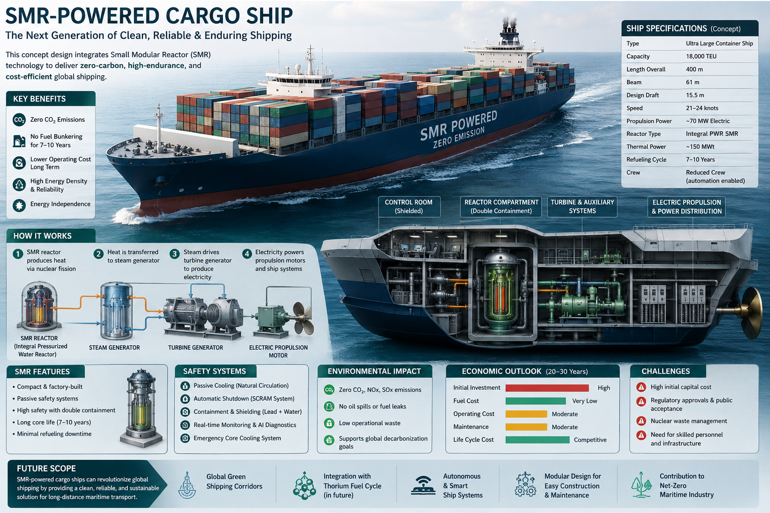
- Literature review on marine nuclear systems
- SMR design selection
- Thermal & structural simulation
- Safety analysis (failure scenarios)
- Economic feasibility study
- Prototype digital modeling (CAD/ANSYS)
11. Timeline
Sl No | Phase | Duration
1 | Research | 3 months
2 | Design | 4 months
3 | Simulation | 3 months
4 | Analysis | 2 months
5 | Final Report | 1 month

12. Expected Outcomes
- Conceptual ship design with SMR integration
- Safety and feasibility validation
- Emission reduction model
- Cost-benefit analysis
13. Challenges
- Public acceptance
- Nuclear liability issues
- High capital investment
- Skilled workforce requirement
14. Future Scope
- Commercial deployment by 2040
- Nuclear-powered green shipping corridors
- Integration with global decarbonization goals
15. Conclusion
SMR-powered cargo ships represent a next-generation maritime solution combining:
- Clean energy
- High efficiency
- Long endurance
With proper regulatory support and technological advancement, this can revolutionize global shipping.

