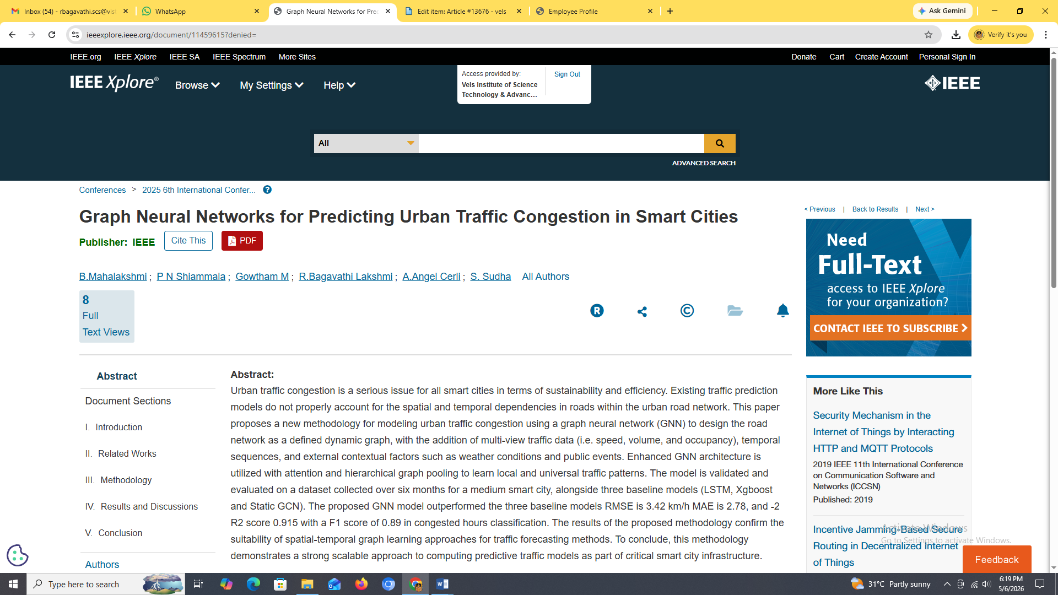

Graph Neural Networks for Predicting Urban Traffic Congestion in Smart Cities

