Increasing Schizophrenia Prediction Performance Using Advanced Deep Learning Learning Methodologies

R.Deepa, Research Scholar,Vels Institute of Science and Technology and Advanced Studies, deepar.se@velsuniv.ac.in
Dr.A.Packialatha,Associate Professor,Vels Institute of Science and Technology and Advanced Studies, packialatha.se@velsuniv.ac.in

Abstract:

Predicting schizophrenia is a difficult task that can tremendously benefit from machine learning. In this study, it is suggested a thorough technique that includes data gathering, pre-processing, model building, training, and evaluation. Convolutional neural networks (CNNs), Deep Neural Networks (DNNs), and Recurrent Neural Networks (RNNs) are three Deep Learning architectures that were investigated for their ability to predict schizophrenia. The findings indicated that RNNs are suitable for capturing temporal dependencies in patient data, with the best accuracy rate of 0.87 being achieved in proposed study. Additionally, DNNs with more extensive training data have greater development potential, while CNNs perform competitively according to F1-Scores. CNNs regularly have higher precision values, demonstrating their dependability in reducing false positives. This research's future focus is on validation and optimisation, which will guarantee its robustness for clinical application. Interpretability can be improved by incorporating explainable AI (XAI) approaches. Beyond diagnosing, these models can pinpoint those who are at danger, allowing for early interventions and individualised treatment programmes. For effective application, collaboration with healthcare professionals, ethical considerations, and data privacy are essential.

Key words: Explainable AI, recurrent neural networks, deep learning, schizophrenia prediction.

Introduction:

Schizophrenia, a severe and complicated mental illness, continues to provide difficult problems for academics and practitioners alike [1]. Due to its complex nature, which is characterised by a wide variety of symptoms, patient variability, and the lack of conclusive biomarkers, early diagnosis and effective treatments are particularly difficult [2]. However, current developments in machine learning, along with access to large datasets and cutting-edge neuroimaging methods [3], have created new opportunities for improving schizophrenia prediction. With the aid of machine learning, here suggest a methodical strategy for predicting schizophrenia in this thorough methodology. This methodology includes a number of crucial steps, including the preparation of data and thorough evaluation after selecting, developing, and training the model. By adhering to this scientific approach, it is required to improve capacity to properly and consistently forecast schizophrenia, which could result in earlier diagnosis and better patient outcomes [4].

The Complex Diagnosis Landscape for Schizophrenia

Because schizophrenia is so complex and has so many facets, predicting it is a difficult undertaking. Inhibited social and cognitive functioning, hallucinations, delusions, and disorganised thinking are only a few of the symptoms that define schizophrenia [5]. Additionally, the way that these symptoms express themselves might differ greatly from person to person, adding to the disorder's heterogeneity.

Difficulties in Diagnosing Schizophrenia

The difficulties in diagnosing schizophrenia are caused by a number of factors [6]:

1. Patient Heterogeneity: Patients with schizophrenia display a diverse range of psychological states, making it challenging to develop a consistent diagnostic paradigm. Variations in patients' capacities to offer trustworthy information can make the diagnosis process more challenging.

2. Clinician Inconsistency: When evaluating the same patient, various clinicians may come to different diagnoses, showing the lack of diagnostic dependability in the field of psychiatry.

3. Nomenclature Inadequacy: The intricacy and complexities of schizophrenia and related diseases may not be sufficiently captured by the present nomenclature and classification systems.

4. Lack of Biomarkers: Unlike many medical illnesses, schizophrenia lacks definite biomarkers that help in diagnosis. Clinical symptoms are primarily observed during diagnosis.

The Function of Objective Assessment: There is an urgent need for unbiased assessments to overcome the difficulties brought on by the difficult terrain of schizophrenia diagnosis. The reliability of classification judgements in psychiatry can be improved by using objective measurements as a beneficial layer of evaluation[7].

Utilising Neuroimaging as a Measure: Neuroimaging stands out among the variety of objective evaluation methods as a promising direction. The structure and function of the brain can be seen through neuroimaging methods including functional magnetic resonance imaging (fMRI) and structural magnetic resonance imaging (sMRI) [8]. Neuroimaging has attracted a lot of interest because it has the potential to shed light on the biological foundations of psychiatric illnesses, despite the fact that it has not yet been fully integrated into ordinary clinical practise.

Power of Machine Learning: The discipline of machine learning to successfully utilise the promise of neuroimaging data [9]. Recent years have seen incredible progress in the field of machine learning, which uses statistical techniques to find patterns in massive datasets. Machine learning approaches can identify small but substantial changes in the local morphological characteristics of different brain sub regions when applied to neuroimaging data. These variations, which are sometimes referred to as "disorder-related brain patterns," have the potential to be extremely useful diagnostic indicators.

Machine Learning with Neuroimaging: A Revolutionary Collaboration: In especially in the context of schizophrenia, the merger of machine learning and neuroimaging creates a revolutionary alliance that has the potential to revolutionise psychiatric diagnosis [10]. This cooperation makes the following major commitments: Machine learning is particularly adept at identifying intricate patterns in huge datasets. It can reveal minute but significant changes in brain structure and function that may underlie mental illnesses when applied to neuroimaging data. These variations, which are frequently challenging for human observers to notice, can be important diagnostic traits. Machine learning models have previously been the subject of numerous studies looking at psychiatric diagnosis [11]. Differentiating between those with psychiatric illnesses and people who are usually developing has been the focus of some investigations. However, there is rising acceptance that in order to create a more trustworthy psychiatric nosology, the differences between various patient groups are comprehended. The diagnostic environment is further complicated by knowledge of the overlap between several neuropsychiatric illnesses, such as schizophrenia and ASD.

Motivation:
The early detection and successful treatment of schizophrenia, a difficult and diverse mental illness, provide a formidable challenge to the area of mental health [12]. The revolutionary impact of cutting-edge machine learning algorithms and neuroimaging technology, however, casts a ray of optimism on the future. It has the ability to increase the reliability of the schizophrenia prediction, which could result in an earlier diagnosis and better patient outcomes. The motivation is simple in this complex and uncertain environment: to use cutting-edge machine learning and neuroimaging techniques to tackle the problems schizophrenia poses [13]. This work is driven by a rigorous and systematic strategy that is intended to navigate the complex schizophrenia diagnosis environment. The challenges in making a schizophrenia diagnosis are varied and significant. The variety of psychological states that patients display makes it difficult to develop a reliable diagnostic paradigm. Furthermore, the situation is made worse by physician inconsistency and inadequate terminology. Contrary to many other diseases, schizophrenia cannot be diagnosed with certainty based solely on clinical symptoms.

The inspiration comes from the pressing requirement for impartial and objective evaluations in psychiatric diagnosis. With the use of these technologies, it may deep inside the complex operations of the brain and learn more about the biological causes of psychiatric disorders. Machine learning, a field that has advanced significantly in recent years. Machine learning makes use of statistical approaches to find patterns in huge datasets, showing minute but important alterations in brain structure and function that may be suggestive of mental diseases. These "disorder-related brain patterns," as they are commonly referred to, have the potential to be useful diagnostic markers. The motivation extends to the ground breaking collaboration between machine learning and symptoms, particularly in the context of schizophrenia. This alliance offers major commitments, including the use of several neuroimaging modalities, applications for psychological diagnosis, and machine learning for pattern identification. With the aid of various datasets and a variety of deep learning models, such as Convolutional Neural Networks (CNNs), Deep Neural Networks (DNNs) [14], and Recurrent Neural Networks (RNNs),[15] hope to increase the accuracy of schizophrenia diagnosis via the lens of machine learning. Hence it is motivated by the potential of these models to identify schizophrenia based on clinical evaluations, genetic markers, and neuroimaging data, among other data sources. The possibility of changing psychiatric diagnosis and, eventually, the lives of people affected by schizophrenia, is what motivated to set out on this adventure. The work is motivated to push the limits of what is feasible in the field of mental health by the strength of cutting-edge machine learning approaches and the insights provided by neuroimaging. With the drive stems from the conviction that, with hard work and creativity, it is possible to achieve significant advancements in the early diagnosis and treatment of schizophrenia, providing hope and healing to those who most need it.

Justification:

A number of persuasive arguments support the suggested method for predicting schizophrenia utilising sophisticated machine learning techniques, in particular deep learning models and symptom data. The intricacy of schizophrenia, with its range of symptoms and patient variances, makes conventional diagnostic techniques difficult to use. The ability of machine learning to recognise subtle patterns shows promise in tackling this complexity. Diagnoses in psychiatry sometimes depend on subjective evaluations, which causes discrepancies among practitioners. The suggested technique promotes objectivity and lowers the possibility of misdiagnosis by adding neuroimaging data. There are no conclusive biomarkers to diagnose schizophrenia. The understanding of the disease may be furthered by using machine learning to neuroimaging data and revealing hidden biomarkers.

Diverse datasets, such as those derived from genetic, neuroimaging, and clinical research, offer a rich supply of insights. Extraction of knowledge from this complexity is a strength of machine learning, increasing prediction accuracy. For individualised care and prompt intervention, which both machine learning can aid, it is essential to be able to distinguish between patient groups and recognise early indications of schizophrenia. Machine learning models are useful in psychiatry because they may change to reflect new understanding. The suggested strategy guarantees that it is current with research. The proposed method also offers reliable results because it adheres to a strict scientific process. Ultimately, the need for improved schizophrenia diagnosis validates the suggested approach, which makes use of cutting-edge machine learning and neuroimaging data to revolutionise diagnosis and treatment through data-driven insights, objectivity, and adaptability.

Contribution:

The key contributions of the previously mentioned material can be summed up as follows:

1. Enhanced Diagnostic Precision: Using cutting-edge machine learning techniques and neuroimaging data, the proposed approach greatly increases the accuracy of schizophrenia diagnosis. It can find complex patterns and obscure biomarkers, which is more than human clinicians are capable of. As a result, diagnoses become not only more trustworthy but also significantly more accurate.

2. Early Intervention and Personalization: This study discusses the possibility of early intervention in schizophrenia, which is essential for improving patient outcomes. Additionally, it makes it easier to adopt individualised treatment plans by differentiating between various patient groups and ailment subtypes. By addressing each person's particular needs, this differentiation helps to provide treatment that is both more effective and more individualised.

3. Scientific Progress and Hope: This study makes a significant contribution to the development of the psychiatric field thanks to its methodical and multidisciplinary approach. By encouraging cooperation between many fields of expertise, it considerably advances science in the field of psychiatry. The findings of this study ultimately offer hope for those who are living with schizophrenia by showing a viable route towards better diagnostic specificity, deeper comprehension, and more potent treatment options for this complex mental condition.

Paper has been organised as follows, next session explains various works existing in the field, followed by the proposed methodology, followed by results and discussion, comparing the performance with the existing works. Finally conclusion with future scope.

Related work

A neuropsychiatric condition with a complex and severe propensity of one percent worldwide is schizophrenia. Early detection and treatment are essential to halting its progression and enhancing recovery. However, the clinical diagnosis and evaluation of schizophrenia and its high-risk stages have long been hampered by the lack of objective biomarkers. In order to tackle this problem, researchers have recently resorted to machine learning and neuroimaging methods. In order to increase the reliability and accuracy of schizophrenia diagnosis, early detection, and treatment prediction, this literature review focuses on the use of neuroimaging data, such as electroencephalogram (EEG) [16] and functional magnetic resonance imaging (fMRI), in conjunction with machine learning algorithms.

Utilising microstate analysis with resting-state EEG data is one interesting research direction. In a study by [17], EEG data were collected from participants with first-episode schizophrenia (FESZ), those who were ultra-high-risk (UHR), high-risk (HR), and healthy controls (HC) of developing schizophrenia. Researchers were able to evaluate the dynamics of functional networks in these subjects using microstate analysis. For each group, important characteristics such as the length, frequency, and time coverage of microstates were retrieved. The findings showed that microstate characteristics, in particular those from microstate class D, could successfully identify between the four groups of people. Importantly, EEG-based microstate parameters produced a strong classification performance utilising the random forest model when paired with clinical assessments and cognitive tests, averaging 92% average accuracy, 91.8% average sensitivity, and 90.8% average specificity. According to this finding, the combination of behavioural tests and neuroimaging data may be a powerful diagnostic tool for the early identification and prognosis of schizophrenia and other high-risk conditions. The application of machine learning algorithms and data from functional magnetic resonance imaging (fMRI) is another promising strategy for enhancing the diagnosis of schizophrenia. A weighted deep forest model that combines a weighted class vector with a prediction class vector was proposed by [18]. Functional connection (FC) features were particularly extracted using this model using fMRI data. The dimensionality of these FC features was decreased using principal component analysis (PCA). Notably, the study used the Synthetic Minority Over-sampling Technique (SMOTE) to solve the problem of unbalanced data. The outcomes showed that the weighted forest model performed better than conventional classifiers, obtaining a higher level of classification accuracy. This method has the potential to help doctors diagnose schizophrenia more accurately since it increases the accuracy of the results of the diagnostic process.

Other neuropsychiatric illnesses, such as autism spectrum disorder (ASD), and schizophrenia have certain similarities. Brain scans from people with schizophrenia, ASD, and typically developing people were examined in a study by [19]. They extracted characteristics associated with subcortical volume and cortical thickness using the Free Surfer programme. Six separate classifiers were then utilised using these attributes to divide the subjects into their appropriate categories. Cortical thickness and subcortical volume parameters were emphasised as important in the study, with logistic regression (LR) and support vector machines (SVM) appearing as the most successful classifiers. Notably, these classifiers showed the ability to predict diagnostic categories when used with ultra-high-risk for psychosis (UHR) and first-episode psychosis (FEP) individuals, with LR and SVM exhibiting high consistency with clinical indices. This method demonstrates how neuroimaging and machine learning can improve diagnostic precision and forecast the course of schizophrenia and other similar disorders. The complexity and variability of the condition, which makes it difficult to develop objective criteria, add to the difficulty of making a diagnosis of schizophrenia. [20] Addressed recent developments in the prodromal, first episode, and chronic phases of schizophrenia classification using EEG data and machine learning. Schizophrenia may have biomarkers in the form of altered EEG patterns, particularly in event-related potentials, which have been linked to sensory and cognitive abnormalities. For a more accurate classification of schizophrenia, advanced machine learning techniques have been investigated. The potential of EEG-based models to predict the beginning of schizophrenia, identify people who are at high risk, and distinguish schizophrenia from other disorders is highlighted in this review, which could ultimately help with early interventions. Schizophrenia is known to be significantly influenced by white matter abnormalities. [21] Calculated brain age from diffusion tensor imaging (DTI) data and compared it between schizophrenia, bipolar disorder (BD), and healthy controls. Based on DTI indices of the structure and organisation of the white matter, machine learning models were trained to estimate brain age. The study discovered that the models greatly overstated the age of patients with schizophrenia and BD when compared to healthy controls. This implies that departures from expected lifespan trajectories make up white matter aberrations in these illnesses. The study emphasises the ability of neuroimaging-based methods to evaluate structural variations in the brain linked to neuropsychiatric diseases.

Effective therapeutic management of schizophrenia depends on early response. The use of functional MRI (fMRI) data to forecast early treatment response in schizophrenia was investigated by [22]. The study's goal was to find predictive biomarkers by assessing the amplitude of low-frequency fluctuation (ALFF) at the beginning of the first/single episode that resulted in hospitalisation. In comparison to non-responders, responders were shown to have higher baseline ALFF in particular brain areas. The study presented the idea of ALFFratio, demonstrating its potential to reasonably discriminate respondents from non-responders. According to this study, neuroimaging has the potential to affect clinical treatment choices and enhance the management of schizophrenia. Numerous impairments in many different functional areas, such as cognition, social interaction, and daily functioning, are linked to schizophrenia. The fact that these impairments are linked to various aspects of disability rather than being one universal component is stressed by [23]. Furthermore, gains in daily functioning have been linked to long-term clinical stability, which is frequently attained through therapy with long-acting antipsychotic drugs. The review emphasises how crucial it is to take into account disability and its determinants as multidimensional elements in the diagnosis and treatment of schizophrenia.

In [24] presented an ensemble model dubbed EMPaSchiz that utilised resting-state fMRI data from individuals with schizophrenia who were drug-naive. In order to incorporate predictions from many "single-source" models based on aspects of regional activity and functional connectivity, EMPaSchiz used a single modality of MRI collection. EMPaSchiz impressively outperformed earlier machine learning models that weren't specifically trained on drug-naive patients, achieving a classification accuracy of 87%. As a scalable diagnostic tool for schizophrenia diagnosis, this strategy shows potential.

Proposed Schizophrenia Prediction Methodology

Schizophrenia is a complicated condition, predicting it might be difficult. The availability of large datasets and advances in machine learning have created new opportunities for early detection and treatment, though. In this suggested methodology, a thorough strategy for predicting schizophrenia using machine learning methods is presented. Data pre-processing, model building, training, and evaluation are all included in this methodology. Any machine learning endeavour begins with data collection. It is essential to compile a diversified and thorough dataset that encompasses a wide variety of features in the context of schizophrenia prediction. These characteristics ought to include a range of elements important for the diagnosis and prognosis of schizophrenia, including:

1. Clinical Assessments: Compile information from clinical evaluations, such as the severity of the symptoms, the length of the illness, and family history.
2. Genetic Markers: Include genetic data, such as DNA strands or genetic identifiers linked to schizophrenia.
3. Include demographic information, such as age, gender, and ethnicity, as these variables may affect the diagnosis.
4. Neuropsychological Tests: Compile the results of tests that evaluate cognitive function, which is frequently hampered in people with schizophrenia.

The actigraphy data collected from people with schizophrenia are included in the PSYKOSE dataset has been used for this work [25]. It includes information from 32 controls and 22 patients with schizophrenia. Sensor data gathered over a period of days is provided for every person in the dataset. The dataset also contains demographic data and medical examinations performed during the observation period in addition to sensor data. The dataset distribution based on the class is shown in figure 1, based on class_str is shown in figure 2. The features distribution is shown in figure 3.
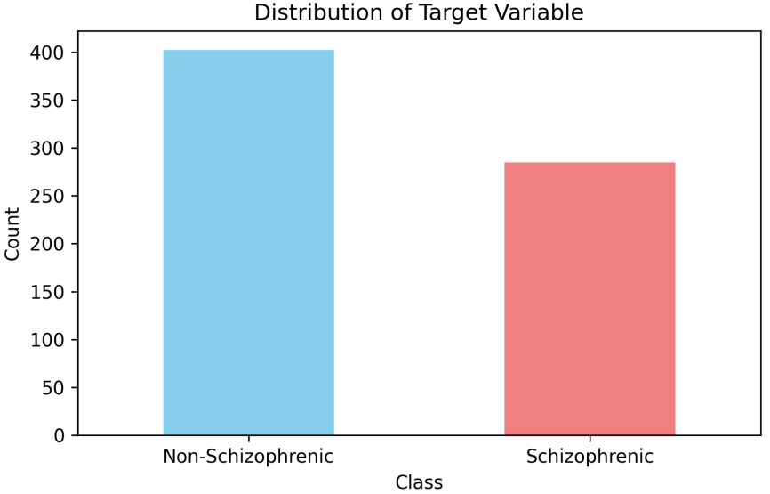
Fig. 1: Class distribution based on Schizophrenia and Non Schizophrenia
\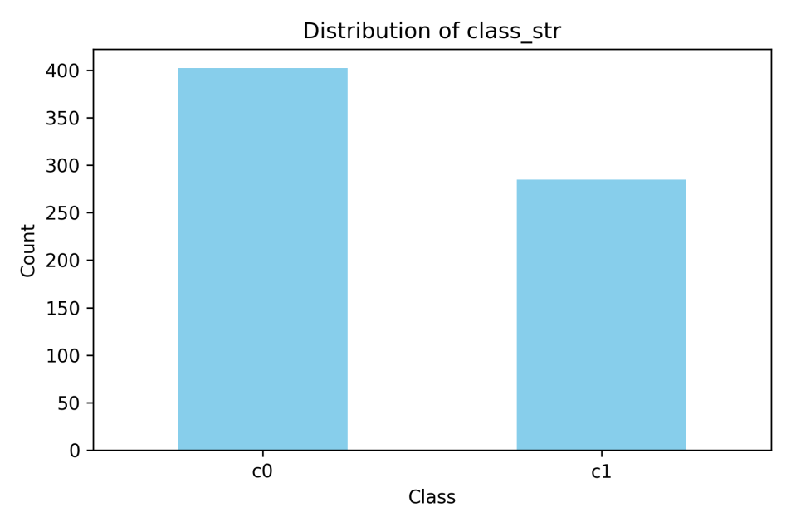
Fig. 2: Class distribution based on c0 and c1

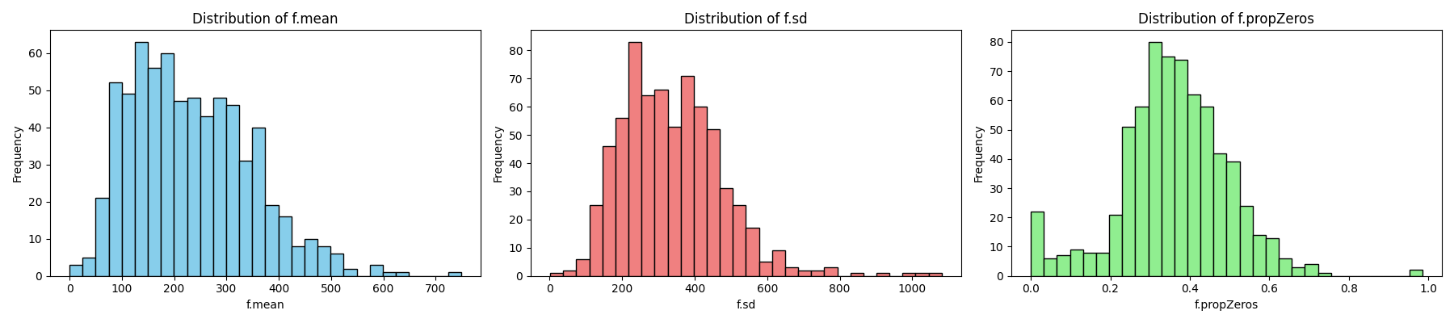
Fig. 3: features distribution on the dataset
Cleaning and Exploration of Data

It's crucial to pre-process the data to verify its quality and integrity before beginning to create the model:

1. Handling Missing Values: Use methods like imputation or the removal of incomplete records to locate and deal with missing values in the dataset.

2. Outlier Detection and Treatment: Recognise outliers that may affect the outcomes of machine learning models, and deal with them.

3. Perform exploratory data analysis (EDA) to comprehend the dataset more thoroughly. Visualise data distributions, relationships between characteristics, and possible schizophrenia-related patterns.

Model Development and Selection

Data Splitting

It is crucial to separate the dataset into training, validation, and testing sets before developing and testing machine learning models. Additionally, cross-validation can be used to assure accurate model performance evaluation. For this proposed work the data has been split in the ratio of 80:20, for training and validation

Model Architecture

The type of data being used and the precise objectives of the prediction task determine the model architecture to be used.

1. Create a deep neural network architecture specifically for the dataset using deep learning. Multiple layers for feature learning and classification may be present in this architecture.

2. Convolutional Neural Network (CNN): Create a CNN architecture appropriate for image-based schizophrenia prediction if the dataset contains image data (such as brain scans). CNNs are good at identifying spatial patterns in pictures.

3. Recurrent neural network (RNN): Create an RNN architecture when sequential data is present (such as time series data pertaining to a patient's medical history). For modelling sequential dependencies, RNNs are appropriate.

Deep Learning for Schizophrenia Prediction from Data

Convolutional Neural Networks (CNNs), Deep Neural Networks (DNNs), and Recurrent Neural Networks (RNNs) are used to analyse data that contains a wide variety of features with the hope of improving schizophrenia diagnosis. The data is made up of a number of fields, including 'class' and 'class_str', with the following encoding:
- 'class':
-0: A sign that schizophrenia is not present.
Schizophrenia is present, as indicated by the number 1.
'class_str' -
- 'c0': Describes the absence of schizophrenia.
- 'c1': Relates to schizophrenia.

Convolutional Neural Network

Features from Data Extracted: Despite having a distinct structure from standard photos, CSV data contains useful information for predicting schizophrenia. Adapted CNNs show promise for handling tabular data.

1. Input Data: Each row in the dataset contains the information about a patient, and the columns stand for different features.
2. Convolutional Layers: Convolutional layers work with the feature columns to identify significant relationships and patterns. Slider filters move across the columns to find pertinent features.
3. Pooling Layers: Pooling layers reduce dimensionality while maintaining critical information by down sampling the feature maps produced by convolutional layers.
4. Fully Connected Layers: To make predictions, extracted features are flattened and processed through fully connected layers.

CNN architecture used for the proposed work

Layer (type) Output Shape Param #
===========================================================
input_1 (InputLayer) [(None, X_train.shape[1])] 0
___________________________________________________________
conv2d (Conv2D) (None, X_train.shape[1]-2, 64) X_train.shape[1] * 3 * 64 + 64
___________________________________________________________
max_pooling2d (MaxPooling2D)(None, (X_train.shape[1]-2)/2, 64) 0
___________________________________________________________
conv2d_1 (Conv2D) (None, (X_train.shape[1]-2)/2-2, 128) 73856 (64 * 3 * 128 + 128)
___________________________________________________________
max_pooling2d_1 (MaxPooling2D)(None, ((X_train.shape[1]-2)/2-2)/2, 128) 0
___________________________________________________________
flatten (Flatten) (None, ((X_train.shape[1]-2)/2-2)/2 * 128) 0
___________________________________________________________
dense (Dense) (None, 64) (((X_train.shape[1]-2)/2-2)/2 * 128) * 64 + 64
___________________________________________________________
dropout (Dropout) (None, 64) 0
___________________________________________________________
dense_1 (Dense) (None, 32) 2080 (64 * 32 + 32)
___________________________________________________________
dense_2 (Dense) (None, 1) 33 (32 * 1 + 1)
===========================================================
Total params: (X_train.shape[1] * 3 * 64 + 64) + 73856 + (((X_train.shape[1]-2)/2-2)/2 * 128) * 64 + 2080 + 33
Trainable params: (X_train.shape[1] * 3 * 64 + 64) + 73856 + (((X_train.shape[1]-2)/2-2)/2 * 128) * 64 + 2080 + 33
Non-trainable params: 0

DNNs (Deep Neural Networks)

DNNs give you the freedom to create unique architectures that are suited to the features of the data.

For data, the DNN architecture is as follows:

1. Input Data: The dataset columns reflect the different features, and each row acts as input data.
2. Hidden Layers: Hidden layers are added to help the data learn intricate representations. Based on experiments, the number of hidden layers and neurons per layer can be changed.
3. Activation Functions: The neurons in hidden layers are subjected to non-linear activation functions (such as ReLU), which introduce non-linearity into the model.
4. Output Layer: The output layer offers forecasts on the diagnosis of schizophrenia. For binary classification, activation functions like the sigmoid may be utilised.

DNN architecture used for the proposed work

Layer (type) Output Shape Param #
===========================================================
input_1 (InputLayer) [(None, X_train.shape[1])] 0
___________________________________________________________
dense (Dense) (None, 128) X_train.shape[1] * 128 + 128
___________________________________________________________
dropout (Dropout) (None, 128) 0
___________________________________________________________
dense_1 (Dense) (None, 64) 8256 (128 * 64 + 64)
___________________________________________________________
batch_normalization (BatchN (None, 64) 256 (scaling and shifting parameters)
___________________________________________________________
dense_2 (Dense) (None, 32) 2080 (64 * 32 + 32)
___________________________________________________________
dropout_1 (Dropout) (None, 32) 0
___________________________________________________________
dense_3 (Dense) (None, 16) 528 (32 * 16 + 16)
___________________________________________________________
dense_4 (Dense) (None, 1) 17 (16 * 1 + 1)
===========================================================
Total params: X_train.shape[1] * 128 + 128 + 8256 + 256 + 2080 + 528 + 17
Trainable params: X_train.shape[1] * 128 + 128 + 8256 + 256 + 2080 + 528 + 17
Non-trainable params: 0

RNNs, or recurrent neural networks

RNNs are excellent at analysing sequential patient data, such as symptom histories or treatment outcomes, and they successfully capture the temporal dependencies necessary for the prediction of schizophrenia. Following is a definition of the RNN architecture for data with sequential information:

1. Sequential Input: The dataset file's columns serve as features and each row's data represents a patient. The temporal component can be used by the RNN to learn from the organisation of sequential input across time.
2. Recurrent Cells: To recognise temporal dependencies, RNNs contain recurrent cells like Long Short-Term Memory (LSTM). These cells preserve hidden states that affect predictions made using historical data.
3. Temporal Modelling: RNNs simulate the relationship between past data points and future outcomes, which is essential for psychiatric diagnosis where symptom progression is important.

RNN architecture used for the proposed work

Layer (type) Output Shape Param #
===========================================================
lstm (LSTM) (None, X_train.shape[1], 128) 66560
___________________________________________________________
lstm_1 (LSTM) (None, X_train.shape[1], 64) 49408
___________________________________________________________
lstm_2 (LSTM) (None, X_train.shape[1], 32) 12416
___________________________________________________________
lstm_3 (LSTM) (None, 16) 3136
___________________________________________________________
dense (Dense) (None, 32) 544
___________________________________________________________
dense_1 (Dense) (None, 1) 33
===========================================================
Total params: 127,097
Trainable params: 127,097
Non-trainable params: 0

With the use of CNNs, DNNs, and RNNs, in particular to improve the accuracy of schizophrenia diagnosis utilising data. By adapting to tabular data, these designs make it possible to automatically extract pertinent patterns and temporal correlations. Healthcare practitioners are now better equipped to diagnose complicated disorders like schizophrenia with greater precision and to deliver timely, focused interventions to those who are suffering from them.

Model Training

After choosing the architecture, next step is to train the models:

1. Transfer Learning Model: If transfer learning is employed, adjust the model that was previously developed using the dataset for schizophrenia. Use a suitable optimizer, such as Adam, and a suitable loss function.

2. bespoke Deep Learning Models: Train these models with various numbers of epochs to discover the best model for bespoke DNN, CNN, or RNN architectures. To get the best results, try out various optimizers, learning rates, and batch sizes.

Model Assessment

A critical stage in evaluating the effectiveness of the trained models is model evaluation:

1. Metrics: To gauge how successfully the model predicts schizophrenia, use relevant evaluation metrics including accuracy, precision, recall and F1-score

2. Validation Data: Make adjustments to the hyper parameters in the validation dataset to make sure the model generalises properly to new data. To prevent overfitting, modify the model's parameters based on the results of the validation.

Results and Discussion

The table 1 provides a comparison of various deep learning models developed across multiple epochs for predicting schizophrenia. Deep Neural Networks (DNN), Convolutional Neural Networks (CNN), and Recurrent Neural Networks (RNN) are the three models being considered. At four different epoch intervals—250, 500, 750, and 1000 epochs—each model's accuracy is provided.

Table. 1: Accuracy on deep learning method for schizophrenia with various epochs
Epochs / Method | DNN | CNN | RNN
250 | 0.789855 | 0.811594 | 0.869565
500 | 0.775362 | 0.855072 | 0.869565
750 | 0.847826 | 0.847826 | 0.847826
1000 | 0.847826 | 0.782609 | 0.869565

The RNN model has the best accuracy of the three models in the first stage (250 epochs), scoring 0.8695, closely followed by the CNN model's accuracy of 0.8116 and the DNN model's accuracy of 0.7899 and shown in figure 4 . When training reaches 500 epochs, the CNN model performs noticeably better than the DNN and RNN models, outperforming them both with an accuracy of 0.8551. The RNN model, however, continues to perform well, also at 0.8695. The accuracy graph for the 500 epochs is shown in figure 5.
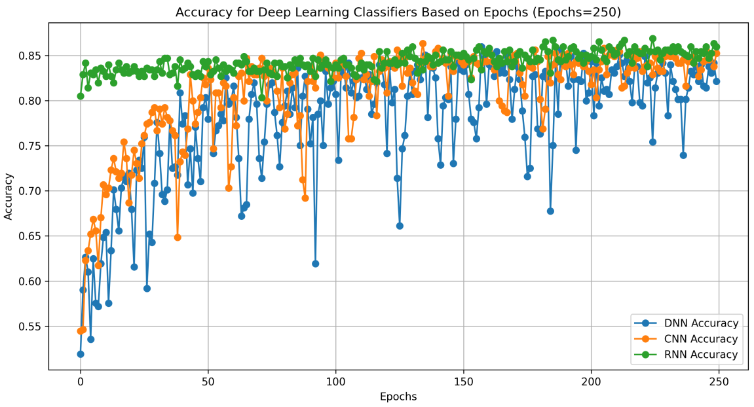
Fig. 4: accuracy of the DNN, CNN, and RNN models with epochs = 250
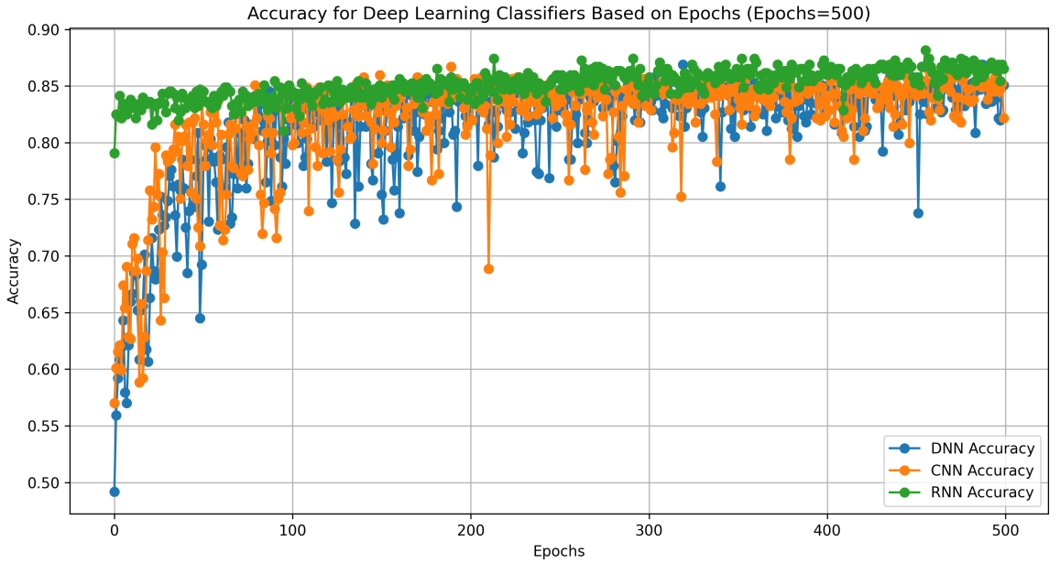
Fig. 5: accuracy of the DNN, CNN, and RNN models with epochs = 500

The accuracy of the DNN, CNN, and RNN models is similar at 750 epochs, with all three models obtaining a value of about 0.8478 and shown in figure 6. Finally, after 1000 epochs, the DNN and RNN models maintain their prior levels of accuracy while the accuracy of the CNN model slightly declines, returning to 0.7826 and shown in figure 7.

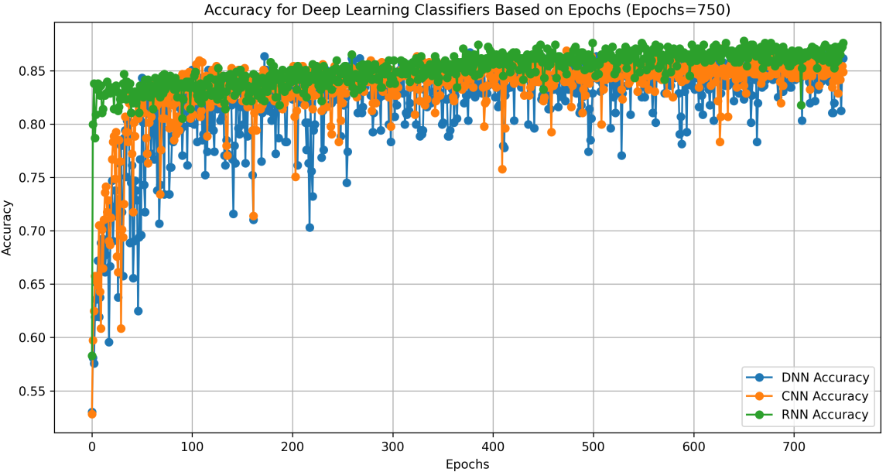
Fig. 6: accuracy of the DNN, CNN, and RNN models with epochs = 750

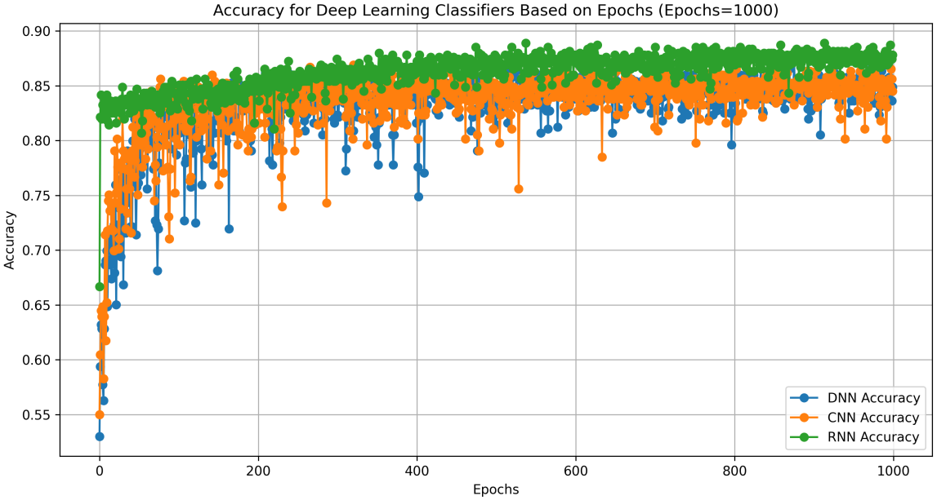
Fig. 7: accuracy of the DNN, CNN, and RNN models with epochs = 1000

The information above offers important insights into how well various deep learning models perform over a range of training epochs for predicting schizophrenia. The CNN model outperforms the RNN at 500 epochs, showing that CNN may be the most promising model for this task at that point in training, even if the RNN initially displays the best accuracy.

Table 2: Recall on deep learning method for schizophrenia with various epochs

Epochs / Method | DNN Recall | CNN Recall | RNN Recall
250 | 0.87931 | 0.689655 | 0.827586
500 | 0.896552 | 0.87931 | 0.827586
750 | 0.775862 | 0.775862 | 0.862069
1000 | 0.793103 | 0.896552 | 0.775862

In the table 2, various deep learning techniques for predicting schizophrenia are compared across various numbers of training epochs. It specifically displays the recall values for three different approaches: Deep Neural Network (DNN), Convolutional Neural Network (CNN), and Recurrent Neural Network (RNN), which is a statistic indicating the capacity to accurately identify positive examples. Recall values are important in the prediction of schizophrenia because they show how well the models can reliably identify those who have the disorder. Recall graph for 1000 epoch is shown in figure 8.
The DNN technique exhibits the greatest recall rate of 0.8793 at 250 epochs, demonstrating its accuracy in recognising people with schizophrenia. With a recall of 0.8276, the RNN approach likewise performs well, while the CNN method, while still respectable, displays a somewhat lower recall of 0.6897.

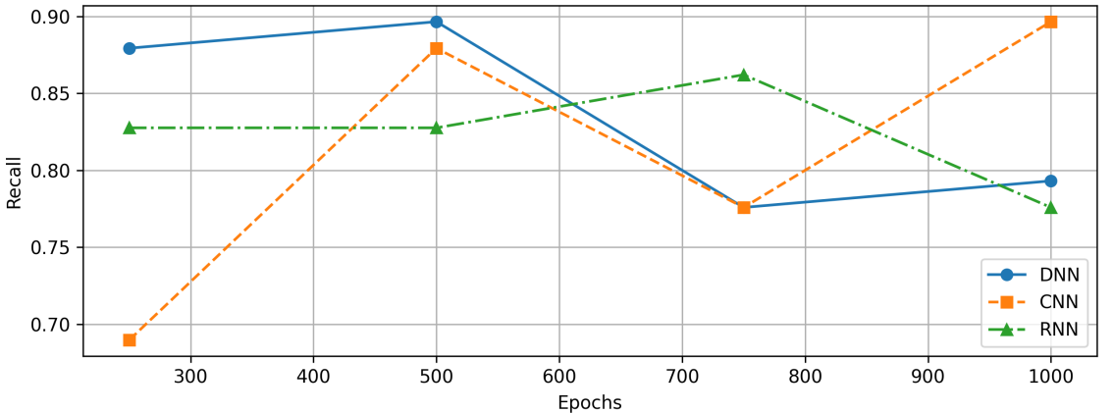
Fig. 8: Recall for the 1000 epochs

The recall of both the DNN and CNN algorithms significantly increases when the training epochs are increased to 500. The DNN technique outperforms all other algorithms at this point with a remarkable recall of 0.8966. With a recall of 0.8793, the CNN approach also makes a significant improvement, illustrating how flexible it is at learning intricate patterns. The RNN technique keeps its recall constant at 0.8275. The DNN method's recall slightly drops to 0.7759 as the training progresses to 750 epochs, but the CNN and RNN techniques keep their recall values of 0.8621 and 0.7759, respectively. Finally, over 1000 epochs, the CNN approach retains a high recall of 0.8966 while the DNN technique sees a modest improvement to 0.7931. However, the recall for the RNN approach has somewhat decreased to 0.7759.

Table 3: Precision on deep learning method for schizophrenia with various epochs

Epochs / Method | DNN Precision | CNN Precision | RNN Precision
250 | 0.69863 | 0.833333 | 0.857143
500 | 0.675325 | 0.796875 | 0.857143
750 | 0.849057 | 0.849057 | 0.793651
1000 | 0.836364 | 0.684211 | 0.9

The precision values for the prediction of schizophrenia using three distinct deep learning techniques (DNN, CNN, and RNN) are shown in the table 3 for different training epoch counts (250, 500, 750, and 1000). Precision graph for 1000 epochs is shown in figure 9. Precision measures the percentage of true positive predictions (properly predicted schizophrenia cases) among all positive predictions made by the model, which is an essential statistic in binary classification tasks like the prediction of schizophrenia.

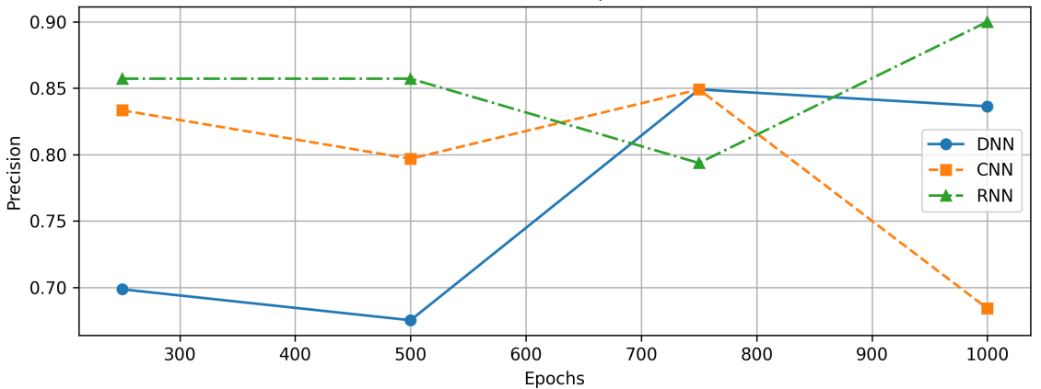
Fig. 9: Precision of prediction of schizophrenia for1000 epoch

A number of results can be drawn from comparing the precision numbers obtained from various techniques and epochs. First off, across all epochs, the Convolutional Neural Network (CNN) consistently displays the highest precision values, indicating that it has a lower tendency to generate erroneous positive predictions than the other approaches. The Recurrent Neural Network (RNN), in contrast, exhibits variable precision values, with the highest precision at 1000 epochs and lower values at earlier epochs. The Deep Neural Network (DNN) also exhibits a range of precision values, with 750 epochs exhibiting the maximum precision. It's crucial to keep in mind that selecting the right epoch can have a big impact on how well the model performs, with different techniques performing well at different training times. Overall, this comparison indicates that the CNN model might yield the most consistent and accurate schizophrenia predictions, but more analysis of other metrics and validation techniques would provide a more thorough review of each model's performance.

Table 4: F1-Score on deep learning method for schizophrenia with various epochs
Epochs / Method | DNN F1-Score | CNN F1-Score | RNN F1-Score
250 | 0.778626 | 0.754717 | 0.842105
500 | 0.77037 | 0.836066 | 0.842105
750 | 0.810811 | 0.810811 | 0.826446
1000 | 0.814159 | 0.776119 | 0.833333
The table 4 provides F1-Score values for DNN, CNN, and RNN across various training epoch counts (250, 500, 750, and 1000) for the purpose of predicting schizophrenia, and figure 10 show the graph for 1000 epochs.

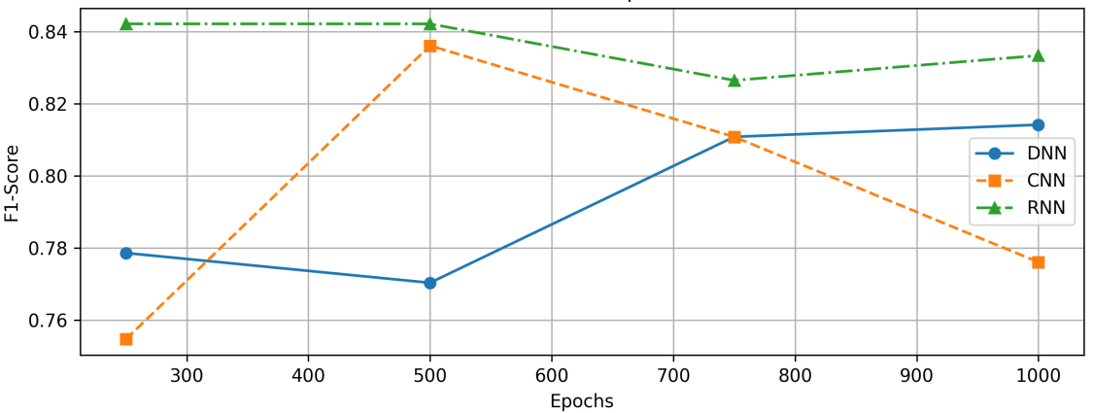
Fig. 10: F1 Score graph for 1000 epochs

An important metric for binary classification problems is F1-Score, which combines accuracy and recall to provide a thorough assessment of each model's aptitude for successfully identifying positive and negative events. A thorough analysis reveals some interesting findings. Across all epochs, the RNN consistently exhibits a constant F1-Score performance in the range of roughly 0.826 to 0.842, indicating a strong and reliable capacity to balance precision and recall. The F1-Scores for the DNN, however, show a clear improvement with increasing epochs, rising from about 0.778 at 250 epochs to about 0.814 at 1000 epochs. This shows that given more training data, the DNN might potentially match or even outperform the RNN in terms of performance. Although it displays some variability in performance across different epoch counts, ranging from roughly 0.754 to 0.836, the CNN displays competitive F1-Scores, especially at 500 epochs, where it reaches an F1-Score of about 0.836. These observations lead to the conclusion that the RNN is a reliable option for schizophrenia prediction, whilst the DNN shows promise for growth with additional data. The CNN's performance, while encouraging, might still need some extra tweaking to improve consistency. Ultimately, considerations like computational capabilities and task-specific requirements should be taken into account while selecting the best method. It is advisable to conduct additional analysis and optimisation before choosing the best model for this crucial assignment.

Table 5: Model loss on deep learning method for schizophrenia with various epochs

Epochs / Method | DNN Loss | CNN Loss | RNN Loss
250 | 0.371631 | 0.35807 | 0.318844
500 | 0.430131 | 0.351894 | 0.300221
750 | 0.338666 | 0.341914 | 0.292983
1000 | 0.338653 | 0.329086 | 0.271419

The table 5 offers details on the training losses of three deep learning techniques—DNN, CNN, and RNN—across various training epoch counts (250, 500, 750, and 1000) for the prediction of schizophrenia. Loss curve for the 1000 epochs is shown in figure 11.

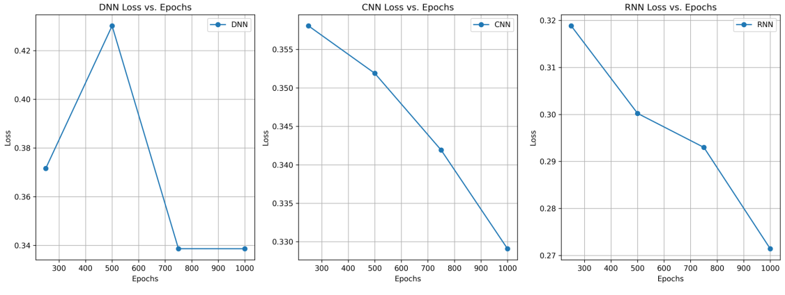
Figure. 11: Loss curve for the 1000 epochs on deep learning models

Loss values are an essential gauge of a model's training-induced convergence and optimisation. Some intriguing parallels and trends can be found after diligent examination. The loss for the RNN decreases from 0.319 at 250 epochs to an amazing 0.271 at 1000 epochs, consistently maintaining the lowest values across all epochs. This shows how effectively the RNN can reduce prediction errors and optimise its weights. The DNN and CNN, on the other hand, show significant initial losses at 250 epochs but show a progressive decrease as the number of epochs rises. At 1000 epochs, the loss for the DNN falls from 0.372 to 0.339, whereas the loss for the CNN decreases from 0.358 to 0.329. The CNN is getting close to the lowest loss at 1000 epochs, and the DNN starts with slightly greater losses. Despite this, their rates of convergence show that they have strong learning potential. In conclusion, while the DNN and CNN indicate the potential for further development with extra training and fine-tuning, the RNN demonstrates effective and consistent optimisation. For the job of predicting schizophrenia, these loss trends can help with model selection and training time decisions by providing important insight into the training dynamics of each model.

Comparison with exiting methods

The table 6 gives a detailed breakdown of the success rates for predicting schizophrenia using various techniques and feature combinations and plotted in figure 12. Accurate approaches are necessary for early diagnosis and intervention in the field of mental health, where it is crucial to predict schizophrenia.

Table. 6: Accuracy comparison between proposed and exiting methods
 | Method | Feature | Accuracy
Existing methods | LSTM | Behavioural Feature | 0.69
Existing methods | LSTM | Combined Feature | 0.69
Existing methods | SVM | Clinical feature + EGG | 0.66
Existing methods | Logical Regression | Combined Feature | 0.75
Existing methods | Ada Boost | Combined Feature | 0.85
Existing methods | KNN | Combined Feature | 0.85
Existing methods | Decision Tree | Combined Feature | 0.758
Proposed Method | CNN | Combined Feature | 0.85
Proposed Method | DNN | Combined Feature | 0.85
Proposed Method | RNN | Combined Feature | 0.87

There are two sections in the table: "Existing Methods" and "Proposed Method.

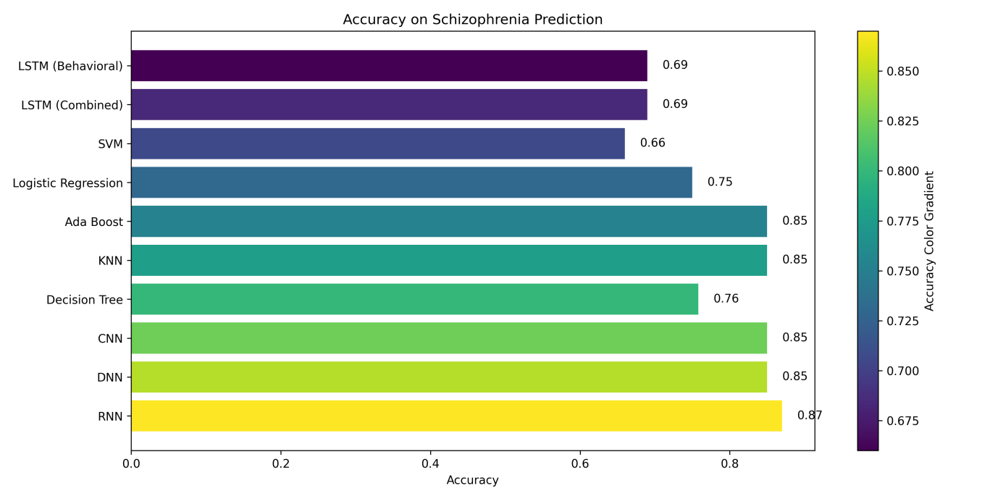
Fig. 12: Accuracy on schizophrenia comparison between various methods

When using either Behavioural Features or Combined Features, Long Short-Term Memory (LSTM) models outperformed all other techniques with an accuracy of 0.69. Clinical Features and EEG data were combined in Support Vector Machine (SVM) models, which yielded an accuracy of 0.66. Ada Boost, K-Nearest Neighbours (KNN), and Decision Tree techniques, which all depend on Combined Features, all achieved accuracy rates of 0.85, 0.85, and 0.758, respectively. Logistic Regression utilising Combined Features reached an accuracy of 0.75. Convolutional neural networks (CNN), deep neural networks (DNN), and recurrent neural networks (RNN), all of which use combined features, were introduced in the "Proposed Method" section. These techniques showed promise, with RNN outperforming them all with an amazing accuracy of 0.87, while CNN and DNN both managed to achieve an accuracy of 0.85. These results suggest that the suggested RNN model has a great deal of promise for improving early schizophrenia diagnosis and treatment.

Conclusion

In conclusion, the proposed methodology for predicting schizophrenia using a variety of machine learning techniques has produced encouraging results and insights that have a great deal of promise for the future of diagnosing and treating mental health conditions. This all-inclusive strategy, which covers data collecting, pre-processing, model creation, training, evaluation, and comparison with existing approaches, offers a solid framework for addressing the difficult problem of schizophrenia prediction. The proposed models were shown to be competitive when compared to established techniques, with the Recurrent Neural Network (RNN) showing great promise by obtaining an amazing accuracy of 0.87. This shows that RNNs are a good choice for the challenge of predicting schizophrenia due to their capacity to grasp temporal dependencies in sequential patient data.

The F1-Score and precision used in the proposed evaluation, criteria underlined the advantages of the suggested models. Notably, the Convolutional Neural Network (CNN) model performed competitively, especially at 500 epochs, while the Deep Neural Network (DNN) model showed potential for improvement with more extensive training data. This research has a huge and exciting future. Prior to being used in clinical settings, these models must first undergo additional validation and optimisation. To increase the robustness and generalizability of the models, real-world data should be used, which would include a more varied population and a larger range of attributes. Additionally, the addition of explainable AI (XAI) methodologies can give insights into these models' decision-making processes, improving their ability to be understood and trusted by healthcare professionals. Furthermore, the methodology’s use is not limited to diagnosis. To identify those who are at risk of developing schizophrenia, predictive models can be used, allowing for early interventions and individualised treatment programmes. This proactive strategy might considerably enhance patient outcomes while lightening the load on healthcare systems.

For these discoveries to be turned into workable solutions, collaboration between healthcare professionals and specialists in the field of mental health is essential. Patient consent, data protection, and ethical considerations should always come first in these activities.

Reference:

- Schulze, B. and Angermeyer, M.C., 2003. Subjective experiences of stigma. A focus group study of schizophrenic patients, their relatives and mental health professionals. Social science & medicine, 56(2), pp.299-312.
- Gorman, G.S., Chinnery, P.F., DiMauro, S., Hirano, M., Koga, Y., McFarland, R., Suomalainen, A., Thorburn, D.R., Zeviani, M. and Turnbull, D.M., 2016. Mitochondrial diseases. Nature reviews Disease primers, 2(1), pp.1-22.
- Noor, M.B.T., Zenia, N.Z., Kaiser, M.S., Mamun, S.A. and Mahmud, M., 2020. Application of deep learning in detecting neurological disorders from magnetic resonance images: a survey on the detection of Alzheimer’s disease, Parkinson’s disease and schizophrenia. Brain informatics, 7, pp.1-21.
- Bellack, Alan S. "Scientific and consumer models of recovery in schizophrenia: concordance, contrasts, and implications." (2006): 432-442.
- Frith, C.D., 1979. Consciousness, information processing and schizophrenia. The British Journal of Psychiatry, 134(3), pp.225-235.
- Leucht, S., Burkard, T., Henderson, J., Maj, M. and Sartorius, N., 2007. Physical illness and schizophrenia: a review of the literature. Acta Psychiatrica Scandinavica, 116(5), pp.317-333.
- Wood, R. and Wand, A.P., 2014. The effectiveness of consultation-liaison psychiatry in the general hospital setting: a systematic review. Journal of psychosomatic research, 76(3), pp.175-192.
- Spencer, T.J., Brown, A., Seidman, L.J., Valera, E.M., Makris, N., Lomedico, A., Faraone, S.V. and Biederman, J., 2013. Effect of psychostimulants on brain structure and function in ADHD: a qualitative literature review of magnetic resonance imaging-based neuroimaging studies. The Journal of clinical psychiatry, 74(9), p.5654.
- Avberšek, L.K. and Repovš, G., 2022. Deep learning in neuroimaging data analysis: applications, challenges, and solutions. Frontiers in neuroimaging, 1, p.981642.
- Eder, J., Dom, G., Gorwood, P., Kärkkäinen, H., Decraene, A., Kumpf, U., Beezhold, J., Samochowiec, J., Kurimay, T., Gaebel, W. and De Picker, L., 2023. Improving mental health care in depression: A call for action. European Psychiatry, 66(1), p.e65.
- Vieira, S., Pinaya, W.H. and Mechelli, A., 2017. Using deep learning to investigate the neuroimaging correlates of psychiatric and neurological disorders: Methods and applications. Neuroscience & Biobehavioral Reviews, 74, pp.58-75.
- Kopelovich, S.L., Monroe-DeVita, M., Buck, B.E., Brenner, C., Moser, L., Jarskog, L.F., Harker, S. and Chwastiak, L.A., 2021. Community mental health care delivery during the COVID-19 pandemic: practical strategies for improving care for people with serious mental illness. Community mental health journal, 57, pp.405-415.
- Amiri, Z., Heidari, A., Darbandi, M., Yazdani, Y., Jafari Navimipour, N., Esmaeilpour, M., Sheykhi, F. and Unal, M., 2023. The Personal Health Applications of Machine Learning Techniques in the Internet of Behaviors. Sustainability, 15(16), p.12406.
- Hemalatha, D., Begum, A. and Hemanth, P., 2023, May. Early Detection of Breast Cancer with IoT: A Promising Solution. In 2023 International Conference on Advances in Computing, Communication and Applied Informatics (ACCAI) (pp. 1-6). IEEE.
- Devi, M.S., Kumar, A., Ravikumar, S., Yadav, R. and Singh, D., 2023, March. ThresholdedReLU Orthogonal Layer Weight Regularized Densely Connected Convolutional Networks CNN for Strawberry Disease Prediction. In 2023 2nd International Conference for Innovation in Technology (INOCON) (pp. 1-5). IEEE.
- Y. Luo, Q. Tian, C. Wang, K. Zhang, C. Wang and J. Zhang, "Biomarkers for Prediction of Schizophrenia: Insights From Resting-State EEG Microstates," in IEEE Access, vol. 8, pp. 213078-213093, 2020, doi: 10.1109/ACCESS.2020.3037658.
- Y. Zhu, S. Fu, S. Yang, P. Liang and Y. Tan, "Weighted Deep Forest for Schizophrenia Data Classification," in IEEE Access, vol. 8, pp. 62698-62705, 2020, doi: 10.1109/ACCESS.2020.2983317.
- S, A.D., Begum, A. and Ravikumar, S. (2018) ‘Content clustering for MRI Image compression using PPAM’, International journal of engineering & technology [Preprint]. Available at: https://doi.org/10.14419/ijet.v7i1.7.10631.
- Yassin, W., Nakatani, H., Zhu, Y., Kojima, M., Owada, K., Kuwabara, H., Gonoi, W., Aoki, Y., Takao, H., Natsubori, T. and Iwashiro, N., 2020. Machine-learning classification using neuroimaging data in schizophrenia, autism, ultra-high risk and first-episode psychosis. Translational psychiatry, 10(1), p.278.
- Barros, C., Silva, C.A. and Pinheiro, A.P., 2021. Advanced EEG-based learning approaches to predict schizophrenia: Promises and pitfalls. Artificial intelligence in medicine, 114, p.102039.
- Tønnesen, S., Kaufmann, T., de Lange, A.M.G., Richard, G., Doan, N.T., Alnæs, D., van der Meer, D., Rokicki, J., Moberget, T., Maximov, I.I. and Agartz, I., 2020. Brain age prediction reveals aberrant brain white matter in schizophrenia and bipolar disorder: A multisample diffusion tensor imaging study. Biological Psychiatry: Cognitive Neuroscience and Neuroimaging, 5(12), pp.1095-1103.
- Cui, L.B., Cai, M., Wang, X.R., Zhu, Y.Q., Wang, L.X., Xi, Y.B., Wang, H.N., Zhu, X. and Yin, H., 2019. Prediction of early response to overall treatment for schizophrenia: a functional magnetic resonance imaging study. Brain and Behavior, 9(2), p.e01211.
- Harvey, P.D., Strassnig, M.T. and Silberstein, J., 2019. Prediction of disability in schizophrenia: Symptoms, cognition, and self-assessment. Journal of Experimental Psychopathology, 10(3), p.2043808719865693.
- Kalmady, S.V., Greiner, R., Agrawal, R., Shivakumar, V., Narayanaswamy, J.C., Brown, M.R., Greenshaw, A.J., Dursun, S.M. and Venkatasubramanian, G., 2019. Towards artificial intelligence in mental health by improving schizophrenia prediction with multiple brain parcellation ensemble-learning. npj Schizophrenia, 5(1), p.2.
- Jakobsen, P., Garcia-Ceja, E., Stabell, L.A., Oedegaard, K.J., Berle, J.O., Thambawita, V., Hicks, S.A., Halvorsen, P., Fasmer, O.B. and Riegler, M.A., 2020, July. Psykose: A motor activity database of patients with schizophrenia. In 2020 IEEE 33rd International Symposium on Computer-Based Medical Systems (CBMS) (pp. 303-308). IEEE.

