
Clear Wealth: An Intelligent, Client-Side Personal Finance and Investment Management System
Guru Prasath B, Dr. U. Hemamalini
Department of Computer Applications (UG), School of Computing Sciences
Vels Institute of Science, Technology and Advanced Studies (VISTAS), Chennai, India

Abstract
Personal financial management has evolved from simple expense tracking into comprehensive wealth management requiring strategic budgeting, investment forecasting, and behavioral analysis. This paper introduces "ClearWealth," a holistic, browser-based personal finance application designed to address these multifaceted needs. Unlike traditional backend-heavy trackers, ClearWealth operates as a highly responsive client-side application utilizing HTML5, CSS3, and JavaScript, augmented by Chart.js for data visualization and html2pdf.js for automated reporting. The system integrates secure local authentication for multi-user data segregation, a dynamic 50-30-20 budget tracking algorithm, Systematic Investment Plan (SIP) and Lumpsum calculators, goal-oriented savings trackers, and an AI-driven advisory module that analyzes localized financial states. This study details the architectural framework, mathematical models governing the investment calculators, and the user-interface design principles that drive financial mindfulness. Experimental deployment demonstrates that integrating real-time visual feedback with embedded investment planning significantly enhances user engagement and financial literacy.
Keywords: Personal Finance, Budgeting, Investment Calculator, Multi-User Authentication, 50-30-20 Rule, Chart.js, HTML2PDF, Web Application.

I. INTRODUCTION
In the contemporary digital economy, managing personal finances extends far beyond merely logging daily expenditures. Individuals are increasingly required to act as their own wealth managers, balancing immediate liquidity needs against long-term investment goals and recurring obligations. The proliferation of digital payment methods has increased the velocity of personal transactions, often resulting in fragmented financial visibility. Consequently, there is a critical need for integrated platforms that not only track expenses but also provide strategic budgeting frameworks and investment forecasting.

This paper presents ClearWealth (formerly conceived as Smart Finance Manager), a comprehensive web-based application engineered to centralize personal financial data. The application differentiates itself by moving beyond retrospective tracking to proactive financial planning. It incorporates the widely recognized 50-30-20 budgeting rule dynamically, mapping user expenses into Needs, Wants, and Savings categories in real-time. Furthermore, recognizing the importance of wealth compounding, the system embeds specialized calculators for Systematic Investment Plans (SIP) and Lumpsum investments directly into the user workflow.

Operating entirely within the browser environment, ClearWealth leverages modern Document Object Model (DOM) manipulation, Chart.js for interactive analytics, and html2pdf.js for generating exportable monthly reports. The system also features a robust dual-state authentication interface, ensuring localized data segregation for multiple users. The subsequent sections of this manuscript detail the literature informing the system's design, the client-side architecture, the mathematical models underpinning its functional modules, and a comprehensive discussion of its potential impact on user financial behaviour.

II. LITERATURE REVIEW
The design of ClearWealth is grounded in established behavioral economics and human-computer interaction (HCI) research pertaining to personal finance.
A. Budgeting Paradigms and the 50-30-20 Rule Traditional zero-based budgeting, while mathematically rigorous, often suffers from high abandonment rates due to the extensive manual effort required. Warren and Tyagi popularized the 50-30-20 rule, which simplifies budgeting by allocating 50% of after-tax income to Needs, 30% to Wants, and 20% to Savings or debt repayment. By hardcoding this heuristic into the graphical interface, financial software can provide users with immediate, low-cognitive-load assessments of their financial health.
B. Visualization in Financial Literacy Cognitive load theory suggests that numerical financial data is difficult for the human brain to process at scale. Visualizations—such as the expense breakdown charts and progress bars utilized in ClearWealth—transform abstract arrays of numbers into spatial representations, significantly improving comprehension. The integration of libraries like Chart.js allows for immediate visual feedback, turning the act of data entry into an interactive learning experience.

C. Investment and Goal Tracking Behavioral finance indicates that users are more likely to save when their savings are attached to explicit, named goals with defined deadlines. Furthermore, illustrating the power of compound interest through interactive calculators (SIP/Lumpsum) serves as a potent behavioral nudge, shifting user focus from short-term consumption to long-term wealth generation.

III. ARCHITECTURAL DESIGN
ClearWealth is engineered using a robust, client-side modular architecture. By processing data locally within the browser, the application minimizes latency, ensuring a fluid user experience.
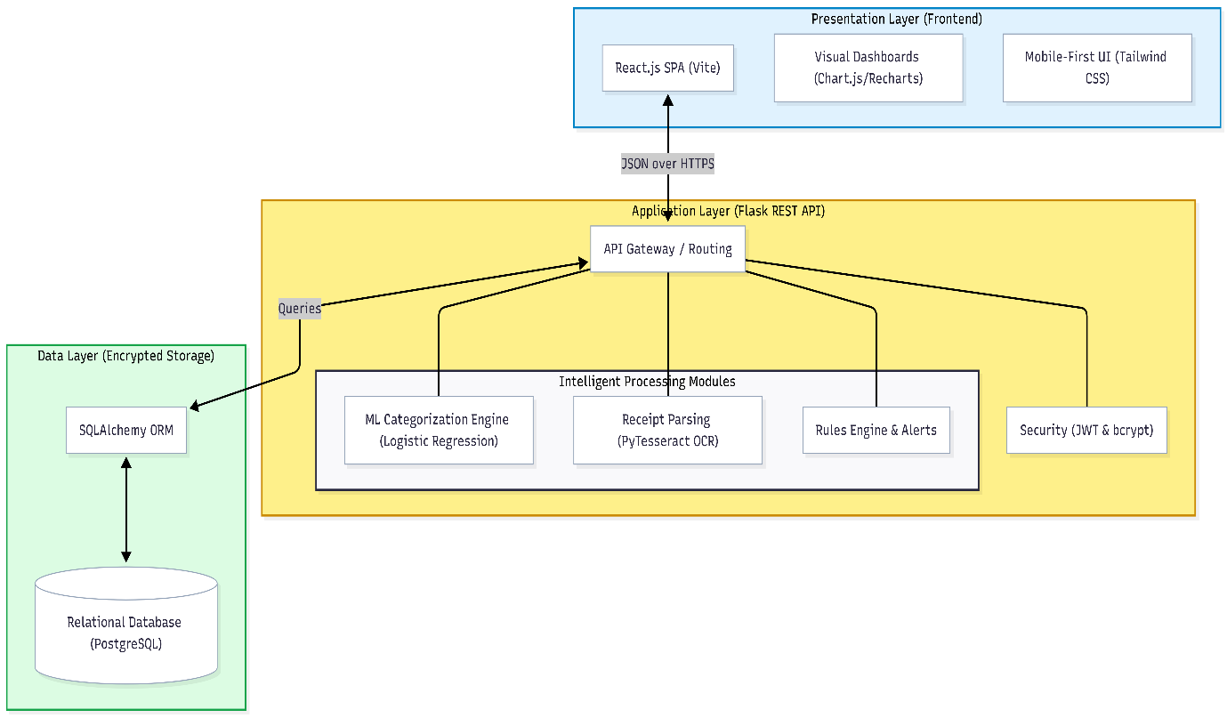

A. Dual-State Interface and Authentication The application is architected around a dual-state design pattern: the Authentication View and the Main Dashboard View. Utilizing HTML5 Web Storage (local Storage), the system simulates a backend database to store encrypted user credentials and segregates data. When a user authenticates, the JavaScript engine retrieves only the data arrays (incomes, expenses, goals, bills) associated with that specific user session, completely isolating it from other accounts on the same device.

B. Frontend Framework and UI/UX The user interface is constructed using semantic HTML5 and CSS3, styled with a modern glass morphism aesthetic utilizing Font Awesome icons for visual hierarchy. The layout features a persistent left-hand sidebar navigation mapping to distinct operational sections. The main content area functions as a dynamic view-port, toggling CSS display properties to create a seamless Single-Page Application (SPA) experience.
C. Third-Party Library Integration To achieve professional-grade functionality, ClearWealth integrates two critical external libraries. Chart.js is invoked within a canvas element to render responsive, animated doughnut and bar charts representing expense categorizations. html2pdf.js is utilized in the Reports section, allowing the DOM to be serialized, styled, and exported as an A4-sized PDF.

IV. CORE MODULES AND IMPLEMENTATION
The system is divided into functional modules, each addressing a specific domain of personal wealth management.
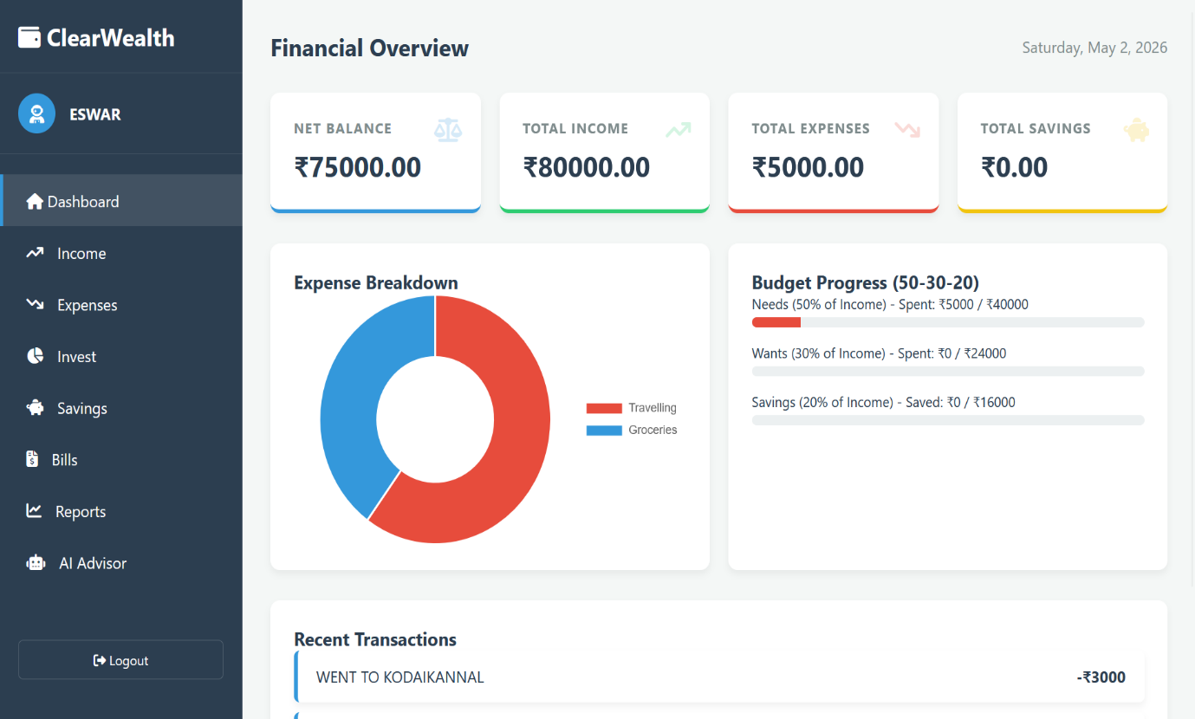

A. Dashboard and 50-30-20 Tracking The Dashboard serves as the command center. It aggregates data into primary metrics: Net Balance, Total Income, Total Expenses, and Total Savings. Below these metrics, the system implements the 50-30-20 rule utilizing dynamic CSS width manipulations on progress bars. As users input expenses, the JavaScript engine maps the chosen category and recalculates the percentage filled against the total logged income. Colour coding provides immediate heuristic feedback.

B. Transaction Management (Income & Expenses) Data ingestion occurs through structurally validated HTML forms. Categories are pre-defined into essential segments: Shopping, Travelling, Groceries, Entertainment, Food & Dining, and Others. This structured taxonomy feeds directly into the Chart.js visualization engine to produce accurate categorical breakdowns.
C. Investment Calculators (SIP and Lumpsum) A standout feature of ClearWealth is the embedded 'Invest' module, which contains mathematical engines for projecting wealth.
- SIP Calculator: Calculates the future value of a Systematic Investment Plan using the formula for the future value of an annuity. The algorithm takes the monthly investment amount, expected annual return rate, and tenure in years, converting the annual rate to a monthly rate to project compounded returns over time.
- Lumpsum Calculator: Utilizes the standard compound interest formula to project the growth of a single, upfront investment over a specified horizon.

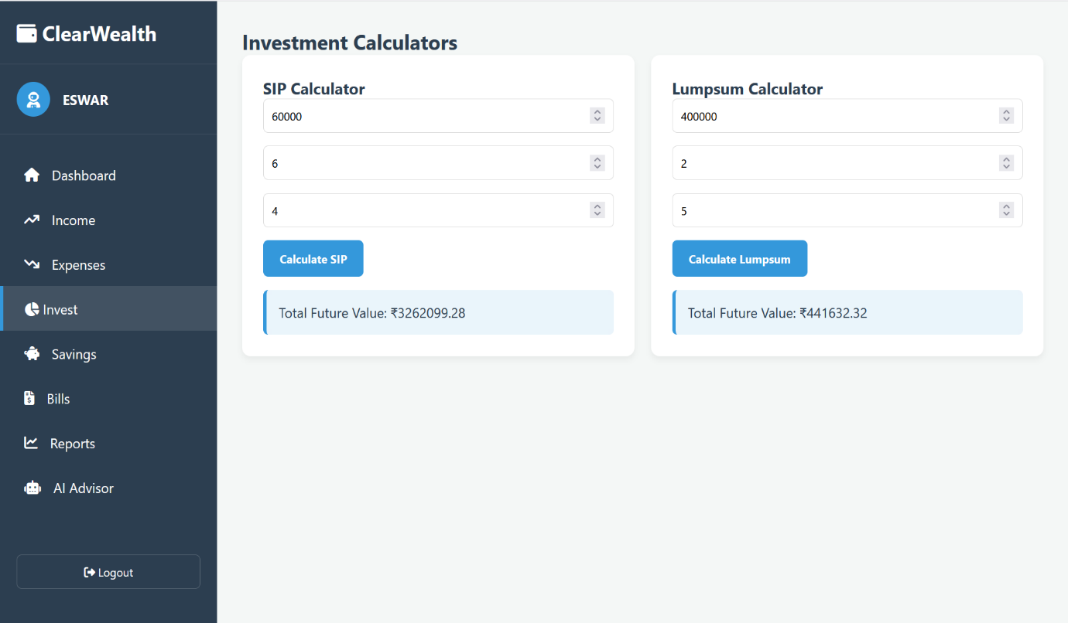

D. Savings Goals and Bill Reminders To promote proactive management, the system includes dedicated modules for Savings and Bills. The Bills section acts as an EMI tracker. By separating fixed recurring obligations from variable expenses, the system enhances cash-flow predictability.

E. Reporting and AI Advisory The Reports module synthesizes the current month's data into a unified canvas chart, which can be downloaded instantly via an export function. The AI Advisor section represents a rule-based inference engine. It analyses the ratio of expenses to income and the progress within the 50-30-20 framework to generate personalized, text-based insights.

V. COMPREHENSIVE DISCUSSION
The development of ClearWealth underscores a paradigm shift in how personal finance applications can be constructed. By moving away from heavy backend architectures to a robust, client-side SPA model using standard web technologies, the application achieves zero-latency data entry and visualization. This responsiveness is critical; behavioral research indicates that friction in data entry is the primary cause of budgeting abandonment.
Furthermore, the integration of the 50-30-20 rule directly into the visual hierarchy bridges the gap between tracking and planning. Users do not merely see that they spent money on 'Food'; they see that their 'Wants' category is approaching its 30% limit. This contextualization transforms raw data into actionable intelligence.
The inclusion of the SIP and Lumpsum calculators within the same environment as daily expense tracking serves a profound psychological purpose. It forces the user to confront the opportunity cost of their expenditures. Money saved from a reduced 'Wants' budget can immediately be modeled in the SIP calculator to demonstrate long-term wealth generation, creating a powerful positive feedback loop for financial discipline.

VI. DETAILED CONCLUSION
The ClearWealth project successfully demonstrates that a comprehensive, highly interactive personal wealth management system can be engineered utilizing lightweight, front-end web technologies combined with local storage mechanisms. By holistically combining secure user authentication, income tracking, categorized expense logging, goal-oriented savings, bill reminders, and advanced investment calculators into a single interface, the application solves the problem of financial fragmentation.
The most significant achievement of this system is its adherence to automated, visual financial paradigms. By hardcoding the 50-30-20 budgeting framework into dynamic progress bars and utilizing Chart.js for immediate categorical breakdowns, ClearWealth reduces the cognitive burden on the user. The system transforms abstract financial ledgers into intuitive, spatial progress indicators. Additionally, the inclusion of an automated reporting tool (via html2pdf.js) and a rule-based AI advisory module ensures that users are not just collecting data, but are receiving synthesized, actionable insights.
Ultimately, ClearWealth bridges the gap between daily budgeting and long-term wealth generation. It proves that software design, when aligned with behavioral economics, can serve not just as a tracking utility, but as an active agent in promoting financial literacy, discipline, and sustained wealth accumulation.

VII. FUTURE SCOPE
While ClearWealth currently operates as a highly efficient client-side tool with local authentication, future iterations will focus on backend scalability, automation, and advanced machine learning capabilities.
- Cloud Synchronization & Database Integration: Transitioning the local state management to a cloud-based NoSQL or relational database (e.g., Firebase, PostgreSQL) will allow users to access their financial data seamlessly across multiple devices while ensuring data persistence.
- Live Market Data Integration: The SIP and Lumpsum calculators will be upgraded to pull live API data from mutual fund and stock market indices, allowing users to track real-world portfolio performance.
- Deep AI Predictive Analytics: The current rule-based AI Advisor will be replaced with a deep learning model trained on historical spending patterns. This predictive engine will forecast cash-flow shortages, recommend optimal times for SIP investments, and identify recurring subscription leakages.
- Open Banking Automation: Integrating secure open-banking APIs (such as the Account Aggregator framework) will eliminate the need for manual data entry entirely, pulling bank transactions directly into the ClearWealth categorization engine in real time.

REFERENCES
[1] E. Warren and A. W. Tyagi, All Your Worth: The Ultimate Lifetime Money Plan. New York: Free Press, 2005. [2] R. H. Thaler and C. R. Sunstein, Nudge: Improving Decisions About Health, Wealth, and Happiness. Yale University Press, 2008. [3] D. Kahneman, Thinking, Fast and Slow. Farrar, Straus and Giroux, 2011. [4] Chart.js Contributors, "Chart.js Documentation," 2024. [Online]. Available: https://www.chartjs.org/ [5] eKoopmans, "html2pdf.js: Client-side HTML-to-PDF rendering using pure JS," 2024. [Online]. Available: https://github.com/eKoopmans/html2pdf.js [6] Fonticons, Inc., "FontAwesome Accessibility and Iconography," 2024. [Online]. Available: https://fontawesome.com [7] A. E. Khandani, A. J. Kim, and A. W. Lo, "Consumer Credit Risk Models via Machine-Learning Algorithms," Journal of Banking and Finance, 2010.

