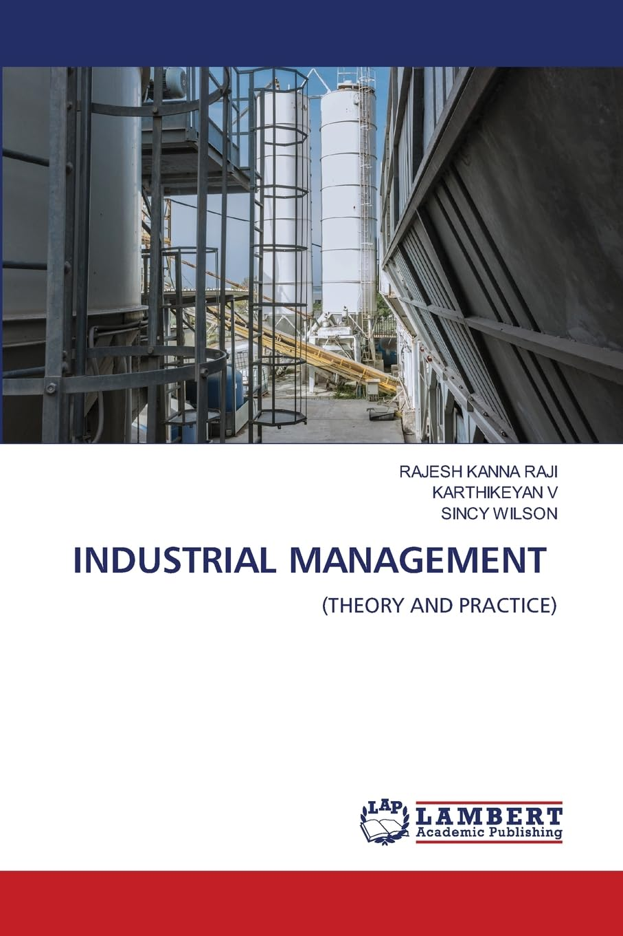

In simple terms Industrial Relations deals with the worker employee relation in any industry Government has attempted to make Industrial Relations more health the by enacting Industrial Disputes Act 1947. To solve the dispute and to reduce the latency of dispute. This in turn improves the relations. This book aims to provide a comprehensive framework for understanding the key issues in Industrial Management theory equips readers with the knowledge to engage effectively and practices of industrial trade in India.
Product details
Publisher ‏ : ‎ LAP Lambert Academic Publishing
Publication date ‏ : ‎ 3 July 2025
Language ‏ : ‎ English
Print length ‏ : ‎ 260 pages
ISBN-10 ‏ : ‎ 6208448913
ISBN-13 ‏ : ‎ 978-6208448912
Item Weight ‏ : ‎ 354 g
Dimensions ‏ : ‎ 15.01 x 1.5 x 22 cm
Country of Origin ‏ : ‎ India
Importer ‏ : ‎ Atlantic Publishers and Distributors (P) Ltd., 7/22, Ansari Road, Darya Ganj, New Delhi - 110002 INDIA, Email – customercare@atlanticbooks.com, Ph – 011-47320500
Packer ‏ : ‎ Atlantic Publishers and Distributors (P) Ltd., 7/22, Ansari Road, Darya Ganj, New Delhi - 110002 INDIA, Email – customercare@atlanticbooks.com, Ph – 011-47320500

