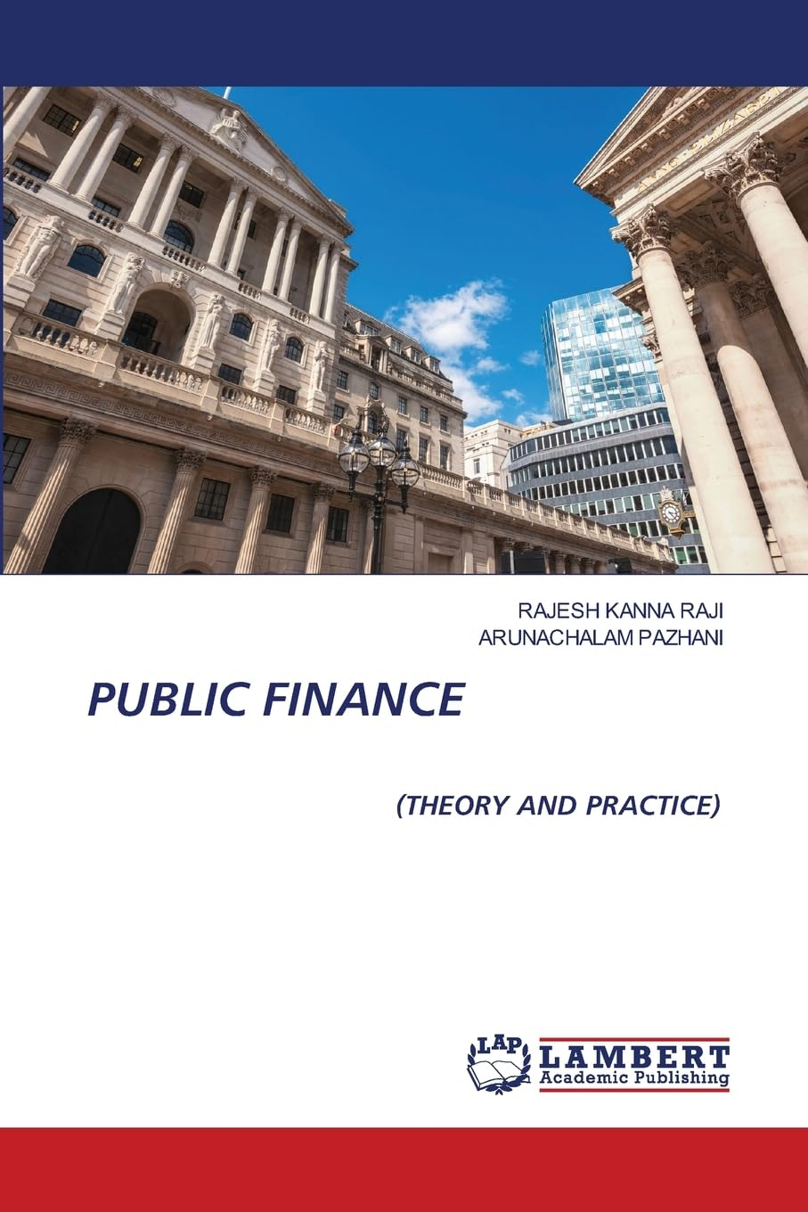

Public Economics is a branch of economics that deals with the role of government in the economy. It examines the allocation of resources, income distribution, and market failures, and analyses the effects of government interventions, such as taxation, public expenditure, and regulation, on economic efficiency and social welfare. By understanding the principles of Public Economics, policymakers can design policies that promote economic efficiency, social welfare, and sustainable development. In developing countries like India which have adopted economic development huge resources are required for implementation of government investment. The government takes greater interest to create infrastructure, industrial development in vital sector be sides transport and communication. Deficit financing is a useful tool.

Product details
- Publisher ‏ : ‎ LAP Lambert Academic Publishing
- Publication date ‏ : ‎ 7 April 2025
- Language ‏ : ‎ English
- Print length ‏ : ‎ 236 pages
- ISBN-10 ‏ : ‎ 6200081557
- ISBN-13 ‏ : ‎ 978-6200081551
- Item Weight ‏ : ‎ 322 g
- Dimensions ‏ : ‎ 15.01 x 1.37 x 22 cm
- Country of Origin ‏ : ‎ India
- Importer ‏ : ‎ Atlantic Publishers and Distributors (P) Ltd., 7/22, Ansari Road, Darya Ganj, New Delhi - 110002 INDIA, Email – customercare@atlanticbooks.com, Ph – 011-47320500

