Intranasal dalfampridine-loaded mucoadhesive polymeric nanoparticles for brain targeting: formulation and therapeutic evaluation in a cuprizone-induced demyelination model
Jaghatha Therassama¹, Justus Oliver Jaslin Edward², Somasundaram Arumugam³, Pavazhaviji Pazhani^{4,} Jose Prakash Dharmian^{1*}
¹ Department of Pharmaceutics, Crescent School of Pharmacy, B.S.Abdur Rahman Crescent Institute of Science & Technology, Chennai, Tamil Nadu, India. 600048
² Sun College of Pharmacy and Research Centre, Kanyakumari District, Tamil Nadu, India. 629204
³National Institute of Pharmaceutical Education and Research (NIPER)-Kolkata, Chunilal Bhawan, 168, Maniktala Main Road, Kolkata, West Bengal, India. 700054
⁴Department of Pharmaceutics, School of Pharmaceutical Sciences, Vels Institute of Sciences, Technology and Advanced Studies, Pallavaram, Chennai, Tamil Nadu-600043.

Abstract:

The present study aimed to develop and comprehensively evaluate dalfampridine-loaded chitosan nanoparticles (DLM-CSNPs) for enhanced intranasal brain delivery in a cuprizone-induced demyelination model of multiple sclerosis (MS). The optimized nanoparticles were found to have a particle size of 166.5 nm with a small particle distribution (PDI 0.24), a positive surface charge (Zeta Potential +24.97 mV), and high entrapment efficiency (82%). Ex Vivo Permeation studies demonstrated that the permeation rate of the drug from DLM-CSNPs (902.26 µg/cm²) was significantly higher compared to the drug solution (609.96 µg/cm²). Histopathological studies confirmed the safety of the drug on the nasal mucosa. Sub-acute toxicity studies indicated the lack of significant systemic, hepatic, and renal toxicity of the compound after 28 days of repeated intranasal administration, even at a dose of 4 mg/kg. Pharmacokinetic studies indicated the better targeting of the brain by the intranasal route, where the brain C_{max} was two-fold higher, brain AUC 0-12 was significantly higher, brain T_{max} was significantly lower, and the brain/plasma ratios were significantly higher compared to the oral route. When compared to the traditional oral route of administration, the intranasal DLM-CSNPs treatment has demonstrated improved delivery of the formulation to the central nervous system, functional recovery, decreased neuroinflammation, and neuroprotective effects, suggesting the therapeutic potential of the DLM-CSNPs formulation for the management of multiple sclerosis.

Keywords: Multiple sclerosis, Dalfampridine, Chitosan nanoparticles, Cuprizone, Neuroinflammation

Introduction

Multiple sclerosis (MS), also known as multiple scleroses, is an uncommon neurological disorder that impacts the central nervous system (CNS). The main characteristic of the disease is the progressive deterioration of the CNS, which results in axonal injury, closely associated with cognitive as well as neuropsychiatric disturbances, thereby causing disability in the patient’s life[1]Managing MS continues to pose a major challenge for clinicians and researchers because only a few treatments provide meaningful therapeutic benefit. DLM, 4-aminopyridine, to address one of the most disabling symptoms of MS, impaired walking ability. By inhibiting voltage-gated potassium channels, it increases axonal conduction and helps to facilitate nerve impulse transmission even through demyelinated axons. By this mechanism, the potential of DLM to improve walking speed and mobility has been shown to provide a significant improvement to the quality of life of MS patients [2]. Despite its clinical utility, the effectiveness of Dalfampridine following oral administration is constrained by substantial hepatic first-pass metabolism and limited permeability across the blood–brain barrier (BBB), resulting in suboptimal drug concentrations at the target site. To address these challenges, nanotechnology-based drug delivery approaches have been investigated to improve brain targeting and therapeutic outcomes. In particular, chitosan–lecithin nanoparticulate systems have emerged as promising carriers due to their favorable biocompatibility, biodegradability, and inherent mucoadhesive characteristics. When administered via the intranasal route, these nanoparticles may facilitate direct nose-to-brain transport through the olfactory and trigeminal neural pathways [3]. When administered via the intranasal route, these nanoparticles may facilitate direct nose-to-brain transport through the olfactory and trigeminal neural pathways [4]. This alternative route bypasses the BBB, thereby enhancing central nervous system delivery while minimizing systemic exposure [5]. This strategy increases the concentration of the drug in the brain and decreases the drug concentration in the body. Hence, this strategy is considered to be an efficient method for the delivery of DLM in the treatment of MS [6]. In this context, the present study was designed to develop DLM-CSNPs and systematically characterise the formulation in terms of particle size, polydispersity index, zeta potential, and encapsulation efficiency, along with in vitro and ex vivo evaluation of drug release, nasal permeation, and safety assessment. In order to elucidate the molecular, histological, and functional mechanisms underlying the therapeutic effects of DLM-CSNPs, pharmacokinetic, sub-acute toxicity, and mechanistic studies were systematically carried out. Pharmacokinetic studies were conducted to evaluate the brain targeting and systemic exposure after intranasal administration [7]. The sub-acute toxicity evaluation was conducted to evaluate the safety profile of DLM-CSNPs at low, medium, and high doses by monitoring body weight and hepatic and renal biomarker levels. We also assessed changes in motor coordination, mechanical sensitivity, and anxiety-like behaviours in male rats undergoing cuprizone (CPZ)-induced demyelination. The neuroprotective potential of the formulation was also assessed in the animal model of MS. The exact cause of MS is still not clearly known. However, it is believed that genetic as well as environmental factors contribute to the induction and progression of the disease. The neuropathology of MS includes the presence of several inflammatory lesions in the CNS, microgliosis, astrocytosis, loss of oligodendrocytes, demyelination, and axonal injury [8]. It is essential to have a clear idea about the pathophysiology of MS to explore new therapeutic options and to manage the disease effectively. To study the pathophysiology of MS, several animal models have been developed. These include toxin-induced demyelination, virus-induced demyelination, and EAE [9]. Among all the above, the CPZ model is widely recognized and used to study the pathophysiology of MS. In the CPZ model, the administration of CPZ results in the apoptosis of oligodendrocytes, resulting in a high degree of demyelination in the corpus callosum as well as in the white matter areas. However, when the administration of CPZ is stopped, spontaneous remyelination occurs, closely resembling the relapsing-remitting nature of MS in humans. It acts as a potent copper chelator, inhibiting mitochondrial activity and causing oxidative stress, resulting in demyelination and neurodegeneration [10]. The molecular mechanisms were elucidated by quantitative RT-PCR analysis of key pro-inflammatory cytokines, namely, TNF-α and IL-6. Histopathological evaluation of the corpus callosum and sciatic nerve tissues was conducted by staining with Hematoxylin and Eosin (H&E) and Luxol Fast Blue (LFB) stains. In addition, MBP immunohistochemistry of sections of the sciatic nerve was employed for the assessment of the preservation of the myelin. The TEM was also employed for the assessment of the neuroprotective effects through the measurement of the axon diameter, the thickness of the myelin, the fiber diameter, and the g-ratio [11]. The overall aim of the approach was to establish the safety and efficacy of the DLM-CSNPs as nanocarriers for the improved nose-to-brain delivery of DLM for the enhancement of the bioavailability and the neuroprotective effects in the treatment of MS.

Materials and methods
Dalfampridine (DLM, purified grade) was kindly supplied by Hetero Pharmaceuticals Pvt. Ltd., Hyderabad, India. Chitosan (medium molecular weight), Lecithin (≥98% phosphatidylcholine), and Poloxamer 407 were procured from Sigma-Aldrich. All other solvents, chemicals, and reagents employed in this study were of analytical grade and were utilized without any additional purification. Fresh goat nasal mucosa was collected from a registered local slaughterhouse via Cape Bio Lab, Marthandam, Tamil Nadu, India, immediately following animal sacrifice. The excised tissue was transported to the laboratory in chilled phosphate buffer solution (pH 6.4) within 1 hour of procurement and subsequently utilized for ex vivo permeation and nasociliotoxicity studies. Ultrapure water was utilized for all experimental procedures. The animal feed was sourced from Krishna Valley Agrotech, Pune, while RO water and bedding were provided by Cape Bio Lab and Research Centre, Marthandam, India. Cuprizone (bis(cyclohexanone) oxaldihydrazone) was procured from Otto Chemie Pvt. Ltd. (India) and used as received for the induction of demyelination in the experimental animals.
Preparation of DLM loaded CS-NPs
Dalfampridine-loaded chitosan nanoparticles (DLM-CSNPs) were formulated through a solvent injection process shown in Figure 1. In this method, 5 mg of DLM and lecithin (LC) were dissolved in 1–5 mL of ethanol to obtain a clear ethanolic solution containing both components. Chitosan (CS) and Poloxamer 407 were separately dissolved in an aqueous medium that had been slightly acidified with glacial acetic acid. The ethanolic phase was then introduced dropwise to the aqueous phase, and a uniform mixture was achieved by a polypropylene syringe containing a 22-gauge needle, stirring constantly at high-speed homogenization at 12,000 rpm for 5 minutes. Afterward, the organic solvent was removed by reduced pressure rotary evaporation for about 10 minutes to produce a uniform dispersion of nanoparticles. Centrifugation of the dispersion at 45,000 rpm for 1 hour at 4 °C was then carried out to produce a nanoparticle pellet, and the resulting nanoparticle pellets were carefully separated from the supernatant and washed three times with Milli-Q water to remove any traces of the drug not associated with the nanoparticle. For stabilization and storage, the purified nanoparticles were re-dispersed in a 10% (w/v) mannitol solution, which acted as a cryoprotectant, and subsequently freeze-dried[12] . The lyophilized DLM-CSNPs powder was stored at 2–8 °C until further analysis. The average particle size, polydispersity index (PDI), and zeta potential were measured using a Malvern Panalytical ZTS1240 Nanoparticle Analyzer (MAL1274173, 3.3.0.42). The surface character and size of DLM-CSNPs were evaluated by SEM (ZEISS EVO 18, Carl Zeiss, Germany).
Optimization of DLM-CSNPs:
Optimization of DLM-CSNPs was carried out through a statistically validated RSM approach using Box-Behnken Design. Box-Behnken design was chosen for being efficient for studying the influence of various formulation variables using minimum number of experiments while ensuring good prediction ability. Chitosan concentration (A), poloxamer concentration (B), and lecithin concentration (C) were chosen as independent variables on the basis of preliminary screening studies, and these factors were manipulated over three different levels each in the predetermined range. Fifteen combinations of formulations were prepared in this study, and the developed NPs were characterized for critical quality attributes such as particle size, zeta potential, and entrapment efficiency.
Particle Size and Zeta Potential Studies
The properties related to particle size, size distribution, and surface charge for the prepared nanoparticles were analyzed using advanced techniques of light scattering. The values of mean particle size and polydispersity index (PDI), which shows the homogeneity of particle size distribution, were estimated using the technique of Dynamic Light Scattering (DLS). The value of surface charge or zeta potential for the nanoparticles was evaluated using the Electrophoretic Light Scattering (ELS) method. All measurements were made by a HORIBA SZ-100 Nanoparticle Analyzer (Model SZ-100V2) (HORIBA Scientific, Kyoto, Japan) with the use of specialized SZ-100 software version 2.42 for data analysis. All nanoparticle samples were suitably diluted with deionized water to avoid multiple scattering effects during the analysis in order to detect each particle. Measurements were carried out at 25 ± 1°C, as the variation of temperature significantly affects the movement of particles. In dynamic light scattering (DLS) method, particle hydrodynamic diameter is measured based on the analysis of Brownian motion of the particles in suspension, while in electrophoretic light scattering (ELS) the velocity of the particles subjected to an electric field is used for the calculation of zeta potential. All measurements were made three times to ensure accuracy of the result. Particle size, polydispersity index (PDI), and zeta potential values obtained in the course of measurements were represented by means of the expression mean ± SD [13].
Entrapment Efficiency (%EE)
The entrapment efficiency (%EE) of DFP incorporated in DFP-loaded chitosan–lecithin nanoparticles (DFP-CSLCNPs) were established by measuring the amount of free drug in the dispersion medium. It involves separating the free drug from the encapsulated drug within the nanoparticles using spectrophotometry. In the first step, the mixture containing DFP-CSLCNPs consisting of both encapsulated and free DFP was centrifuged at 5,000 revolutions per minute (rpm) for one hour. Following centrifugation, the formed pellets consisted of DFP-CSLCNPs, and free DFP was located in the supernatant.
The free DFP in the supernatant was separated from the particles and quantified using UV-visible spectrophotometry at a wavelength maximum of 262 nm. The concentration of free DFP was calculated using a pre-established calibration curve [13]. The entrapment efficiency was obtained through subtraction of the free drug from the total amount of drug loaded during nanoparticle preparation (W₍Total DFP₎). Entrapment efficiency can be calculated as follows:
%EE=W Total DFP-W Free DFPW Total DFP*100
W₍Free DFP₎ indicates the quantity of free untrapped drug in the supernatant
W₍Total DFP₎ refers to the total amount of drug that was used in the formulation
All experiments were done in triplicates, and data were reported as mean ± SD. The method gives an efficient evaluation of the drug loading capability of the nanoparticulate system.

In vitro release

The in vitro release profile of DLM from both the DLM SOLN and the DLM-CSNPs was assessed using a dialysis bag diffusion method. A quantity of DLM-CSNPs equivalent to roughly 1 mg of the drug was placed inside pre-soaked dialysis sacs and then transferred into 100 ml of phosphate buffer (pH 6.4), maintained at 37 °C and stirred gently at 50 rpm. At specified time points (0.5, 1, 2, 4, 8, 12, 16, and 24 hours), 1 ml of the medium was removed and replaced with fresh buffer to preserve sink conditions. Each collected sample was analyzed in triplicate using a UV spectrophotometer set at 262 nm. To interpret the release mechanism, the obtained release data for DLM-CSNPs were further applied to several kinetic models, including zero-order, first-order, Korsmeyer–Peppas, Higuchi, and Hixson–Crowell models [14].

Ex Vivo Permeability Study

Fresh nasal tissue was collected from goat nasal cavities obtained from a local slaughterhouse. The excised tissue was mounted in a Franz diffusion cell with an effective permeation area of 0.785 cm². The receptor compartment was filled with 10 ml of phosphate-buffered saline (pH 6.4) maintained at 37 °C, while the donor compartment received either the test formulation or pure DLM equivalent to 1 mg of drug after a 20-minute equilibration period. To maintain proper aeration and gentle mixing, a gas mixture containing 95% O₂ and 5% CO₂ was continuously bubbled through the setup. At predefined time intervals (0.5, 1, 2, 4, 6, 8, 12, and 24 hours), 1 mL aliquots were withdrawn from the receptor medium and immediately replenished with fresh buffer to maintain sink conditions. All collected samples were filtered and quantified using a UV spectrophotometer at 262 nm. Blank tissues without DLM were run in parallel to ensure that no endogenous components interfered with the analysis [14] .

Ex vivo histopathological Studies on goat nasal mucosa

Goat nasal mucosae were collected from a nearby slaughterhouse, rinsed, and preserved in phosphate buffer saline (PBS, pH 6.4). The tissue was carefully trimmed into two equal portions of uniform size and thickness. Each fragment was subjected to different treatments: PBS (pH 6.4) and DLM CSNP. After a 2-hour exposure period, the tissues were preserved with 10% neutral buffered formalin and processed for microscopic evaluation Paraffin-embedded sections were stained with hematoxylin and eosin (H&E) and examined under a light microscope to evaluate epithelial integrity, inflammatory changes, or structural alterations indicative of mucosal toxicity [15] .
Stability Study of DLM-CSNPs

Accelerated stability testing was performed for a period of 45 days under regulated conditions of 40 ± 2 °C temperature and 75 ± 5% relative humidity, following ICH recommendations. The nanoparticle formulations were packed in airtight amber-colored glass containers and evaluated at scheduled time points (day 0, 7, 14, and 45). At each interval, changes in particle size, zeta potential, drug content, and physical characteristics were systematically assessed [16].

Experimental Animals
Adult male Wistar albino rats (2–3 months old; 150–250 g) were procured from Cape Biolab and Research Centre, Tamil Nadu, India. Animals were housed under standardized laboratory conditions at a controlled temperature of 22–24 °C with a 12 h light–dark cycle prior to and during the experimental period. They had free access to water and were fed a commercially available pelleted diet (Amruth Laboratory Animal Feed, manufactured by Krishna Valley Aggrotech, Pune, India). All procedures, including in vivo safety and toxicological evaluation, Pharmacokinetic study, and behavioral assessments in the CPZ model, were conducted in compliance with CCSEA guidelines (Government of India) and approved by the Institutional Animal Ethics Committee of Cape Biolab and Research Centre, Tamil Nadu, India (Approval No. CBLRC/IAEC/03/01-2025).
In vivo safety and toxicological evaluation
A 28-day repeated-dose toxicity study was conducted to evaluate the safety of the optimized DLM-CSNP formulation in male Wistar rats (2–3 months old; 150–250 g). Animals were randomly assigned to four groups (n = 6), including a control group receiving vehicle only and three treatment groups administered intranasal DLM-CSNPs at 1, 2, and 4 mg/kg body weight [17]. Throughout the experimental period, animals were housed under controlled laboratory conditions with free access to standard pellet diet and water. Clinical observations were performed daily to detect any signs of toxicity, while body weight and food intake were recorded at regular intervals to identify potential treatment-related changes. At the end of the 28-day dosing schedule, rats were anesthetized with an intraperitoneal injection of ketamine (75 mg/kg) in combination with xylazine (5 mg/kg) prior to further sample collection and evaluation [18]. Blood samples were collected via retroorbital plexus into appropriate tubes and centrifuged to obtain serum for biochemical analysis. Serum was evaluated for hepatic function markers, including alanine aminotransferase (ALT), aspartate aminotransferase (AST), and alkaline phosphatase (ALP), as well as glucose levels. In addition, renal function markers, namely creatinine and urea, were measured using standard diagnostic assay kits according to the manufacturer’s instructions. Vital organs, including the brain, liver, and kidneys, were carefully isolated, weighed, and examined for gross abnormalities. The collected tissues were fixed in formalin, processed using standard paraffin-embedding techniques, sectioned, and stained with hematoxylin and eosin (H&E) for histopathological examination to identify any microscopic or structural alterations [19,20].
Pharmacokinetic study
For pharmacokinetic evaluation in plasma and brain, male Wistar rats (200–250 g) were assigned to two experimental groups (oral and intranasal). A terminal sampling strategy was adopted, where three animals were used at each of nine time points (0, 0.08, 0.25, 0.5, 1, 2, 4, 8, and 12 h), giving a total of 54 animals. Group I received dalfampridine solution (2 mg/kg) via oral gavage, whereas Group II was administered dalfampridine-loaded chitosan nanoparticles (2 mg/kg) intranasally under light isoflurane anesthesia. At each scheduled time point, animals were anesthetized, and approximately 1.5–2 mL of blood was collected through cardiac puncture, followed by euthanasia and brain tissue collection. This study design was selected to avoid repeated blood withdrawal from the same animal. Standard experimental guidelines indicate that rats possess a limited circulating blood volume (approximately 58–70 mL/kg), and frequent sampling beyond recommended limits may affect physiological stability[21]. Therefore, independent animals were used at each time point to ensure both ethical compliance and reliable pharmacokinetic measurements. At each sampling point, animals were anesthetized and blood (1.5–2 mL) was withdrawn by cardiac puncture into heparinized tubes. Samples were centrifuged at 4000 rpm for 10 minutes at 4 °C to separate plasma, which was subsequently stored at −80 °C pending analysis [22]. Immediately thereafter, animals were sacrificed and the brains were carefully removed, rinsed with chilled saline, gently blotted, and weighed. Tissue homogenization was carried out in phosphate buffer (pH 7.4) at a 1:3 (w/v) ratio under cold conditions. The homogenates were centrifuged at 10,000 rpm for 15 minutes at 4 °C, and the supernatants were collected and preserved at −80 °C until further quantifications[23]. All animal experiments were conducted in compliance with institutional animal ethics committee guidelines.

Derivatization Procedure
Prior to chromatographic analysis, plasma and brain extracts were subjected to a derivatization process to enhance the analytical sensitivity and detectability of DLM. An aliquot of the extracted sample or calibration standard was treated with the derivatizing reagent under optimized conditions and gently vortex-mixed to ensure complete reaction. The derivatization reaction was allowed to proceed at room temperature for a predetermined duration, resulting in the formation of a stable derivatized product with improved UV absorbance. Following completion of the reaction, the derivatized samples were filtered through a 0.22 µm membrane filter and subjected to HPLC analysis. The same derivatization procedure was uniformly applied to calibration standards, quality control samples, and study samples [23].

HPLC–UV Analysis
DLM concentrations in plasma and brain homogenates were determined using a validated reverse-phase high-performance liquid chromatography method coupled with UV detection (RP-HPLC–UV). Separation was carried out on a C18 analytical column (250 × 4.6 mm, 5 µm particle size) under isocratic conditions. The mobile phase comprised acetonitrile and phosphate buffer (pH 7.4) in a 30:70 (v/v) proportion, delivered at a flow rate of 1.0 mL/min. The column compartment was maintained at 30 °C, and analyte detection was performed at 262 nm with a 20 µL injection volume. Biological samples were prepared using a protein precipitation technique with acetonitrile, followed by centrifugation and membrane filtration prior to chromatographic analysis. Quantification was achieved using matrix-matched calibration standards constructed in blank plasma and brain homogenate across a concentration range of 5–200 ng/mL. The analytical procedure was validated in compliance with ICH Q2(R1) and US FDA bioanalytical method validation guidelines to ensure accuracy, precision, linearity, selectivity, and reproducibility [23].
Induction of MS and animal grouping
Adult male Wistar rats (n = 6 per group) were divided into four groups. Group I (normal control) received standard chow and 1.5 mL of carboxymethylcellulose (CMC) orally, Group II was administered CPZ (450 mg/kg) (negative control) suspended in 1% CMC orally group III DLM SOLN 2 mg/kg/day treated by oral route against 450 mg/kg CPZ orally and Group IV received the same CPZ regimen orally along with intranasal DLM CSNPs 2 mg/kg/day for four weeks (28days), as shown in Figure 2 [17]. Animals were monitored daily for signs of toxicity or mortality, and body weight and food intake were recorded. Male rats were selected based on previous findings showing higher CPZ susceptibility compared to females [24]. After treatment, behavioural assessments, including the Rotarod and Sciatic Function Index (SFI), were conducted to evaluate motor coordination and gait. At study completion, rats were anaesthetized with ketamine (75 mg/kg) and xylazine (5 mg/kg). The brain and sciatic nerve were excised for analysis [18]. Assessments included gene expression of TNF-α and IL-6 in the rat’s corpus callosum, and histopathology of the brain and sciatic nerve using Haematoxylin & Eosin (H&E) and Luxol Fast Blue (LFB) staining. and Immunohistochemistry for Myelin Basic Protein (MBP) and Transmission Electron Microscopy (TEM) were performed on sciatic nerve sections to assess intensity of myelin demyelination, myelin thickness, and g-ratio [25] .
Body weight recording
To determine the influence of 450 mg/kg CPZ administration and the respective treatments on body weight variation, the weight of each animal was monitored and recorded weekly during the experimental period. The final body weight of each animal was also measured just before euthanasia to assess the cumulative effect of CPZ exposure and therapeutic interventions.
Animal Acclimatization and Behavioral Setup
Animals were handled daily for one week prior to testing to ensure adaptation to human contact and the experimental environment. Behavioral assessments were conducted in a semi-soundproof room, with subjects placed in the testing area at least 30 minutes before each session for habituation. All possible sources of environmental or physical stress were minimized to prevent interference with behavioural performance
Rotarod Test
Motor coordination, balance, and motor learning were assessed using a speed-adjustable rotarod apparatus (Labgo Digital Rota Rod, India). CPZ exposure is known to induce demyelination in motor-control regions such as the corpus callosum, cerebellum, and basal ganglia, leading to impaired performance on this task (rotarod). To ensure consistency, animals were pre-trained for three consecutive days with five-minute sessions each. During testing, each rat was placed on a rotating rod (3 cm diameter, 30 cm above the platform) set at a constant speed of 25 rpm, and the latency to fall was recorded over a 5-minute trial [26] .
Sciatic Functional Index (SFI)
The Sciatic Functional Index (SFI) was used as a standard method to assess hind-limb motor performance and functional recovery following sciatic nerve impairment caused by CPZ and the therapeutic intervention of DLM-CSNPs. At the end of the treatment regimen, blue ink was applied to the plantar surfaces of the hind paws, and each rat was allowed to walk across blotting paper to obtain clear gait imprints. For each animal, at least three valid prints from the normal (N) and experimental (E) limbs were analyzed. From these footprints, print length (PL; heel to third toe), toe spread (TS; distance between the first and fifth toes), and intermediate toe spread (ITS; distance between the second and fourth toes) were measured. These parameters were used to calculate the sciatic functional index (SFI) according to the formula:
SFI = –38.3[(EPL – NPL)/NPL] + 109.5[(ETS – NTS)/NTS] + 13.3[(EITS – NITS)/NITS] –8.8. Values near 0 indicate normal sciatic nerve function, whereas scores approaching –100 denote marked functional impairment [27].
Quantitative PCR (qPCR) test for IL-6 and TNF-α: Corpus Callosum
At the end of the experimental period, rats were deeply anesthetized with ketamine (75 mg/kg) and xylazine (5 mg/kg, i.p.), and brain tissues were rapidly collected for molecular analysis. Total RNA was isolated using a commercial RNA extraction kit (Origin, India) as per the manufacturer’s protocol, followed by DNase I treatment to remove residual genomic DNA. Approximately 1000 ng of purified RNA from each sample was reverse-transcribed into complementary DNA using a ready-to-use RT master mix. Quantitative real-time PCR was performed in triplicate using a SYBR Green detection system on a CFX Connect Real-Time PCR instrument (Bio-Rad) in a final reaction volume of 10 µL containing 2× SYBR Green master mix, gene-specific primers (10 µM), cDNA template, and nuclease-free water. The amplification protocol included an initial denaturation at 95 °C for 3 minutes, followed by 39 cycles of denaturation at 95 °C and annealing at optimized temperatures for TNF-α (55 °C), IL-6 (54.3 °C), and β-actin (62.3 °C). A melt curve analysis (65–95 °C) was conducted to verify amplification specificity. Relative expression levels of TNF-α and IL-6 were calculated using the comparative Ct (2⁻ΔΔCt) method with β-actin as the internal control and expressed as fold change relative to the control group. Primer sequences were as follows: TNF-α forward 5′-ACACACGAGACGCTGAAGTA-3′ and reverse 5′-GGAACAGTCTGGGAAGCTCT-3′; IL-6 forward 5′-GAGCATTGGAAGTTGGGGTA-3′ and reverse 5′-TGATGGATGCTTCCAAACTG-3′; β-actin forward 5′-GGCTGTATTCCCCTCCATCG-3′ and reverse 5′-CCAGTTGGTAACAATGCCATGT-3′ [28] .
Histological Examination: Hematoxylin and Eosin Staining
The corpus callosum and sciatic nerve tissues were carefully isolated and preserved in 10% neutral buffered formalin. Following routine tissue processing, samples were embedded in paraffin blocks and sectioned at a thickness of 5 µm. The obtained sections were subjected to hematoxylin and eosin staining to assess the overall histology [29,30] .
Histological Examination: Luxol Fast Blue Staining
Formalin-fixed, paraffin-embedded corpus callosum and sciatic nerve sections (3–5 µm) were mounted on glass slides, deparaffinized in xylene, and rehydrated through graded ethanol (100%, 95%, 70%) to distilled water. Sections were stained with 0.1% Luxol Fast Blue (MBSN; Abcam) prepared in 95% ethanol and incubated at 60 °C overnight. Excess dye was removed with 95% ethanol, followed by differentiation in 0.05% lithium carbonate and 70% ethanol until optimal contrast was achieved. Slides were rinsed in distilled water, optionally counterstained with cresyl violet for nuclear visualization, dehydrated through graded alcohols, cleared in xylene, and coverslipped using DPX.LFB-stained sections were imaged under identical conditions using an AccuScope microscope at 63× magnification. Quantitative analysis was performed using ImageJ. Images were converted to RGB, the blue channel was isolated using the Color Deconvolution plugin, and a fixed threshold was uniformly applied across all images to identify myelin-positive regions. The myelin-positive area was expressed as a percentage of the defined region of interest (ROI). ROIs were selected from comparable anatomical regions, and identical analysis parameters were maintained across all groups to ensure reproducibility [30].
Immunohistochemistry for Myelin Basic Protein (MBP)
Paraffin sections (5 µm) of sciatic nerve tissue were deparaffinized and rehydrated, followed by heat-mediated antigen retrieval using citrate buffer (pH 6.0) at 95°C for 20 minutes. Endogenous peroxidase activity was suppressed using 3% hydrogen peroxide. Non-specific binding sites were blocked with 5% normal goat serum for 30 minutes at room temperature.Sections were incubated overnight at 4°C with primary anti-MBP antibody (MilliporeSigma, MAB386). After washing, slides were treated with an appropriate HRP-conjugated anti-mouse secondary antibody. Immunoreactivity was visualized using DAB and counterstained with hematoxylin. MBP expression was evaluated exclusively based on staining intensity. Images were captured under identical illumination, exposure, and magnification settings to ensure consistency. Staining intensity was assessed semi-quantitatively by two independent observers blinded to treatment groups using a standardized scoring scale. Discrepancies between observers were resolved by consensus, and mean intensity scores per sample were used for statistical analysis [29].

Transmission Electron Microscopy (TEM)
Sciatic nerve segments were initially fixed in 2.5% glutaraldehyde in phosphate bufferfollowed by secondary fixation with osmium tetroxide, dehydrated through graded ethanol, and embedded in Epon resin. Ultrathin sections (~70 nm) were prepared using an ultramicrotome and visualized using a transmission electron microscope (TEM) operated at 80–120 kV. TEM images were acquired at identical magnifications and exposure settings for all samples. Ultrastructural and morphometric analyses were performed using ImageJ (NIH, USA) after calibration with the microscope scale bar. For each animal, multiple randomly selected, non-overlapping fields were analyzed to minimize sampling bias. Axonal diameter, fiber diameter, myelin sheath thickness, and the g-ratio (axon diameter/fiber diameter) were measured using the straight-line tool [29].
Statistical analysis
All statistical computations were carried out using GraphPad Prism (version 10.6.1). Results are presented as mean ± standard error of the mean (SEM). Differences among experimental groups were assessed using one-way analysis of variance (ANOVA), followed by Tukey’s multiple comparison test. Statistical significance was assigned at p < 0.05.
Results
Optimization of DLM-CSNPs:
Statistical analysis of the data was done using Design Expert Software, and models were formulated with respect to quadratic polynomial equations that could describe the relation of responses and formulation variables. Adequacy and significance of the developed model were ascertained through ANOVA, regression analysis, and lack of fit tests as mentioned in Table 1. Experimental findings indicated extensive variance in size (60 nm - 300 nm), zeta potential (+5 mV to +40 mV), and entrapment efficiency (40% to 85%), suggesting substantial dependence of the response on formulating factors. According to the statistics, a quadratic model appeared to fit all three-response data.
The size model was proven to be statistically significant with an F-value of 4.84 and a p-value of less than 0.05, together with the very high coefficient of determination (R² = 0.8970), meaning that the observed variability of approximately 89.7% could be explained using the given model. Analogously, zeta potential was shown to have a statistically significant relation with the factors under consideration (F-value = 5.95; R² = 0.9146), whereas entrapment efficiency was also significantly dependent on the chosen factors (F-value = 4.93; R² = 0.8988). In all scenarios, the lack-of-fit was not significant, proving that the chosen models were correct in modeling the experimental data. Also, the resulting polynomial equations in terms of coded factors made it possible to predict the response and analyze the effect of each factor and the interaction between the factors. The influence of different formulation parameters on particle size showed that the concentration of chitosan was positively correlated, meaning that higher concentrations of polymers led to increased particle sizes due to higher viscosity and polymer entanglements. On the other hand, the concentration of poloxamer showed a highly significant negative correlation with particle size, implying that the high concentrations of surfactants decreased the interfacial tension and prevented particle aggregation as discussed in figure 3. Additionally, the quadratic effect of poloxamer concentration on particle size suggested the existence of a nonlinear relationship, which means that extremely high surfactant concentrations cause micelles, resulting in larger particle sizes. Meanwhile, the concentration of lecithin had a relatively insignificant effect on particle size, and this implied that its main function might be related to structure stabilization. Zeta potentials showed that both poloxamer and lecithin significantly affected the surface charge of nanoparticles and their interactions.
The mathematical relationship obtained for the mean particle size (Y1) using BBD suggested that a quadratic model should be adopted, as follows:
Y = α_{o} + α₁A + α₂B + α₃C + α₁₂AB + α₁₃ AC + α₂₃BC + α₁₁A² + α₂₂B² + α₃₃C²
Y₁ = 127.62 +56.23A -115.23B +12.92C -81.77AB -21.15AC +12.88BC +8.59 A² +102.50 B² -23.66 C²
The mathematical relationship obtained for the mean zeta poteantial (Y2) using BBD suggested that a quadratic model should be adopted, as follows:
Y = α_{o} + α₁A + α₂B + α₃C + α₁₂AB + α₁₃ AC + α₂₃BC + α₁₁A² + α₂₂B² + α₃₃C²
Y₂ = 34.95-5.94A +21.91B -15.29C -18.99AB +4.06AC +17.59 BC +5.41 A² +0.6795 B² -14.27 C²
The mathematical relationship obtained for the mean entrapment efficiency (Y3) using BBD suggested that a quadratic model should be adopted, as follows:
Y = α_{o} + α₁A + α₂B + α₃C + α₁₂AB + α₁₃ AC + α₂₃BC + α₁₁A² + α₂₂B² + α₃₃C²
Y3 = 83.70+ +2.46A +4.79B -9.86C -38.36AB +7.84AC +13.12BC +7.29 A²+19.48 B²-25.59 C²

The positive effect of poloxamer on the nanoparticles could be attributed to its capability of stabilizing and evenly distributing charge on the nanoparticle surface, while the presence of lecithin negatively impacted this parameter, which could be because of its lipophilic properties causing partial masking of the positive charge introduced by chitosan. Chitosan-poloxamer and poloxamer-lecithin interactions were significant, and this highlights the importance of their combined effects for achieving adequate electrostatic stability. Achieving a high enough zeta potential value is very important for colloidal stability; otherwise, particles will aggregate, especially in intranasal drugs that require stable suspension within the nasal cavity. The entrapment efficiency is mainly affected by interaction and quadratic effects rather than any single factor. The negative interaction effect between the chitosan and poloxamer implies that the excessive concentration of the surfactant leads to enhanced diffusion of the drug molecule into the external aqueous phase. This consequently decreases the entrapment efficiency. On the other hand, the significant positive quadratic effect of the poloxamer reveals that the drug entrapment efficiency increases if there is an optimal amount of the surfactant due to stabilization of the nanoparticle matrix. The quadratic effect of lecithin was significant because high amounts of this compound reduced the entrapment efficiency. On the whole, the study showed that poloxamer concentration was the key variable influencing all three responses, while the effects exerted by chitosan and lecithin concentrations came next. It is notable that the regression models created were quite reliable, featuring high R² and adequate precision. As a result, based on the calculated desirability function, the optimal response values can be expected to be close to a particle size of 127.6 nm, zeta potential of +34.95 mV, and entrapment efficiency of 83.7%. These characteristics are optimal for efficient delivery to the brain via the nose because of their small particle size, mucoadhesive properties provided by the high zeta potential, and the required drug content ensured by high entrapment efficiency.
Drug–Polymer Compatibility, Particle Characteristics, and Surface Morphology
FTIR analysis was used to assess molecular interactions and establish the chemical compatibility of DLM and formulation excipients. Figure 4a compares and illustrates the spectra of pure DLM, chitosan, lecithin, poloxamer 407, and the optimized DLM-CSNPs formulation. The pure drug exhibited peaks at 3373 cm⁻¹ (N-H stretching), 2933 cm⁻¹ (C-H stretching), and 1737 cm⁻¹ (C=O stretching). Chitosan-lecithin has a wide band about 3300 cm⁻¹ from overlapping O-H and N-H vibrations, with peaks at 2926 cm⁻¹ and 2856 cm⁻¹ for aliphatic C-H groups. As reported in Spectrometric Identification of Organic Compounds (REF SPECTRO) (RESPONSE 3.1), N–H stretching vibrations typically occur in the range of 3300–3500 cm⁻¹, supporting the present findings. The absence of new peaks indicates that no chemical reaction or degradation occurred during the nanoparticle formulation. These findings confirm the structural integrity, compatibility, and successful encapsulation of DLM-CSNPs [31]The DLM-CSNPs displayed a mean particle diameter of 166.5 nm, confirming their nanoscale range and uniform dispersion as shown in figure 4b. The polydispersity index (0.24) reflected a narrow size distribution, while the zeta potential (+24.97 mV) suggested good colloidal stability due to sufficient surface charge repulsion as depicted in figure 4c. The encapsulation efficiency (82%) and drug loading capacity (16.1%) indicated effective drug incorporation within the polymeric matrix. figure 4d: (RESPONSE 3.1)Figure 3d: SEM image of DLM-loaded nanoparticles showing spherical morphology with particle size in the range of 150–180 nm, consistent with DLS measurements. Morphological evaluation through Scanning Electron Microscopy (SEM) showed that the nanoparticles were spherical, smooth, and evenly distributed, with no evidence of aggregation. The consistency in particle shape and uniformity aligns well with the observed physicochemical characteristics, confirming that the prepared nanocarrier system is both stable and suitable for sustained drug delivery.
The DLM-CSNPs showed a sustained release of the DLM over 24 hours, unlike the DLM SOLN, where the drug was released in a rapid burst, as depicted in Figure 5a. The DLM solution released approximately 65.56 ± 0.21% of the drug in 2 hours, indicating almost complete release after 24 hours due to its rapid solubility in water under sink conditions [32,33]. Conversely, the cumulative release of the drug from the DLM-CSNPs formulation was found to be 82.21± 3.03% after 24 hours, indicating the efficacy of the formulation in the sustained release of the drug. Kinetic studies indicated that the release of the drug from the DLM-CSNPs formulation followed the Korsmeyer Peppas model (R² = 0.9783), indicating that the release process is Fickian diffusion-controlled since the value of 'n' is below 0.45. The Higuchi model also indicated that the release process is diffusion-controlled since the R² value was found to be 0.9649. The first-order model had a lower fitness value (R² = 0.9373) for the data. The biphasic release profile, which consists of an initial burst release and a subsequent slow release, indicates that the rapid release of the drug is from the surface-adsorbed portion of the drug, while the slow release is from the diffusion of the drug through the polymer matrix. Such pharmacokinetic advantages of the biphasic release profile are desirable for MS therapy, where rapid onset of action and sustained release of the drug are needed. Additionally, sustained release of the drug from the nanocarriers could compensate for the short mucociliary residence time of intranasal formulations.
Ex vivo nasal drug permeation of DLM-CSNPs
As shown in Figure 5b, the DLM-CSNPs showed significantly higher penetration of the drug into the nasal mucosa after 24 hours compared to the plain DLM SOLN. The DLM-CSNPs showed 902.26 ± 1.74 µg/cm² penetration, while the DLM SOLN showed 609.96 ± 1.22 µg/cm² penetration. This confirms the efficiency of the DLM-CSNPs formulation in terms of their permeability. To confirm the permeability coefficient of DLM-CSNPs, an ex vivo Franz diffusion cell was used. Using the Franz diffusion cell, the steady-state flow (Jss) and the apparent permeability coefficient (Papp) were calculated. Jss values were 71.82 ± 0.12 µg/cm²/h and 26.97 ± 3.44 µg/cm²/h for DLM-CSNPs and the plain DLM SOLN, respectively. The high permeability of DLM-CSNPs may be attributed to their diameter of less than 200 nm, which enhances their interaction with the nasal mucosa. The formulation showed controlled permeation over 24 hours, indicating that the DLM-CSNPs formulation may show sustained release of the drug, thus reducing the dosing interval. In contrast, the low diffusion of DLM from the plain solution may be due to the low lipophilicity of DLM, which limits its diffusion through the membrane [34] . Therefore, the significant increase in cumulative permeation, as seen in the nanoparticle formulation, indicates its efficacy in enhancing intranasal drug administration as well as brain targeting, making it an important approach for the treatment of MS.
Naso Ciliotoxicity and Biocompatibility of DLM-CSNPs
The histopathological examination of the nasal mucosa tissue of goats showed that the tissue exposed to the optimized DLM-CSNPs formulation appeared to have the normal tissue architecture, cilia, and no signs of irritation, inflammation, or tissue damage, as depicted in Figure 6b, similar to the control group, Figure 6a. This indicates that the optimized DLM-CSNPs formulation is biocompatible and safe for use in nasal administration, likely because of the non-toxic and mucoadhesive nature of the chitosan and lecithin used in the formulation [35].
Stability Study of DLM-CSNP
The DLM-CSNPs formulation was evaluated for accelerated stability for a period of 45 days, in accordance with the ICH guidelines. The formulation was periodically evaluated for its physical appearance, particle size, zeta potential, and entrapment efficiency (%EE) during the study period. The results obtained showed that there was no significant change in the formulation, and the values remained within the acceptable range, as depicted in Table 2. In addition, the DLM-CSNPs formulation showed excellent colloidal stability during the study period, with no signs of aggregation, precipitation, phase separation, and turbidity, indicating that the formulation is highly stable, and the results obtained indicate its potential for use in the near future.

In vivo safety and toxicological evaluation
An in vivo safety evaluation was conducted to examine the toxicological effects of repeated intranasal administration of DLM-CSNPs in male Wistar rats. Animals received daily intranasal doses of placebo (control) or DLM-CSNPs at 1, 2, and 4 mg/kg for 28 days as part of a sub-acute toxicity study. Throughout the treatment period, animals were monitored for mortality, clinical signs of toxicity, and behavioural abnormalities. No treatment-related mortality or overt signs of systemic or local toxicity were observed in any DLM-CSNPs–treated group. Animals maintained normal behavior and activity, with no evidence of nasal irritation, bleeding, respiratory distress, ocular abnormalities, or abnormal motor movements. Body weight measurements. Figure 7 showed a steady and physiological increase across all groups from day 1 to day 28, with no statistically significant differences between control and DLM-CSNP–treated animals (**p < 0.01). Food and water intake remained comparable among groups, further indicating the absence of treatment-related adverse effects. The maintenance of normal body weight gain during repeated dosing suggests that intranasal DLM-CSNPs administration did not impose metabolic stress or systemic toxicity. These findings, together with the lack of clinical abnormalities, demonstrate that DLM-CSNPs are well tolerated even at the highest tested dose (4 mg/kg). In our study, the results support the sub-acute safety and suitability of intranasal DLM-CSNPs for prolonged nose-to-brain delivery, providing a favorable safety profile for further pharmacokinetic and efficacy investigations.
Assessment of DLM-CSNPs-induced hepatic and renal toxicity
The hepatic and renal safety was also examined through the biochemical assessment of liver and kidney function markers following the repeated intranasal administration of the DLM-CSNP formulation at low (1 mg/kg), medium (2 mg/kg), and high (4 mg/kg) doses. In addition, histopathological assessment was conducted in brain, liver, and kidney tissues following H&E staining. Previous research on the repeated dose oral toxicity of free DLM (4-aminopyridine) was conducted by Frejo et al., which showed a narrow safety margin following the repeated oral dose hepatic and renal toxicity in rats. In contrast, the present investigation table.3,4 showed that repeated intranasal administration of DLM-CSNPs at low and medium doses (1 and 2 mg/kg) did not induce hepatic or renal toxicity. Serum biomarkers including ALT, AST, and ALP serve as important indicators of hepatic function and cellular integrity and were therefore assessed to evaluate the hepatotoxic potential of intranasal DLM-CSNPs. The results showed only slight variations across treatment groups compared to control, with values remaining within normal physiological ranges. Although statistically significant increases were observed at higher doses (2 and 4 mg/kg), these changes were minor and not suggestive of meaningful liver injury. In addition, glucose levels remained stable, indicating the absence of metabolic imbalance. Collectively, these findings suggest that intranasal DLM-CSNPs do not induce significant hepatotoxic effects under subacute exposure conditions. H&E-stained sections of the brain, liver, and kidney revealed normal histoarchitecture without evidence of inflammation, cellular degeneration, necrosis, or structural abnormalities across all treatment groups shown in Figure.7. Even at the highest dose (4 mg/kg), only mild, non-pathological biochemical variations were observed, with no corresponding histological alterations in any of the examined organs [36]. The study revealed increased hepatic enzymes, altered renal function markers, and histological changes in the liver and kidney tissues following 28 days of oral exposure in rats. The increased safety profile of the intranasal route may be attributed to the reduced systemic exposure, especially at low doses, and the controlled release of the drug from the matrix of the nanoparticle. In addition, the bypass of the first-pass effect may also be responsible for the reduced organ burden following intranasal exposure.
Brain Targeting Efficiency and Pharmacokinetic Profiling of Intranasal DLM-CSNPs
In order to further evaluate route-dependent variations in systemic exposure and brain delivery of DLM, pharmacokinetic research was carried out using the mid dosage (2 mg/kg) after the sub-acute toxicity evaluation was finished. The pharmacokinetic profiles of DLM following DLM-SOLN oral and DLM-CSNPs intranasal administration (2 mg/kg) in male Wistar rats were evaluated. After oral administration, DLM was gradually absorbed figure 9. a,b showed that, reaching a plasma C_{max} of 60 ng/mL at 1 h, while brain concentrations peaked later at 2 h with a C_{max} of 58.9 ng/g, indicating delayed CNS penetration. The plasma AUC₀–∞ (304.7 ng·h/mL) and brain AUC₀–12 (323.9 ng·h/g) resulted in a modest brain-to-plasma AUC ratio of 1.15, reflecting limited brain targeting via the oral route. Intranasal route showed rapid and increased brain uptake, with detectable drug concentrations at 0.08 h and peak brain concentrations at 0.25 h. The brain concentration of the drug was significantly increased in the intranasal route compared with the oral route (p < 0.01). The increase in the brain concentration was almost two-fold in the intranasal route compared with the oral route. The plasma concentration was also increased in the intranasal route compared with the oral route (p < 0.05). The brain AUC₀-12 was significantly increased in the intranasal route compared with the oral route (p < 0.01). The brain T_{max} was significantly reduced in the intranasal route compared with the oral route (p < 0.01). Non-compartmental analysis revealed route-dependent differences in elimination parameters [37]. The intranasal route had a reduced elimination rate constant (K_e = 0.169 h⁻¹), increased half-life (t_½ = 4.10 h), and reduced clearance (4.91 L/h/kg) compared with the oral route (K_e = 0.215 h⁻¹, t_½ = 3.22 h, clearance = 6.56 L/h/kg; p < 0.05). The apparent volume of distribution was comparable between both routes, indicating similar tissue distribution characteristics. Brain-to-plasma ratios based on C_{max} and AUC were significantly higher following intranasal delivery (p < 0.05–0.01), To better characterize the nose-to-brain delivery of dalfampridine, drug targeting efficiency (DTE%) and direct transport percentage (DTP%) were derived from the AUC data. The DTE% of 123.4% demonstrates superior brain-targeting capability of the intranasal formulation compared with oral administration. The DTP% of 18.9% indicates that a portion of the administered dose reaches the brain through direct nasal pathways, whereas the remainder is delivered via systemic circulation after absorption into the bloodstream, confirming preferential brain targeting shown in table 5 The mucoadhesive property of chitosan improves nose-to-brain transport by extending the residence time in the nose and minimizing mucociliary clearance. Erdő et al. demonstrated that intranasal administration delivers drugs to the brain via both direct olfactory/trigeminal pathways and indirect systemic routes. Consistent with these findings, the DLM CSNP showed enhanced brain exposure and reduced T_{max}, indicating improved nose-to-brain transport and supporting its advantage over conventional formulations. [38]. These pharmacokinetic characteristics ensure rapid access of DLM to the brain in a sustained manner, which is required for the effective blockage of potassium channels in demyelinated axons. To deliver the drug orally, a greater systemic exposure is required to produce adequate concentrations in the brain, resulting in delayed and moderate CNS delivery. In contrast, intranasal DLM-CSNPs showed improved brain targeting at a reduced dose of 2 mg/kg, indicating efficient brain targeting with reduced systemic exposure.
Effect of cuprizone on weight loss
Subsequent to the pharmacokinetic study, the pharmacodynamic significance of the increased brain exposure following the use of DLM-CSNPs (2 mg/kg) was investigated in the context of the CPZ model of demyelination. Body weight was used as a functional parameter of disease progression and treatment-related physiological changes related to MS. As presented in Figure 10, the body weights of the animals in the control group increased in a steady and physiological manner during the entire experimental period. Animals treated with CPZ showed a reduced body weight from the first week through the end of the experiment on day 28. These results are in accordance with the CPZ-induced metabolic disorder and neurological stress related to the demyelinating disease [24]. Animals treated with a combination of CPZ and DLM- SOLN showed partial alleviation of CPZ-induced body weight loss. Though the body weights in this group are significantly increased compared to the CPZ group, the body weights are still less than those in the control group. This response may be related to reduced CNS availability and rapid systemic clearance of free DLM. Animals treated with DLM-CSNPs alongside CPZ maintained a comparatively stable body weight profile throughout the study. Thus, at the end of the experimental period, the body weights of the animals in this group were found to be closer to those of the control animals, indicating the attenuation of CPZ-induced physiological decline. This may be due to the better targeting of the drug to the brain, sustained release, and prolonged exposure by the nanoparticulate system. In demyelinating disease models, body weight reduction has been associated with impaired axonal conduction, reduced locomotor activities, and increased physiological stress. However, the maintenance of body weight following DLM-CSNPs treatment may be due to better neuronal function, which may be explained by the sustained potassium channel blockade and support of axonal signal transmission. This may result in better metabolic balance and physiological stability. These studies thus show the better efficacy of DLM-CSNPs compared to the conventional DLM SOLN in attenuating CPZ-induced weight loss and thus their potential as an optimized treatment approach in MS.
Rotarod
Motor coordination deficits in the CPZ model arise primarily from demyelination-induced impairment of axonal conduction, resulting in reduced neuronal excitability and disrupted motor control. In the present study, as shown in Figure 11, CPZ exposure for four weeks caused a significant decline in rotarod performance [39]. As evidenced by a marked reduction in fall-off time compared with control animals (63 ± 7.92 s vs 121 ± 1.14 s; ****p < 0.0001). This statistically significant difference further validates the severe level of motor dysfunction associated with CPZ-induced myelin loss. Administration of DLM- SOLN in CPZ-treated rats showed significant improvement in rotarod performance compared to the CPZ-treated group (####p < 0.0001 vs. CPZ). However, the fall-off times were significantly lower than those of the control group (****p < 0.0001 vs. control). Treatment of rats with DLM-CSNPs along with CPZ showed significant improvement in motor coordination, as evidenced by an increase in the latency to fall compared to the CPZ-treated group (94.16 ± 3.4 s vs. 63 ± 7.92 s) (####p < 0.0001 vs. CPZ). Performance in this group was also significantly improved relative to the CPZ + DLM SOLN group (&&&&p < 0.0001 vs CPZ + DLM SOLN) and approached control values, although a significant difference remained when compared with controls (****p < 0.0001 vs control) [40].
The significant improvement in rotarod performance following DLM-CSNPs treatment correlates with the pharmacology of DLM as a potassium channel blocker. Blockade of potassium channels prolongs the action potential, allowing for enhanced coordinated motor output. The enhanced efficacy of DLM-CSNPs compared to the DLM SOLN form indicates the advantage of enhanced brain targeting of CSNPs.
Sciatic Functional Index (SFI)
Hind-limb paw print analysis and quantification of sciatic nerve function indicated that differences were evident in gait and motor function of experimental groups. Representative images of hind limb paw prints of experimental groups (Figure 12a) clearly indicated differences in gait of experimental groups. Control animals showed normal gait with defined toes, wide toe spread, and normal stride geometry. CPZ-treated rats showed marked gait abnormalities with smear marks, diminished toe spread, elongated heel marks, and abnormal stride geometry. CPZ + DLM SOLN -treated rats showed partial improvement with defined toes and normal stride geometry, although gait abnormalities were evident. Animals treated with CPZ + DLM CSNP showed marked improvement with defined toes, improved symmetry, and diminished drag marks, almost similar to control animals. Gait abnormalities are major contributors to disability in MS. Quantification of sciatic nerve function (Figure 12b) clearly indicated that control animals had normal values of SFI around zero, indicating normal nerve function. On the other hand, CPZ-treated rats showed a significant decrease in SFI values by around 62 units ****p < 0.0001 vs. control. Treatment with DLM-SOLN caused a moderate but significant improvement in SFI values by around 40 units ###p < 0.001 vs. CPZ. DLM-CSNPs treatment caused a marked change in SFI values to nearly normal by around 24 units ####p < 0.0001 vs. CPZ &&p < 0.01 vs. CPZ + DLM SOLN. These improvements indicate that there has been an increase in neural conduction and functional improvement compared to the CPZ-treated group. MS, an autoimmune disease, often leads to gait difficulties that progressively worsen over time. These gait difficulties contribute significantly to the increase in Expanded Disability Status Scale scores. DLM, a potassium channel inhibitor, has been approved for use in the treatment of MS to enhance ambulation in MS patients. DLM’s functional benefits have been assessed by conducting tests that measure motor coordination, including the rotarod and footprint test [41]. DLM inhibits potassium channels that act by controlling neuronal conduction. Therefore, the findings suggest that CPZ causes significant gait difficulties, while DLM-CSNP improves gait by enhancing neural conduction. These results highlight the therapeutic potential of DLM-CSNPs as a promising intervention for demyelination-related peripheral nerve deficits [42]. In our study, the combined findings demonstrate that CPZ induces extensive gait abnormalities and sciatic nerve dysfunction, while DLM-CSNPs significantly reverses these effects by improving neural conduction and promoting functional recovery. These results highlight the therapeutic potential of DLM-CSNPs as a promising intervention for demyelination-related peripheral nerve deficits.

Quantitative PCR (qPCR) test for IL-6 and TNF-α: Corpus Callosum
qPCR analysis of the expression of IL-6 and TNF-α in the corpus callosum was carried out to investigate CPZ-induced neuroinflammation in the primary area of demyelination in the white matter and the anti-inflammatory and neuroprotective effects of DLM-CSNPs treatment. As presented in Figure 13, the quality of the RNA extracted from the tissue of the corpus callosum in the brains of mice from all the groups was confirmed by the presence of intact bands of 28S and 18S rRNA. The quality of the RNA in the brains of mice from the CPZ + DLM-CSNPs treatment group was similar to the quality in the brains of mice from the control group (Table 6) [43]. In addition, the melt curve and amplification plots for the expression of β-actin, IL-6, and TNF-α were shown to have a single peak in the melting curve and a sigmoid curve for the expression of the three genes. These findings confirmed that the primers were specific for the expression of interest, as shown in Figure 14a, b. As presented in Figure 15a, b, the relative expression of the genes and clustergram analysis revealed a significant increase in the expression of IL-6 and TNF-α in the brains of mice from the CPZ and CPZ + DLM SOLN treatment. Elevated cytokine expression in CPZ-treated rats is in line with IL-6-induced glial activation and TNF-α-induced oligodendrocyte injury in MS [44]. Oral administration of DLM SOLN and CPZ did not show significant reduction in IL-6 and TNF-α expression compared with the CPZ-alone treatment group. It is therefore believed that oral administration of DLM SOLN was ineffective in reducing CPZ-induced neuroinflammation because IL-6 and TNF-α expression were still high. It is believed that DLM SOLN has poor brain penetration and is cleared quickly from the body [45,46]. Consequently, oral administration failed to adequately modulate the inflammatory pathways associated with oligodendrocyte injury and demyelination, highlighting the limitations of conventional DLM delivery in this model. Intranasal administration of DLM-CSNPs effectively attenuated neuroinflammatory signalling, likely through enhanced nasal residence and direct nose-to-brain transport, thereby improving central drug availability and supporting a molecular environment favourable for myelin preservation and neuroprotection.
Histological Examination: Corpus Callosum
Figure 16 presents the histopathological evaluation of the corpus callosum using hematoxylin and eosin (H&E) staining to examine tissue architecture and CPZ-induced structural alterations associated with experimental MS. Brain sections from the control group displayed well-preserved histoarchitecture, with intact intercellular matrix, regularly arranged neurons, and clearly identifiable glial cells, indicating normal tissue organization shown in Figure 16a. Sections from CPZ-treated rats (Figure 16b) revealed lack of normal histological pattern of the corpus callosum, which appeared as irregular, widely separated nerve fibers, reduced neuronal density, axonal swelling, focal edema, diffuse neuronal injury, and rounded axonal bulbs, which are features consistent with demyelination-associated structural damage and white-matter disruption [47,48]. The animals treated with oral administration of DLM SOLN, containing CPZ + DLM SOLN (Figure 16c), showed partial attenuation of injury, as evidenced by partial recovery of neuronal organization, partial reduction of axonal distortion in the disrupted nerve fibers, although moderate degenerative changes were observed. Animals treated with intranasal administration of DLM-CSNPs (Figure 16d), in combination with CPZ, showed pronounced preservation of the architecture of the corpus callosum, as evidenced by enhanced neuronal organization, reduction of axonal swelling, minimum edema, and mild changes in glial cells. These observations indicate enhanced neuroprotective effects, which may be due to the enhanced ability of the drug to target the brain through the nose-to-brain approach [49].

LFB staining of the corpus callosum (Figure 17a-d) showed clear differences in myelin content among the groups. In our study, the control animals, the corpus callosum retained a strong, uniform blue colour, reflecting compact, well-preserved myelinated fibres. This pattern is typical of healthy white matter, where axons and oligodendrocytes remain structurally intact. CPZ exposure produced a completely different picture. The stained sections appeared pale, with scattered and poorly defined fibers instead of the dense, continuous bundles seen in the control group. These changes indicate extensive breakdown of myelin and a loss of normal fiber organization, which are characteristic of CPZ-induced white-matter injury[50]. Our study proved that Animals receiving DLM-CSNPs treatment showed noticeable improvement compared with the CPZ group [51]. Overall, the staining pattern and quantitative changes indicate that DLM-CSNPs helps counteract CPZ-induced demyelination and supports the restoration of corpus callosum integrity.
Histological Examination: Sciatic Nerve
Haematoxylin and Eosin Staining was conducted in order to assess the neural histoarchitecture and the CPZ-induced structural abnormalities related to the demyelination in MS (Figure 18a-d). Sections from the control group in our study revealed well-preserved tissue architecture with well-compact myelinated nerve fibers, normal axonal profiles, and well-distributed Schwann cell nuclei. These findings revealed the normal architecture of the neural tissues. The study further revealed the pathological abnormalities in the CPZ-treated animals, such as reduced density of the nerve fibers, axonal swelling, and disruption of the myelin lamellae, which confirmed the neurotoxicity and demyelinating activity of CPZ [52]. Animals treated with oral DLM SOLN along with CPZ revealed partial improvement in the tissue architecture with some features of remyelination, along with some degenerative features. These histological results correlate with the limited exposure observed for the brain and peripheral nerves from our pharmacokinetic study. In contrast, our results showed that DLM-CSNPs administered intranasally resulted in a significant improvement in neural architecture, as characterized by improved fiber alignment, reduction in vacuolization, and preservation as well as improvement in myelin structure, with features that are consistent with enhanced remyelination [25]. These histological results correlate with improved exposure and prolonged drug availability observed for the brain from our pharmacokinetic study as well as attenuation of neuroinflammatory markers. The integrity of myelin sheaths in the sciatic nerves was checked using Luxol Fast Blue (LFB) staining. LFB binds selectively to myelin lipids, and intact myelin sheaths are intensely blue under microscopic examination. In contrast, demyelinated areas are pale. In our study, healthy and compact myelin sheaths in the peripheral nerve fibers of the control group had strong and uniform LFB staining [53]. In contrast, In CPZ-treated rats had significantly reduced and irregular LFB staining with fragmented myelin lamellae and disorganized fibers, reflecting demyelination and damage to Schwann cells. These alterations are due to oxidative stress and mitochondrial damage caused by copper-chelating activity. As shown figure 19e quantitative findings confirm that, minimal demyelination in control rats, while CPZ treatment caused a marked increase in the demyelinated area (****p < 0.0001 vs control). Oral CPZ + DLM SOLN partially reduced demyelination compared with CPZ (###p < 0.0001), whereas DLM-CSNP treatment produced a significantly greater reduction (&&&&p < 0.0001 vs CPZ + DLM SOLN), approaching near-normal levels. Overall, these results confirm that the results seen with Luxol Fast Blue staining were supported by corresponding changes in H&E staining, which showed parallel improvements in overall nerve architecture, axonal integrity, and fibre organization, indicating coordinated structural preservation with improved myelin recovery, compared to oral DLM SOLN [25,54].
Immunohistochemistry for Myelin Basic Protein (MBP): Sciatic Nerve
In our study, Myelin Basic Protein (MBP) immunohistochemistry was used to assess myelin integrity in the sciatic nerve, as reduced MBP immunoreactivity reflects peripheral demyelination shown in figure 20a-d. The sciatic nerve fibers in the control group had robust and continuous brown MBP staining with a compact and organized architecture, indicating that the myelin sheaths were preserved and had not been compromised in the nerve fibers [53,54]. Conversely, the rats that had been exposed to CPZ had significantly reduced, fragmented, and irregular MBP staining, indicating severe peripheral nerve demyelination, which is characteristic of the effects of CPZ-induced oxidative stress. Quantitative analysis of MBP immunostaining intensity (Figure 20e) showed high MBP expression in control sciatic nerves, whereas CPZ treatment significantly reduced MBP intensity (****p < 0.0001), indicating peripheral demyelination. Oral CPZ + DLM SOLN produced partial recovery of MBP intensity (####p < 0.0001 vs. CPZ), while intranasal DLM-CSNP treatment resulted in a greater restoration, approaching control levels (****p < 0.0001 vs. CPZ) [55]. This improvement is in accordance with the structural preservation observed in H&E and LFB staining and the improved brain exposure observed in the pharmacokinetic analysis, which confirm the superior myelin preservation of DLM-CSNPs compared with DLM SOLN. These findings confirm the superior neuroprotective effect of intranasal DLM-CSNPs compared with oral DLM SOLN and create a conducive environment for remyelination, thus demonstrating the promising role of intranasal DLM-CSNPs in the treatment of MS.
Transmission Electron Microscopy (TEM): Sciatic Nerve
Transmission electron microscopy (TEM) was used to examine ultrastructural changes in the sciatic nerve, including myelin sheath organization, axonal integrity, and Schwann cell–axon interactions, to assess CPZ–induced damage and the effects of DLM formulations. As shown in Figure 21a, sciatic nerves from control animals exhibited uniformly arranged axons surrounded by thick, compact, and concentrically layered myelin sheaths, with intact axoplasm and preserved Schwann cell morphology, indicative of normal peripheral nerve ultrastructure[55]. In the CPZ-treated rats, as depicted in Figure 21b, the sciatic nerve had severe ultrastructural damage, where the myelin sheaths were found to be thin, separated, and fragmented, the axons were swollen, the axoplasm was vacuolated, the mitochondrial morphology was disrupted, and the distance between the axons was increased, indicating severe nerve damage. The rats that were treated with the oral administration of CPZ + DLM SOLN had a partially preserved nerve, where the myelin sheaths were not as fragmented as those of the CPZ-treated rats, and the axonal morphology was partially improved, as depicted in Figure 21c [56]. These features indicate effective attenuation of demyelination and stabilization of axon–Schwann cell interactions. Taken together, the TEM findings confirm that CPZ induces severe axonal and myelin damage in the sciatic nerve. At the same time, oral DLM SOLN provides limited structural protection, and DLM-CSNP (i.n) treatment more effectively preserves myelin architecture and supports recovery processes associated with remyelination [57]. Figure 21(e-h): The increase in g-ratio, along with reduced axon and fiber diameter, emphasizes the degree of myelin damage and axonal compromise in the CPZ model, while the significant reduction in myelin thickness emphasizes the compromise in Schwann cell function and myelin integrity. Treatment with oral DLM SOLN showed partial improvement in the parameters by normalizing axon diameter and myelin thickness, but the values were significantly altered compared to the control group, indicating that structural improvement was not fully achieved [58].

Discussion
The current study has been quite successful in demonstrating the development, optimization, and effectiveness of intranasally administered dalfampridine-loaded chitosan nanoparticles (DLM-CSNPs) as a promising tool for targeted brain delivery for the treatment of multiple sclerosis (MS). In summary, the results of this study cover various parameters including physicochemical characteristics, performance in vitro and ex vivo studies, pharmacokinetics, safety aspects, and therapeutic effectiveness in vivo. All these features have clearly shown the advantage of using DLM-CSNPs as an alternative to oral treatment. The utilization of Box-Behnken Design for optimizing the formulation variables has proved to be an effective method of obtaining a complete insight into the individual and combined impact of the different formulation variables. This optimized formulation of DLM-CSNPs showed good physicochemical properties and proved that this statistical design technique was successful in formulating a good nanoparticle for intranasal delivery to the brain for MS therapy. The physicochemical characteristics of DLM-CSNPs significantly contribute to their biological properties. The particle size of ~166.5 nm belongs to the optimum range suitable for efficient absorption and transport of the nanoparticle to neurons. In the current investigation of intranasal dalfampridine loaded chitosan nanoparticles (DLM-CSNPs), there are important improvements regarding drug delivery utilizing nano-formulation technologies in the treatment of MS in comparison to solid lipid nanoparticles (SLNs) loaded with dimethyl fumarate (DMF) as described by Ojha et al. Despite similarities between the two investigations in terms of nanotechnology utilization for MS treatment, there are several factors that differ. Among them is the particle size and charge of the formulations. Particle size and charge of the SLNs were found to be around 300 nm with negative zeta potential (-34.89 mV), while the DLM-CSNPs have smaller particle size (about 166.5 nm) with positive zeta potential (+24.97 mV). The smaller size of the particles obtained in the present work is beneficial for nasal administration since the efficiency of transport through olfactory and trigeminal routes to the brain increases when the particles are smaller than 200 nm. In addition to ensuring the colloidal stability of SLNs owing to their negative zeta potential, chitosan nanoparticles can be attributed an additional advantage of mucoadhesiveness owing to their positive surface charge. This is clearly a functional superiority over SLNs, which do not have any mucoadhesive properties [59]. Studies have already indicated that nanoparticles with a size less than 200 nm are capable of being absorbed via the nasal passages through olfactory or trigeminal routes. A polydispersity index equal to 0.24 suggests that the size distribution of particles in the sample is highly homogenous, ensuring consistency and predictable interactions with other components. In addition, the zeta potential of +24.97 mV indicates good colloidal stability and the presence of favorable electrostatic interactions between DLM-CSNPs and the nasal mucosal lining. It must be noted that the high entrapment efficiency (82%) and drug loading ability of the carriers prove the effectiveness of the chosen chitosan-lecithin combination as a drug delivery system. Encapsulation leads to a sufficient amount of the drug contained inside nanoparticles, preventing the premature loss of the pharmaceutical agent. The lack of any interaction of the drug with excipients has been proved via FTIR study; thus, the drug remained active after the preparation procedure. In vitro drug release studies have shown the biphasic release curve: a burst of release followed by the sustained release during 24 hours. Such properties are favorable for treating MS patients since there is a necessity of the rapid effect from the drug due to improvement of nerve conduction, while sustaining its level is important to maintain a pharmacological effect. It must be stated that the release mechanism is characterized by Fickian diffusion, according to Korsmeyer-Peppas equation. Thus, the drug diffusion is considered to be controlled by the polymer. It is highly effective for intranasal administration systems. The ex vivo permeation experiments also served to confirm the superior performance of the nanoparticle formulation. The much higher permeation of DLM-CSNPs (902.26 µg/cm²) versus that of the simple drug solution (609.96 µg/cm²) is a direct indication of the improved ability of the delivery system to transport drugs across tissues. This increase is likely due to the small size of the nanoparticles, mucoadhesive properties of chitosan, and transient opening of tight junctions, all of which contribute to paracellular transport. A higher flux rate and greater permeability coefficient suggest effective drug transport across the nasal mucosa, an essential factor for effective brain targeting. Crucially, the biocompatibility of the formulation was established by nasociliotoxicity and sub-acute toxicity experiments. No structural damage or irritation was observed upon microscopic examination of nasal mucosa, indicating that the nanoparticle formulation was safe for intranasal administration. Furthermore, no toxicity symptoms were observed following repeated dosing for 28 consecutive days, as evidenced by stable body weight and normal biochemical analysis and histology of vital organs. The results are especially noteworthy given the narrow therapeutic index of dalfampridine when taken orally. The pharmacokinetic results give strong support for the increased brain targeting ability when using the intranasal approach. Compared to the oral dose of DLM-CSNPs, faster drug absorption and increased brain concentrations with higher brain C_{max} were evident in the intranasal administration. The two-fold brain concentration increase and brain-to-plasma ratio show that the intranasal route delivers drugs directly into the brain and bypasses the first-pass effect. Besides, the longer half-life and lower clearance rate mean that the drug remains in both systemic circulation and brain tissues for a more extended period of time. Thus, the data proves the increased bioavailability of the drug after intranasal administration. The therapeutic importance of pharmacokinetics results was further shown in the CPZ model of MS demyelination. It is known that exposure to this compound leads to weight loss and motor and sensory abnormalities as well as neuroinflammation, all of which mimic the key symptoms of MS disease. However, when the animals were treated with DLM-CSNPs, they showed better body weight maintenance and improvement in motor skills assessed using the rotarod test as well as close-to-normal SFIs values. On a molecular basis, the treatment with DLM-CSNPs resulted in the suppression of pro-inflammatory cytokine markers (TNF-α and IL-6). The inhibition of these cytokines which are implicated in the damaging effects on oligodendrocytes and demyelination process suggests the neuroprotective effects of DLM-CSNPs. Conversely, oral delivery of dalfampridine could not have a significant effect on inflammation markers in rats because of insufficient brain permeation. Additional confirmation of these results through the use of histopathological studies and ultrastructural analysis led to consistent outcomes. Protection of neurons, decreased damage to axons, and maintenance of healthy myelin were achieved by treatment of animals using the DLM-CSNPs group and indicate the efficiency of this drug. Increased myelin integrity was confirmed using Luxol Fast Blue dye, and enhanced MBP expression was performed through the application of immunohistochemical methods. Furthermore, transmission electron microscopy confirmed the presence of restored myelin sheath and neuronal structures. This shows that there are numerous advantages of the nanocarrier including high permeability, prolonged delivery, increased targeting, fewer side effects, and greater effectiveness than oral delivery. Thus, this study demonstrates the superiority of DLM-CSNPs in overcoming the drawbacks of oral administration of the same compound. The combination of nanotechnology with nasal administration is one of the best approaches to delivering drugs to the CNS in patients with MS. The results obtained from the cuprizone-induced demyelination model indicate the potential clinical relevance of the developed intranasal formulation. Recent studies by Illum and Hanson and Frey further demonstrate that nanoparticle-based systems improve nasal residence time and drug absorption, leading to enhanced brain bioavailability. From a translational perspective, this non-invasive route may improve patient compliance and allow flexible dosing strategies. However, as highlighted by Drath et al., long-term safety, particularly regarding nasal mucosal integrity and mucociliary function, requires careful evaluation before clinical application [60]. The development of DLM-CSNPs significantly increases the bioavailability and therapeutic efficacy of this treatment, while providing a noninvasive option that is completely safe. This makes it highly suitable for the treatment of multiple sclerosis.

Conclusion:
The Dalfampridine-loaded chitosan nanoparticles was successfully developed and optimized for intranasal administration to improve brain targeting in the treatment of multiple sclerosis. The optimized formulation of dalfampridine-loaded chitosan nanoparticles showed good pharmacokinetic and physical properties, sustained release of the drug, and improved permeation through the nose. Moreover, the formulation showed good stability without compromising the integrity of the mucosal membranes. The pharmacokinetic results showed an increase in the bioavailability of the drug in the brain, a rapid onset of action, a long half-life, and an increase in the ratio of drug concentration in the brain to plasma after intranasal administration of dalfampridine. Moreover, the results showed no significant toxicity in the body, liver, and kidneys after repeated administration of the drug for 28 days. In the cuprizone-induced demyelination model, the dalfampridine-loaded chitosan nanoparticles showed marked improvement in motor coordination and gait, reduced body weight loss caused by CPZ, reduced levels of pro-inflammatory cytokines TNF-α and IL-6, and restored myelin structures in the central nervous system. In addition, histological and ultrastructural investigations showed that DLM-CSNPs preserve neuronal architecture, myelin integrity, and axonal organisation, as confirmed by H&E and Luxol Fast Blue staining and transmission electron microscopy. This nanoparticle formulation showed better neuroprotective effects in comparison to the conventional dalfampridine solution. These results, taken together, validate intranasal DLM-CSNPs as a safe, effective, and highly promising vehicle for the treatment of multiple sclerosis, allowing for better therapeutic outcomes through brain targeting and reduced systemic burden.
Acknowledgments
The authors sincerely acknowledge B.S. Abdur Rahman Crescent Institute of Science & Technology, Chennai, Tamil Nadu, India, and Cape Bio Lab and Research Centre, Marthandam, Tamil Nadu, India, for providing animal facilities and ethical support to conduct in vivo studies. The authors also extend their gratitude to the National Institute of Pharmaceutical Education and Research (NIPER), Kolkata, India, for providing instrumental facilities, technical assistance, and resources to carry out this research.
CRediT Authorship contribution statement
Jaghatha Therassama: Original draft preparation, methodology, resource provision, review and editing, supervision, and project administration. Jose Prakash Dharmian: Study conceptualization, methodology development, software validation, experimental investigation, manuscript review, and editing. Justus Oliver Jaslin Edward: Methodology support, formal data analysis, data interpretation, curation, and graphical representation. Somasundaram Arumugam: Formal analysis, investigation, and visualization. Pavazhaviji Pazhani: Software validation, investigation, and editing.
Data availability: All data generated and evaluated during this investigation can be obtained from the corresponding author upon reasonable request.
Funding: This research was conducted without financial support from any governmental, commercial, or non-profit funding agencies.
Declarations
Ethical Approval: This study involved animal experiments performed by one of the authors and was approved by the Institutional Animal Ethics Committee of Cape Bio Lab & Research Centre, Tamil Nadu, India, under the ethical code CBLRC/IAEC/03/01-2025.
Conflicts of Interest: The authors confirm that there are no financial or personal relationships that could have influenced the outcomes of this research.
Competing Interests: The authors report no competing interests related to this study.

References:
[1] Dobson R, Giovannoni G. Multiple sclerosis – a review. Eur J Neurol 2019;26:27–40. https://doi.org/10.1111/ene.13819.
[2] Sears E, Steimel T. New Drugs Approved in 2010. Baylor University Medical Center Proceedings 2011;24:146–52. https://doi.org/10.1080/08998280.2011.11928706.
[3] Bilapatte A, More A, Satpute K, Syed SM. Formulation and evaluation of carbamazepine loaded ethosomal nasal in-situ gel for brain targeted drug delivery. Journal of Holistic Integrative Pharmacy 2025;6:57–63. https://doi.org/https://doi.org/10.1016/j.jhip.2025.03.002.
[4] Alwali B, Parumasivam T, Al-Tabakha MM. Intranasal drug delivery: Unlocking the nose-to-brain route for central nervous system therapies. Int J Pharm X 2026;11. https://doi.org/10.1016/j.ijpx.2026.100521.
[5] Xiong R, Lei J, Pan S, Zhang H, Tong Y, Wu W, et al. Post-marketing safety surveillance of dalfampridine for multiple sclerosis using FDA adverse event reporting system. Front Pharmacol 2023;14. https://doi.org/10.3389/fphar.2023.1226086.
[6] Nguyen TTL, Duong VA. Advancements in Nanocarrier Systems for Nose-to-Brain Drug Delivery. Pharmaceuticals 2025;18. https://doi.org/10.3390/ph18050615.
[7] Devdikar S, Shetkar B, Badagu R, Satpute K, Syed SM. QbD-Based Development and Optimization of Intranasal Levodopa Liposomal Spray for Improved Brain Targeting in Parkinson’s Disease. J Pharm Innov 2025;20:291. https://doi.org/10.1007/s12247-025-10229-8.
[8] Saito Y, Baba S, Komaki H, Nishino I. A 7-year-old female with hypotonia and scoliosis. Brain Pathology 2022;32. https://doi.org/10.1111/bpa.13076.
[9] Lassmann H, Bradl M. Multiple sclerosis: experimental models and reality. Acta Neuropathol 2017;133:223–44. https://doi.org/10.1007/s00401-016-1631-4.
[10] Kipp M. How to Use the Cuprizone Model to Study De- and Remyelination. Int J Mol Sci 2024;25. https://doi.org/10.3390/ijms25031445.
[11] Oruk S, Ergul Erkec O, Huyut Z, Acikgoz E. Neuroprotective effects of ghrelin in cuprizone-induced rat model of multiple sclerosis. Metab Brain Dis 2025;40. https://doi.org/10.1007/s11011-025-01603-z.
[12] Walbi IA, Ahmad MZ, Ahmad J, Algahtani MS, Alali AS, Alsudir SA, et al. Development of a Curcumin-Loaded Lecithin/Chitosan Nanoparticle Utilizing a Box-Behnken Design of Experiment: Formulation Design and Influence of Process Parameters. Polymers (Basel) 2022;14. https://doi.org/10.3390/polym14183758.
[13] Gandhi H, Kumar D, Ghosh S, Basu B, Kapoor DN. Design, development, and evaluation of magnetic nanoparticles and docetaxel-loaded nanosystem for brain targeting. Ther Deliv 2025;16:819–34. https://doi.org/10.1080/20415990.2025.2541573.
[14] Zameer S, Ali J, Vohora D, Najmi AK, Akhtar M. Development, optimisation and evaluation of chitosan nanoparticles of alendronate against Alzheimer’s disease in intracerebroventricular streptozotocin model for brain delivery. J Drug Target 2021;29:199–216. https://doi.org/10.1080/1061186X.2020.1817041.
[15] Emami A, Tepper J, Short B, Yaksh TL, Bendele AM, Ramani T, et al. Toxicology Evaluation of Drugs Administered via Uncommon Routes: Intranasal, Intraocular, Intrathecal/Intraspinal, and Intra-Articular. Int J Toxicol 2018;37:4–27. https://doi.org/10.1177/1091581817741840.
[16] Malviya R, Raj S, Fuloria S, Subramaniyan V, Sathasivam K, Kumari U, et al. Evaluation of antitumor efficacy of chitosan-tamarind gum polysaccharide polyelectrolyte complex stabilized nanoparticles of simvastatin. Int J Nanomedicine 2021;16:2533–53. https://doi.org/10.2147/IJN.S300991.
[17] Gadhave DG, Kokare CR. Nanostructured lipid carriers engineered for intranasal delivery of teriflunomide in multiple sclerosis: optimization and in vivo studies. Drug Dev Ind Pharm 2019;45:839–51. https://doi.org/10.1080/03639045.2019.1576724.
[18] Gadhave DG, Kokare CR. Nanostructured lipid carriers engineered for intranasal delivery of teriflunomide in multiple sclerosis: optimization and in vivo studies. Drug Dev Ind Pharm 2019;45:839–51. https://doi.org/10.1080/03639045.2019.1576724.
[19] Tzankova V, Aluani D, Kondeva-Burdina M, Yordanov Y, Odzhakov F, Apostolov A, et al. Hepatoprotective and antioxidant activity of quercetin loaded chitosan/alginate particles in vitro and in vivo in a model of paracetamol-induced toxicity. Biomedicine and Pharmacotherapy 2017;92:569–79. https://doi.org/10.1016/j.biopha.2017.05.008.
[20] Pokharkar V, Patil-Gadhe A, Palla P. Efavirenz loaded nanostructured lipid carrier engineered for brain targeting through intranasal route: In-vivo pharmacokinetic and toxicity study. Biomedicine and Pharmacotherapy 2017;94:150–64. https://doi.org/10.1016/j.biopha.2017.07.067.
[21] Fouad SA, Shamma RN, Basalious EB, El-Nabarawi MM, Tayel SA. Novel instantly-dispersible nanocarrier powder system (IDNPs) for intranasal delivery of dapoxetine hydrochloride: in-vitro optimization, ex-vivo permeation studies, and in-vivo evaluation. Drug Dev Ind Pharm 2018;44:1443–50. https://doi.org/10.1080/03639045.2018.1459675.
[22] More A, Zafar A, Alsaidan OA, Rafeeq M, Hazazi A, Binshaya AS, et al. Pravastatin-Loaded nanostructured lipid carriers: formulation optimization and in-vivo assessment for antihyperlipidaemic effect in rats. J Drug Target 2026:1–17. https://doi.org/10.1080/1061186X.2026.2632863.
[23] Ceylan B, Önal C, Önal A. DEVELOPMENT OF AN HPLC METHOD FOR THE DETERMINATION OF FAMPRIDINE (DALFAMPRIDINE) IN HUMAN PLASMA BY FLUORIMETRIC DERIVATIZATION AND APPLICATION TO A PROTOTYPE PHARMACOKINETIC STUDY. Revue Roumaine de Chimie 2025;70:215–22. https://doi.org/10.33224/rrch.2025.70.3-4.09.
[24] Begum Z, Raghunath G. Cuprizone Induced Demyelination in Male Wistar Rats with Timeline Changes Admistered through Oral Gavage. n.d.
[25] Safwat SM, El Tohamy M, Aboonq MS, Alrehaili A, Assinnari AA, Bahashwan AS, et al. Vanillic Acid Ameliorates Demyelination in a Cuprizone-Induced Multiple Sclerosis Rat Model: Possible Underlying Mechanisms. Brain Sci 2024;14. https://doi.org/10.3390/brainsci14010012.
[26] Nicola MA, Attaai AH, Abdel-Raheem MH, Mohammed AF, Abu-Elhassan YF. Neuroprotective effects of rutin against cuprizone-induced multiple sclerosis in mice. Inflammopharmacology 2024;32:1295–315. https://doi.org/10.1007/s10787-024-01442-x.
[27] Akgül S. Oleuropein Administration Alleviates Nerve Damage Induced by Sciatic Nerve Constriction Injury in Rats. Journal of Clinical Practice and Research 2025;47:130–9. https://doi.org/10.14744/cpr.2025.39455.
[28] Bustin SA, Benes V, Garson JA, Hellemans J, Huggett J, Kubista M, et al. The MIQE guidelines: Minimum information for publication of quantitative real-time PCR experiments. Clin Chem 2009;55:611–22. https://doi.org/10.1373/clinchem.2008.112797.
[29] Safwat SM, Aboonq MS, El Tohamy M, Mojaddidi M, Al-Qahtani SAM, Zakari MO, et al. New Insight into the Possible Roles of L-Carnitine in a Rat Model of Multiple Sclerosis. Brain Sci 2024;14. https://doi.org/10.3390/brainsci14010023.
[30] Sajadi E, Raoofi ; Amir, Abdi S, Azimi ; Hadi, Abdollahifar M-A, Sajadi E; The Modified Method of Luxol Fast Blue for Paraffin-Embedded Myelin Sheath Staining El Método Modificado de Luxol Fast Blue para la Tinción de Mielina Fijada en Parafina. vol. 38. 2020.
[31] Bunaciu AA, Hoang VD, Aboul-Enein HY. Fourier transform infrared spectroscopy used in drug excipients compatibility studies. Appl Spectrosc Rev 2025;60:385–403. https://doi.org/10.1080/05704928.2024.2438747.
[32] Walbi IA, Ahmad MZ, Ahmad J, Algahtani MS, Alali AS, Alsudir SA, et al. Development of a Curcumin-Loaded Lecithin/Chitosan Nanoparticle Utilizing a Box-Behnken Design of Experiment: Formulation Design and Influence of Process Parameters. Polymers (Basel) 2022;14. https://doi.org/10.3390/polym14183758.
[33] Siepmann J, Siepmann F. Mathematical modeling of drug dissolution. Int J Pharm 2013;453:12–24. https://doi.org/10.1016/j.ijpharm.2013.04.044.
[34] Bari NK, Fazil M, Hassan MQ, Haider MR, Gaba B, Narang JK, et al. Brain delivery of buspirone hydrochloride chitosan nanoparticles for the treatment of general anxiety disorder. Int J Biol Macromol 2015;81:49–59. https://doi.org/10.1016/j.ijbiomac.2015.07.041.
[35] Ugwoke MI, Agu RU, Verbeke N, Kinget R. Nasal mucoadhesive drug delivery: Background, applications, trends and future perspectives. Adv Drug Deliv Rev 2005;57:1640–65. https://doi.org/10.1016/j.addr.2005.07.009.
[36] Frejo MT, del Pino J, Lobo M, García J, Capo MA, Díaz MJ. Liver and kidney damage induced by 4-aminopyridine in a repeated dose (28 days) oral toxicity study in rats: Gene expression profile of hybrid cell death. Toxicol Lett 2014;225:252–63. https://doi.org/10.1016/j.toxlet.2013.12.016.
[37] Rowley HA. The alphabet of imaging in acute stroke does it spell improved selection and outcome? Stroke, vol. 44, Lippincott Williams and Wilkins; 2013. https://doi.org/10.1161/STROKEAHA.
[38] Erdő F, Bors LA, Farkas D, Bajza Á, Gizurarson S. Evaluation of intranasal delivery route of drug administration for brain targeting. Brain Res Bull 2018;143:155–70. https://doi.org/10.1016/j.brainresbull.2018.10.009.
[39] Faizi M, Salimi A, Seydi E, Naserzadeh P, Kouhnavard M, Rahimi A, et al. Toxicity of cuprizone a Cu2+ chelating agent on isolated mouse brain mitochondria: A justification for demyelination and subsequent behavioral dysfunction. Toxicol Mech Methods 2016;26:276–83. https://doi.org/10.3109/15376516.2016.1172284.
[40] Goodman AD, Brown TR, Krupp LB, Schapiro RT, Schwid SR, Cohen R, et al. Articles Sustained-release oral fampridine in multiple sclerosis: a randomised, double-blind, controlled trial. n.d.
[41] Kurtzke JF. Rating neurologic impairment in multiple sclerosis: An expanded disability status scale (EDSS). Neurology 1983;33:1444–52. https://doi.org/10.1212/wnl.33.11.1444.
[42] Göbel K, Wedell JH, Herrmann AM, Wachsmuth L, Pankratz S, Bittner S, et al. 4-Aminopyridine ameliorates mobility but not disease course in an animal model of multiple sclerosis. Exp Neurol 2013;248:62–71. https://doi.org/10.1016/j.expneurol.2013.05.016.
[43] Lee JTY, Tsang WH, Chow KL. Simple Modifications to Standard TRIzol&#174; Protocol Allow High-Yield RNA Extraction from Cells on Resorbable Materials. J Biomater Nanobiotechnol 2011;02:41–8. https://doi.org/10.4236/jbnb.2011.21006.
[44] Arnett HA, Mason J, Marino M, Suzuki K, Matsushima GK, Ting JPY. TNFα promotes proliferation of oligodendrocyte progenitors and remyelination. Nat Neurosci 2001;4:1116–22. https://doi.org/10.1038/nn738.
[45] Silverman HA, Dancho M, Regnier-Golanov A, Nasim M, Ochani M, Olofsson PS, et al. Brain region-specific alterations in the gene expression of cytokines, immune cell markers and cholinergic system components during peripheral endotoxin-induced inflammation. Mol Med 2014;20:601–11. https://doi.org/10.2119/molmed.2014.00147.
[46] Al-Qahtani AA, Alhamlan FS, Al-Qahtani AA. Pro-Inflammatory and Anti-Inflammatory Interleukins in Infectious Diseases: A Comprehensive Review. Trop Med Infect Dis 2024;9. https://doi.org/10.3390/tropicalmed9010013.
[47] Hassan BAA, El Shakaa NM, Hammouda GA, Ahmed MHR. A Histological Study of the Impact of Bone Marrow Mesenchymal Stem Cells-Derived Exosomes on the Corpus Callosum in a Cuprizone-Induced Mouse Model of Multiple Sclerosis. Egyptian Journal of Histology 2025;48:526–39. https://doi.org/10.21608/ejh.2025.366901.2225.
[48] El-Sayed SAM, Fouad GI, Rizk MZ, Beherei HH, Mabrouk M. Comparative Neuroprotective Potential of Nanoformulated and Free Resveratrol Against Cuprizone-Induced Demyelination in Rats. Mol Neurobiol 2025;62:2710–25. https://doi.org/10.1007/s12035-024-04415-x.
[49] Bacia A, Wollmann R, Soliven B. K+ channel blockade impairs remyelination in the cuprizone model. Glia 2004;48:156–65. https://doi.org/10.1002/glia.20067.
[50] Schmidt T, Awad H, Slowik A, Beyer C, Kipp M, Clarner T. Regional heterogeneity of cuprizone-induced demyelination: Topographical aspects of the midline of the corpus callosum. Journal of Molecular Neuroscience 2013;49:80–8. https://doi.org/10.1007/s12031-012-9896-0.
[51] Kostadinova I, Landzhov B, Danchev N, Vezenkov L, Oskar A. Effect of 4-aminopyridine and newly synthesized original 4-aminopyridine derivatives on cuprizone-induced demyelination of corpus callosum in mice. Comptes Rendus de L’Academie Bulgare Des Sciences 2020;73:1139–44. https://doi.org/10.7546/CRABS.2020.08.13.
[52] Memari E, Hosseinian MA, Mirkheshti A, Arhami-Dolatabadi A, Mirabotalebi M, Khandaghy M, et al. Comparison of histopathological effects of perineural administration of bupivacaine and bupivacaine-dexmedetomidine in rat sciatic nerve. Experimental and Toxicologic Pathology 2016;68:559–64. https://doi.org/10.1016/j.etp.2016.09.001.
[53] Rayilla RSR, Naidu MUR, Babu PP. Surgically Induced Demyelination in Rat Sciatic Nerve. Brain Sci 2023;13. https://doi.org/10.3390/brainsci13050754.
[54] Kostadinova I, Landzhov B, Danchev N, Vezenkov L, Oskar A. Effect of 4-aminopyridine and newly synthesized original 4-aminopyridine derivatives on cuprizone-induced demyelination of corpus callosum in mice. Comptes Rendus de L’Academie Bulgare Des Sciences 2020;73:1139–44. https://doi.org/10.7546/CRABS.2020.08.13.
[55] Adamo AM. Nutritional factors and aging in demyelinating diseases Topical Collection on Ageing. Genes Nutr 2014;9. https://doi.org/10.1007/s12263-013-0360-8.
[56] Dietrich M, Hartung HP, Albrecht P. Neuroprotective Properties of 4-Aminopyridine. Neurol Neuroimmunol Neuroinflamm 2021;8. https://doi.org/10.1212/NXI.0000000000000976.
[57] Bacia A, Wollmann R, Soliven B. K+ channel blockade impairs remyelination in the cuprizone model. Glia 2004;48:156–65. https://doi.org/10.1002/glia.20067.
[58] Tseng K, Li H, Clark A, Sundem L, Zuscik M, Noble M, et al. 4‐Aminopyridine promotes functional recovery and remyelination in acute peripheral nerve injury. EMBO Mol Med 2016;8:1409–20. https://doi.org/10.15252/emmm.201506035.
[59] Ojha S, Kumar B. Preparation and statistical modeling of solid lipid nanoparticles of dimethyl fumarate for better management of multiple sclerosis. Adv Pharm Bull 2018;8:225–33. https://doi.org/10.15171/apb.2018.027.
[60] Kisku A, Nishad A, Agrawal S, Paliwal R, Datusalia AK, Gupta G, et al. Recent developments in intranasal drug delivery of nanomedicines for the treatment of neuropsychiatric disorders. Front Med (Lausanne) 2024;11. https://doi.org/10.3389/fmed.2024.1463976.

Table 1. ANOVA for Quadratic model
Particle size
Source | Sum of Squares | df | Mean Square | F-value | p-value
Model | 52780.24 | 9 | 5864.47 | 4.84 | 0.0486 | significant
A-Chitosan | 9638.79 | 1 | 9638.79 | 7.95 | 0.0371
B-Polaxamer | 20045.56 | 1 | 20045.56 | 16.54 | 0.0097
C-Lecithin | 326.77 | 1 | 326.77 | 0.2696 | 0.6257
AB | 3963.03 | 1 | 3963.03 | 3.27 | 0.1304
AC | 1097.56 | 1 | 1097.56 | 0.9056 | 0.3850
BC | 188.33 | 1 | 188.33 | 0.1554 | 0.7097
A² | 251.06 | 1 | 251.06 | 0.2072 | 0.6681
B² | 12261.67 | 1 | 12261.67 | 10.12 | 0.0245
C² | 821.79 | 1 | 821.79 | 0.6781 | 0.4477
Residual | 6059.76 | 5 | 1211.95
Lack of Fit | 5859.76 | 4 | 1464.94 | 7.32 | 0.2695 | not significant
Pure Error | 200.00 | 1 | 200.00
Cor Total | 58840.00 | 14
Zeta potential
Source | Sum of Squares | df | Mean Square | F-value | p-value
Model | 1198.16 | 9 | 133.13 | 5.95 | 0.0319 | significant
A-Chitosan | 107.40 | 1 | 107.40 | 4.80 | 0.0800
B-Polaxamer | 724.97 | 1 | 724.97 | 32.41 | 0.0023
C-Lecithin | 457.20 | 1 | 457.20 | 20.44 | 0.0063
AB | 213.78 | 1 | 213.78 | 9.56 | 0.0271
AC | 40.40 | 1 | 40.40 | 1.81 | 0.2367
BC | 350.99 | 1 | 350.99 | 15.69 | 0.0107
A² | 99.65 | 1 | 99.65 | 4.45 | 0.0885
B² | 0.5389 | 1 | 0.5389 | 0.0241 | 0.8827
C² | 299.21 | 1 | 299.21 | 13.38 | 0.0146
Residual | 111.84 | 5 | 22.37
Lack of Fit | 99.34 | 4 | 24.84 | 1.99 | 0.4828 | not significant
Pure Error | 12.50 | 1 | 12.50
Cor Total | 1310.00 | 14
Entrapment efficiency
Source | Sum of Squares | df | Mean Square | F-value | p-value
Model | 2410.16 | 9 | 267.80 | 4.93 | 0.0468 | significant
A-Chitosan | 18.46 | 1 | 18.46 | 0.3400 | 0.5851
B-Polaxamer | 34.62 | 1 | 34.62 | 0.6378 | 0.4608
C-Lecithin | 190.20 | 1 | 190.20 | 3.50 | 0.1201
AB | 872.26 | 1 | 872.26 | 16.07 | 0.0102
AC | 150.86 | 1 | 150.86 | 2.78 | 0.1564
BC | 195.44 | 1 | 195.44 | 3.60 | 0.1163
A² | 180.92 | 1 | 180.92 | 3.33 | 0.1275
B² | 442.68 | 1 | 442.68 | 8.15 | 0.0356
C² | 961.36 | 1 | 961.36 | 17.71 | 0.0084
Residual | 271.44 | 5 | 54.29
Lack of Fit | 221.44 | 4 | 55.36 | 1.11 | 0.6043 | not significant
Pure Error | 50.00 | 1 | 50.00
Cor Total | 2681.60 | 14

Table 2. Stability evaluation of DLM-CSNPs under different storage conditions
Parameter | 0 Day | 7th Day | 15th Day | 45th Day
Particle Size (nm) | 166.5 ± 0.24 | 166.01± 0.02 | 168.11± 0.34 | 169.2 ± 0.21
PDI (%) | 0.24 ± 0.23 | 0.244 ± 10 | 0.26 ± 0.06 | 0.28 ± 0.43
Zetapotential (mV) | 24.97 ± 0.11 | 25 ± 0.08 | 25.34 ± 0.44 | 26.02 ± 0.32
Entrapment Efficiency (%EE). | 82 ± 0.02 | 81 ± 0.05 | 81± 0.86 | 80.45±0.78

Table 3. Impact of DLM-CSNP administration at 1, 2, and 4 mg/kg on hepatic biochemical markers in rats evaluated on days 14 and 28
Treatment | ALT (U/L) |  | AST (U/L)
Treatment | 14th Day | 28th Day | 14th Day | 28th Day
Control | 123.5± 2.09 | 124.4±0.23 | 52.14±2.70 | 52.99±1.68
DLM-CSNPs 1mg/kg | 131.2±5.23^{ns} | 133.2±0.11^{ns} | 51.45±0.41^{ns} | 52.68±2.00^{ns}
DLM-CSNPs 2mg/kg | 132.8±4.28^{ns} | 133.89±4.27* | 53.56±1.91* | 54.64±1.01*
DLM-CSNPs 4mg/kg | 135.2±4.34* | 137.4±4.00* | 53.12±0.22* | 55.03±0.55*
Treatment | ALP (U/L) |  | Glucose (mg/dl)
Treatment | 14th Day | 28th Day | 14th Day | 28th Day
Control | 619.6±01.22 | 628 ± 11.02 | 169.1 ± 2.13 | 172.2 ± 2.21
DLM-CSNPs 1mg/kg | 611.0±32.01* | 622.4±34.01* | 172.4 ± 2.30* | 172.6±2.28*
DLM-CSNPs 2mg/kg | 623.4±43.42* | 634.4±24.01* | 170.9± 1.75** | 171.3±1.68**
DLM-CSNPs 4mg/kg | 640.6±27.39* | 648.7±27.41* | 170.9± 1.75** | 171.3±1.68**
DLM-CSNPs: Dalfampridine-Loaded Chitosan Nanoparticles
Quantitative results are presented as mean ± SD (n = 6).
Statistical analysis - one-way ANOVA: Dunnett’s post hoc test.
Statistical relevance was assigned at p < 0.05.
*p < 0.05 vs. control group; **p < 0.01 vs. control group

Table 4. Assessment of renal function indicators following repeated dosing of DLM-CSNPs (1, 2, and 4 mg/kg) for 14 and 28 days in experimental rats.
Treatment | Creatinine (mg/dl) |  | Urea (mg/dl)
Treatment | 14th Day | 28th Day | 14th Day | 28th Day
Control | 0.50±0.021 | 0.51±0.019 | 37.19±0.77 | 37.32±0.76
DLM-CSNPs 1mg/kg | 0.48±0.031* | 0.49±0.028* | 37.17±1.59* | 37.20±1.59*
DLM-CSNPs 2mg/kg | 0.49±0.022** | 0.47±0.019* | 38.06±1.43* | 38.67±1.43*
DLM-CSNPs 4mg/kg | 0.50±0.022** | 0.52±0.023** | 38.01±1.37** | 39.32±1.36**
DLM-CSNPs: Dalfampridine-Loaded Chitosan Nanoparticles
Quantitative results are presented as mean ± SD (n = 6).
Statistical analysis - one-way ANOVA: Dunnett’s post hoc test.
Statistical relevance was assigned at p < 0.05.
*p < 0.05 vs. control group; **p < 0.01 vs. control group

Table 5. Comparative Pharmacokinetic Parameters of DLM (2 mg/kg) Following DLM-SOLN Oral and DLM CSNPs Intranasal Administration in Normal Male Wistar Rats

S.No | Parameter | Oral | Intranasal
1 | Plasma C_{max} (ng/mL) | 60 | 90
2 | Brain C_{max} (ng/g) | 58.9 | 118
3 | Plasma T_{max} (h) | 1 | 1
4 | Brain T_{max} (h) | 2 | 0.25
5 | Plasma AUC₀–12 (ng·h/mL) | 281.0 | 360.3
6 | Brain AUC₀–12 (ng·h/g) | 323.9 | 534.7
7 | Plasma AUC₀–∞ (ng·h/mL) | 304.7 | 407.6
8 | Elimination rate constant, Ke (h⁻¹) | 0.215 | 0.169
9 | Half-life, t½ (h) | 3.22 | 4.10
10 | Clearance, Cl/F (L/h/kg) | 6.56 | 4.91
11 | Volume of distribution, Vd/F (L/kg) | 30.5 | 29.0
12 | Brain/Plasma ratio (C_{max}) | 0.98 | 2.10
13 | Brain/Plasma ratio (AUC) | 1.15 | 1.48
14 | DTE (%) | - | 123.4
15 | DTP (%) | - | 18.9%

Table 6. UV absorbance readings of RNA extracted from rat brain tissues
Mean/ SD | RNA Conc. (µg/mL) | A260/280 | A260/230
Mean | 1476.33 | 2.08 | 2.01
SD | 210.41 | 0.06 | 0.02
The A260/A280 ratios (2.08 ± 0.06 / 2.01 ± 0.02) indicate high RNA purity and consistent extraction quality across all groups. The isolated RNA was suitable for downstream applications, including cDNA synthesis and qPCR analysis of TNF-α and IL-6.

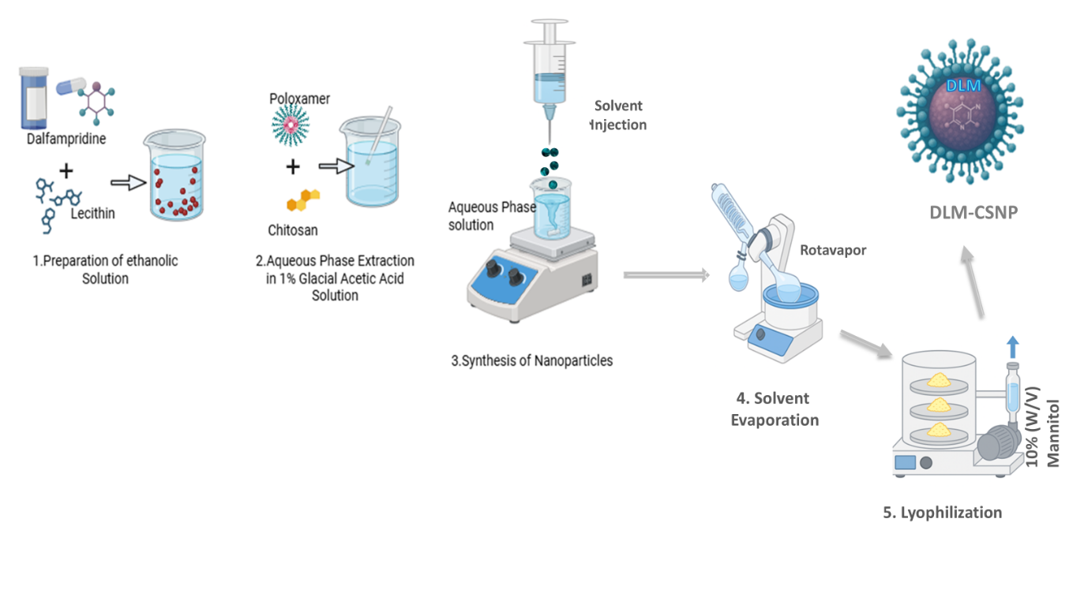
Figure 1. A Schematic representation of the preparation of Dalfampridine-loaded Chitosan Nanoparticle (DLM-CSNPs) by the solvent injection method.

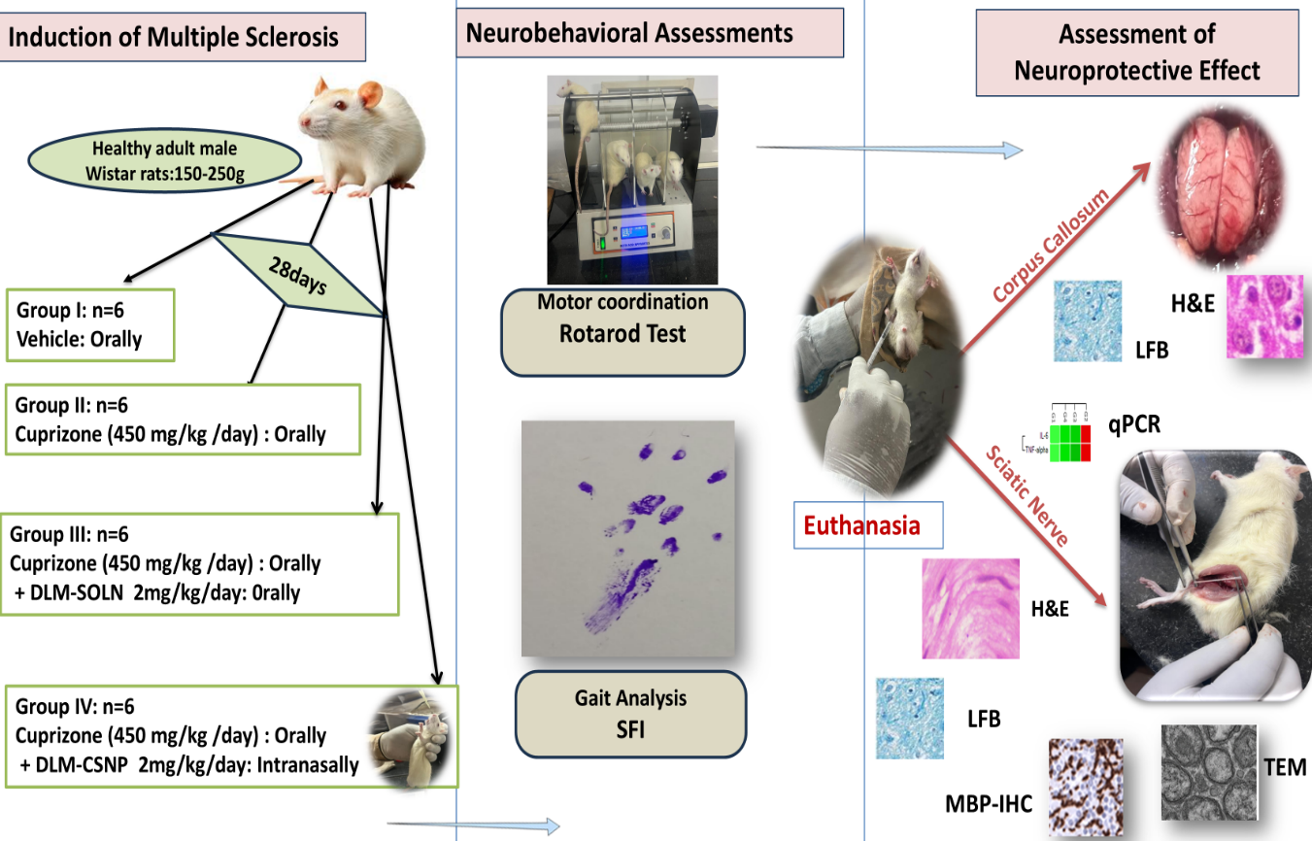
Figure 2. A Schematic representation of the Induction of Multiple Sclerosis and neuroprotective assessment of Dalfampridine-loaded Chitosan Nanoparticle (DLM-CSNPs).

Figure 3: contour plot of (a) Particle size, b) Zeta potential, c) Entrapment efficiency and 3d surface plot of d) Particle size, e) Zeta potential, f) Entrapment efficiency

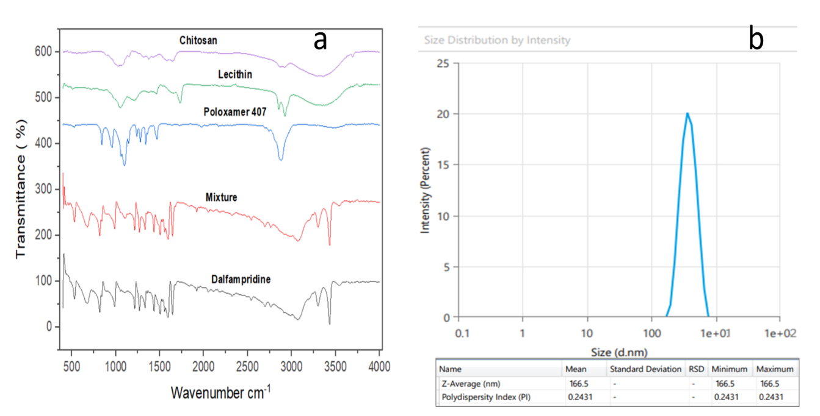

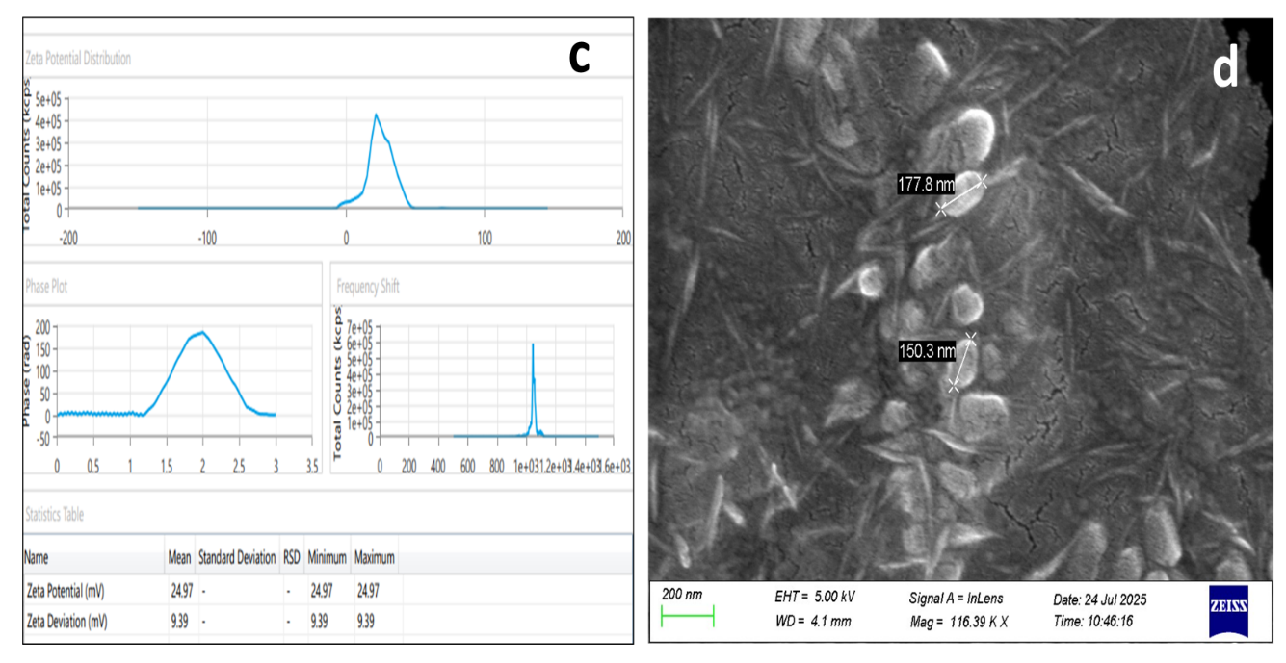
Figure 4: (a) Fourier Transform Infrared (FTIR) spectra, (b& c) Physicochemical characterization of DLM-CSNPs: Particle size distribution and Zeta potential, (d) Morphological characterization of DLM-CSNPs: Scanning Electron Microscopy (SEM) image.

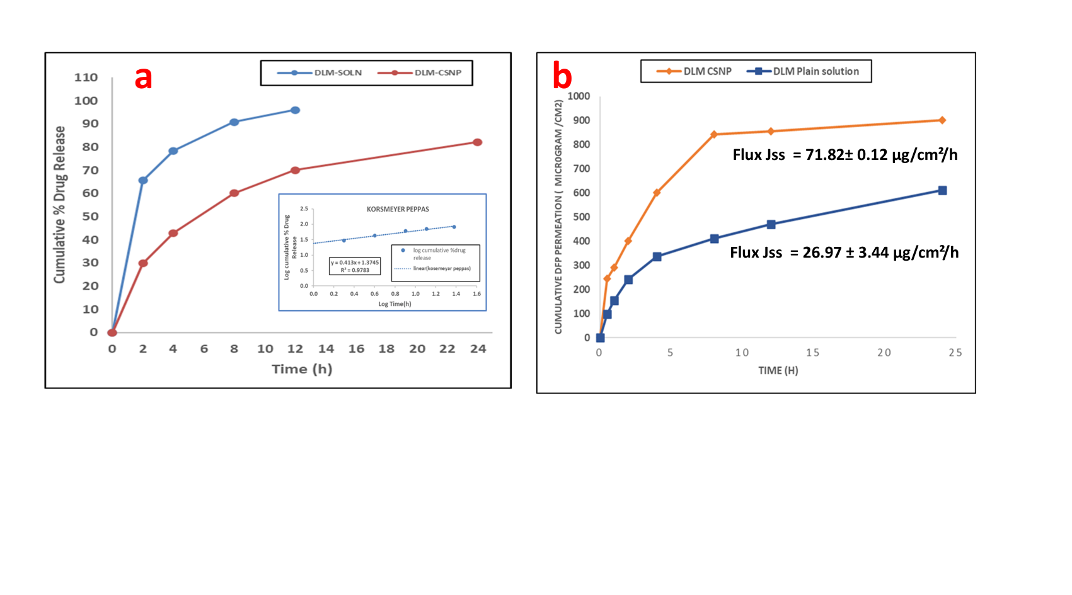
Figure 5: (a) Cumulative % drug release profile (b) Ex vivo nasal permeation profile of Dalfampridine (DLM) from Chitosan– Nanoparticles (CSNPs) compared with DLM-SOLN

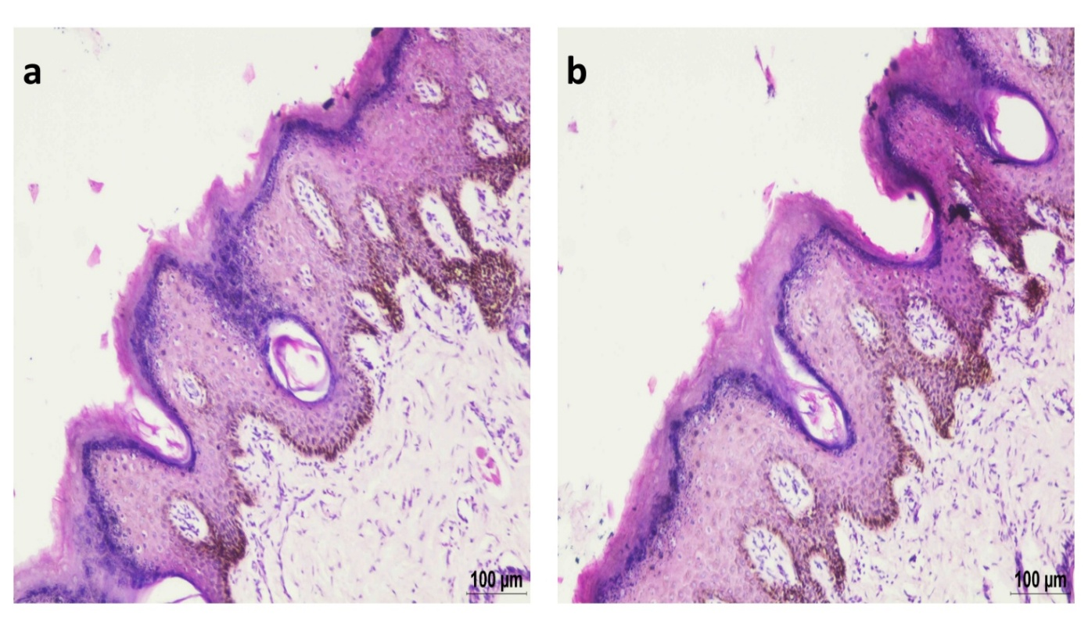
Figure 6: Naso Ciliotoxicity and Biocompatibility of DLM-CSNPs - Histopathological images of goat nasal mucosa from the control group (a) and the DLM- CSNPs group (b) showing within normal limits Haematoxylin & Eosin staining at 10X magnification.

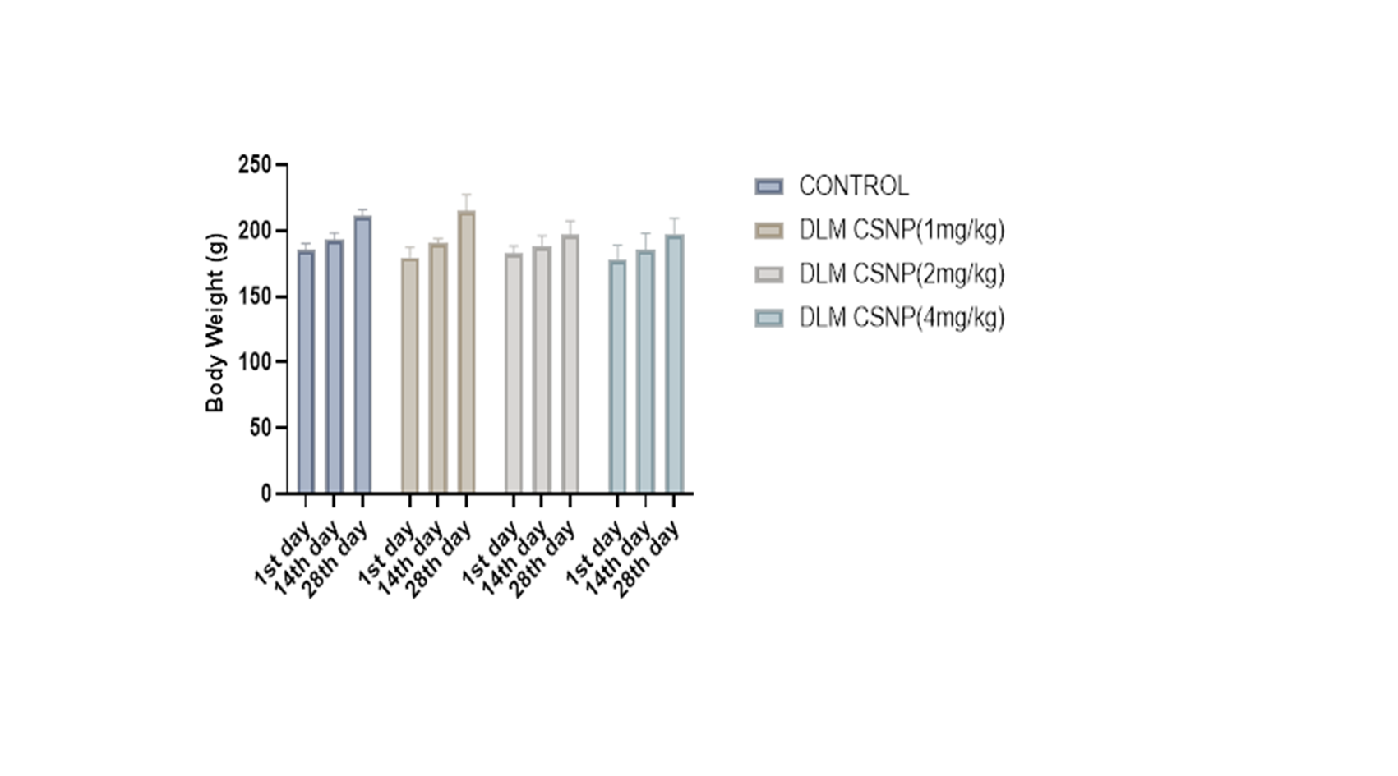
Figure 7: Group-wise comparison of body weight gain in control and intranasal DLM-CSNPs–treated animals (1–4 mg/kg) (mean ± SD, n = 6; **p < 0.01)

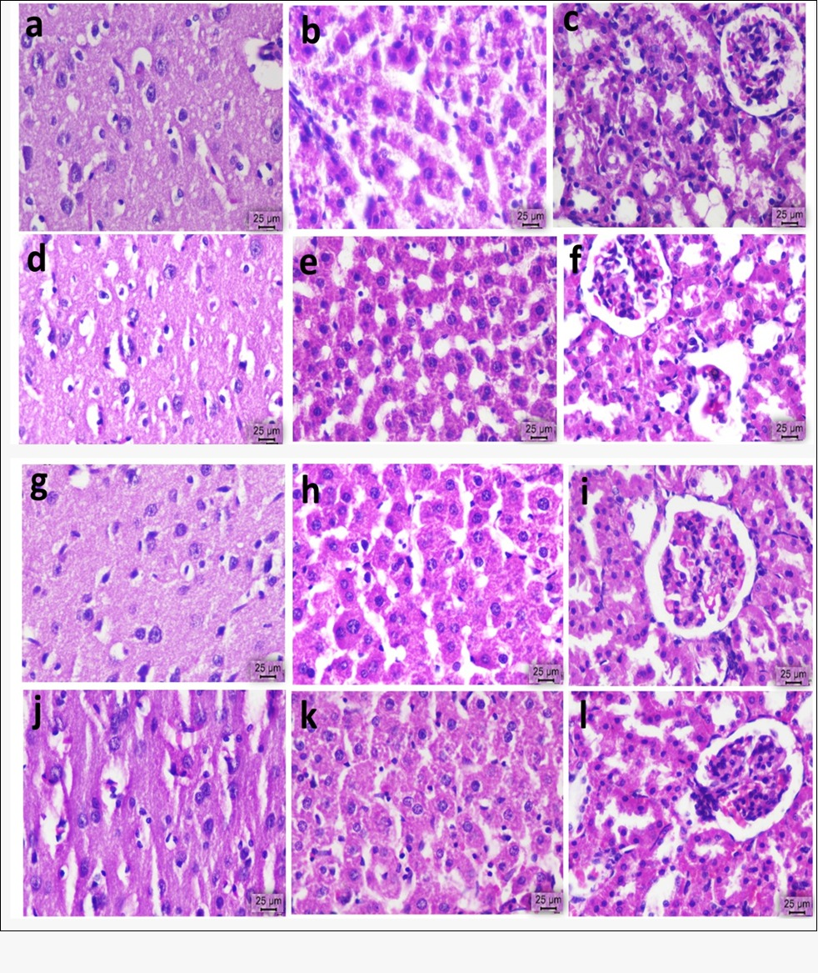Figure 8: Histopathological examination of major organs following the sub-acute toxicity study of the DLM-CSNPs formulation. Representative Hematoxylin and Eosin (H&E)–stained sections of the heart, liver, and kidney from animals treated with control (a–c), 1 mg/kg (d–f), 2 mg/kg (g–i) and 4 mg/kg (j-l) are presented. Scale bar = 25 µm.
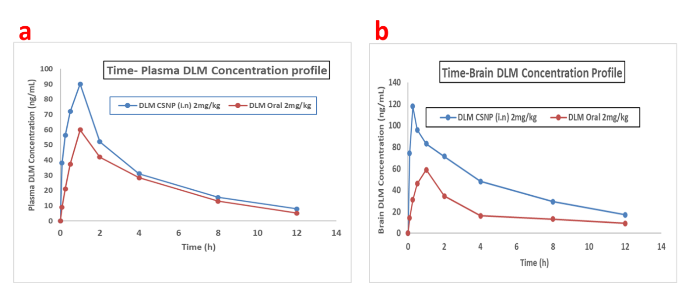
Figure 9 Plasma (a) and brain (b) concentration–time profiles of dalfampridine following oral DLM- SOLN and DLM-CSNPs intranasal administration (2 mg/kg) in male Wistar rats (mean ± SD, n = 3).

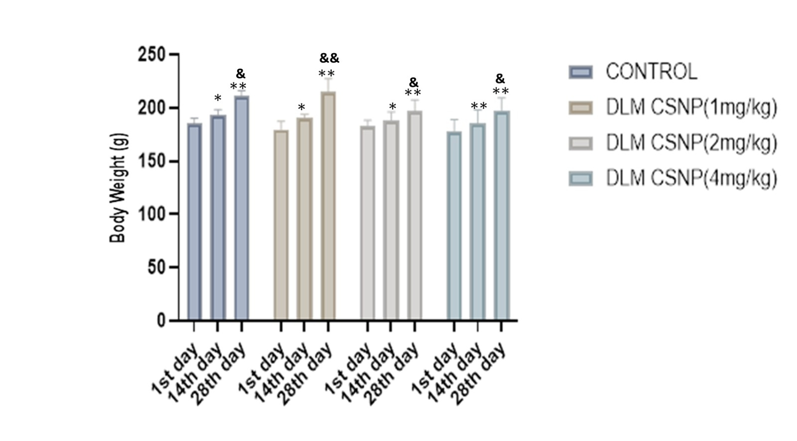Figure 10. Effect of intranasal DLM-CSNPs on body weight during hepatic and renal toxicity study. Data are mean ± SD (n = 6). Two-way ANOVA followed by Tukey’s test. **p < 0.01 vs control; &p < 0.05 vs respective 14th day.

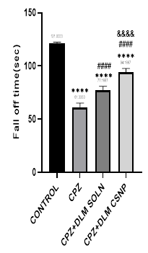
Figure 11. Effect of DLM formulations on motor coordination in CPZ–treated rats, assessed using the rotarod test. (i) Latency to fall from the rotating rod following four weeks of treatment. Statistical significance was determined using one-way ANOVA followed by Tukey’s multiple comparisons post hoc test. ****p < 0.0001 vs control; ####p < 0.0001 vs CPZ; &&&&p < 0.0001 vs CPZ + DLM SOLN. Data are presented as mean ± SD (n = 6).

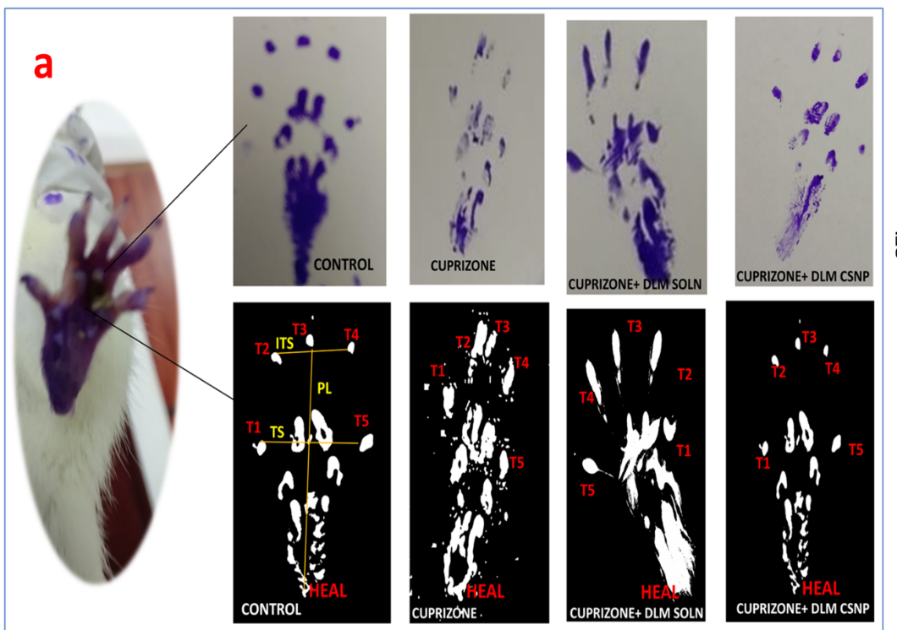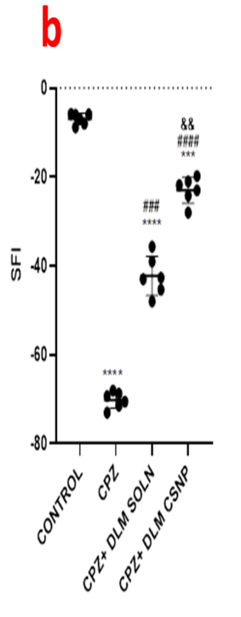
Figure 12. Effect of DLM formulations on gait pattern and sciatic nerve function in CPZ–treated rats. (a) Representative hind-limb paw-print images. (b) Quantitative analysis of Sciatic Functional Index (SFI). Data are expressed as mean ± SD (n = 6). Statistical analysis was performed using one-way ANOVA followed by Tukey’s multiple comparisons post hoc test. ***p < 0.001 vs control; ####p < 0.0001 vs CPZ; &&p < 0.01 vs CPZ + DLM SOLN.

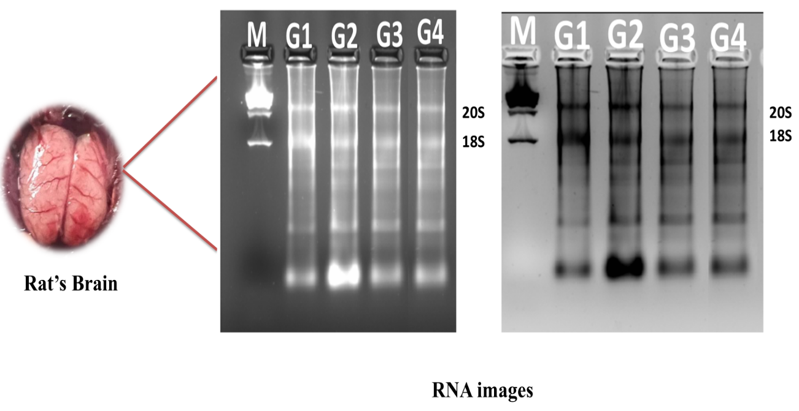

Figure 13. Assessment of RNA integrity in brain tissue samples. A representative electrophoresis image showing distinct RNA bands for the Control group (G1), CPZ-treated group (G2), CPZ + DLM-SOLN-treated group (G3) and CPZ + DLM-CSNPs-treated group (G4). Lane M denotes the 1 Kb DNA ladder (Abclonal) used as a molecular size reference.

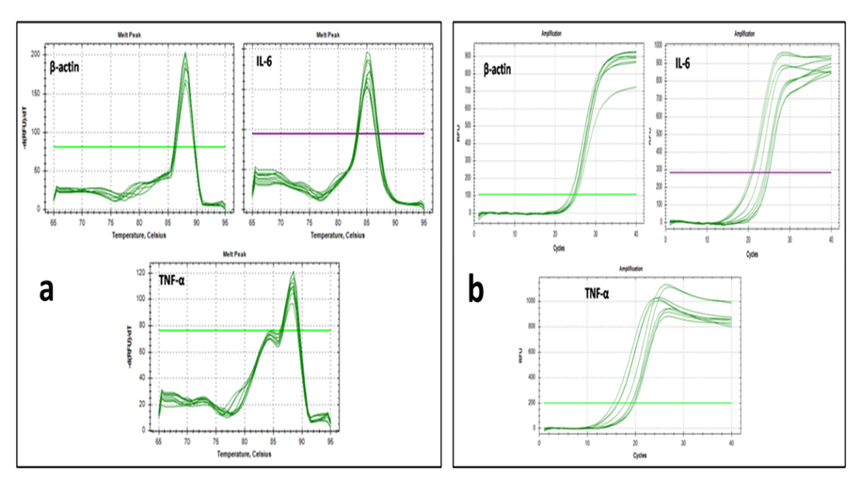

Figure 14. qPCR validation of pro-inflammatory gene expression. (a) Melt peak analysis of target genes showing single, sharp peaks for TNF-α, IL-6, and β-actin, confirming amplification specificity and absence of primer-dimer formation. (b) Log amplification curves of the same genes demonstrating efficient and consistent amplification across all treatment groups.

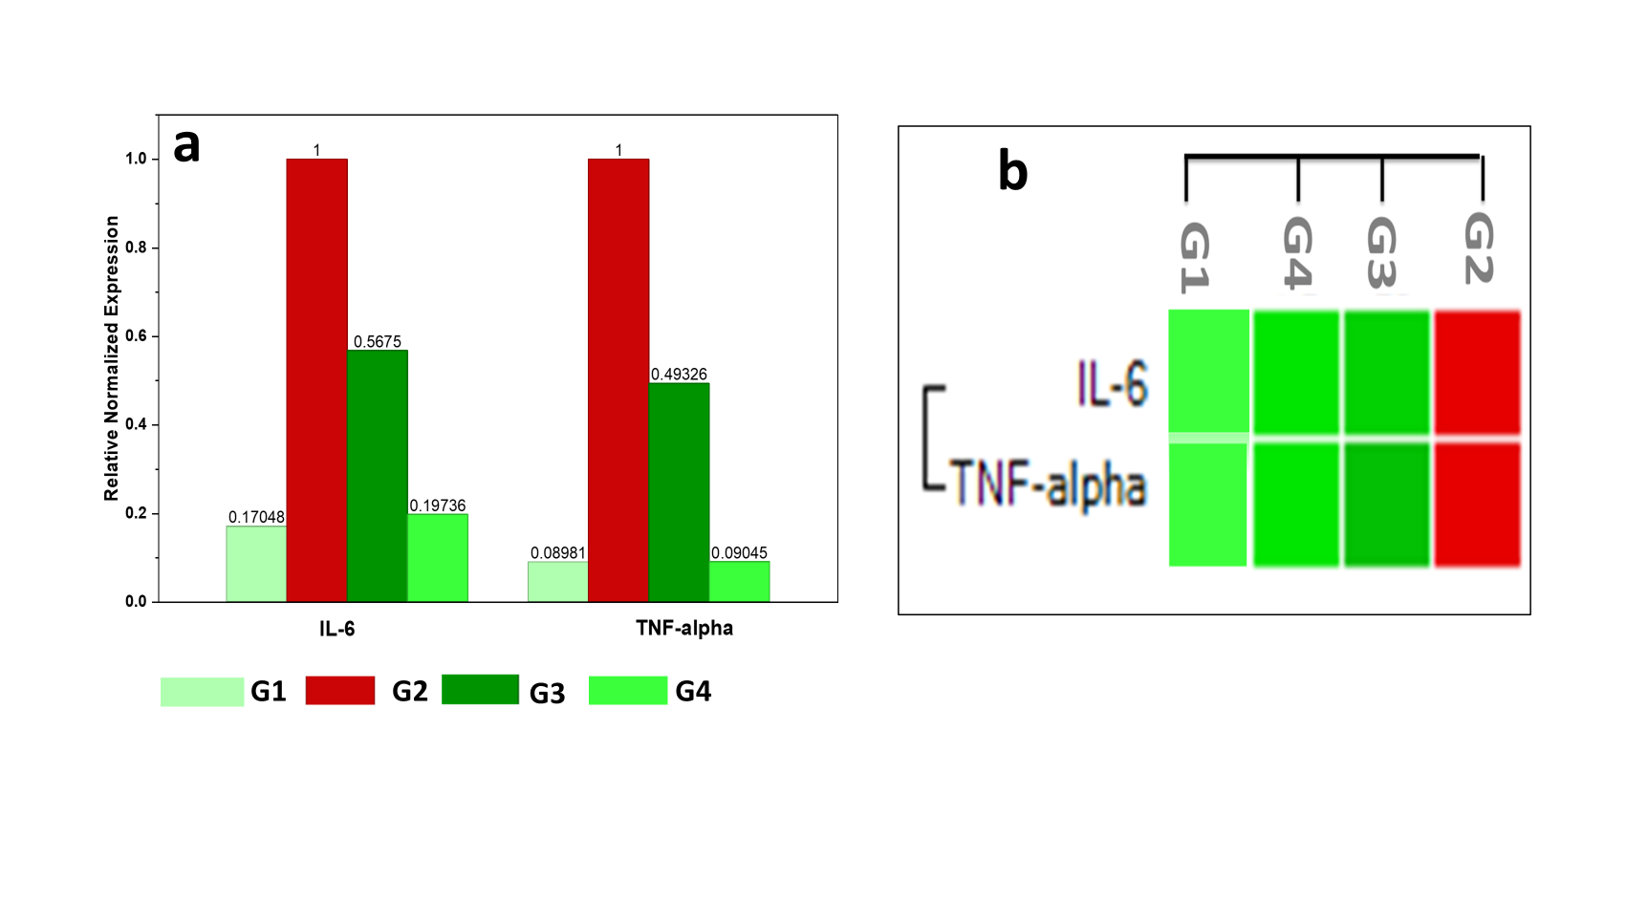

Figure 15. Relative mRNA expression of IL-6 and TNF-α in the corpus callosum.(a) Normalized gene expression (fold change) relative to β-actin.(b) Heatmap showing cytokine expression patterns across groups. G1: Control; G2: CPZ; G3: CPZ + DLM-SOLN; G4: CPZ + intranasal DLM-CSNPs. CPZ significantly increased IL-6 and TNF-α expression, whereas DLM-CSNPs treatment markedly reduced cytokine levels compared with CPZ (p < 0.01–0.001), indicating attenuation of neuroinflammation.

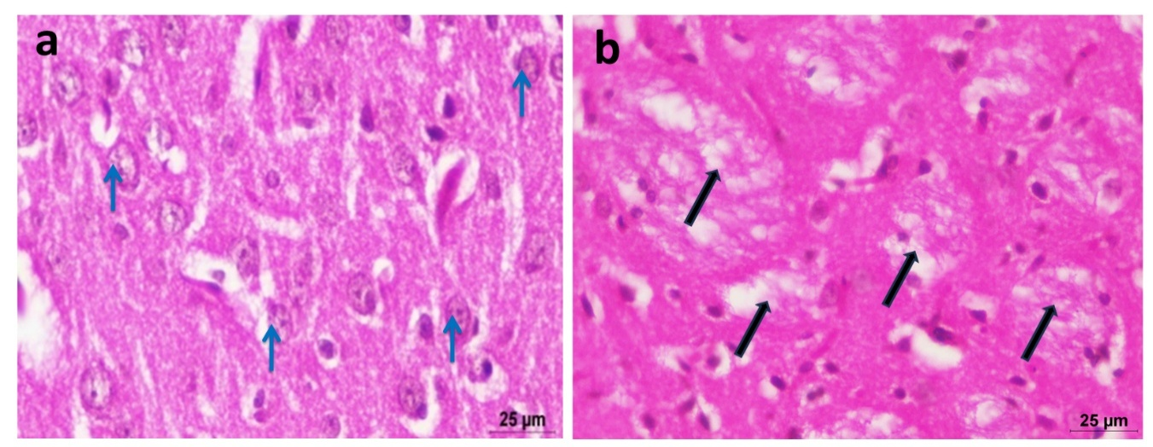
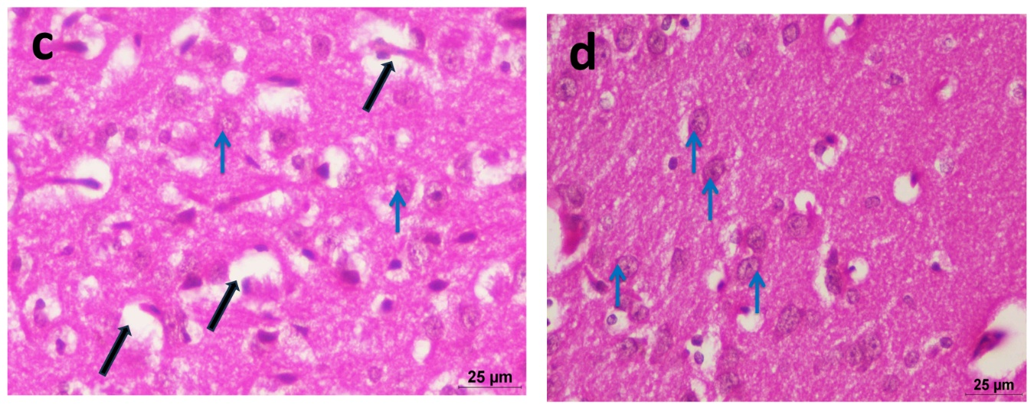

Figure 16. H&E-stained sections of the corpus callosum from different experimental groups. (a) Control rat brain showing normal histoarchitecture with well-organized neurons (blue arrow). (b) CPZ–intoxicated rats showing axonal swelling with disruption of nerve fibers (black arrow). (c) CPZ + DLM- SOLN group showing pale-stained nerve fibers in the corpus callosum with areas of disrupted nerve fibers (black arrow). (d) CPZ + DLM-CSNPs–treated rats showing near-normal tissue organization with preserved neuronal structure (blue arrow).
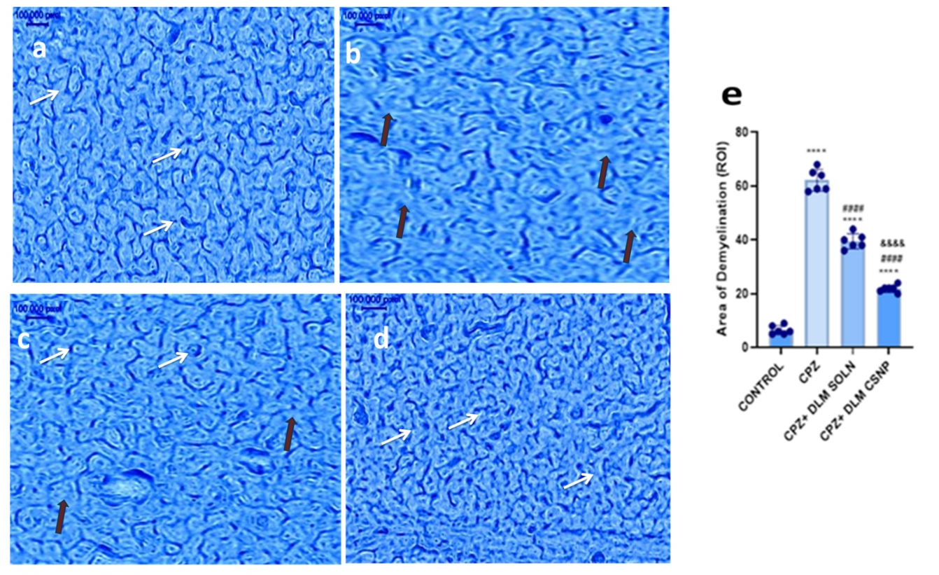
Figure 17. Luxol Fast Blue (LFB) stained sections demonstrating myelin alterations in the corpus callosum across different experimental groups. (a) The control section (b), CPZ-treated section (c), Section from the CPZ + DLM-SOLN (oral) (d), Section from the CPZ + DLM-CSNPs (i.n). white arrows indicate myelinated fibers and black arrows indicate the areas of demyelination, (e) Quantitative analysis score of demyelinating areas in different studied groups. (scale bar = 100.000 pixels). Statistical analysis was performed using one-way ANOVA followed by Tukey’s multiple comparison post hoc test. ****p < 0.0001 vs control; ####p < 0.0001 vs CPZ; &&&&p < 0.0001 vs CPZ + DLM SOLN

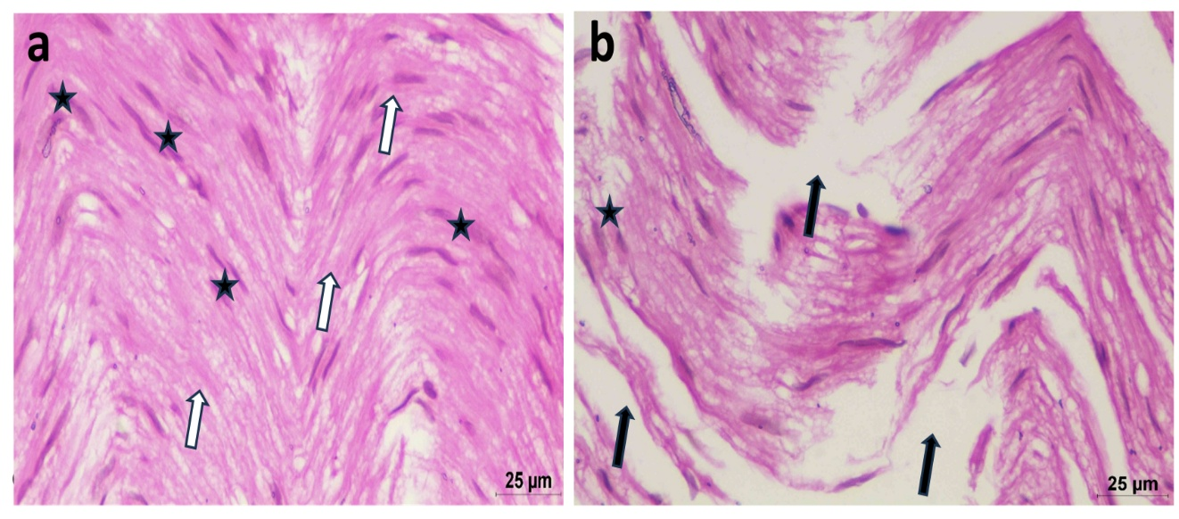
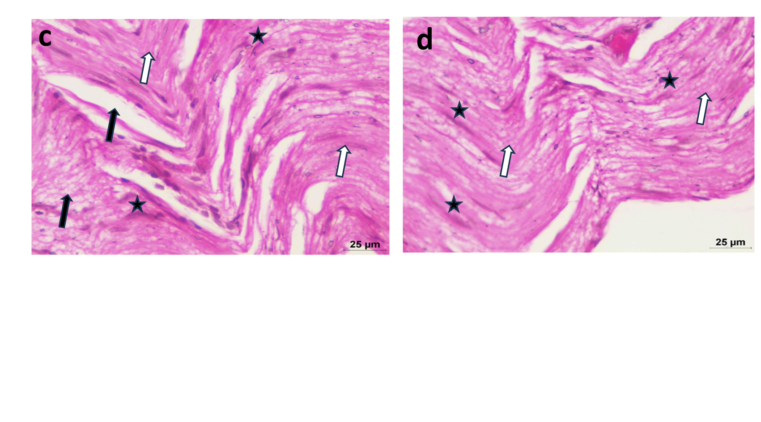

Figure 18. Histological analysis of the sciatic nerve by H&E staining (Scale bar = 25 μm). a) Control group displayed densely packed, uniformly arranged myelinated fibers (white arrows) with regular Schwann cell nuclei (black star). (b) CPZ group showed loosely arranged, broadened nerve fibers with areas of partial demyelination (black arrows). (c) Oral CPZ+DLM SOLN group exhibited partial recovery with moderately organised fibres (white arrows) and incomplete myelin restoration (black arrows). (d) CPZ+ DLM-CSNPs (i.n) treated group revealed near-normal nerve architecture with well-preserved myelinated sheaths (white arrows).
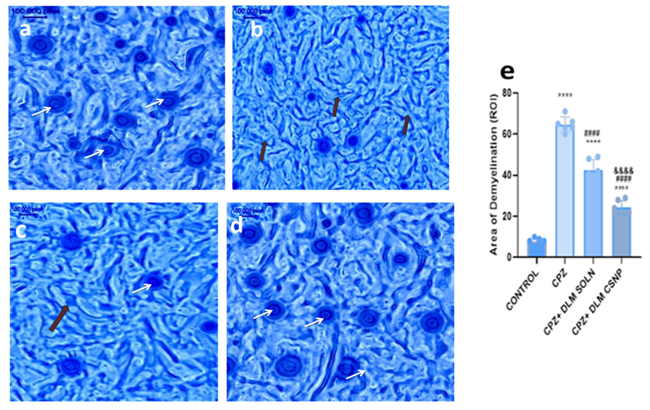
Figure 19. Luxol Fast Blue (LFB) staining of sciatic nerve sections showing group-wise changes in myelin (a) The control section (b), CPZ-treated section (c), Section from the CPZ + DLM-SOLN (oral) (d), Section from the CPZ + DLM-CSNPs (i.n): white arrows indicate myelinated fibers and black arrows indicate the areas of demyelination, (e) Quantitative analysis score of demyelinating areas in different studied groups. (scale bar = 100.000 pixels). Statistical analysis was performed using one-way ANOVA followed by Tukey’s multiple comparison post hoc test. ****p < 0.0001 vs control; ####p < 0.0001 vs CPZ; &&&&p < 0.0001 vs CPZ + DLM SOLN.
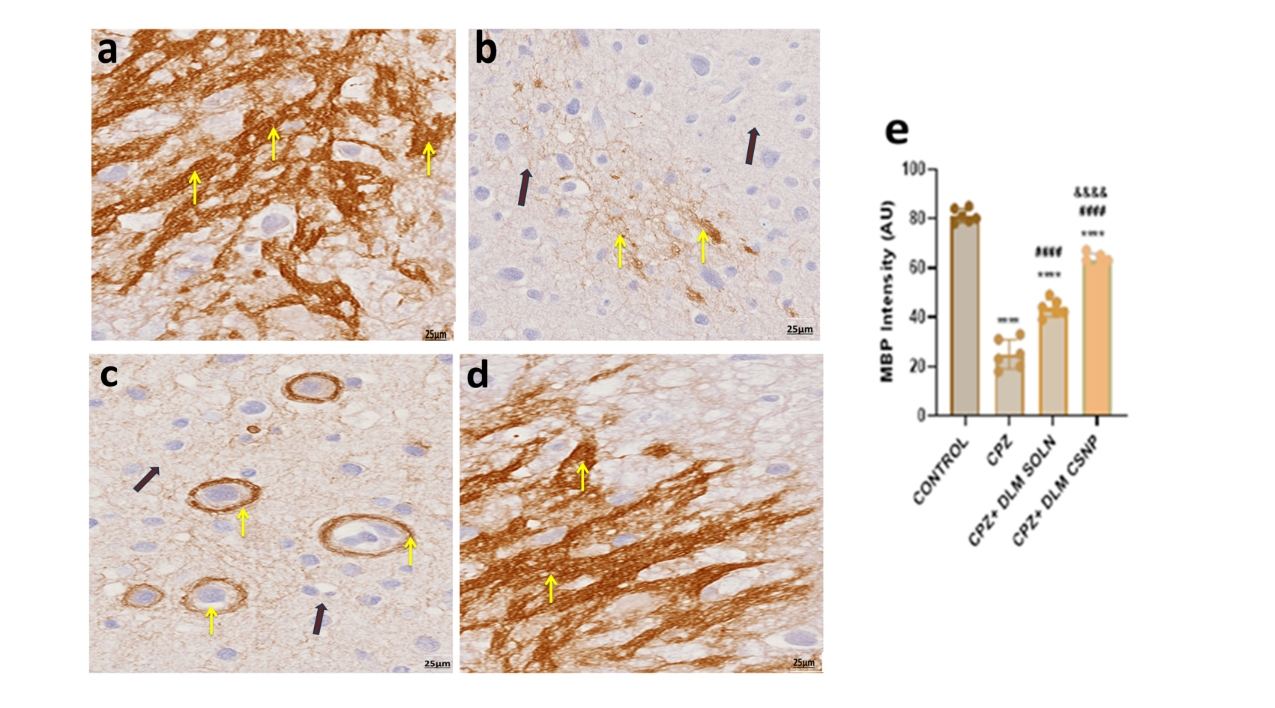
Figure 20. Immunohistochemical localization of Myelin Basic Protein (MBP) in sciatic nerve sections from different experimental groups. (a) Control group section (b) CPZ group section (c) CPZ + DLM- SOLN (oral) group section (d) CPZ + DLM- CSNP (i.n) section: myelinated nerve fibers (yellow arrow) and demyelinated nerve fibers (black arrow) (e) Quantitative analysis of MBP-positive area (scale bar = 40X). Statistical analysis was performed using one-way ANOVA followed by Tukey’s multiple comparison post hoc test. ****p < 0.0001 vs control; ####p < 0.0001 vs CPZ; &&&&p < 0.0001 vs CPZ + DLM SOLN.
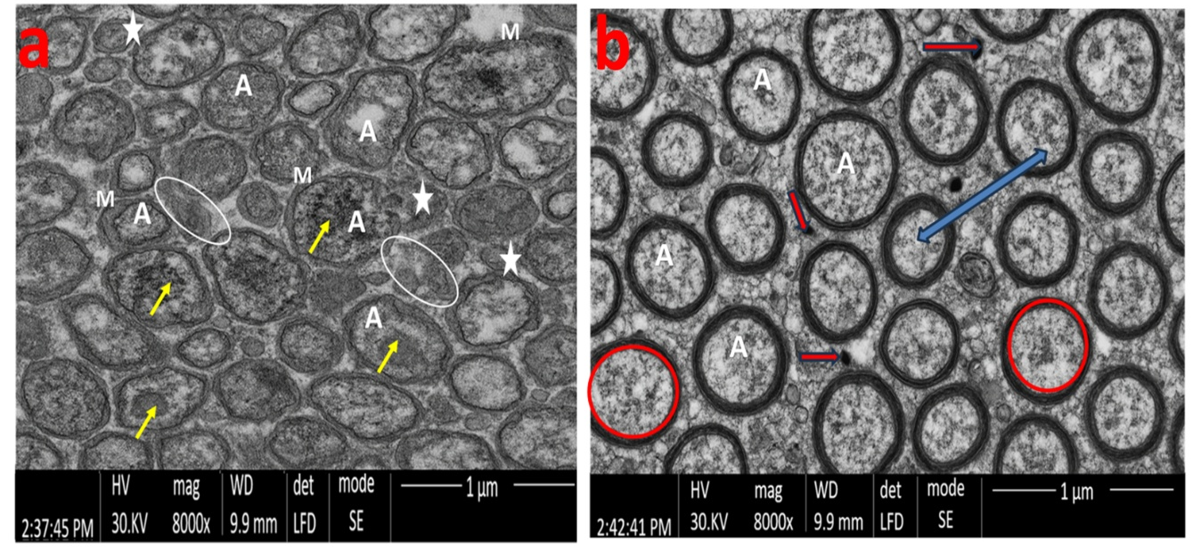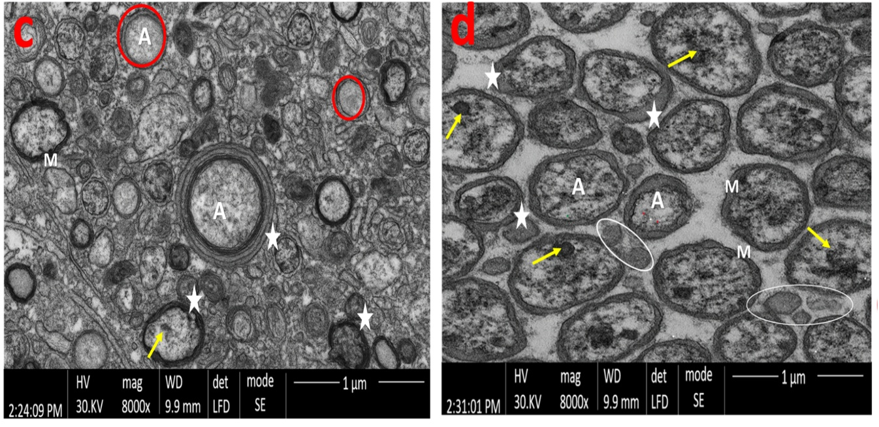
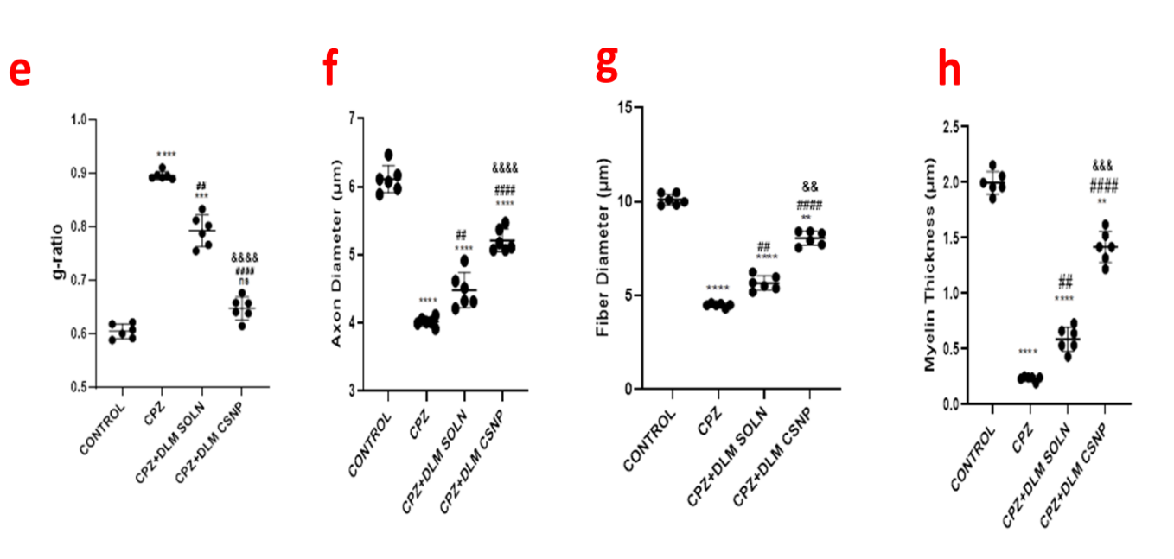
Figure 21. Transmission electron micrographs illustrating ultrastructural features of the sciatic nerve in different experimental groups (scale bar = 1 µm). a) Section from the control group displays well-organized, large myelinated fibers with compact and thick myelin layers (M), the axoplasm (A) contains visible mitochondria (yellow arrow). Small-diameter fibers are enclosed by Schwann cells (white star), each axon embedded in its cytoplasmic pocket. b) CPZ-exposed nerve fibers show clear signs of endoneurial edema, evident separation between adjacent axons (blue arrow), reactive astrocytes (red arrow), a higher number of unmyelinated axons (A) and areas of myelin disruption with demyelinated profiles. c) oral DLM SOLN + CPZ group showed a few numbers of slightly myelinated axons (A). d) Nerve section from the CPZ + DLM-CSNP treated group demonstrates nearly preserved morphology, with both large and small axons (A) surrounded by compact myelin (M) similar to the control appearance. Quantitative TEM morphometric analysis of the sciatic nerve showing (e) g-ratio, (f) axon diameter, (g) fiber diameter, and (h) myelin thickness across experimental groups. Data are expressed as mean ± SD. Statistical analysis was performed using one-way ANOVA followed by Tukey’s multiple comparisons test. ****p < 0.0001 vs control; ##p < 0.01 vs CPZ; &&p < 0.01 vs CPZ + DLM SOLN.

Figure captions
Figure 1. A Schematic representation of the preparation of Dalfampridine-loaded Chitosan Nanoparticle (DLM-CSNPs) by the solvent injection method.
Figure 2. A Schematic representation of the Induction of Multiple Sclerosis and neuroprotective assessment of Dalfampridine-loaded Chitosan Nanoparticle (DLM-CSNPs).
Figure 3: contour plot of (a) Particle size, b) Zeta potential, c) Entrapment efficiency and 3d surface plot of d) Particle size, e) Zeta potential, f) Entrapment efficiency
Figure 4: (a) Fourier Transform Infrared (FTIR) spectra, (b& c) Physicochemical characterization of DLM-CSNPs: Particle size distribution and Zeta potential, (d) Morphological characterization of DLM-CSNPs: Scanning Electron Microscopy (SEM) image.
Figure 5: (a) Cumulative % drug release profile (b) Ex vivo nasal permeation profile of Dalfampridine (DLM) from Chitosan– Nanoparticles (CSNPs) compared with DLM-SOLN
Figure 6: Naso Ciliotoxicity and Biocompatibility of DLM-CSNPs - Histopathological images of goat nasal mucosa from the control group (a) and the DLM- CSNPs group (b) showing within normal limits Haematoxylin & Eosin staining at 10X magnification.
Figure 7: Group-wise comparison of body weight gain in control and intranasal DLM-CSNPs–treated animals (1–4 mg/kg) (mean ± SD, n = 6; **p < 0.01)
Figure 8: Histopathological examination of major organs following the sub-acute toxicity study of the DLM-CSNPs formulation. Representative Hematoxylin and Eosin (H&E)–stained sections of the heart, liver, and kidney from animals treated with control (a–c), 1 mg/kg (d–f), 2 mg/kg (g–i) and 4 mg/kg (j-l) are presented. Scale bar = 25 µm.
Figure 9 Plasma (a) and brain (b) concentration–time profiles of dalfampridine following oral DLM- SOLN and DLM-CSNPs intranasal administration (2 mg/kg) in male Wistar rats (mean ± SD, n = 3).
Figure 10. Effect of intranasal DLM-CSNPs on body weight during hepatic and renal toxicity study. Data are mean ± SD (n = 6). Two-way ANOVA followed by Tukey’s test. **p < 0.01 vs control; &p < 0.05 vs respective 14th day.
Figure 11. Effect of DLM formulations on motor coordination in CPZ–treated rats, assessed using the rotarod test. (i) Latency to fall from the rotating rod following four weeks of treatment. Statistical significance was determined using one-way ANOVA followed by Tukey’s multiple comparisons post hoc test. ****p < 0.0001 vs control; ####p < 0.0001 vs CPZ; &&&&p < 0.0001 vs CPZ + DLM SOLN. Data are presented as mean ± SD (n = 6).
Figure 12. Effect of DLM formulations on gait pattern and sciatic nerve function in CPZ–treated rats. (a) Representative hind-limb paw-print images. (b) Quantitative analysis of Sciatic Functional Index (SFI). Data are expressed as mean ± SD (n = 6). Statistical analysis was performed using one-way ANOVA followed by Tukey’s multiple comparisons post hoc test. ***p < 0.001 vs control; ####p < 0.0001 vs CPZ; &&p < 0.01 vs CPZ + DLM SOLN.

Figure 13. Assessment of RNA integrity in brain tissue samples. A representative electrophoresis image showing distinct RNA bands for the Control group (G1), CPZ-treated group (G2), CPZ + DLM-SOLN-treated group (G3) and CPZ + DLM-CSNPs-treated group (G4). Lane M denotes the 1 Kb DNA ladder (Abclonal) used as a molecular size reference.

Figure 14. qPCR validation of pro-inflammatory gene expression. (a) Melt peak analysis of target genes showing single, sharp peaks for TNF-α, IL-6, and β-actin, confirming amplification specificity and absence of primer-dimer formation. (b) Log amplification curves of the same genes demonstrating efficient and consistent amplification across all treatment groups.

Figure 15. Relative mRNA expression of IL-6 and TNF-α in the corpus callosum.(a) Normalized gene expression (fold change) relative to β-actin.(b) Heatmap showing cytokine expression patterns across groups. G1: Control; G2: CPZ; G3: CPZ + DLM-SOLN; G4: CPZ + intranasal DLM-CSNPs. CPZ significantly increased IL-6 and TNF-α expression, whereas DLM-CSNPs treatment markedly reduced cytokine levels compared with CPZ (p < 0.01–0.001), indicating attenuation of neuroinflammation.

Figure 16. H&E-stained sections of the corpus callosum from different experimental groups. (a) Control rat brain showing normal histoarchitecture with well-organized neurons (blue arrow). (b) CPZ–intoxicated rats showing axonal swelling with disruption of nerve fibers (black arrow). (c) CPZ + DLM- SOLN group showing pale-stained nerve fibers in the corpus callosum with areas of disrupted nerve fibers (black arrow). (d) CPZ + DLM-CSNPs–treated rats showing near-normal tissue organization with preserved neuronal structure (blue arrow).
Figure 17. Luxol Fast Blue (LFB) stained sections demonstrating myelin alterations in the corpus callosum across different experimental groups. (a) The control section (b), CPZ-treated section (c), Section from the CPZ + DLM-SOLN (oral) (d), Section from the CPZ + DLM-CSNPs (i.n). white arrows indicate myelinated fibers and black arrows indicate the areas of demyelination, (e) Quantitative analysis score of demyelinating areas in different studied groups. (scale bar = 100.000 pixels). Statistical analysis was performed using one-way ANOVA followed by Tukey’s multiple comparison post hoc test. ****p < 0.0001 vs control; ####p < 0.0001 vs CPZ; &&&&p < 0.0001 vs CPZ + DLM SOLN

Figure 18. Histological analysis of the sciatic nerve by H&E staining (Scale bar = 25 μm). a) Control group displayed densely packed, uniformly arranged myelinated fibers (white arrows) with regular Schwann cell nuclei (black star). (b) CPZ group showed loosely arranged, broadened nerve fibers with areas of partial demyelination (black arrows). (c) Oral CPZ+DLM SOLN group exhibited partial recovery with moderately organised fibres (white arrows) and incomplete myelin restoration (black arrows). (d) CPZ+ DLM-CSNPs (i.n) treated group revealed near-normal nerve architecture with well-preserved myelinated sheaths (white arrows).
Figure 19. Luxol Fast Blue (LFB) staining of sciatic nerve sections showing group-wise changes in myelin (a) The control section (b), CPZ-treated section (c), Section from the CPZ + DLM-SOLN (oral) (d), Section from the CPZ + DLM-CSNPs (i.n): white arrows indicate myelinated fibers and black arrows indicate the areas of demyelination, (e) Quantitative analysis score of demyelinating areas in different studied groups. (scale bar = 100.000 pixels). Statistical analysis was performed using one-way ANOVA followed by Tukey’s multiple comparison post hoc test. ****p < 0.0001 vs control; ####p < 0.0001 vs CPZ; &&&&p < 0.0001 vs CPZ + DLM SOLN.
Figure 20. Immunohistochemical localization of Myelin Basic Protein (MBP) in sciatic nerve sections from different experimental groups. (a) Control group section (b) CPZ group section (c) CPZ + DLM- SOLN (oral) group section (d) CPZ + DLM- CSNP (i.n) section: myelinated nerve fibers (yellow arrow) and demyelinated nerve fibers (black arrow) (e) Quantitative analysis of MBP-positive area (scale bar = 40X). Statistical analysis was performed using one-way ANOVA followed by Tukey’s multiple comparison post hoc test. ****p < 0.0001 vs control; ####p < 0.0001 vs CPZ; &&&&p < 0.0001 vs CPZ + DLM SOLN.
Figure 21. Transmission electron micrographs illustrating ultrastructural features of the sciatic nerve in different experimental groups (scale bar = 1 µm). a) Section from the control group displays well-organized, large myelinated fibers with compact and thick myelin layers (M), the axoplasm (A) contains visible mitochondria (yellow arrow). Small-diameter fibers are enclosed by Schwann cells (white star), each axon embedded in its cytoplasmic pocket. b) CPZ-exposed nerve fibers show clear signs of endoneurial edema, evident separation between adjacent axons (blue arrow), reactive astrocytes (red arrow), a higher number of unmyelinated axons (A) and areas of myelin disruption with demyelinated profiles. c) oral DLM SOLN + CPZ group showed a few numbers of slightly myelinated axons (A). d) Nerve section from the CPZ + DLM-CSNP treated group demonstrates nearly preserved morphology, with both large and small axons (A) surrounded by compact myelin (M) similar to the control appearance. Quantitative TEM morphometric analysis of the sciatic nerve showing (e) g-ratio, (f) axon diameter, (g) fiber diameter, and (h) myelin thickness across experimental groups. Data are expressed as mean ± SD. Statistical analysis was performed using one-way ANOVA followed by Tukey’s multiple comparisons test. ****p < 0.0001 vs control; ##p < 0.01 vs CPZ; &&p < 0.01 vs CPZ + DLM SOLN.

