About the Author
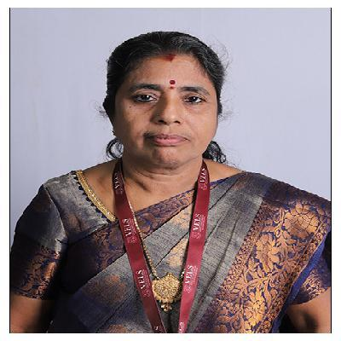

Dr. M. Thaiyalnayaki is Professor, Department of Commerce, Vels Institute of Science, Technology and Advanced Studies (VISTAS), Pallavaram, Chennai, Tamil Nadu, India. She has over 36 years of Teaching Experience and Research in Commerce, Corporate Secretaryship and Management Studies.
She has contributed over 100 Articles in National and International Journals. She has guided 15 M.Phil., and 10 Ph.D Scholars besides guiding 8 Ph.D Scholars. She has guided around 2,500 UG Projects. She has also published Four academic books.
She was awarded the ‘Global Excellence Award’ for her Distinguished Service in Higher Education, Leadership and Research from UNIFACVEST University, Brazil, South America, 2022.
International Council for Education, Research and Training (ICERT) has confer the honour to her and she was awarded “Maulana Abdul Kalam Azad Education Excellence Award 2022”.
She was also awarded “Life Time Achievement Award, 2023” for her exemplary service rendered in higher education by Indian Academic Researchers Association, Tamil Nadu, India.

