CUSTOMER SEGMENTATION AND PRODUCT RECOMMENDATION SYSTEM

M Varshini Dr. V. Raghavendran

III BCA Assistant Professor

Varshinimaruthavel@gmail.com raghavendran.scs@vistas.ac.in

Abstract

In today’s data-driven business environment, understanding customer behaviour is crucial for enhancing customer satisfaction and increasing profitability. This project presents a comprehensive system that combines customer segmentation and product recommendation techniques to analyse customer data effectively. The system utilizes the K-Means clustering algorithm to group customers based on attributes such as age, annual income, and spending score. These clusters represent distinct customer segments with similar characteristics.
Further, the project integrates association rule mining using the Apriori algorithm to identify frequently purchased product combinations within each customer segment. This enables businesses to understand purchasing patterns and generate targeted recommendations. The application is developed using Python and deployed through a Streamlit-based user interface, allowing users to upload datasets, perform clustering, visualize results, and view recommendations interactively.
The proposed system provides valuable insights into customer behaviour, enabling businesses to design personalized marketing strategies and improve decision-making processes.

1.0 Introduction
With the rapid growth of digital technologies, organizations are generating and collecting vast amounts of customer data. Analyzing this data effectively can provide meaningful insights that help businesses improve their services, enhance customer experience, and increase revenue. Traditional methods of analysis are often insufficient to handle large datasets and uncover hidden patterns. Therefore, advanced data mining and machine learning techniques are essential.
Customer segmentation is a widely used technique in marketing that divides customers into groups based on similar characteristics. This helps businesses tailor their marketing strategies to specific customer groups. Clustering algorithms, particularly K-Means, are commonly used for this purpose due to their simplicity and efficiency.
In addition to segmentation, understanding purchasing behavior is equally important. Market Basket Analysis is a technique used to discover relationships between products frequently purchased together. The Apriori algorithm is one of the most popular methods used for this analysis.
This project aims to integrate both customer segmentation and product recommendation into a single system. By doing so, businesses can not only identify different customer groups but also understand their purchasing habits, enabling them to offer personalized recommendations.

2. Literature Review
Customer segmentation and recommendation systems have been widely studied in the field of data mining and machine learning. Various techniques have been proposed and implemented to improve customer understanding and business performance.
Clustering techniques such as K-Means, Hierarchical Clustering, and DBSCAN have been extensively used for customer segmentation. Among these, K-Means is one of the most popular algorithms due to its simplicity, scalability, and efficiency in handling large datasets. Studies have shown that K-Means performs well in grouping customers based on numerical attributes such as income and spending patterns.
Market Basket Analysis has been widely used in retail industries to analyze purchasing behavior. The Apriori algorithm is a foundational method used to identify frequent itemsets and generate association rules. It works by identifying item combinations that occur frequently in transaction datasets and helps businesses understand product relationships.
Recent research has focused on combining clustering with association rule mining to enhance recommendation systems. By applying association rules within customer clusters, businesses can generate more targeted and meaningful recommendations. This approach improves the relevance of recommendations compared to traditional methods.
The integration of machine learning techniques with user-friendly interfaces, such as web-based dashboards, has also gained attention. Tools like Streamlit enable rapid development of interactive applications, making data analysis accessible to non-technical users.

3. Objective
The main objectives of this project are:
- To develop a system for segmenting customers based on their demographic and behavioral attributes.
- To implement the K-Means clustering algorithm for identifying distinct customer groups.
- To analyze purchasing patterns using the Apriori algorithm.
- To generate product recommendations based on customer segments.
- To design an interactive and user-friendly interface for data upload, analysis, and visualization.
- To improve decision-making by providing actionable insights into customer behavior.
- To demonstrate the integration of machine learning and data mining techniques in a real-world application.

4. Methodology
The project follows a systematic approach consisting of data collection, preprocessing, clustering, association rule mining, and visualization.

Data Collection
The system uses a combined dataset containing customer details such as CustomerID, Age, Income, Spending Score, and Product. Each customer may have multiple entries corresponding to different products purchased.

Data Preprocessing
The dataset is cleaned to remove inconsistencies such as missing values and extra spaces in column names. Duplicate customer entries are handled by separating unique customer data for clustering.

Customer Segmentation
The K-Means clustering algorithm is applied to group customers based on selected numerical features. The number of clusters is chosen dynamically by the user. Each customer is assigned a cluster label representing their segment.

Visualization
Scatter plots are used to visualize customer clusters based on selected features. Pie charts are used to show the distribution of customers across clusters. Consistent color mapping is maintained for better interpretation.

Product Analysis
After clustering, the dataset is analyzed to identify purchasing patterns within each cluster. The Apriori algorithm is used to generate frequent itemsets from transactional data.

Recommendation Generation
Frequent itemsets are filtered to identify meaningful product combinations. These combinations are presented as recommendations in a user-friendly format.

User Interface
The system is implemented using Streamlit, providing features such as login/signup, dataset upload, visualization, and recommendation display.

5. Algorithm

K-Means Clustering Algorithm
- Select the number of clusters (K).
- Initialize K centroids randomly.
- Assign each data point to the nearest centroid.
- Recalculate centroids based on assigned points.
- Repeat steps 3 and 4 until convergence.

Apriori Algorithm
- Set minimum support threshold.
- Generate frequent 1-itemsets.
- Generate candidate itemsets of higher order.
- Prune itemsets that do not meet support threshold.
- Repeat until no further itemsets can be generated.

6. Hardware and Software Specifications

Hardware Requirements
- Processor: Intel i3 or higher
- RAM: Minimum 4 GB
- Storage: 500 MB free space
- System: Laptop/Desktop

Software Requirements
- Programming Language: Python
- Libraries:
  - Pandas
  - NumPy
  - Matplotlib
  - Scikit-learn
  - mlxtend
- Framework: Streamlit
- IDE: VS Code
- Operating System: Windows

7. Flowchart
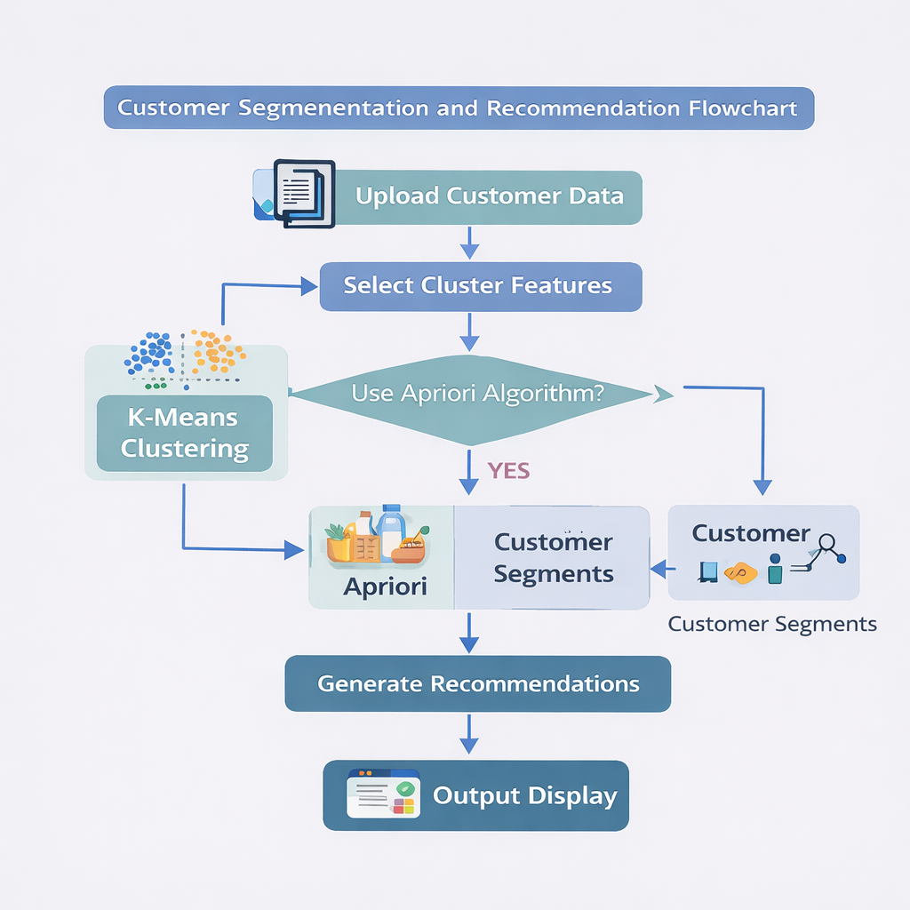

The flowchart illustrates the step-by-step process of the system. It begins with uploading the customer dataset, followed by selecting relevant features such as age, income, and spending score. The system then applies the K-Means clustering algorithm to group customers into different segments based on their similarities. After clustering, the Apriori algorithm is used to analyze purchasing patterns and identify frequently bought product combinations within each cluster. Finally, the system generates recommendations and displays the results using visualizations like scatter plots, pie charts, and product suggestions.
8. System implementation
8.1 Login page
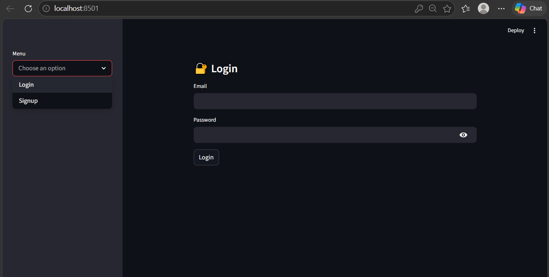
8.2 Signup page
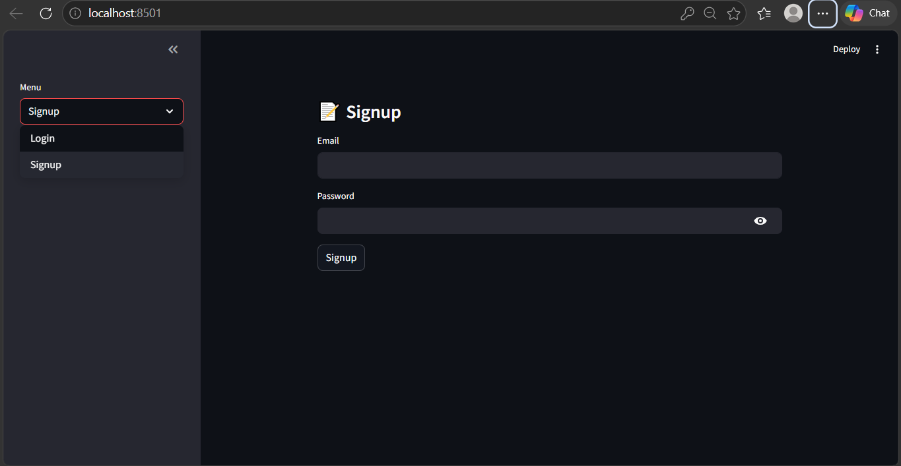

8.3 Dataset upload

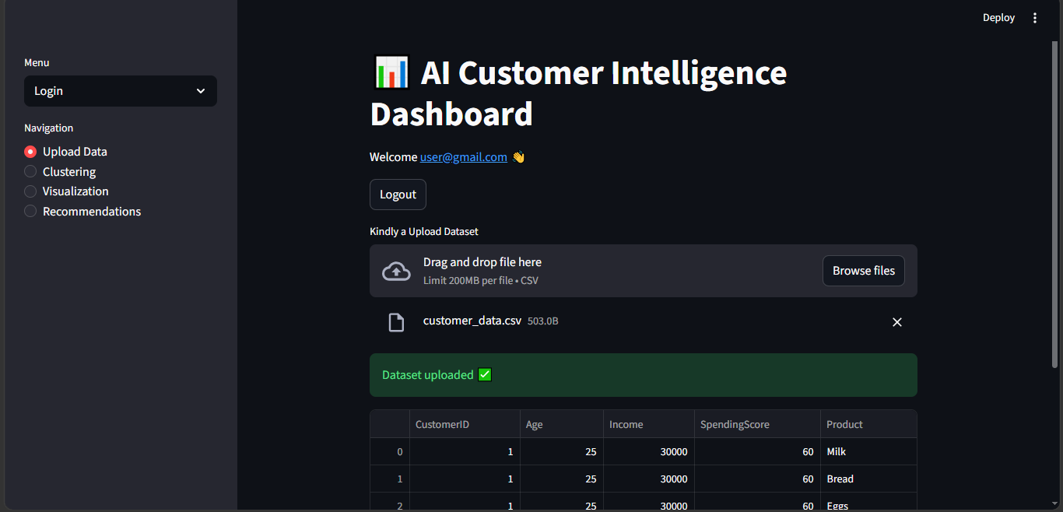

8.4 Feature selection

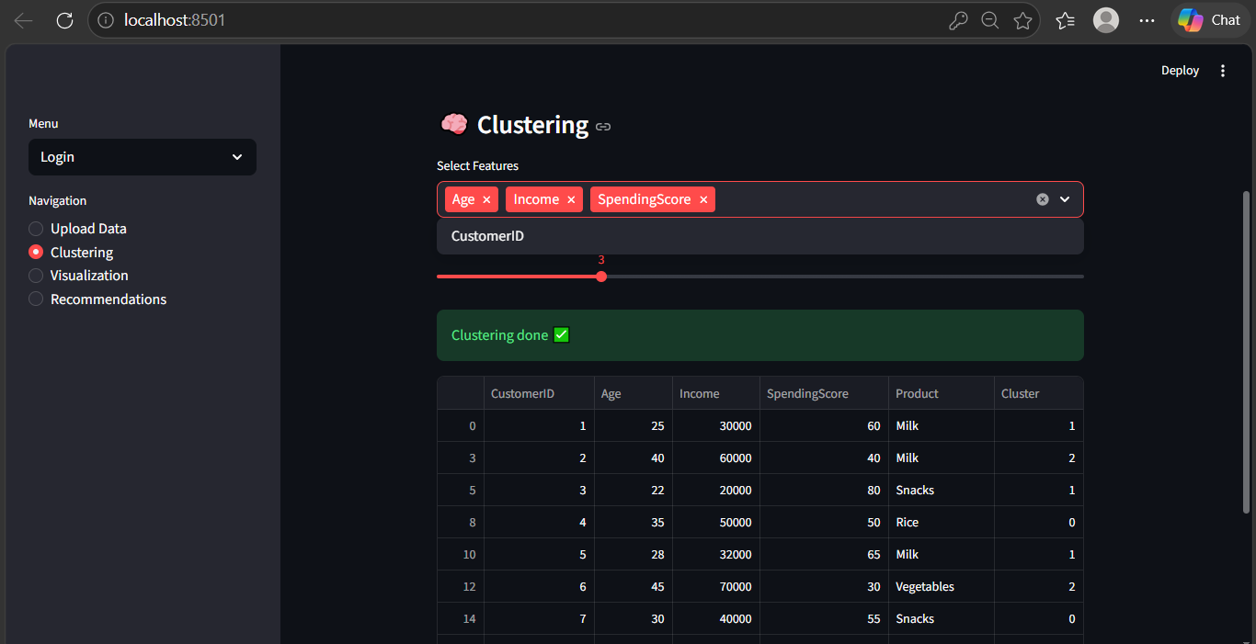

8.5 Scatter plot

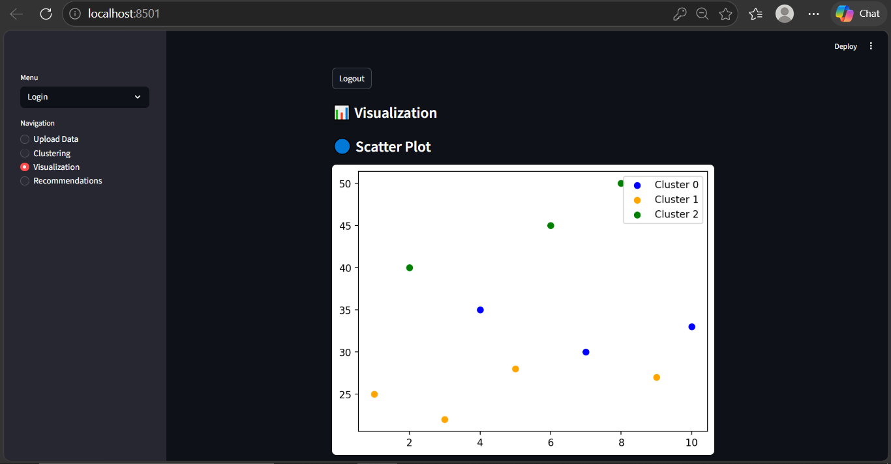

8.6 Pie chart

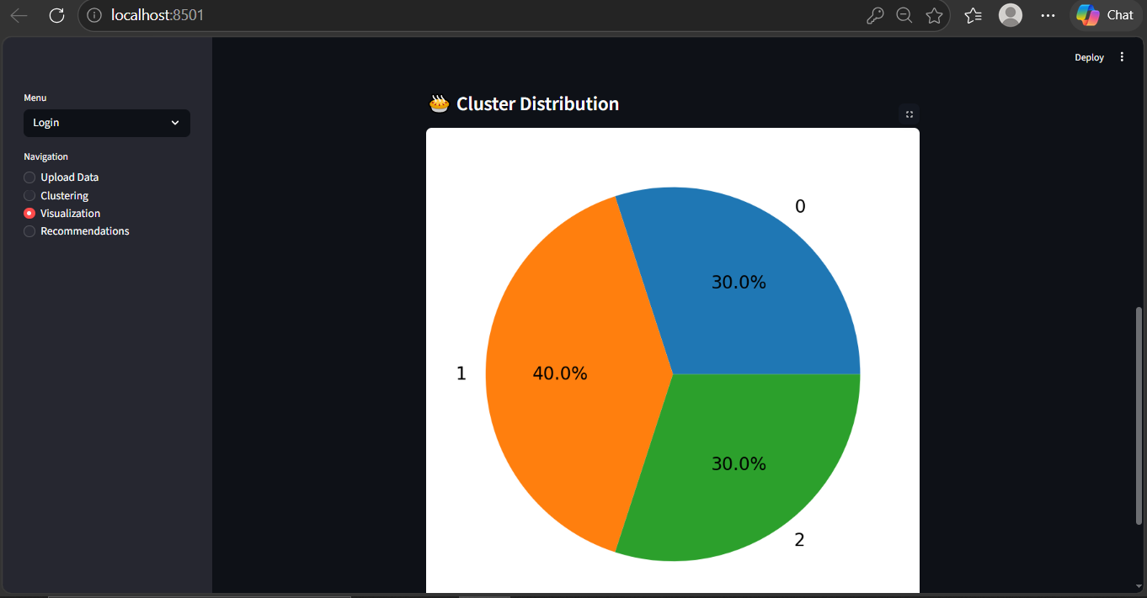

8.7 Recommendations

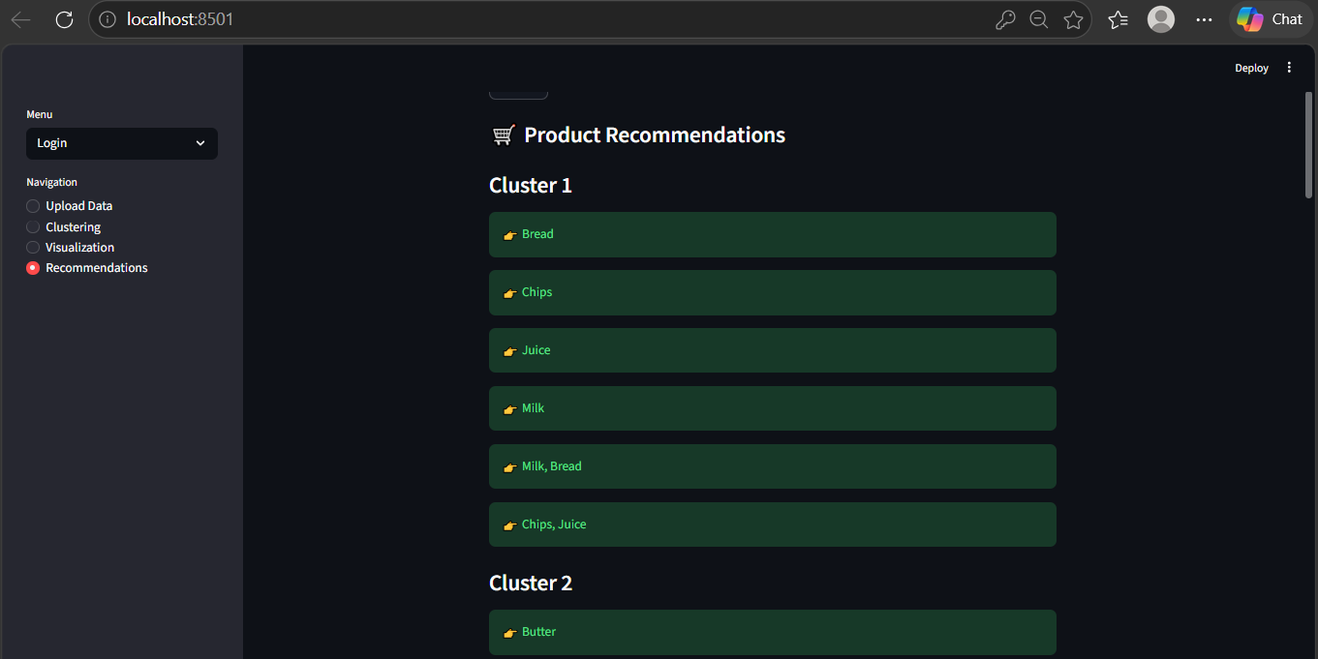

8.8 Top products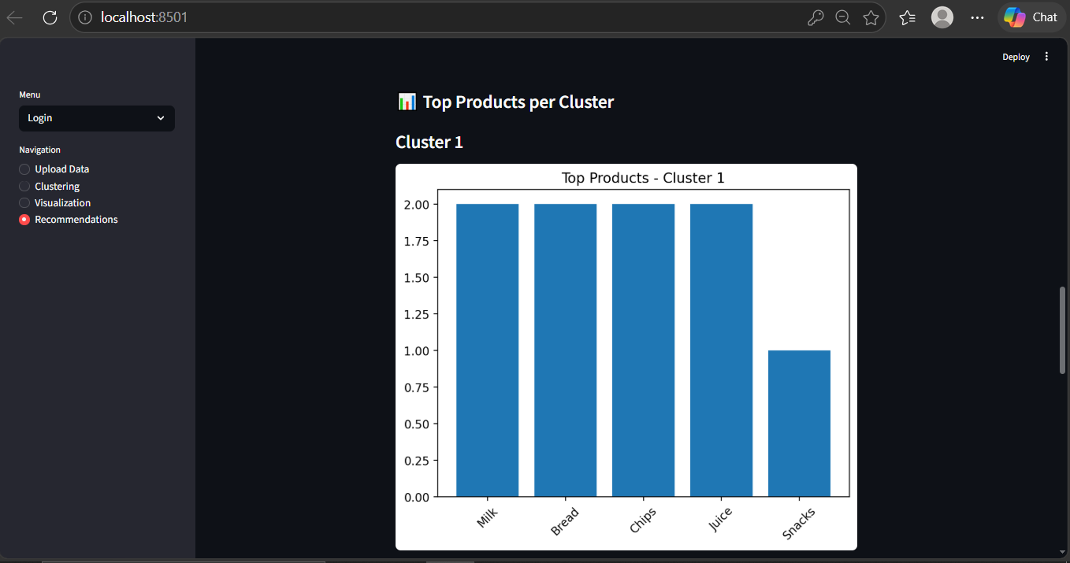

8.9 Logout

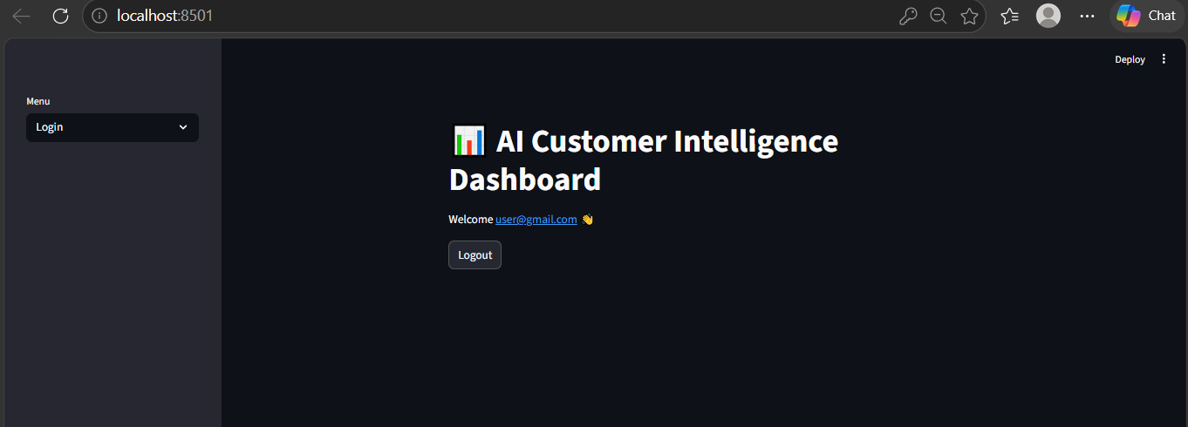

9. Results
The system successfully segments customers into different clusters based on their attributes. Each cluster represents a group of customers with similar characteristics. Visualization tools such as scatter plots and pie charts help in understanding the distribution and relationships between clusters.
The Apriori algorithm identifies frequently purchased product combinations within each cluster. These patterns are used to generate meaningful recommendations such as “Customers often buy Bread and Milk together.” The system effectively demonstrates how combining clustering and association rule mining can provide deeper insights into customer behavior.
The user interface allows users to interact with the system easily by uploading datasets, selecting features, and viewing results dynamically. The results show that the system can be used for targeted marketing and recommendation strategies.

10. Conclusion
This project successfully demonstrates the integration of customer segmentation and product recommendation techniques into a single application. By using the K-Means algorithm, customers are grouped into meaningful segments, and the Apriori algorithm is used to identify purchasing patterns within these segments.
The system provides valuable insights that can help businesses understand their customers better and improve marketing strategies. The use of a user-friendly interface makes the system accessible to non-technical users.
Future enhancements can include the use of advanced algorithms, real-time data processing, and deployment on cloud platforms. Overall, the project highlights the importance of data-driven decision-making in modern business environments.
11. References
1. J. Han, M. Kamber, and J. Pei, Data Mining: Concepts and Techniques, 3rd ed. San Francisco, CA, USA: Morgan Kaufmann, 2011.
2. R. Agrawal and R. Srikant, “Fast Algorithms for Mining Association Rules,” in Proc. 20th Int. Conf. Very Large Data Bases (VLDB), 1994, pp. 487–499.
3. G. K. Gupta, Introduction to Data Mining with Case Studies. New Delhi, India: PHI Learning, 2014.
4. F. Pedregosa et al., “Scikit-learn: Machine Learning in Python,” Journal of Machine Learning Research, vol. 12, pp. 2825–2830, 2011.
5. A. K. Pujari, Data Mining Techniques, 3rd ed. Hyderabad, India: Universities Press, 2013.

